

Capstone Project Final Report

**FPTU CAPSTONE PROJECT MANAGEMENT**

|  |  |
| --- | --- |
|  | **FCPM Team** |
|  |  |
|  | Do Dinh Duc – SE04936 |
|  | Bui Trung Kien – SE05182 |
| **Group Members** | Nguyen Ngoc Khanh - SE05045 |
|  |
|  | Nguyen Duc Long – SE05906 |
|  | Nguyen Minh Khang – SE05904 |
| **Supervisor** | Nghiem Thi Lan Phuong |
|  |  |
| **Capstone Project code** | FCPM |
|  |  |

**Hanoi, Sep 1st, 2020**

Table of Contents

Acknowledgements 5

**DEFINITIONS AND ACRONYMS** 6

**CHAPTER 1: INTRODUCTION** 7

1.1 Purpose 7

1.2 Project Information 7

1.3 The people 7

1.4 Background 8

1.5 The Existing System 9

1.6 Proposal of the system 10

1.6.1 System functions 10

1.6.2 Out-of-scope functions 11

1.6.3 Special approaches 11

**CHAPTER 2: SOFTWARE PROJECT MANAGEMENT PLAN (SPMP)** 12

2.1 Purpose 12

2.1.1 Software processing model 12

2.1.2 Roles and Responsibilities 13

2.2 PROJECT MANAGEMENT PLAN 15

2.2.1 Estimated Tasks 15

2.2.2 Meeting sessions 16

2.2.3 Coding Convention 17

2.2.4 Risk Management Plan 17

2.2.5 Communication Plan 18

**CHAPTER 3: SOFTWARE REQUIREMENTS SPECIFICATION (SRS)** 19

3.1 Purpose 19

3.2 Functional Requirements 19

3.2.1 Use Case Diagram 19

3.2.2 Business Rules 21

3.2.3 Use Cases 21

3.2.4 Use Cases Detail 25

3.3 Non-functional Requirement 54

3.3.1 Security 54

3.3.2 Supportability 55

3.3.3 Accuracy 55

3.3.4 Maintainability and Extensibility 55

3.3.5 Performance 55

3.3.6 Usability 55

3.4 Entity Relationship Diagram 56

**CHAPTER 4: SOFTWARE DESGIN** 57

4.1 Purpose 57

4.2 Architectural overview 57

4.2.1 System Architecture 57

4.2.2 System Architectural Explanation 58

4.3 Design of FPT Project Management System 61

4.3.1 Architectural Layers Design 61

4.3.2 Database Design 63

4.4 SEQUENCE DIAGRAM 74

4.4.1: Description of the Sequence Diagram 74

4.5. User Interface Design 154

4.5.1 Description of the User Interface 154

**5. Software Test Documentation** 235

5.1. Introduction 235

5.1.1 Purpose 235

5.1.2 Scope of testing 235

5.2. Test Plan 236

5.2.1 Testing tools and Environment 236

5.2.2 Resources and Responsibilities 237

5.2.3 Test Strategy 238

5.3. Test Approach 241

5.3.1 Unit test 241

5.3.2 Integration and System test 241

5.4. Test Report 242

5.4.1 Unit test 242

5.4.2 System test 244

**6. Software User’s Manual** 247

6.1. Installation Guide 247

6.2. User’s Guide 247

6.2.1 General function 247

## Acknowledgements

*We wish to express our deepest gratitude to our supervisor Mrs. Nghiem Thi Lan Phuong for her continuous sharing and motivating throughout the project. Under the instructions of Mrs. Phuong, the project team always felt comfortable and confident. Apart from all the technologies and methodologies, Mrs. Phuong shared with us the philosophy of keeping the right attitude towards problems. We believe that was the most important factor that led to the success of this project.*

*We would also like to thank the instructors at FPT University for all the classes. We hope you would find this project as a reflection of the knowledge and experiences you have given us during this period of four years.*

*Finally, we truly appreciate the random fellows on the internet who has discussed with us.*

*Without them, it would have likely been a real struggle to solve every tiny problem.*

# **DEFINITIONS AND ACRONYMS**

|  |  |
| --- | --- |
| **Terminologies** |  |

|  |  |  |
| --- | --- | --- |
| **No** | **Definition** | **Explanation** |
| **1** | **FCPM** | FPTU Capstone Project Management website. |
| **2** | **FCPM** | A stand-alone application that manages students’ system in the 9th semester of the school. |
| **3** | **FCPM Store** | FPTU Capstone Project Management Website Store |
| **4** | **FCPM Console** | FPTU Capstone Project Management Website Console |
| **5** | **FCPM Developer** | People who develops FPTU Capstone Project Management for web applications. |
| **6** | **FCPM User** | People who need FPTU Capstone Project Management Website for their projects |
| **7** | **User** | The term includes FCPM Developer and FCPM User |

|  |  |
| --- | --- |
| **Acronyms** |  |
| **Acronym** | **Definition** |
| **CPU** | Central Processing Unit |
|  |  |
| **RDBMS** | Relational Database Management System |
|  |  |
| **GUI** | Graphical User Interface |
|  |  |
| **HTTP** | Hypertext Transfer Protocol |
|  |  |
| **HTTPS** | Hypertext Transfer Protocol Secure |
|  |  |
| **IDE** | Integrated Development Environment |
|  |  |
| **UML** | Unified Modelling Language |
|  |  |
| **SRS** | Software Requirement Specification |
| **UC** | Use Case |
| **UI** | User Interface |
| **UX** | User Experience |
| **URL** | Uniform Resource Locator |
| **FCPM** | FPT Capstone Project Management |

# **CHAPTER 1: INTRODUCTION**

## 1.1 Purpose

This chapter provides an overview of the project including background information, a literature review of the existing system and raising a proposal for ideas of improvement.

## 1.2 Project Information

* Project name: FPTU Capstone Project Management
* Project code: **FCPM**
* Project group name: **FCPM**
* Product type: **Web Application**
* Timeline: **Sep 1st** **2020**

## 1.3 The people

|  |  |  |  |  |
| --- | --- | --- | --- | --- |
| **NO** | **NAME** | **ROLES** | **E-MAIL** | **PHONE** |
| 1 | *Nghiem Thi Lan Phuong* | Supervisor | [phuongntl@fpt.edu.vn](mailto:phuongntl@fpt.edu.vn) | 0989376681 |
| 2 | *Do Dinh Duc* | Leader | [ducddse04936@fpt.edu.vn](mailto:ducddse04936@fpt.edu.vn) | 0968480997 |
| 3 | *Bui Trung Kien* | Member | [kienbtse05182@fpt.edu.vn](mailto:kienbtse05182@fpt.edu.vn) | 0983268048 |
| 4 | *Nguyen Ngoc Khanh* | Member | [khanhnnse05045@fpt.edu.vn](mailto:khanhnnse05045@fpt.edu.vn) | 0914092466 |
| 5 | *Nguyen Duc Long* | Member | [longndse05906@fpt.edu.vn](mailto:longndse05906@fpt.edu.vn) | 0978299648 |
| 6 | *Nguyen Minh Khang* | Member | [khangnmse05904@fpt.edu.vn](mailto:khangnmse05904@fpt.edu.vn) | 0971091547 |

## 1.4 Background

Each student studying at FPT University has a 4-year path to complete subjects according to the school's schedule. Each student must complete a graduation thesis as the final step to graduation. This made us think of a project of creating a software that provides students with functions such as registering, discussing, completing deadlines, exchanging with teachers ... With the abilities of reducing cost and time, it would be advantageous.

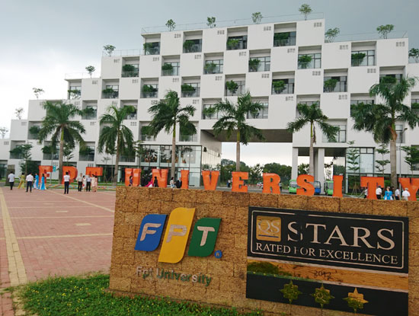

*Figure 1-1: FPT University*

## 1.5 The Existing System

As far as we know, most universities in Vietnam still manage projects manually.

Currently, FPT University has a number of websites for students to easily track their study progress and register their graduation project such as http://fap.fpt.edu.vn/ to help students keep track of everything. subject information, exam schedule, score report, ...

As far as we know, the page http://fap.fpt.edu.vn/ only has the project registration feature, not the project management feature for the training room. So we had the idea to create a project management system to help students, supervisors, training department and head of department easily and most convenient to use.

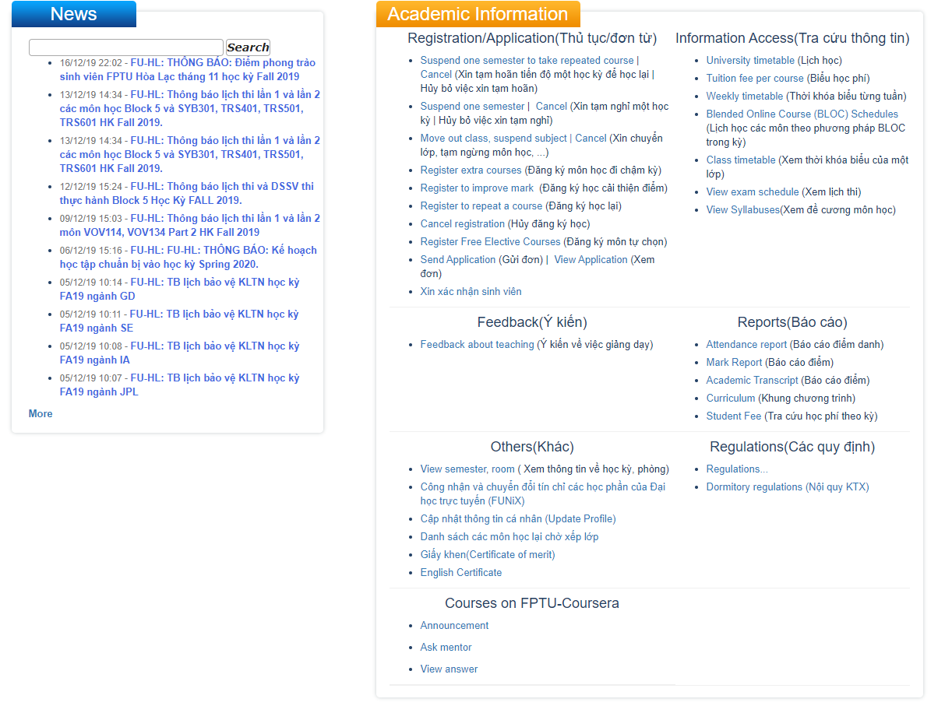

## 1.6 Proposal of the system

### 1.6.1 System functions

* Allow the student to:
* Allow the student to login with FPT email accounts.
* Allow the student to discuss and find teammates for capstone project in forum.
* Allow the student to communicate via chat feature.
* Allow the student to view and research project management models.
* Allow the student to register projects.
* Allow the student to view information and choose supervisors.
* Allow the student to edit the capstone project’s name.
* Allow the student to report the working process of the group.
* Allow the student to report following Jira’s task template.
* Allow the student to view news and notifications.
* Allow supervisor to:
* Allow the supervisor to login with FPT email accounts.
* Allow the supervisor to discuss and gather team’s members for capstone project in forum.
* Allow the supervisor to communicate via chat feature.
* Allow the supervisor to view the list of registrants.
* Allow the supervisor to confirm / reject the project.
* Allow the supervisor to confirm / reject the request of changing project name.
* Allow the supervisor to view the group’s working process.
* Allow the supervisor to view and comment on reports.
* Allow the Training Department to:
* Allow the training department to login with FPT email accounts.
* Allow the training department to view capstone project in forum.
* Allow the training department to communicate via chat feature.
* Allow the training department to view the list of registrants.
* Allow the training department to manage capstone projects.
* Allows the training department to confirm / reject the request of changing project name.
* Allow the training department to manage users.
* Allow the Head of Department to:
* Allow the head of department to login with FPT email account.
* Allow the head of department to view capstone projects in forum.
* Allow the head of department to communicate via chat feature.
* Allow the head of department to confirm / reject the project.
* Allow the head of department to view dashboard of all capstone projects.
* Allow the head of department to view process of working in group.

### 1.6.2 Out-of-scope functions

Because of the time limitation, we did not implement these following functions in the FCPM initial version 1.0.0 release of the project but they are not permanently excluded. We are aware of their importance and they will be developed in future version 2.0.0:

* FCPM adds functions for affairs department.
* FCPM adds functions for examination council.
* FCPM completes functions of assessing the process of project.
* FCPM integrates API of project management systems.

Finally, we used some new approaches to solve the stated problems. Having awareness of the importance of new technologies, we aimed at applying them to our project.

### 1.6.3 Special approaches

* Using Spring boot for business development.
* Using Spring data JPA.
* Using IntelliJ IDEA 2020.2.3.
* Using MySQL Workbench 8.0 CE to manage data.
* Using HTML, CSS, Bootstrap to create frontend.
* Using MS Excel create templates for imported data.

# **CHAPTER 2: SOFTWARE PROJECT MANAGEMENT PLAN (SPMP)**

## 2.1 Purpose

* Helping readers understand the organization and activities of the project and making it easy for readers to visualize how the project is going.
* Setting out the principles that the team members must adhere to and strictly follow throughout the project.
* Each team member must be conscious of the team project, so all team members must use this document to clarify their responsibilities.

### 2.1.1 Software processing model

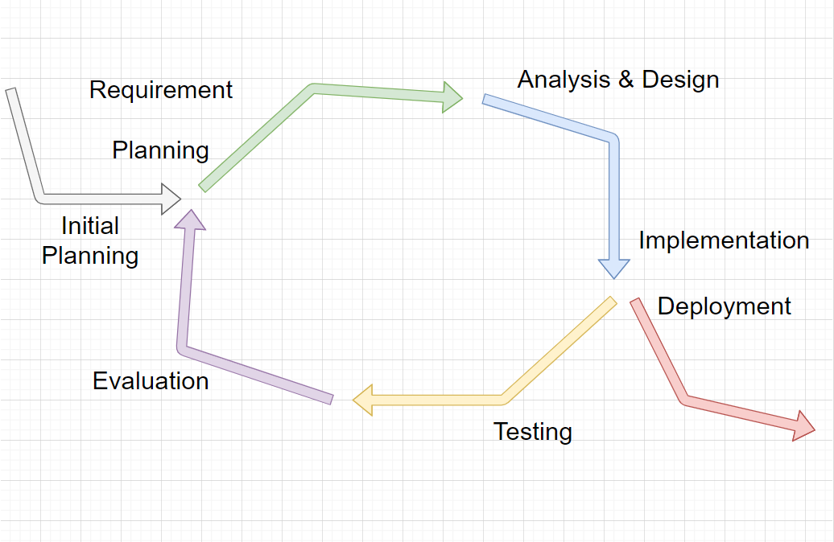*Figure: Iterative development model*

The project used the Iterative Process Model

The Iterative Process Model is mostly used when the scope of the project is big, the major requirements are defined clearly, some more details will be added later in software development. By using this software processing model, we broke down the developing system tasks into series of smaller tasks which were completed separately, allowing us to take advantage of what was learned during the development of earlier parts of the system. In addition, the iterative model is easier than other models when the issues are discovered. They are reported back to the team, and solutions will be found while the project is still in development.

### 2.1.2 Roles and Responsibilities

#### 2.1.2.1 Organization Structure

|  |  |
| --- | --- |
| Role | Responsibility |
| Project Manager | Planning, dividing works among team members, developing schedules, supporting team members, coordinating communication with team members, maintaining a comfortable and proficient working atmosphere, and keeping the team focused on working for the main goal. |
| Technical Leader | Choosing and deciding what technologies should be used, instruct and support team members in using technologies they may not be familiar with, overseeing the work being done by other developers |
| Test Leader | Test execution, including test set-up and test run, evaluating test runs, recovering errors, defect loggings, and recording test results. |
| Developer | Code the product, discuss, exchange and review code of other developers. |
| Designer | Design product’s user interface |
| Tester | Test the product |

*Table 2-1: Project Structure*

#### 2.1.2.2 Project Team Members

|  |  |
| --- | --- |
| **Team Member** | **Role** |
| DucDDSE04936 | Project Manager, Technical Leader, Developer, Designer |
| KienBTSE05182 | Test Leader, Developer, Designer, Tester |
| KhanhNNSE05045 | Developer, Designer, Tester |
| LongNDSE05906 | Developer, Designer, Tester |
| KhangNMSE05904 | Developer, Designer, Tester |

*Table: Project Team Members*

#### 2.1.2.3 Tools and Techniques

|  |  |  |
| --- | --- | --- |
| **Software Tool** | **Version** | **Description** |
| Jira | Online | Management tools |
| GitHub | Online | Source code control |
| Source Tree | 3.1.3 | Source code control |
| Microsoft Words | 2019 | Document tools |
| Microsoft Excel | 2019 | Document tools |
| MySQL Workbench 8.0 CE | 2019 | My SQL |
| Facebook | Online | Communication tool |
| Skype | Online | Communication tool |
| Process Model |  | Iterative Model |
| Draw.io | Online | Diagram, UML tool, chart |
| Spring Boot | 2.3.3 | IDE for coding |
| Spring Data JPA | 2.0.3 | IDE for coding |
| Hibernate |  | IDE for coding |
| Visual Studio Code | 1.34.0 | IDE for coding |
| HTML |  | IDE for coding |
| CSS |  | IDE for coding |
| Bootstrap |  | IDE for coding |
| JS, JQuery |  | IDE for coding |
| IntelliJ IDEA | 2020.2.3 | IDE for coding |

## 2.2 PROJECT MANAGEMENT PLAN

### 2.2.1 Estimated Tasks

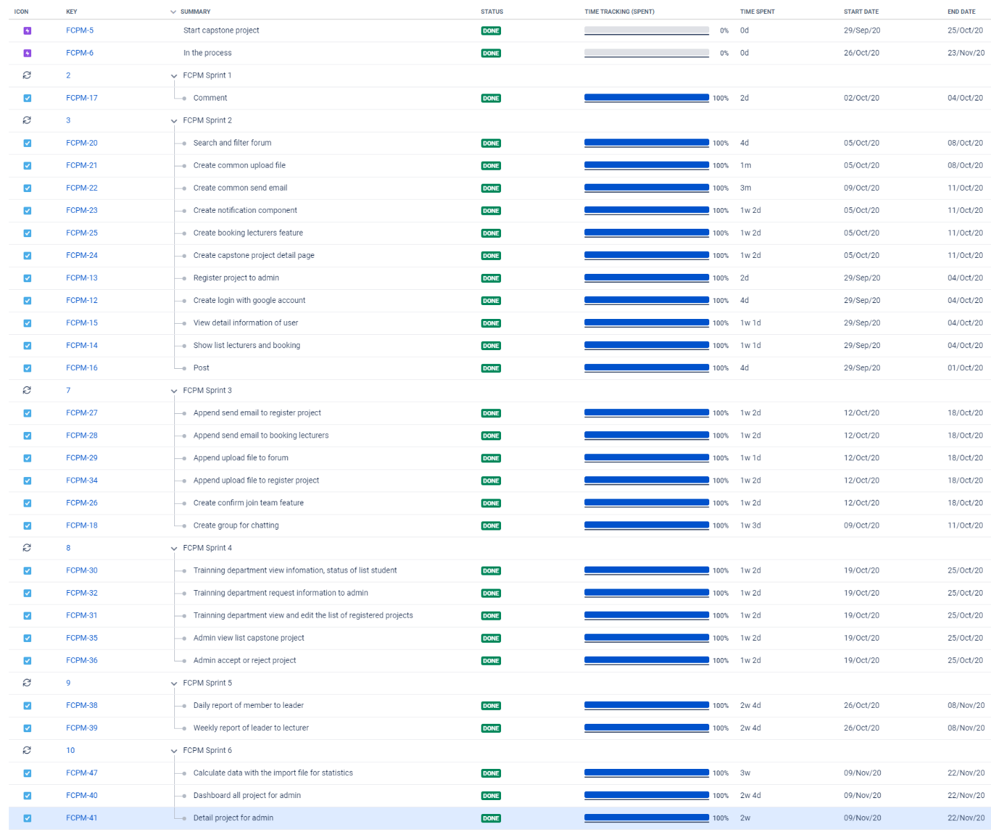

### 2.2.2 Meeting sessions

All meeting sessions were be written following this template:

|  |  |  |  |  |  |
| --- | --- | --- | --- | --- | --- |
| Meeting/Project Name: | | FCPM | | | |
| Date of meeting: | | 25/8/2020 | *Time: (Type)* | | *1 hours (Face-to-face)* |
| Meeting Called by: | | DucDD | ***Location:*** | | *FPT University – P205* |
| Note Taker: | | KhangNM | ***Time Keeper:*** | | DucDD |
| 1. Meeting Objectives  1. Assigning new tasks for members  2. Conducting report No.2 | | | | | |
| 2. Attendance | | | | | |
| ***Name*** | ***Roles*** | ***E-mail*** | ***Phone*** | |
| Do Dinh Duc | Project Manager | [Ducddse04936@fpt.edu.vn](mailto:Ducddse04936@fpt.edu.vn) | 0968480997 | |
| Bui Trung Kien | Developer ,Tester Leader, Doc | [Kienbtse05182@fpt.edu.vn](mailto:Kienbtse05182@fpt.edu.vn) | 0986268048 | |
| Nguyen Ngoc Khanh | Developer ,Tester, Doc | [Khanhnnse05045@fpt.edu.vn](mailto:Khanhnnse05045@fpt.edu.vn) | 0914092466 | |
| Nguyen Minh Khang | Developer ,Tester, Doc | [Khangnmse05904@fpt.edu.vn](mailto:Khangnmse05904@fpt.edu.vn) | 0971091547 | |
| Nguyen Duc Long | Developer ,Tester, Doc | [Longndse05906@fpt.edu.vn](mailto:Longndse05906@fpt.edu.vn) | 09782996448 | |
| 3. Done tasks  1. Building project structure.  2. Configuring git repository with security.  3. Conducting report No.1 | | | | |
| 4. New tasks  1. Backend    2. Frontend | | | | |
| 5. Risks & Difficulties | | | | |

### 2.2.3 Coding Convention

Sonar Lint tool for checking convention of Java

### 2.2.4 Risk Management Plan

|  |  |  |  |  |
| --- | --- | --- | --- | --- |
| **No** | **Description** | **Avoidance plan** | **Contingency plan** | **Status** |
| R1 | Data loss | Using GitHub for version control.  - Teaching members how to use Git and resolving conflicts.  - Always have important backups. | - Restoring backed up  data from GitHub. | Closed |
| R2 | Illness or  absence of  team  members | - Providing schedules in advance.  - For long periods of absence,  members should notify the group in advance. | - Assigning the tasks of  absent member to  other members.  - Working overtime if  necessary. | Closed |
| R3 | Misunderstanding of  Requirements | - Discussing requirements carefully with the customer.  - Always ask for clarification if requirements are unclear.  - Commenting needs to meet | -Making sure idea’s business logic is carefully analysed. | Closed |
| R4 | Changes in requirements | - Every new update of requirement has to be reviewed by all team  members and supervisor.  - Team member has to analyse requirements carefully before raising up to team. | - If requirement has new update, all members have to join the meeting to be aware and to make decisions. | Closed |
| R5 | Conflicts  between team  members | - Everything must be documented.  - Every team member has to express clearly and carefully. | - Making sure any  miscommunication  has to be resolved. | Closed |
| R6 | Failed to  meet deadline | - Planning and developing schedule carefully.  - Assigning tasks carefully.  - Defining punishment for team members who neglect work. | - Finding the root cause  of the problem.  - Reassigning tasks.  - Focusing on important  functions first. | Closed |

*Table 2-5: Risk Management*

### 2.2.5 Communication Plan

*Weekly meeting schedule*: We used Iterative and Incremental Process Model, then we divided the system into two sub-systems, each sub-system was divided into series of small tasks. The amount of work by the whole team, after that the task will be assigned to team members by the Team Leader, and depending on difficulty levels, the Technical Leader set deadlines for each task. We had a meeting inform to all team about what each member finished last week, the status (fast, on time or slow), the issues met and how to solve them. When any member raised any issue, the whole team helped to find out a solution together. After that, the team defined detailed stories for next week tasks.

*Daily meeting schedule*: Each sub-system had one development team with different schedule. Starting each workday, each team had a stand-up meeting to inform to others: “What did I do yesterday?”, “What will I do today?” and “Is there any difficulty?”. By focusing on what each person accomplished the day before and will accomplish on that day, the team gained an excellent understanding of what had been done and what remained.

*Unscheduled meeting*: When someone had an important problem that he wanted to solve immediately, we had a meeting for discussion, usually via some online channels: Skype, Facebook or Phone.

*Communication channel*: Our main communication channel was Skype. On the other hand, we used face-to-face meetings, Facebook group to comment issues. However, we sometimes

made phone calls or instant messages if someone had a problem.

# **CHAPTER 3: SOFTWARE REQUIREMENTS SPECIFICATION (SRS)**

## 3.1 Purpose

Software Requirements Specifications chapter provides general, as well as specific information of the system, it outlines functional and non-functional requirements of our website. Following these requirements, FCPM performs its intended functionality used in designing developing and testing. All members work based on the information that provided in this document.

## 3.2 Functional Requirements

### 3.2.1 Use Case Diagram

The figure below is displayed the use cases we had in this project.

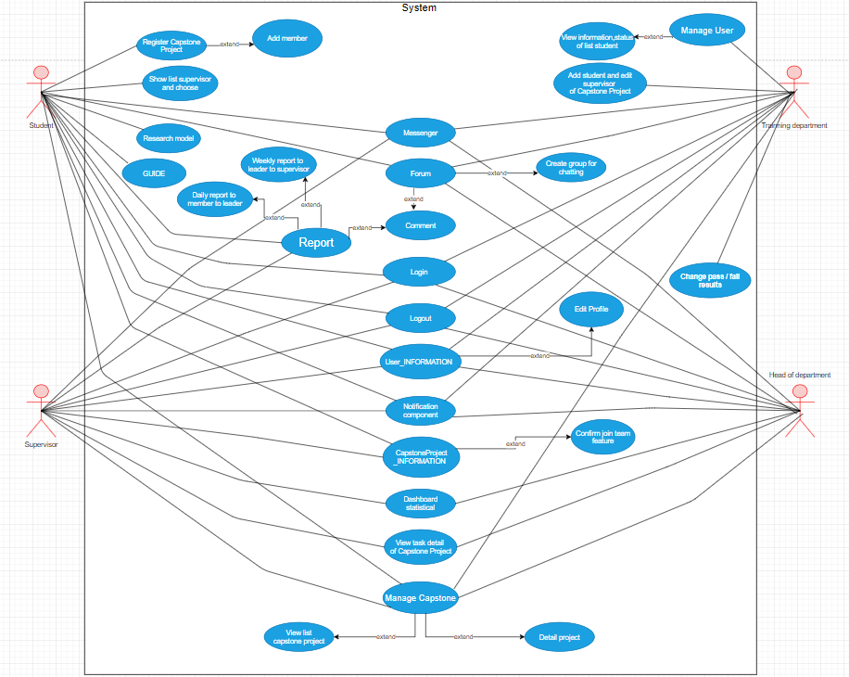

Figure: Use case diagram

### 3.2.2 Business Rules

|  |  |
| --- | --- |
| **No** | **Description** |
| B1 | Username must not be empty. |
| B2 | Username must be unique. |
| B3 | User’s full name must not be empty. |
| B4 | The email must not be empty. |
| B5 | Email address must be valid. |
| B6 | Each email address can be used for only one account. |
| B7 | Capstone Project must have sites and semesters |
| B8 | Phone number must be valid. |
| B9 | The administrator is able to: active/ deactivate account, change account role, change request state. |
| B10 | Only users whose role is: Head of department, Supervisor view statistical dashboard of the screen. |
| B11 | The administrator is able to: active/ deactivate account, change account role, change request state of student, supervisor. |
| B12 | Exported files must be Microsoft Excel files with valid formats. |
| B13 | Only leader can be created weekly report. |
| B14 | Only student can create reports. |
| B15 | Only training department add news. |
| B16 | Only training department can manage users. |
| B17 | Users must have sites and semesters |

*Table: Business rules*

### 3.2.3 Use Cases

|  |  |
| --- | --- |
| **Actor** | **Description** |
| Student | FPT students who have qualified for the project, are preparing to do a project can easily find their project group and register for the project in the fastest and most convenient way. Students will know the information of instructors to choose the right supervisor for the group. And in the process of making projects, students can also exchange and report on weekly work with supervisors. |
| Supervisor | The supervisor looks at the project teams of his choice and makes a decision to accept or reject the instruction. During the project, the supervisor can see the daily and weekly reports sent by the leader of team, and the supervisor will decide whether the project team is protected or not. |
| Training department | The training department will view the project registration list and view information and status of the project group. The training department will decide what the group will do and the supervisor will guide the group. Training department will synthesizes the results and decide the success or failure of the project team |
| Head of department | The Head of Department will see all of: the information, the project team list and the details of the team's project making process. |

***Table: Actor description***

|  |  |  |  |
| --- | --- | --- | --- |
|  | **Actor** | **Name** | **Description** |
| **UC-001** | Student, Supervisors, Training department, Head of department | Login | Login to system with FCPM account. |
| **UC-002** | Student, Supervisors, Training department, Head of department | Logout | Logout to system with FCPM account |
| **UC-003** | Student | Register Capstone Project | Students register capstone project to system |
| **UC-004** | Student | Add member | Students add members to register project |
| **UC-005** | Student | Research model | Students research models for reference |
| **UC-006** | Student | Show list supervisors and booking | Students choose supervisor of their group |
| **UC-007** | Student | View GUIDE | View GUIDE to reference |
| **UC-008** | Student | Upload file | Students upload file to register projects or add posts |
| **UC-009** | Student | Send mail | Students send mail to register project and booking supervisor |
| **UC-010** | Student, Supervisor, Training department, Head of department | Chat | Users chat together |
| **UC-011** | Student | Create chat | Students create group for chatting and invite other student who do not have project group to talk, exchange. |
| **UC-012** | Student | Confirm join team feature | After talking through a group chat, Students will agree to form a group to register project |
| **UC-013** | Student | Edit Profile | Students can edit profile |
| **UC-014** | Student, Supervisors, Training department, Head of department | Notification component | When there is any information, there will be a notice to the student, supervisors, training department, head of department |
| **UC-015** | Student, Supervisors, Training department, Head of department | Comment | Students, supervisors, training department, head of department can comment, exchange information with each other |
| **UC-016** | Student, Supervisors | Daily report to member to leader | Every day, members who complete tasks must report to leader |
| **UC-017** | Leader | Weekly report to leader to supervisor | Every week, the leader must report to supervisor during the past week, team has performed |
| **UC-018** | Training department | Manage User | Training department can manage all information of user |
| **UC-019** | Training department | View information, status of list student | Training department can view information of list student and view status of students who are eligible to do projects or students don not have groups to add to another group |
| **UC-020** | Training department | Add student and edit supervisor of Capstone Project | Training department can add student and edit supervisor of Capstone Project |
| **UC-021** | Head of department, Supervisor | View list capstone project | Allow students, supervisor see the list capstone project |
| **UC-022** | Head of department, Supervisor | View detail project | Head of department, supervisors can view detail project |
| **UC-023** | Head of department, Supervisor | Manage Capstone Project | Head of department and supervisors can manage capstone project |
| **UC-024** | Supervisors, Head of department | View task detail of Capstone Project | Supervisors and head of department can view task detail of Capstone Project |
| **UC-025** | Supervisors, Head of department | Dashboard statistical of project | Supervisors and head of department will dashboard statistical all information project of registered groups |
| **UC-026** | Student, Supervisor, Head of department, Training department | View information of user | Students, supervisors, head of department and training department can view information of users |
| **UC-027** | Head of department | Approve capstone project in the project registration stage | Head of department can approve capstone project in the project registration stage |
| **UC-028** | Training department | Change pass / fail results | Training department can Change pass / fail results capstone project |
| **UC-029** | Training department | Create notification | Training department can create notification |
| **UC-030** | Training department | View history record | Training department can view history record |
| **UC-031** | Student | Change name capstone project | Student can change name capstone project |
| **UC-032** | Student, Supervisor, Head of department, Training department | View List Post | Student, Supervisor, Head of department, Training department view list post |
| **UC-033** | Student, Supervisor, Head of department, Training department | Get comment | Student, Supervisor, Head of department, Training department get comment |
| **UC-034** | Student, Supervisor, Head of department, Training department | Add post | Student, Supervisor, Head of department, Training department add post |
| **UC-035** | Student, Supervisor, Head of department, Training department | Edit post | Student, Supervisor, Head of department, Training department edit post |
| **UC-036** | Student, Supervisor, Head of department, Training department | Delete post | Student, Supervisor, Head of department, Training department delete post |
| **UC-037** | Student, Supervisor, Head of department, Training department | Search post | Student, Supervisor, Head of department, Training department search post |
| **UC-038** | Training department | Add user | Training department add user |
| **UC-039** | Training department | Approve capstone project in the changing name stage | Training department approve capstone project in the changing name stage |

*Table: Use Case List*

### 3.2.4 Use Cases Detail

#### UC-001. Login

*Use Case Specification*

|  |  |  |  |
| --- | --- | --- | --- |
| UC ID and Name: | **UC- Log in** | | |
| Create by: | DucDD | Date Created: | 10/08/2020 |
| Primary Actor: | Students, Supervisors, Training department, Head of department | Secondary Actor: |  |
| Trigger: | N/A | | |
| Description: | Allow students, supervisors, training department, head of department who have FCPM account to login. | | |
| Preconditions: | Students supervisors, training department, head of department account has been set up and username and password has been generated. | | |
| Post conditions: | Students, supervisors, training department, head of department are logged into FCPM successfully.  System displays Login Page. | | |
| Normal Flow: | **Login:** 1. Student visits the login page.  2. Student click " Sign in with Google "  3. Systems displays account verification  4. Student choose account FPT  5. System displays forum | | |
| Alternative Flows: | Students violates some business rule in step 4  1. Students choose a non-FPT account  3. Go to step 1 in normal flow. | | |
| Exceptions: | Cannot communicate with server 1. FCPM displays error message. | | |
| Priority: | High | | |
| Frequency of Use: | High | | |
| Business Rules: |  | | |
| Other Information: | N/A | | |
| Assumptions: | N/A | | |

#### UC-002. Logout

*Use Case Specification*

|  |  |  |  |
| --- | --- | --- | --- |
| UC ID and Name: | **UC- Logout** | | |
| Create by: | KienBT | Date Created: | 10/08/2020 |
| Primary Actor: | Students, Supervisors, Training department, Head of department | Secondary Actor: |  |
| Trigger: | N/A | | |
| Description: | To prevent other users from stealing information | | |
| Preconditions: | User has logged into FCPM system | | |
| Post conditions: | Students, supervisors, training department, head of department are logged into FCPM successfully.  System displays forum. | | |
| Normal Flow: | **Logout**: 1.Students successfully login to the forum  2.Student select their username in the top right corner of the forum  3.Student click "Logout"  4.System display Login Page | | |
| Alternative Flows: | N/A | | |
| Exceptions: | Cannot communicate with server 1. FCPM displays error message. | | |
| Priority: | High | | |
| Frequency of Use: | High | | |
| Business Rules: |  | | |
| Other Information: | N/A | | |
| Assumptions: | N/A | | |

#### UC-003. Register Capstone Project

*Use Case Specification*

|  |  |  |  |
| --- | --- | --- | --- |
| UC ID and Name: | **UC- Register Capstone Project** | | |
| Create by: | KhanhNN | Date Created: | 10/08/2020 |
| Primary Actor: | Student | Secondary Actor: |  |
| Trigger: | N/A | | |
| Description: | Student register capstone project to system | | |
| Preconditions: | The student has formed his project team | | |
| Post conditions: | 1.The student has successfully formed his project team  2.Students login to their account successfully  3.The system displays forum | | |
| Normal Flow: | **Register**:  1.Students login to their account successfully 2.Students access the forum  3.Students click on " Capstone Project " and choose " Create Capstone "  4.System display Register Project Page  5.Students register project and click “submit” to register | | |
| Alternative Flows: | N/A | | |
| Exceptions: | Cannot communicate with server 1. FCPM displays error message. | | |
| Priority: | High | | |
| Frequency of Use: | High | | |
| Business Rules: |  | | |
| Other Information: | N/A | | |
| Assumptions: | N/A | | |

#### UC-004. Add Member

*Use Case Specification*

|  |  |  |  |
| --- | --- | --- | --- |
| UC ID and Name: | **UC- Add member** | | |
| Create by: | LongND | Date Created: | 10/08/2020 |
| Primary Actor: | Student | Secondary Actor: |  |
| Trigger: | N/A | | |
| Description: | Student add member to register capstone project | | |
| Preconditions: | The student has formed his project team | | |
| Post conditions: | 1.The student has successfully formed his project team  2.Students login to their account successfully  3.The system displays forum | | |
| Normal Flow: | **Add member:**  1.Students login to their account successfully 2.Students access the forum  3.Students click on " Capstone Project " and choose " Create Capstone "  4.System display Register Project Page  5.Student add account member of team  6.Student click button “Add” | | |
| Alternative Flows: | N/A | | |
| Exceptions: | Cannot communicate with server 1. FCPM displays error message. | | |
| Priority: | High | | |
| Frequency of Use: | High | | |
| Business Rules: |  | | |
| Other Information: | N/A | | |
| Assumptions: | N/A | | |

#### UC-005. Research model

*Use Case Specification*

|  |  |  |  |
| --- | --- | --- | --- |
| UC ID and Name: | **UC- Research model** | | |
| Create by: | KhangNM | Date Created: | 10/08/2020 |
| Primary Actor: | Student | Secondary Actor: |  |
| Trigger: | N/A | | |
| Description: | Student research model for reference | | |
| Preconditions: | The student has formed his project team | | |
| Post conditions: | 1.The student has successfully formed his project team  2.Students login to their account successfully  3.The system displays forum | | |
| Normal Flow: | **Research model:**  1.Students login to their account successfully 2.Students access the forum  3.Students click on "Model" to research model | | |
| Alternative Flows: | N/A | | |
| Exceptions: | Cannot communicate with server 1. FCPM displays error message. | | |
| Priority: | High | | |
| Frequency of Use: | High | | |
| Business Rules: |  | | |
| Other Information: | N/A | | |
| Assumptions: | N/A | | |

#### UC-006. Show list supervisor and booking

*Use Case Specification*

|  |  |  |  |
| --- | --- | --- | --- |
| UC ID and Name: | **UC- Show list supervisor and booking** | | |
| Create by: | LongND | Date Created: | 10/08/2020 |
| Primary Actor: | Student | Secondary Actor: |  |
| Trigger: | N/A | | |
| Description: | Student choose instructors of their group | | |
| Preconditions: | Students have registered for the project | | |
| Post conditions: | Students found the details of the supervisors | | |
| Normal Flow: | **Booking supervisor:**  1. Students login to their account successfully 2. Students click on “Capstone Project” at the top of the page, Choose supervisors  3. System display a list supervisors’ page  4. Students click on name of supervisor to show information of supervisor to booking | | |
| Alternative Flows: | N/A | | |
| Exceptions: | Cannot communicate with server 1. FCPM displays error message. | | |
| Priority: | High | | |
| Frequency of Use: | High | | |
| Business Rules: |  | | |
| Other Information: | N/A | | |
| Assumptions: | N/A | | |

#### UC-007. View GUIDE

*Use Case Specification*

|  |  |  |  |
| --- | --- | --- | --- |
| UC ID and Name: | **UC- View GUIDE** | | |
| Create by: | DucDD | Date Created: | 10/08/2020 |
| Primary Actor: | Student | Secondary Actor: |  |
| Trigger: | N/A | | |
| Description: | Student view GUIDE to reference | | |
| Preconditions: | Students have registered for the project | | |
| Post conditions: | Students found the details of the supervisors | | |
| Normal Flow: | **View GUIDE:**  1.Students login to their account successfully 2.Students access the forum  3.Students click on "GUIDE" to research GUIDE | | |
| Alternative Flows: | N/A | | |
| Exceptions: | Cannot communicate with server 1. FCPM displays error message. | | |
| Priority: | High | | |
| Frequency of Use: | High | | |
| Business Rules: |  | | |
| Other Information: | N/A | | |
| Assumptions: | N/A | | |

#### UC-008. Upload file

*Use Case Specification*

|  |  |  |  |
| --- | --- | --- | --- |
| UC ID and Name: | **UC- Upload file** | | |
| Create by: | KhangNM | Date Created: | 10/08/2020 |
| Primary Actor: | Student | Secondary Actor: |  |
| Trigger: | N/A | | |
| Description: | Student upload file to register project or add post | | |
| Preconditions: | Leader gathered enough information about the group members to complete the word file  Leader complete the word file to upload | | |
| Post conditions: | 1.Students login to their account successfully  2.Leader gathered enough information about the group members to complete the word file to upload  3.The system displays the Register Project page to upload file | | |
| Normal Flow: | **Upload file:**  1.Students login to their account successfully 2.Students access the forum  3.Students click on " Capstone Project " and choose " Create Capstone "  4.System display Register Project Page to upload file  5. Students click on “ Upload” to upload file | | |
| Alternative Flows: | N/A | | |
| Exceptions: | Cannot communicate with server 1. FCPM displays error message. | | |
| Priority: | High | | |
| Frequency of Use: | High | | |
| Business Rules: |  | | |
| Other Information: | N/A | | |
| Assumptions: | N/A | | |

#### UC-009. Send mail

*Use Case Specification*

|  |  |  |  |
| --- | --- | --- | --- |
| UC ID and Name: | **UC- Send mail** | | |
| Create by: | KhanhNN | Date Created: | 10/08/2020 |
| Primary Actor: | Student | Secondary Actor: |  |
| Trigger: | N/A | | |
| Description: | Students send mail to register capstone project and booking supervisor | | |
| Preconditions: | Group has enough to member | | |
| Post conditions: | 1.The group has all the information of its members  2.The group had the project's topic | | |
| Normal Flow: | **Send mail:**  1.Student access to email page  2.Student create email  3.Student enter information of team  4.Student send mail to register capstone project and booking supervisor to training department | | |
| Alternative Flows: | N/A | | |
| Exceptions: | Cannot communicate with server 1. FCPM displays error message. | | |
| Priority: | High | | |
| Frequency of Use: | High | | |
| Business Rules: |  | | |
| Other Information: | N/A | | |
| Assumptions: | N/A | | |

#### UC-010. Chat

*Use Case Specification*

|  |  |  |  |
| --- | --- | --- | --- |
| UC ID and Name: | **UC- Chat** | | |
| Create by: | KienBT | Date Created: | 10/08/2020 |
| Primary Actor: | Student, Supervisor, Training department, Head of department | Secondary Actor: |  |
| Trigger: | N/A | | |
| Description: | User chat together | | |
| Preconditions: | User login successfully | | |
| Post conditions: | User access successfully to forum | | |
| Normal Flow: | **Chat:**  1. Users login to their account successfully 2. Users access to forum  3. Users click button “Messenger” to chat | | |
| Alternative Flows: | N/A | | |
| Exceptions: | Cannot communicate with server 1. FCPM displays error message. | | |
| Priority: | High | | |
| Frequency of Use: | High | | |
| Business Rules: |  | | |
| Other Information: | N/A | | |
| Assumptions: | N/A | | |

#### UC-011. Create chat

*Use Case Specification*

|  |  |  |  |
| --- | --- | --- | --- |
| UC ID and Name: | **UC- Create chat** | | |
| Create by: | DucDD | Date Created: | 10/08/2020 |
| Primary Actor: | Student | Secondary Actor: |  |
| Trigger: | N/A | | |
| Description: | Students Create chat and invite other student who do not have project group to talk, exchange | | |
| Preconditions: | Students have not found their own project group | | |
| Post conditions: | Project group does not have enough members | | |
| Normal Flow: | **Create chat:**  1.Students login to their account successfully 2.Students access the forum page to post  3.Student click icon on screen  4.Show room to student chat | | |
| Alternative Flows: | N/A | | |
| Exceptions: | Cannot communicate with server 1. FCPM displays error message. | | |
| Priority: | High | | |
| Frequency of Use: | High | | |
| Business Rules: |  | | |
| Other Information: | N/A | | |
| Assumptions: | N/A | | |

#### UC-012. Confirm join team feature

*Use Case Specification*

|  |  |  |  |
| --- | --- | --- | --- |
| UC ID and Name: | **UC- Confirm join team feature** | | |
| Create by: | KhangNM | Date Created: | 10/08/2020 |
| Primary Actor: | Student | Secondary Actor: |  |
| Trigger: | N/A | | |
| Description: | After talking through a group chat, Students will agree to form a group to register project | | |
| Preconditions: | Students have not found their own project group | | |
| Post conditions: | Project group not enough members | | |
| Normal Flow: | **Confirm join team feature:**  -Students login to their account successfully -Students access the forum page to post  -Students Create chat  - If the student is interested, press the join button, it will automatically add to the chat group  - After the group chat members feel ok, the students in that group will form a group to register the project group. | | |
| Alternative Flows: | N/A | | |
| Exceptions: | Cannot communicate with server 1. FCPM displays error message. | | |
| Priority: | High | | |
| Frequency of Use: | High | | |
| Business Rules: |  | | |
| Other Information: | N/A | | |
| Assumptions: | N/A | | |

#### UC-013. Edit Profile

*Use Case Specification*

|  |  |  |  |
| --- | --- | --- | --- |
| UC ID and Name: | **UC- Edit Profile** | | |
| Create by: | KienBT | Date Created: | 10/08/2020 |
| Primary Actor: | Student | Secondary Actor: |  |
| Trigger: | N/A | | |
| Description: | Student can edit profile | | |
| Preconditions: | Student login to their account successfully | | |
| Post conditions: | Student access successfully to forum | | |
| Normal Flow: | **Edit profile:**  1.Students login to their account successfully 2.Students access the forum  3.Student click to account  4.Student click button “Edit profile” | | |
| Alternative Flows: | N/A | | |
| Exceptions: | Cannot communicate with server 1. FCPM displays error message. | | |
| Priority: | High | | |
| Frequency of Use: | High | | |
| Business Rules: |  | | |
| Other Information: | N/A | | |
| Assumptions: | N/A | | |

#### UC-014. Notification component

*Use Case Specification*

|  |  |  |  |
| --- | --- | --- | --- |
| UC ID and Name: | **UC- Notification component** | | |
| Create by: | LongND | Date Created: | 10/08/2020 |
| Primary Actor: | Student, Supervisor, Training department, Head of department | Secondary Actor: |  |
| Trigger: | N/A | | |
| Description: | When there is any information, there will be a notice to the student, supervisors, training department, head of department | | |
| Preconditions: | 1. Users can access the system.  2. Users logins successfully | | |
| Post conditions: | N/A | | |
| Normal Flow: | **Notification component:**  1.Users login to their account successfully  2.Users access the forum page  3.Select the notifications you want to see  4.Displays details of the notifications you want to see | | |
| Alternative Flows: | N/A | | |
| Exceptions: | Cannot communicate with server 1. FCPM displays error message. | | |
| Priority: | High | | |
| Frequency of Use: | High | | |
| Business Rules: |  | | |
| Other Information: | N/A | | |
| Assumptions: | N/A | | |

#### UC-015. Comment

*Use Case Specification*

|  |  |  |  |
| --- | --- | --- | --- |
| UC ID and Name: | **UC- Comment** | | |
| Create by: | KhanhNN | Date Created: | 10/08/2020 |
| Primary Actor: | Student, Supervisor | Secondary Actor: |  |
| Trigger: | N/A | | |
| Description: | Student and supervisors can comment, exchange information with each other | | |
| Preconditions: | 1. Student, supervisor can access the system.  2. Student, supervisor logins successfully | | |
| Post conditions: | N/A | | |
| Normal Flow: | **Comment:**  1.Students, supervisor login to their account successfully  2. Students, supervisor access the forum page  3. Student, supervisor can enter information you want comment, click send in post | | |
| Alternative Flows: | N/A | | |
| Exceptions: | Cannot communicate with server 1. FCPM displays error message. | | |
| Priority: | High | | |
| Frequency of Use: | High | | |
| Business Rules: |  | | |
| Other Information: | N/A | | |
| Assumptions: | N/A | | |

#### UC-016. Daily report to member to leader

*Use Case Specification*

|  |  |  |  |
| --- | --- | --- | --- |
| UC ID and Name: | **UC- Daily report to member to leader** | | |
| Create by: | DucDD | Date Created: | 10/08/2020 |
| Primary Actor: | Student | Secondary Actor: |  |
| Trigger: | N/A | | |
| Description: | Every day, members who complete tasks must report to leader | | |
| Preconditions: | Members complete their task | | |
| Post conditions: | N/A | | |
| Normal Flow: | **Report**:  1.Students login to their account successfully  2.Students access the forum page  3. Select the Reports section at the top of the page, then select create report  4. Enter information report, then click button submit  5. Display reports of yourself and team members  6. Click name of title to view detail information of report  7. Display report detail | | |
| Alternative Flows: | N/A | | |
| Exceptions: | Cannot communicate with server 1. FCPM displays error message. | | |
| Priority: | High | | |
| Frequency of Use: | High | | |
| Business Rules: |  | | |
| Other Information: | N/A | | |
| Assumptions: | N/A | | |

#### UC-017. Weekly report to leader to supervisor

*Use Case Specification*

|  |  |  |  |
| --- | --- | --- | --- |
| UC ID and Name: | **UC- Weekly report to leader to supervisor** | | |
| Create by: | KienBT | Date Created: | 10/08/2020 |
| Primary Actor: | Leader | Secondary Actor: |  |
| Trigger: | N/A | | |
| Description: | Every week, the leader must report to supervisor during the past week, team has performed | | |
| Preconditions: | Team complete their task | | |
| Post conditions: | N/A | | |
| Normal Flow: | **Report:**  1.Leader login to their account successfully  2.Leader access the forum page  3. Select the Reports section at the top of the page, then select create report  4. Enter information report, then click button submit  5. Display reports of yourself and team members  6. Click name of title to view detail information of report  7. Display report detail | | |
| Alternative Flows: | N/A | | |
| Exceptions: | Cannot communicate with server 1. FCPM displays error message. | | |
| Priority: | High | | |
| Frequency of Use: | High | | |
| Business Rules: |  | | |
| Other Information: | N/A | | |
| Assumptions: | N/A | | |

#### UC-018. Manage User

*Use Case Specification*

|  |  |  |  |
| --- | --- | --- | --- |
| UC ID and Name: | **UC- Manage User** | | |
| Create by: | LongND | Date Created: | 10/08/2020 |
| Primary Actor: | Training department | Secondary Actor: |  |
| Trigger: | N/A | | |
| Description: | Training department can manage all information of users | | |
| Preconditions: | Training department login to their account successfully | | |
| Post conditions: | Training department access successfully the forum page | | |
| Normal Flow: | **Manage User:**  1.Training department login to their account successfully  2.Training department access the forum page  3.Training department manage users  4. Show detail information of users | | |
| Alternative Flows: | N/A | | |
| Exceptions: | Cannot communicate with server 1. FCPM displays error message. | | |
| Priority: | High | | |
| Frequency of Use: | High | | |
| Business Rules: |  | | |
| Other Information: | N/A | | |
| Assumptions: | N/A | | |

#### UC-019. View information, status of list student

*Use Case Specification*

|  |  |  |  |
| --- | --- | --- | --- |
| UC ID and Name: | **UC- View information, status of list student** | | |
| Create by: | KhangNM | Date Created: | 10/08/2020 |
| Primary Actor: | Training department | Secondary Actor: |  |
| Trigger: | N/A | | |
| Description: | Training department can view information of list student and view status of students who are eligible to do projects or students don’t have groups to add to another group | | |
| Preconditions: | Training department has logged into FCPM website | | |
| Post conditions: | “Registered project page” screen will be shown | | |
| Normal Flow: | **View:**  1.Training department login to their account successfully 2.System display “Registered projects list” screen  3. The dropdown section containing the supervisors and student information will be displayed on the screen  4. Training department will select a group in the dropdown to see information, status of list student  5.Training department can switch status from registered _ capstone -> approve_ capstone _ supervisors ->  approve_ capstone_ head ->doing_ capstone | | |
| Alternative Flows: | N/A | | |
| Exceptions: | Cannot communicate with server 1. FCPM displays error message. | | |
| Priority: | High | | |
| Frequency of Use: | High | | |
| Business Rules: |  | | |
| Other Information: | N/A | | |
| Assumptions: | N/A | | |

#### UC-020. Add student and edit supervisor of Capstone Project

*Use Case Specification*

|  |  |  |  |
| --- | --- | --- | --- |
| UC ID and Name: | **UC- Add student and edit supervisor of Capstone Project** | | |
| Create by: | LongND | Date Created: | 10/08/2020 |
| Primary Actor: | Training department | Secondary Actor: |  |
| Trigger: | N/A | | |
| Description: | Training department can add student and edit supervisor of Capstone Project | | |
| Preconditions: | Training department has logged into FCPM website | | |
| Post conditions: | Training department access successfully to forum | | |
| Normal Flow: | **View and edit:**  1.Training department login to their account successfully 2.System display forum  3. Training department click on Capstone Project  4. Training department choose Capstone Project List  5.Training department add student and edit supervisor of Capstone Project | | |
| Alternative Flows: | N/A | | |
| Exceptions: | Cannot communicate with server 1. FCPM displays error message. | | |
| Priority: | High | | |
| Frequency of Use: | High | | |
| Business Rules: |  | | |
| Other Information: | N/A | | |
| Assumptions: | N/A | | |

#### UC-021. View list capstone project

*Use Case Specification*

|  |  |  |  |
| --- | --- | --- | --- |
| UC ID and Name: | **UC- View list capstone project** | | |
| Create by: | DucDD | Date Created: | 10/08/2020 |
| Primary Actor: | Head of department, Supervisor | Secondary Actor: |  |
| Trigger: | N/A | | |
| Description: | Allow students, supervisor see the list capstone project | | |
| Preconditions: | Students, supervisor have logged into FCPM website | | |
| Post conditions: | “Capstone project list” screen will be shown | | |
| Normal Flow: | **View:**  1.Head of department, supervisor access in FCPM website.  2.System display “List capstone project” screen  3. Head of department, supervisor click on Capstone Project  4. Head of department, supervisor choose List Capstone Project | | |
| Alternative Flows: | N/A | | |
| Exceptions: | Cannot communicate with server 1. FCPM displays error message. | | |
| Priority: | High | | |
| Frequency of Use: | High | | |
| Business Rules: |  | | |
| Other Information: | N/A | | |
| Assumptions: | N/A | | |

#### UC-022. View detail Project

*Use Case Specification*

|  |  |  |  |
| --- | --- | --- | --- |
| UC ID and Name: | **UC- View detail Project** | | |
| Create by: | KhangNM | Date Created: | 10/08/2020 |
| Primary Actor: | Student, Supervisor | Secondary Actor: |  |
| Trigger: | N/A | | |
| Description: | Head of department, supervisor can view detail project | | |
| Preconditions: | Head of department, supervisor have logged into FCPM website. | | |
| Post conditions: | Head of department, supervisor access successfully to forum | | |
| Normal Flow: | **View detail:**  1. Head of department, supervisor logins to their account successfully  2. Head of department, supervisors access the forum page  3. Head of department, supervisors click on Capstone Project  4. Head of department, supervisors choose Capstone Project List  5. Head of department, supervisors click on one capstone project to view detail project | | |
| Alternative Flows: | N/A | | |
| Exceptions: | Cannot communicate with server 1. FCPM displays error message. | | |
| Priority: | High | | |
| Frequency of Use: | High | | |
| Business Rules: |  | | |
| Other Information: | N/A | | |
| Assumptions: | N/A | | |

#### UC-023. Manage Capstone Project

*Use Case Specification*

|  |  |  |  |
| --- | --- | --- | --- |
| UC ID and Name: | **UC- Manage Capstone Project** | | |
| Create by: | KienBT | Date Created: | 10/08/2020 |
| Primary Actor: | Head of department, Supervisor | Secondary Actor: |  |
| Trigger: | N/A | | |
| Description: | Head of department, Supervisors can manage capstone project | | |
| Preconditions: | Head of department, Supervisors login to their account successfully | | |
| Post conditions: | Head of department, Supervisors access successfully the forum page | | |
| Normal Flow: | **Manage User:**  1.Training department login to their account successfully  2.Training department access the forum page  3. Head of department, Supervisors manage capstone project | | |
| Alternative Flows: | N/A | | |
| Exceptions: | Cannot communicate with server 1. FCPM displays error message. | | |
| Priority: | High | | |
| Frequency of Use: | High | | |
| Business Rules: |  | | |
| Other Information: | N/A | | |
| Assumptions: | N/A | | |

#### UC-024. View task detail of Capstone Project

*Use Case Specification*

|  |  |  |  |
| --- | --- | --- | --- |
| UC ID and Name: | **UC- View detail Project** | | |
| Create by: | KhanhNN | Date Created: | 10/08/2020 |
| Primary Actor: | Head of department, Supervisor | Secondary Actor: |  |
| Trigger: | N/A | | |
| Description: | Head of department, supervisors can view task detail of Capstone Project | | |
| Preconditions: | Head of department, supervisors have logged into FCPM website. | | |
| Post conditions: | Head of department, supervisors access successfully to forum | | |
| Normal Flow: | **View detail:**  1. Head of department, supervisor logins to their account successfully  2. Head of department, supervisors access the forum page  3. Head of department, supervisors click on Capstone Project  4. Head of department, supervisors choose Capstone Project List  5. Head of department, supervisors click on one capstone project to view task detail of capstone project | | |
| Alternative Flows: | N/A | | |
| Exceptions: | Cannot communicate with server 1. FCPM displays error message. | | |
| Priority: | High | | |
| Frequency of Use: | High | | |
| Business Rules: |  | | |
| Other Information: | N/A | | |
| Assumptions: | N/A | | |

#### UC-025. Dashboard statistical of project

*Use Case Specification*

|  |  |  |  |
| --- | --- | --- | --- |
| UC ID and Name: | ***UC- Dashboard statistical of project*** | | |
| Create by: | KienBT | Date Created: | 10/08/2020 |
| Primary Actor: | Supervisor, Head of department | Secondary Actor: |  |
| Trigger: | N/A | | |
| Description: | Supervisors and head of department will dashboard statistical all information project of registered groups | | |
| Preconditions: | 1.Supervisors, head of department can access the system.  2.Supervisors, head of department login successfully | | |
| Post conditions: | N/A | | |
| Normal Flow: | **Dashboard statistical:**  1.Supervisors, head of department access in FCPM website.  2.System display “Home page” screen  3.Supervisors, head of department clicks on “Dashboard”  4.System displays dashboard statistical of project | | |
| Alternative Flows: | N/A | | |
| Exceptions: | Cannot communicate with server 1. FCPM displays error message. | | |
| Priority: | High | | |
| Frequency of Use: | High | | |
| Business Rules: |  | | |
| Other Information: | N/A | | |
| Assumptions: | N/A | | |

#### UC-026. View information of user

*Use Case Specification*

|  |  |  |  |
| --- | --- | --- | --- |
| UC ID and Name: | **UC- View information of user** | | |
| Create by: | KhangNM | Date Created: | 10/08/2020 |
| Primary Actor: | Student, Training department, Head of department, Supervisor | Secondary Actor: |  |
| Trigger: | N/A | | |
| Description: | Students, Training department, Head of department, Supervisors can view information of user | | |
| Preconditions: | Students, Training department, Head of department, Supervisors have logged into FCPM website | | |
| Post conditions: | Students, Training department, Head of department, Supervisors access successfully to forum | | |
| Normal Flow: | **View:**  1. Students, Training department, Head of department, Supervisors login successfully  2. Students, Training department, Head of department, Supervisors access successfully to forum  3. Students, Training department, Head of department, Supervisors click to name of user  4. System display information of users | | |
| Alternative Flows: | N/A | | |
| Exceptions: | Cannot communicate with server 1. FCPM displays error message. | | |
| Priority: | High | | |
| Frequency of Use: | High | | |
| Business Rules: |  | | |
| Other Information: | N/A | | |
| Assumptions: | N/A | | |

#### UC-027. Approve capstone project in the project registration stage

*Use Case Specification*

|  |  |  |  |
| --- | --- | --- | --- |
| UC ID and Name: | **UC- Approve capstone project in the project registration stage** | | |
| Create by: | LongND | Date Created: | 10/08/2020 |
| Primary Actor: | Head of department | Secondary Actor: |  |
| Trigger: | N/A | | |
| Description: | Head of department can Approve capstone project in the project registration stage of students | | |
| Preconditions: | Head of department has logged into FCPM website | | |
| Post conditions: | Head of department has logged successfully into FCPM website | | |
| Normal Flow: | **Approve capstone project in the project registration stage:**  1. Head of department login successfully to system  2. Head of department access successfully to forum  3. Head of department click on capstone project  4. Head of department choose list capstone project  5. System display capstone projects list  6. Head of department can click button “Accept” or “Reject” project | | |
| Alternative Flows: | N/A | | |
| Exceptions: | Cannot communicate with server 1. FCPM displays error message. | | |
| Priority: | High | | |
| Frequency of Use: | High | | |
| Business Rules: |  | | |
| Other Information: | N/A | | |
| Assumptions: | N/A | | |

#### UC-028. Change pass / fail results

*Use Case Specification*

|  |  |  |  |
| --- | --- | --- | --- |
| UC ID and Name: | **UC- Change pass / fail results** | | |
| Create by: | DucDD | Date Created: | 10/08/2020 |
| Primary Actor: | Training department | Secondary Actor: |  |
| Trigger: | N/A | | |
| Description: | Training department can Change pass / fail results capstone project | | |
| Preconditions: | Training department has logged into FCPM website | | |
| Post conditions: | Training department has logged successfully into FCPM website | | |
| Normal Flow: | **Change pass / fail results**:  1. Training department login successfully to system  2. Training department access successfully to forum  3. Training department click on capstone project  4. Training department choose list capstone project  5. System display list of capstone project  6. Training department can click button “Update” | | |
| Alternative Flows: | N/A | | |
| Exceptions: | Cannot communicate with server 1. FCPM displays error message. | | |
| Priority: | High | | |
| Frequency of Use: | High | | |
| Business Rules: |  | | |
| Other Information: | N/A | | |
| Assumptions: | N/A | | |

#### UC-029. Create notification

*Use Case Specification*

|  |  |  |  |
| --- | --- | --- | --- |
| UC ID and Name: | **UC- Create notification** | | |
| Create by: | KienBT | Date Created: | 10/08/2020 |
| Primary Actor: | Training department | Secondary Actor: |  |
| Trigger: | N/A | | |
| Description: | Training department can create notification | | |
| Preconditions: | Training department has logged into FCPM website | | |
| Post conditions: | Training department has logged successfully into FCPM website | | |
| Normal Flow: | **Create notification:**  1. Training department login successfully to system  2. Training department access successfully to forum  3. Training department click on Notification  4. Training department choose Create notification  5. System display list of Create notification page | | |
| Alternative Flows: | N/A | | |
| Exceptions: | Cannot communicate with server 1. FCPM displays error message. | | |
| Priority: | High | | |
| Frequency of Use: | High | | |
| Business Rules: |  | | |
| Other Information: | N/A | | |
| Assumptions: | N/A | | |

#### UC-030. View history record

*Use Case Specification*

|  |  |  |  |
| --- | --- | --- | --- |
| UC ID and Name: | **UC- View history record** | | |
| Create by: | KhanhNN | Date Created: | 10/08/2020 |
| Primary Actor: | Training department | Secondary Actor: |  |
| Trigger: | N/A | | |
| Description: | Training department can view history record | | |
| Preconditions: | Training department has logged into FCPM website | | |
| Post conditions: | Training department has logged successfully into FCPM website | | |
| Normal Flow: | **View history record:**  1. Training department login successfully to system  2. Training department access successfully to forum  3. Training department click on History  4. System display list of History page | | |
| Alternative Flows: | N/A | | |
| Exceptions: | Cannot communicate with server 1. FCPM displays error message. | | |
| Priority: | High | | |
| Frequency of Use: | High | | |
| Business Rules: |  | | |
| Other Information: | N/A | | |
| Assumptions: | N/A | | |

#### UC-031. Change name capstone project

*Use Case Specification*

|  |  |  |  |
| --- | --- | --- | --- |
| UC ID and Name: | **UC- Change name capstone project** | | |
| Create by: | LongND | Date Created: | 10/08/2020 |
| Primary Actor: | Students | Secondary Actor: |  |
| Trigger: | N/A | | |
| Description: | Students can change name capstone project | | |
| Preconditions: | Students have logged into FCPM website | | |
| Post conditions: | Students have logged successfully into FCPM website | | |
| Normal Flow: | **Change name capstone project:**  1. Students login successfully to system  2. Students access successfully to forum  3. Students click on Capstone Project  4. Students choose My Capstone  5. Students click button “Change name” | | |
| Alternative Flows: | N/A | | |
| Exceptions: | Cannot communicate with server 1. FCPM displays error message. | | |
| Priority: | High | | |
| Frequency of Use: | High | | |
| Business Rules: |  | | |
| Other Information: | N/A | | |
| Assumptions: | N/A | | |

#### UC-032. View list post

*Use Case Specification*

|  |  |  |  |
| --- | --- | --- | --- |
| UC ID and Name: | **UC- View list post** | | |
| Create by: | DucDD | Date Created: | 10/08/2020 |
| Primary Actor: | Student, Supervisor, Head of department, Training department | Secondary Actor: |  |
| Trigger: | N/A | | |
| Description: | Student, Supervisor, Head of department, Training department view list post | | |
| Preconditions: | Student, Supervisor, Head of department, Training department have logged into FCPM website | | |
| Post conditions: | Student, Supervisor, Head of department, Training department have logged successfully into FCPM website | | |
| Normal Flow: | **View list post:**  1 Student, Supervisor, Head of department, Training department login successfully to system  2. Student, Supervisor, Head of department, Training department access successfully to forum  3. Student, Supervisor, Head of department, Training department click on List Post | | |
| Alternative Flows: | N/A | | |
| Exceptions: | Cannot communicate with server 1. FCPM displays error message. | | |
| Priority: | High | | |
| Frequency of Use: | High | | |
| Business Rules: |  | | |
| Other Information: | N/A | | |
| Assumptions: | N/A | | |

#### UC-033. Get comment

*Use Case Specification*

|  |  |  |  |
| --- | --- | --- | --- |
| UC ID and Name: | **UC- Get comment** | | |
| Create by: | KienBT | Date Created: | 10/08/2020 |
| Primary Actor: | Student, Supervisor, Head of department, Training department | Secondary Actor: |  |
| Trigger: | N/A | | |
| Description: | Student, Supervisor, Head of department, Training department get comment | | |
| Preconditions: | Student, Supervisor, Head of department, Training department have logged into FCPM website | | |
| Post conditions: | Student, Supervisor, Head of department, Training department have logged successfully into FCPM website | | |
| Normal Flow: | **Get comment:**  1 Student, Supervisor, Head of department, Training department login successfully to system  2. Student, Supervisor, Head of department, Training department access successfully to forum  3. Student, Supervisor, Head of department, Training department comment | | |
| Alternative Flows: | N/A | | |
| Exceptions: | Cannot communicate with server 1. FCPM displays error message. | | |
| Priority: | High | | |
| Frequency of Use: | High | | |
| Business Rules: |  | | |
| Other Information: | N/A | | |
| Assumptions: | N/A | | |

#### UC-034. Add post

*Use Case Specification*

|  |  |  |  |
| --- | --- | --- | --- |
| UC ID and Name: | **UC- Add post** | | |
| Create by: | KhanhNN | Date Created: | 10/08/2020 |
| Primary Actor: | Student, Supervisor, Head of department, Training department | Secondary Actor: |  |
| Trigger: | N/A | | |
| Description: | Student, Supervisor, Head of department, Training department add post | | |
| Preconditions: | Student, Supervisor, Head of department, Training department have logged into FCPM website | | |
| Post conditions: | Student, Supervisor, Head of department, Training department have logged successfully into FCPM website | | |
| Normal Flow: | **Add post:**  1 Student, Supervisor, Head of department, Training department login successfully to system  2. Student, Supervisor, Head of department, Training department access successfully to forum  3. Student, Supervisor, Head of department, Training department click to button “Add” to add post | | |
| Alternative Flows: | N/A | | |
| Exceptions: | Cannot communicate with server 1. FCPM displays error message. | | |
| Priority: | High | | |
| Frequency of Use: | High | | |
| Business Rules: |  | | |
| Other Information: | N/A | | |
| Assumptions: | N/A | | |

#### UC-035. Edit post

*Use Case Specification*

|  |  |  |  |
| --- | --- | --- | --- |
| UC ID and Name: | **UC- Edit post** | | |
| Create by: | KhangNM | Date Created: | 10/08/2020 |
| Primary Actor: | Student, Supervisor, Head of department, Training department | Secondary Actor: |  |
| Trigger: | N/A | | |
| Description: | Student, Supervisor, Head of department, Training department edit post | | |
| Preconditions: | Student, Supervisor, Head of department, Training department have logged into FCPM website | | |
| Post conditions: | Student, Supervisor, Head of department, Training department have logged successfully into FCPM website | | |
| Normal Flow: | **Edit post:**  1 Student, Supervisor, Head of department, Training department login successfully to system  2. Student, Supervisor, Head of department, Training department access successfully to forum  3. Student, Supervisor, Head of department, Training department click on Edit post | | |
| Alternative Flows: | N/A | | |
| Exceptions: | Cannot communicate with server 1. FCPM displays error message. | | |
| Priority: | High | | |
| Frequency of Use: | High | | |
| Business Rules: |  | | |
| Other Information: | N/A | | |
| Assumptions: | N/A | | |

#### UC-036. Delete post

*Use Case Specification*

|  |  |  |  |
| --- | --- | --- | --- |
| UC ID and Name: | **UC- Delete post** | | |
| Create by: | LongND | Date Created: | 10/08/2020 |
| Primary Actor: | Student, Supervisor, Head of department, Training department | Secondary Actor: |  |
| Trigger: | N/A | | |
| Description: | Student, Supervisor, Head of department, Training department delete post | | |
| Preconditions: | Student, Supervisor, Head of department, Training department have logged into FCPM website | | |
| Post conditions: | Student, Supervisor, Head of department, Training department have logged successfully into FCPM website | | |
| Normal Flow: | **Delete post:**  1 Student, Supervisor, Head of department, Training department login successfully to system  2. Student, Supervisor, Head of department, Training department access successfully to forum  3. Student, Supervisor, Head of department, Training department click to button “Delete” to delete post | | |
| Alternative Flows: | N/A | | |
| Exceptions: | Cannot communicate with server 1. FCPM displays error message. | | |
| Priority: | High | | |
| Frequency of Use: | High | | |
| Business Rules: |  | | |
| Other Information: | N/A | | |
| Assumptions: | N/A | | |

#### UC-037. Search post

*Use Case Specification*

|  |  |  |  |
| --- | --- | --- | --- |
| UC ID and Name: | **UC- Search post** | | |
| Create by: | DucDD | Date Created: | 10/08/2020 |
| Primary Actor: | Student, Supervisor, Head of department, Training department | Secondary Actor: |  |
| Trigger: | N/A | | |
| Description: | Student, Supervisor, Head of department, Training department search post | | |
| Preconditions: | Student, Supervisor, Head of department, Training department have logged into FCPM website | | |
| Post conditions: | Student, Supervisor, Head of department, Training department have logged successfully into FCPM website | | |
| Normal Flow: | **Search post:**  1 Student, Supervisor, Head of department, Training department login successfully to system  2. Student, Supervisor, Head of department, Training department access successfully to forum  3. Student, Supervisor, Head of department, Training department click to  “Search” to search post | | |
| Alternative Flows: | N/A | | |
| Exceptions: | Cannot communicate with server 1. FCPM displays error message. | | |
| Priority: | High | | |
| Frequency of Use: | High | | |
| Business Rules: |  | | |
| Other Information: | N/A | | |
| Assumptions: | N/A | | |

#### UC-038 Add user

*Use Case Specification*

|  |  |  |  |
| --- | --- | --- | --- |
| UC ID and Name: | **UC- Add user** | | |
| Create by: | KienBT | Date Created: | 10/08/2020 |
| Primary Actor: | Training department | Secondary Actor: |  |
| Trigger: | N/A | | |
| Description: | Training department add user | | |
| Preconditions: | Training department has logged into FCPM website | | |
| Post conditions: | Training department has logged successfully into FCPM website | | |
| Normal Flow: | **Add user:**  1. Training department login successfully to system  2. Training department access successfully to forum  3. Training department click on Capstone Project  4. Training department choose Manage user  5. Training department button “Add” to add user | | |
| Alternative Flows: | N/A | | |
| Exceptions: | Cannot communicate with server 1. FCPM displays error message. | | |
| Priority: | High | | |
| Frequency of Use: | High | | |
| Business Rules: |  | | |
| Other Information: | N/A | | |
| Assumptions: | N/A | | |

#### UC-039 Approve capstone project in the changing name stage

*Use Case Specification*

|  |  |  |  |
| --- | --- | --- | --- |
| UC ID and Name: | **UC- Approve capstone project in the changing name stage** | | |
| Create by: | KhanhNN | Date Created: | 10/08/2020 |
| Primary Actor: | Training department | Secondary Actor: |  |
| Trigger: | N/A | | |
| Description: | Training department add user | | |
| Preconditions: | Training department has logged into FCPM website | | |
| Post conditions: | Training department has logged successfully into FCPM website | | |
| Normal Flow: | **Approve capstone project in the changing name stage** :  1. Training department login successfully to system  2. Training department access successfully to forum  3. Training department click on Capstone Project  4. Training department choose Manage user  5. Training department button “change” to changing name | | |
| Alternative Flows: | N/A | | |
| Exceptions: | Cannot communicate with server 1. FCPM displays error message. | | |
| Priority: | High | | |
| Frequency of Use: | High | | |
| Business Rules: |  | | |
| Other Information: | N/A | | |
| Assumptions: | N/A | | |

## 3.3 Non-functional Requirement

### 3.3.1 Security

* The system must use authentication with google
* The authentication server returns information of user logged in with email.
* The security matrix is as the following table:

|  |  |  |  |  |
| --- | --- | --- | --- | --- |
| **Function** | **Student** | **Supervisor** | **Training department** | **Head of department** |
| Login | X | X | X | X |
| Logout | X | X | X | X |
| Register Capstone Project | X |  |  |  |
| Add member | X |  |  |  |
| Research model | X |  |  |  |
| Show list supervisors and booking | X |  |  |  |
| View GUIDE | X |  |  |  |
| Upload file | X |  |  |  |
| Send mail | X |  |  |  |
| Chat | X | X | X | X |
| Create chat | X |  |  |  |
| Confirm join team feature | X |  |  |  |
| Edit Profile | X |  |  |  |
| Notification component | X | X | X | X |
| Comment | X | X | X | X |
| Daily report to member to leader | X | X |  |  |
| Weekly report to leader to supervisor | X | X |  |  |
| Manage User |  |  | X |  |
| View information, status of list student |  |  | X |  |
| Add student and edit supervisor of Capstone Project |  |  | X |  |
| View list capstone project |  | X |  | X |
| View detail project |  | X |  | X |
| Manage Capstone Project |  | X |  | X |
| View task detail of Capstone Project |  | X |  | X |
| Dashboard statistical of project |  | X |  | X |
| View information of user | X | X | X | X |
| Approve capstone project in the project registration stage |  |  |  | X |

### 3.3.2 Supportability

* The application should be easy to use for the user
* The application must have all necessary features to support the user
* The application can be easily extended

### 3.3.3 Accuracy

* The overall accuracy is calculated by diving total number of correct answers by the number of questions asked

### 3.3.4 Maintainability and Extensibility

* Source code must follow the coding convention in order to help developers to understand, improve readability of source code and make the website more maintainable or modify the code.

### 3.3.5 Performance

* Web frontend uses bootstrap to make the website design process simpler and faster, it is also a free toolkit for open-source code to help website templates become more completed and eye-catching.
* This software requires a powerful server machine with high band internet access.
* The app must work on all platforms.
* The system must be usable when many people use it at the same time or at any time.
* Web uses spring boot to help us programmers to simplify the process of programming an application with Spring, focusing only on developing business for the application.

### 3.3.6 Usability

* The interface is beautiful, good-looking for users, simple and easy to use, it does not break at various zoom levels
* Links and buttons are easily clickable
* Must help users to use the application in the most satisfied way
* The screen layout is clearly streamlined
* Screen should be attractive and attractive to the user
* Main functions are organized into tabs for easy and convenient user access
* Having response buttons and clickable menus to help guide end users to their answer when needed
* Buttons containing important commands must be unique

## 3.4 Entity Relationship Diagram

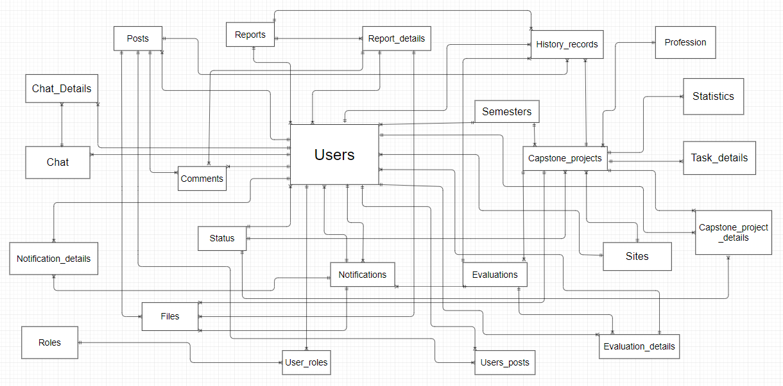

# **CHAPTER 4: SOFTWARE DESGIN**

## 4.1 Purpose

* This chapter is to give the developer team an overview of what the system’s architecture is, and how they should be implemented. This chapter consists of:
* Architecture overview
* Component diagram
* Detailed design
* Detailed description of components
* Database design

## 4.2 Architectural overview

### 4.2.1 System Architecture

#### 4.2.1.1 Diagram

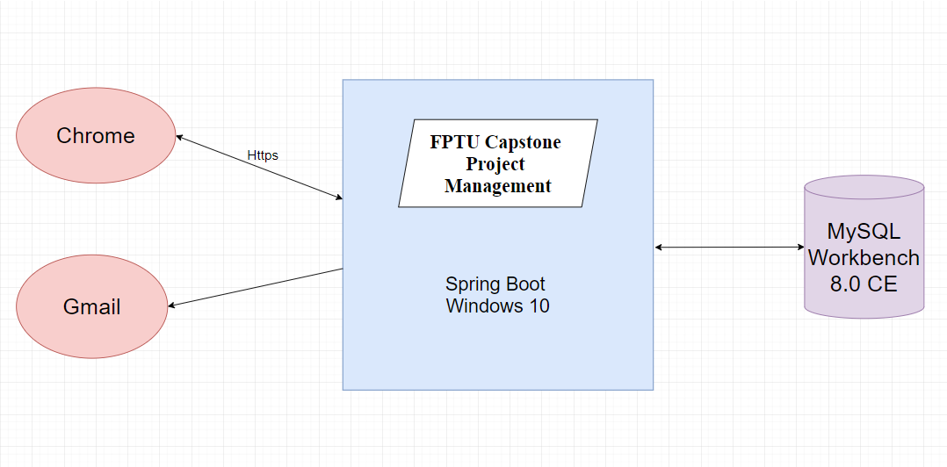

*Figure: System overview*

### 4.2.2 System Architectural Explanation

#### 4.2.2.1 MVC Architectural

##### 4.2.2.1.1 View application – HTML5 & CSS3 & JavaScript & JQuery & Bootstrap.



* Using HTML5 & CSS3 & JavaScript & JQuery & Bootstrap provides advantage of making the website design process simple, fast, eye-catching, and allows users to freely create ideas, create more and more diverse products. This design also helps to save maximum time designing website interface. Not only that, it also brings many advantages for businesses to develop, web developers can easily use and use in the most convenient way.

#### 4.2.2.2 Controller

* In Spring Boot, @Controller annotation indicates that the annotated class is a controller. It is a specialization of @Component and is auto detected through class path scanning. It is typically used in combination with annotated handler methods based on the @Request Mapping annotation.
* In the following application, we demonstrate the usage of @Controller. The application returns current data and time to the client.

#### 4.2.2.3 Model

##### 4.2.2.3.1 SQL Database – MySQL Workbench 8.0 CE

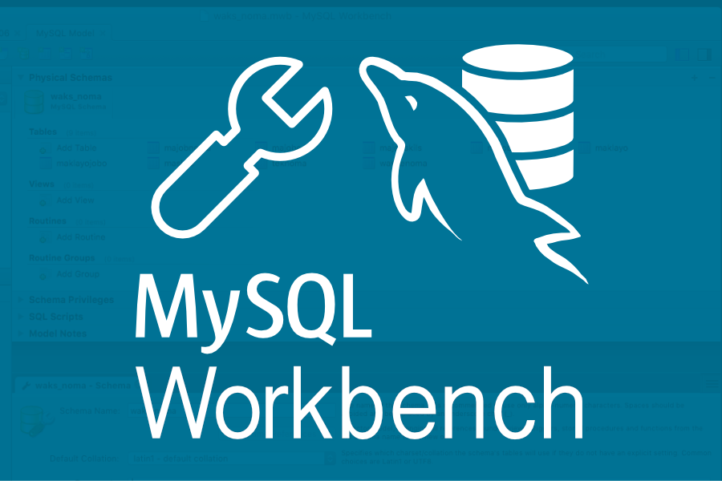

*Figure: MySQL Workbench 8.0 CE*

* MySQL Workbench is a visually modelled and designed database access tool for use with

a relational MySQL server database. MySQL Workbench helps to create new physical data models and supports modification of existing MySQL databases with reverse / forward techniques, optional management functions.

#### 4.2.2.4 Service providers

##### 4.2.2.4.1 Session state

* The session state service manages session state for every user. They store the state in the memory, in external process or in MySQL database. The membership service stores usernames, passwords and other membership data in MySQL

##### 4.2.2.4.2 Mail service



*Figure: Gmail*

## 4.3 Design of FPT Project Management System

### 4.3.1 Architectural Layers Design

#### 4.3.1.1 FCPM – Layers Design

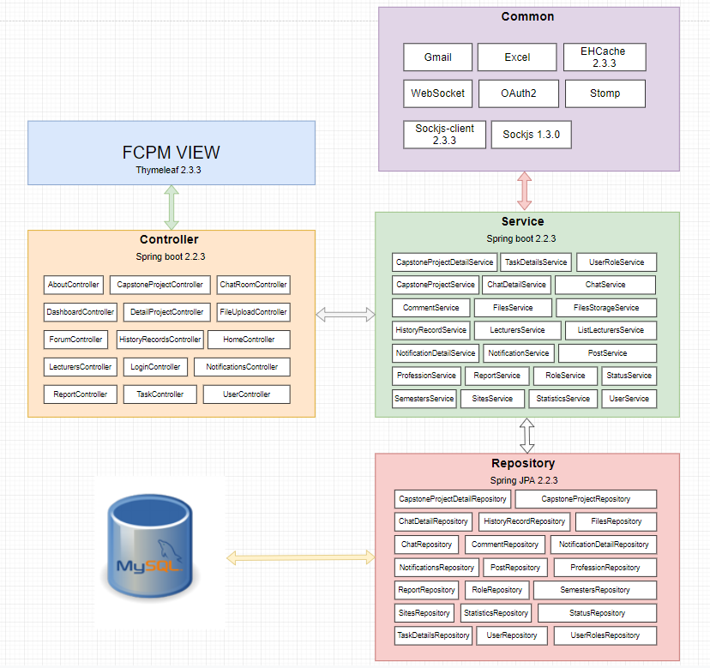

Figure: FCPM- Layers Design

#### 4.3.1.2 Package design

|  |  |  |  |
| --- | --- | --- | --- |
| **No.** | **Directory** | **Description** | **Convention** |
| 1 | /CONFIG | Where the basic configuration of the website is contained | N/A |
| 2 | /Controller | The place we call from the service to handle the URL request | N/A |
| 3 | /DTO | Where DTO to Entity and Entity to DTO Conversion | N/A |
| 4 | /Entity | Where we create entity classes. Each entity will describe a table in DB | N/A |
| 5 | /Repository | The place we write the database query to call from the database | N/A |
| 6 | /Service | The place we call from the repository to process logic and then push back to the controller | N/A |
| 7 | /UTILS | Where we use the web | N/A |
| 8 | /Common | Where supporting code for the backend | N/A |
| 9 | /Static | Where contains html, image files to design the homepage interface | N/A |

### 4.3.2 Database Design

#### 4.3.2.1 Database diagram

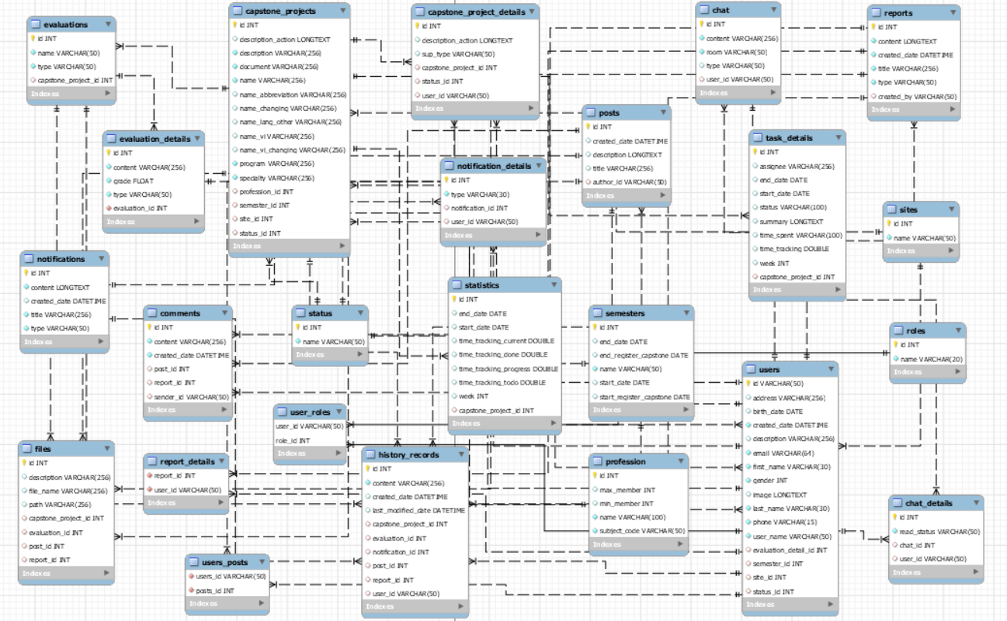

*Figure: FCPM database document diagram*

#### 4.3.2.2 Explanation of database decision

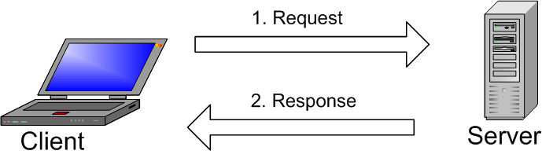

The image above explains the basic structure of the client-server communication model. A client machine communicates with the server machine in a given network. Each client can send a request from the Graphical user interface (GUI) on the screen, and the server will return the desired result as long as both understand each other. The same goes for the main operation in a MySQL environment:

* MySQL creates tables to store data, defining the relationships between those tables.
* The client will send the SQL request with a special command on MySQL.
* The application on the server will respond to the information and return the results on the client machine.

So, we chose MySQL because:

* Flexibility and convenience: You can modify the source code to meet your needs without paying any extra costs. The installation process is also very simple and usually takes less than 30 minutes.
* High Performance: Many server clusters use MySQL. Whether you store big data from e-commerce sites or do heavy IT businesses, MySQL can handle it with smooth, high speeds.
* Industry standard: The data and technology industry has been using MySQL for many years, so it is a basic skill as a programmer. MySQL users can also deploy projects quickly and hire data experts for a fee if they need to.
* Safety: Data security is always the most important issue when choosing RDBMS software. With decentralized access and account management, MySQL has a very high standard of security. Host-based authentication and credential encryption are available.

#### 4.3.2.3 Data Dictionary

##### 4.3.2.3.1 Class Diagram, Table description & Table design

* **Class Diagram**

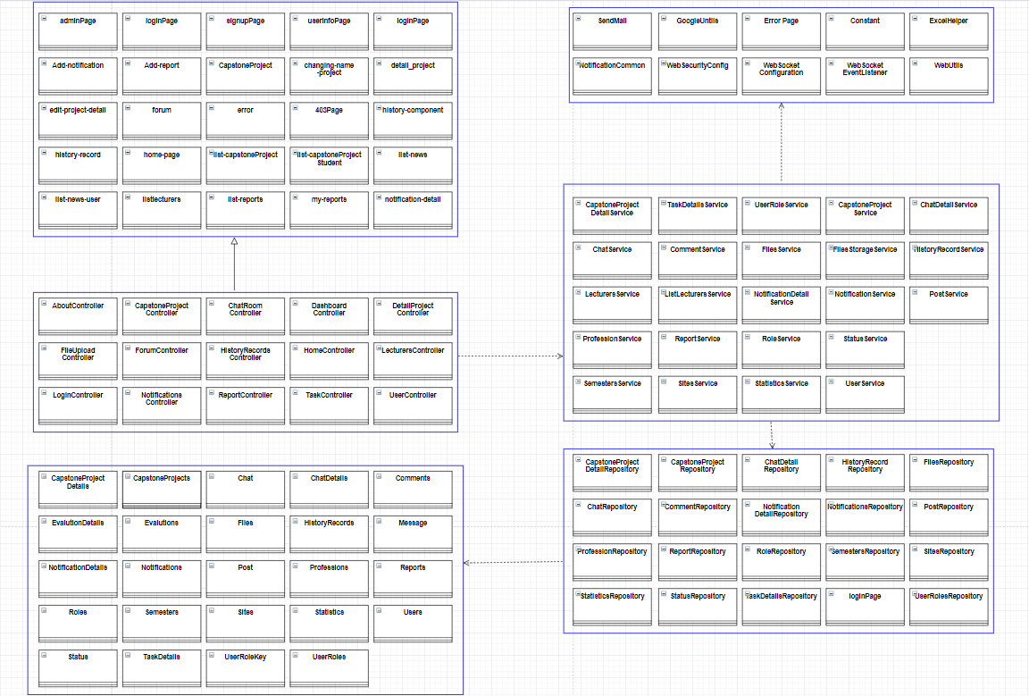

Figure: Class diagram

* **Table description**

|  |  |  |
| --- | --- | --- |
| **No** | **Table Name** | **Description** |
| 1 | users | Save information users. |
| 2 | semesters | Save semesters information of students |
| 3 | roles | 5 roles: Student members, Supervisors, Training department, Head of department, Student leaders. |
| 4 | post | Save posts of users. |
| 5 | comments | Save comments of users. |
| 6 | status | Show and save the status of users and capstone projects. |
| 7 | files | Save file names and paths. |
| 8 | reports | Save daily and weekly reports. |
| 9 | user-roles | To save which users corresponds to which roles. |
| 10 | notifications | Save news and notifications. |
| 11 | report-details | To save which users corresponds to which reports. |
| 12 | evaluations | Send evaluation information from instructors to students. |
| 13 | users-posts | To save which users corresponds to which posts. |
| 14 | capstone-projects | Save information of capstone project. |
| 15 | history-records | Save history with transactions such as adding students, delete students ... |
| 16 | evaluation-details | Send evaluation detail information from instructors to students. |
| 17 | profession | Save profession information of students. |
| 18 | capstone-projects-details | Save detail information of capstone projects. |
| 19 | chat | Save chats. |
| 20 | notification-details | Save detail notification the training department to students, or instructors to students. |
| 21 | statistics | Dashboard statistical all projects. |
| 22 | task-details | Save task details information of capstone project. |
| 23 | sites | Save sites. |
| 24 | chat-details | Save chat details. |

* **Table design**

4.3.2.3.1.1: Users

|  |  |  |  |  |
| --- | --- | --- | --- | --- |
| **Field** | **Type** | | **Allow Nulls** | **Description** |
| ID | VARCHAR (50) |  | |  |
| BIRTH_DATE | DATE | NULL | |  |
| CREATED_dATE | DATETIME |  | |  |
| DESCRIPTION | VARCHAR (256) | NULL | |  |
| EMAIL  ENCRYTED_PASSWORD  FIRST_NAME  GENDER  IMAGE  LAST_NAME  PHONE  USER_NAME  EVALUATION_DETAIL  _ID  LOCATIONS_ID  REPORT_DETAIL_ID  REPORT_RECEIVE_ID  REPORT_ID  STATUS_ID  NOTIFICATION_ID | VARCHAR (64)  VARCHAR (256)  VARCHAR (30)  INT  LONGTEXT  VARCHAR (30)  VARCHAR (15)  VARCHAR (50)  INT  INT  INT  INT  INT  INT  INT | NULL  NULL  NULL  NULL  NULL  NULL  NULL  NULL | |  |

4.3.2.3.1.2: Semesters

|  |  |  |  |
| --- | --- | --- | --- |
| **Field** | **Type** | **Allow Nulls** | **Description** |
| ID | INT |  |  |
| END_DATE  END_REGISTER_CAPSTONE  NAME  START_DATE  START_REGISTER_CAPSTONE | DATE  DATE  VARCHAR  DATE  DATE | NULL  NULL  NULL  NULL |  |
|  |  |  |  |
|  |  |  |  |
|  |  |  |  |

4.3.2.3.1.3: Roles

|  |  |  |  |
| --- | --- | --- | --- |
| **Field** | **Type** | **Allow Nulls** | **Description** |
| ID | INT |  |  |
| NAME | VARCHAR (20) |  |  |

4.3.2.3.1.4: Post

|  |  |  |  |
| --- | --- | --- | --- |
| **Field** | **Type** | **Allow Nulls** | **Description** |
| ID | INT |  |  |
| created_date  description  title  author_id  post_author | DATETIME  LONGTEXT  VARCHAR (256)  VARCHAR (50)  VARCHAR (50) | NULL  NULL  NULL  NULL  NULL |  |

4.3.2.3.1.5: Comments

|  |  |  |  |
| --- | --- | --- | --- |
| **Field** | **Type** | **Allow Nulls** | **Description** |
| ID | INT |  |  |
| content  created_Date  post_id  report_detail_id  sender_id | VARCHAR (256)  DATETIME  INT  INT  VARCHAR (50) | NULL  NULL  NULL |  |

4.3.2.3.1.6: Status

|  |  |  |  |
| --- | --- | --- | --- |
| **Field** | **Type** | **Allow Nulls** | **Description** |
| DESCRIPTION | VARCHAR (256) | NULL |  |
| NAME | VARCHAR (50) |  |  |

4.3.2.3.1.7: Files

|  |  |  |  |
| --- | --- | --- | --- |
| **Field** | **Type** | **Allow Nulls** | **Description** |
| DESCRIPTION | INT |  |  |
| FILE_NAME  PATH  CAPSTONE_PROJECT_ID  EVALUATION_ID  POST_ID  REPORT_DETAIL_ID | VARCHAR (256)  VARCHAR (256)  VARCHAR (256)  INT  INT  INT | NULL  NULL  NULL  NULL  NULL  NULL |  |

4.3.2.3.1.8: Reports

|  |  |  |  |
| --- | --- | --- | --- |
| **Field** | **Type** | **Allow Nulls** | **Description** |
| ID | INT |  |  |
| NAME  TYPE  SENDER_ID | VARCHAR (50)  VARCHAR (50)  VARCHAR (50) |  |  |

4.3.2.3.1.9: User-roles

|  |  |  |  |
| --- | --- | --- | --- |
| **Field** | **Type** | **Allow Nulls** | **Description** |
| USER_ID | VARCHAR (50) |  |  |
| ROLE_ID | INT |  |  |

4.3.2.3.1.10: Notifications

|  |  |  |  |
| --- | --- | --- | --- |
| **Field** | **Type** | **Allow Nulls** | **Description** |
| ID | INT |  |  |
| content  title  type  created_date  sender_id | LONGTEXT  VARCHAR (256)  VARCHAR (50)  DATETIME  VARCHAR (50) | NULL  NULL |  |

4.3.2.3.1.11: Report-details

|  |  |  |  |
| --- | --- | --- | --- |
| **Field** | **Type** | **Allow Nulls** | **Description** |
| LAST_MODIFIED_DATE | DATETIME |  |  |
| REPORT_ID | INT | NULL |  |

4.3.2.3.1.12: Evaluations

|  |  |  |  |  |
| --- | --- | --- | --- | --- |
| **Field** | | **Type** | **Allow Nulls** | **Description** |
| ID | | INT |  |  |
| name  type  capstone_project_id | VARCHAR (50)  VARCHAR (50)  INT | | NULL |  |

4.3.2.3.1.13: Users-post

|  |  |  |  |
| --- | --- | --- | --- |
| **Field** | **Type** | **Allow Nulls** | **Description** |
| USERS_ID | VARCHAR(50) |  |  |
| POSTS_ID | INT |  |  |

4.3.2.3.1.14: Capstone-projects

|  |  |  |  |
| --- | --- | --- | --- |
| **Field** | **Type** | **Allow Nulls** | **Description** |
| ID | INT |  |  |
| DESCRIPTION_ACTION  DESCRIPTION  DOCUMENT  NAME  NAME_ABBREVIATION  NAME_LANG_OTHER  NAME_VI  PROGRAM  SPECIALTY  PROFESSION_ID  STATUS_ID | LONGTEXT  VARCHAR (256)  VARCHAR (256)  VARCHAR (100)  VARCHAR (20)  VARCHAR (20)  VARCHAR (20)  VARCHAR (256)  VARCHAR (10)  INT  INT | NULL  NULL  NULL  NULL  NULL  NULL |  |

4.3.2.3.1.15: History-records

|  |  |  |  |
| --- | --- | --- | --- |
| **Field** | **Type** | **Allow Nulls** | **Description** |
| ID | INT |  |  |
| content  created_date  last_modified_date  capstone_projecT_id  evaluation_id  post_id  report_id  user_id  notification_id | VARCHAR (256)  DATETIME  DATETIME  INT  INT  INT  INT  VARCHAR (50)  INT | NULL  NULL  NULL  NULL  NULL  NULL  NULL  NULL |  |

4.3.2.3.1.16: Evaluation-details

|  |  |  |  |
| --- | --- | --- | --- |
| **Field** | **Type** | **Allow Nulls** | **Description** |
| ID | INT |  |  |
| content  grade  type  evaluation_id  assessor_id | VARCHAR (256)  FLOAT  VARCHAR (50)  INT  VARCHAR (50) |  |  |

4.3.2.3.1.17: Profession

|  |  |  |  |
| --- | --- | --- | --- |
| **Field** | **Type** | **Allow Nulls** | **Description** |
| ID | INT |  |  |
| max_member  min_member  name  subject_code | INT  INT  VARCHAR (100)  VARCHAR (50) | NULL  NULL |  |

4.3.2.3.1.18: Capstone-projects-details

|  |  |  |  |
| --- | --- | --- | --- |
| **Field** | **Type** | **Allow Nulls** | **Description** |
| ID | INT |  |  |
| DESCRIPTION_ACTION  CAPSTONE_PROJECT_ID  STATUS_ID  USER_ID | VARCHAR (50)  VARCHAR (256)  INT  INT | NULL  NULL  NULL  NULL |  |

4.3.2.3.1.19: Chat

|  |  |  |  |
| --- | --- | --- | --- |
| **Field** | **Type** | **Allow Nulls** | **Description** |
| ROOM | VARCHAR (50) |  |  |
| USER_ID | VARCHAR (50) | NULL |  |

4.3.2.3.1.20: Notification-details

|  |  |  |  |
| --- | --- | --- | --- |
| **Field** | **Type** | **Allow Nulls** | **Description** |
| NOTIFICATION_ID | INT | NULL |  |
| USER_ID | VARCHAR (50) | NULL |  |

4.3.2.3.1.21: Statistics

|  |  |  |  |
| --- | --- | --- | --- |
| **Field** | **Type** | **Allow Nulls** | **Description** |
| ID | INT |  |  |
| eND_DATE  START_DATE  TIME_TRACKING_CURRENT  TIME_TRACKING_DONE  TIME_TRACKING_PROGRESS  TIME_TRACKING_TODO  WEEK  CAPSTONE_PROJECT_ID | DATE  DATE  DOUBLE  DOUBLE  DOUBLE  DOUBLE  INT  INT | NULL  NULL  NULL  NULL  NULL  NULL  NULL  NULL |  |

4.3.2.3.1.22: Task-details

|  |  |  |  |
| --- | --- | --- | --- |
| **Field** | **Type** | **Allow Nulls** | **Description** |
| ID | INT |  |  |
| ASSIGNEE  END_DATE  START_DATE  STATUS  SUMMARY  TIME_SPENT  TIME_TRACKING  WEEK  CAPSTONE_PROJECT_ID | VARCHAR (256)  DATE  DATE  VARCHAR (100)  LONGTEXT  VARCHAR (100)  DOUBLE  INT  INT | NULL  NULL  NULL  NULL  NULL  NULL  NULL  NULL  NULL |  |

4.3.2.3.1.23: Sites

|  |  |  |  |
| --- | --- | --- | --- |
| **Field** | **Type** | **Allow Nulls** | **Description** |
| ID | INT |  |  |
| READ_STATUS  CHAT_ID  USER_ID | VARCHAR (50)  INT  VARCHAR(50) | NULL  NULL |  |

4.3.2.3.1.24: Chat-details

|  |  |  |  |
| --- | --- | --- | --- |
| **Field** | **Type** | **Allow Nulls** | **Description** |
| NOTIFICATION_ID | INT | NULL |  |
| USER_ID | VARCHAR(50) | NULL |  |

## 4.4 SEQUENCE DIAGRAM

### 4.4.1: Description of the Sequence Diagram

#### 4.4.1.1: Login

**Class Diagram:**

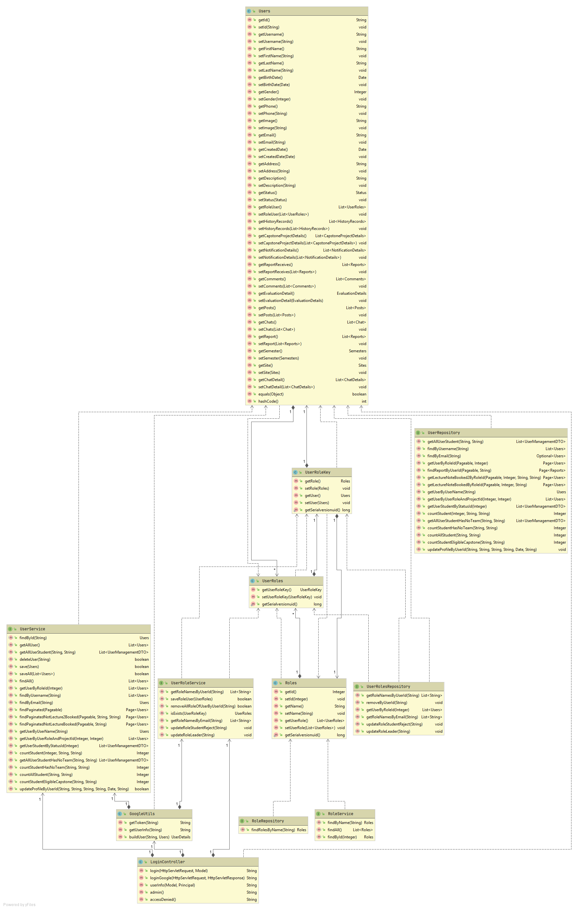

**Sequence Diagram:**

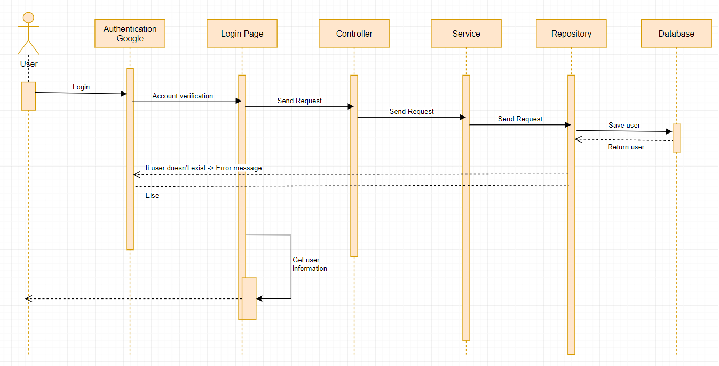

#### 4.4.1.2: Logout

**Sequence Diagram:**

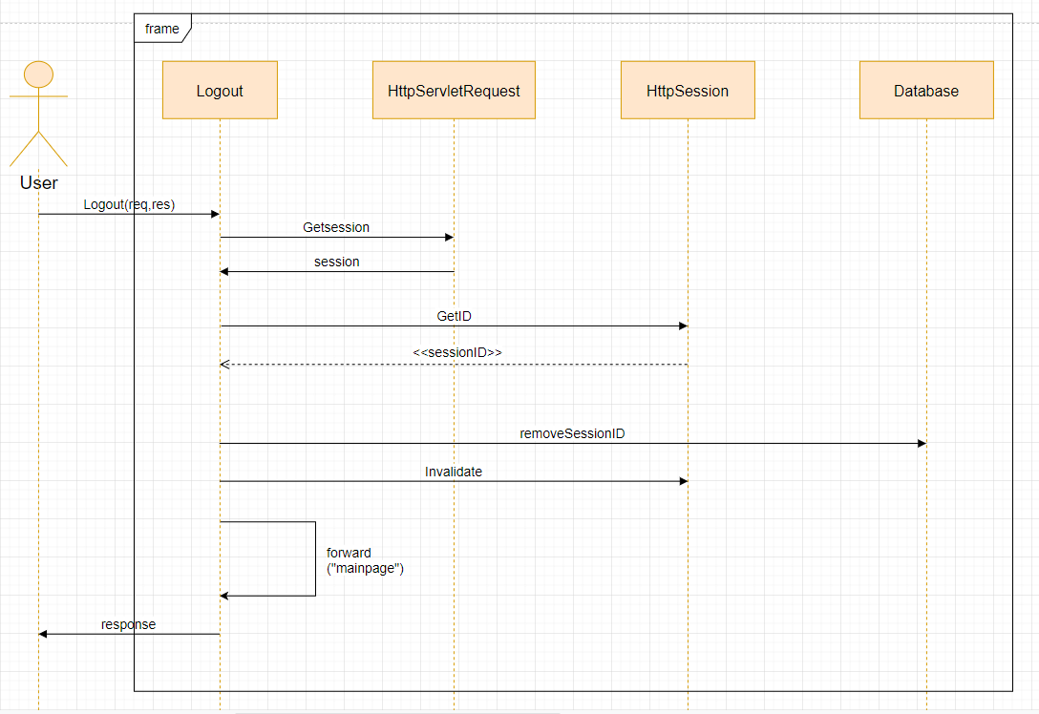

#### 4.4.1.3: Register Capstone Project

**Class Diagram:**

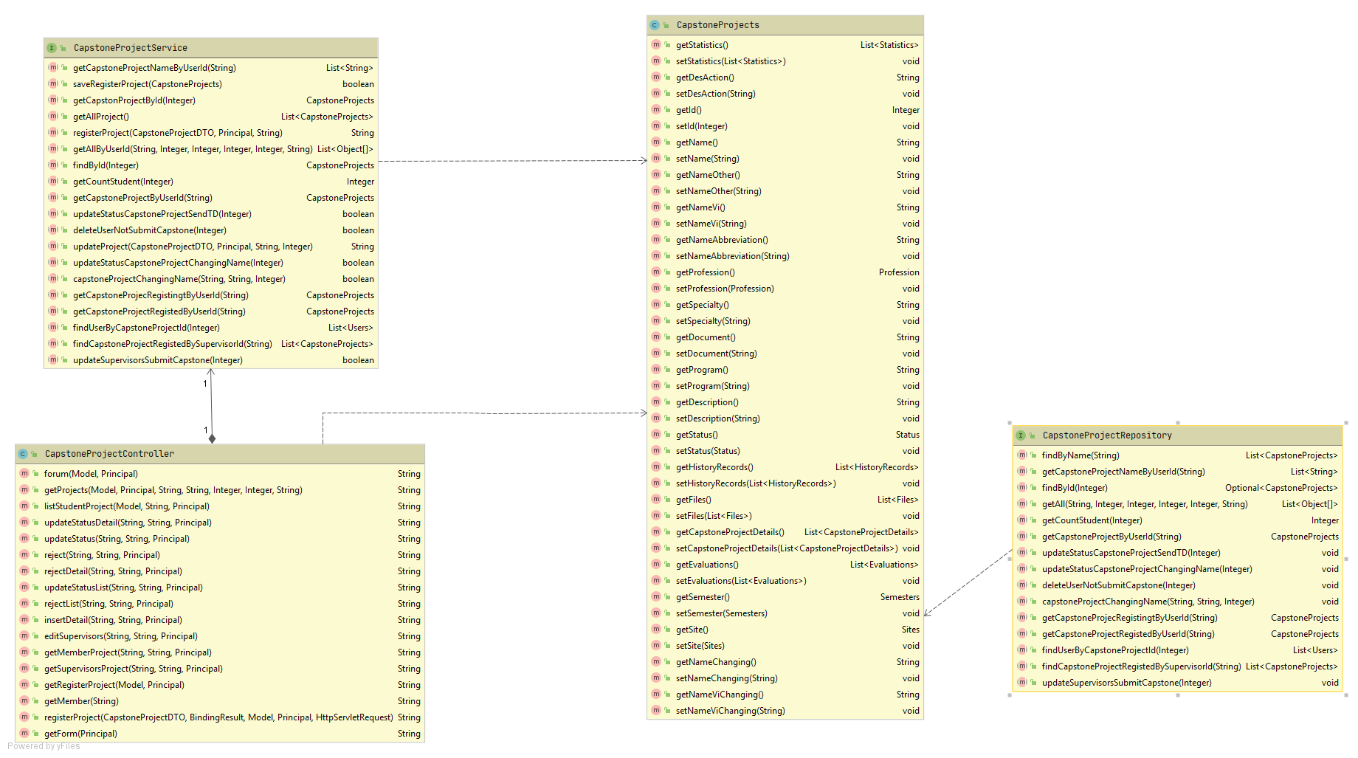

**Sequence Diagram:**

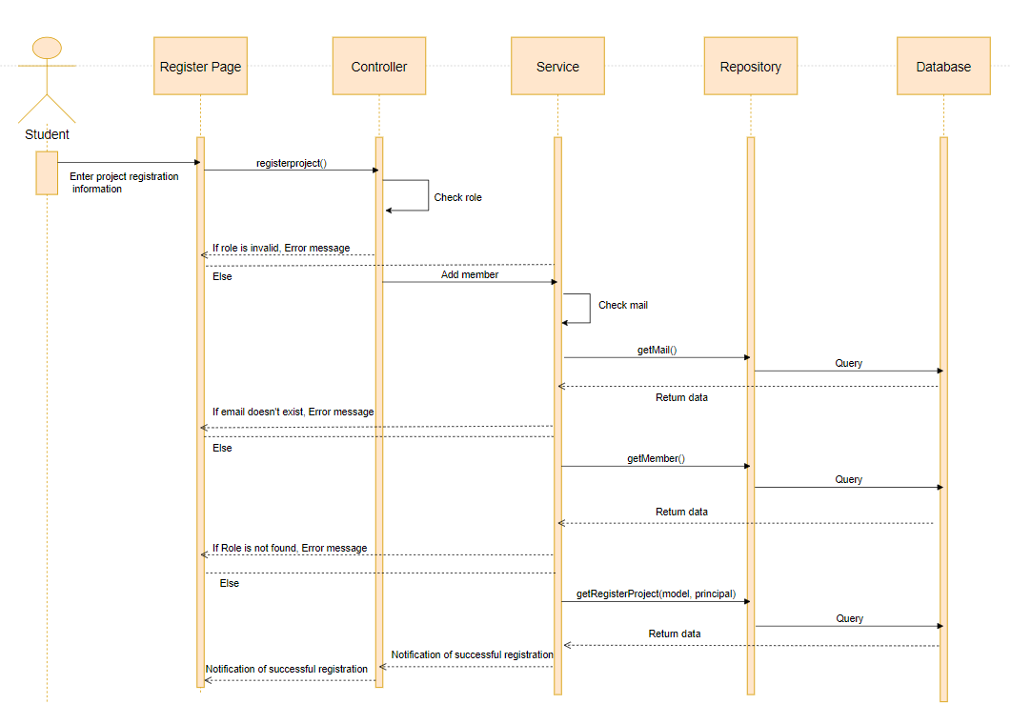

#### 4.4.1.4: Add member

**Class Diagram:**

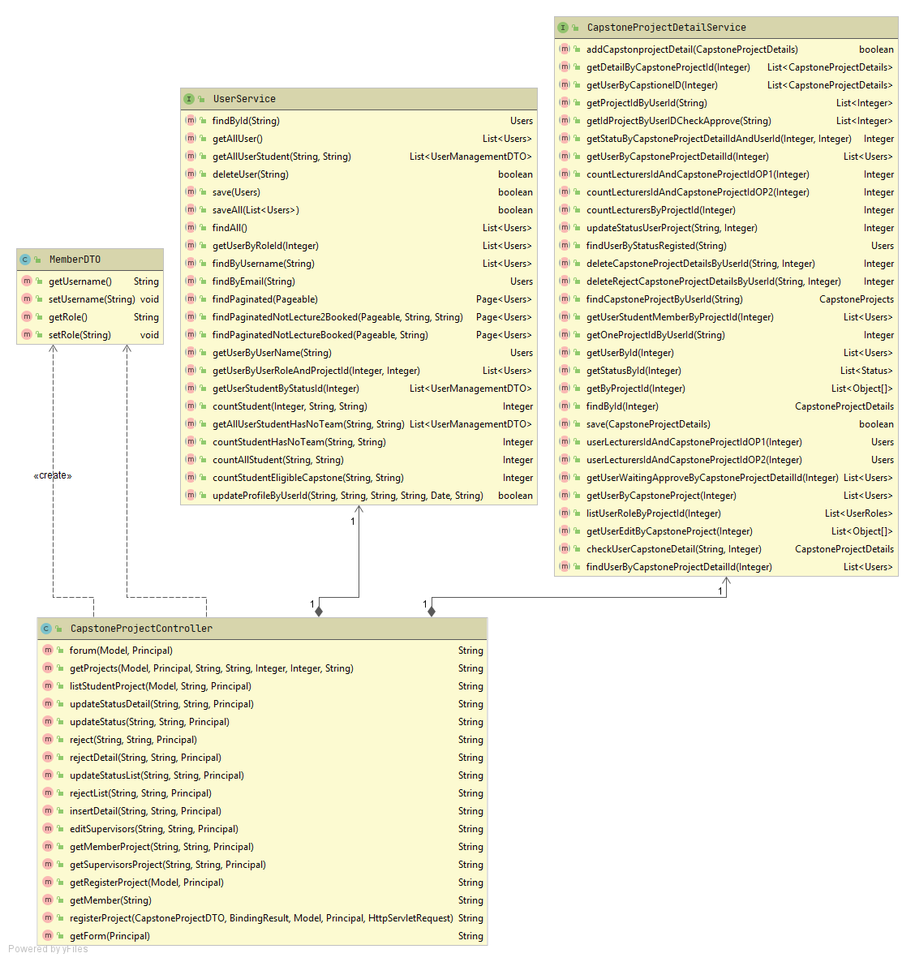

**Sequence Diagram:**

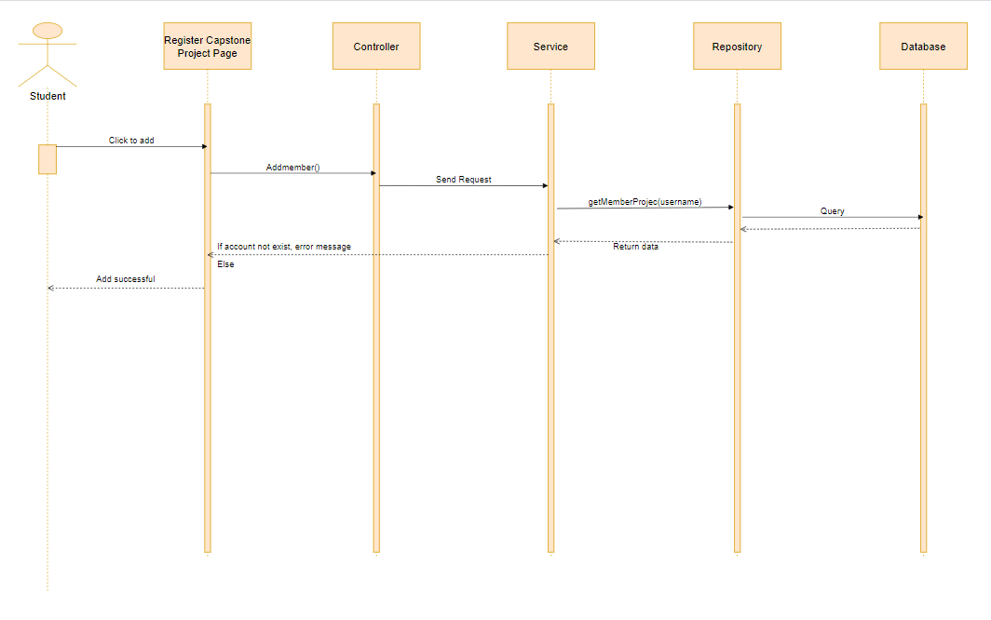

#### 4.4.1.5: Research model

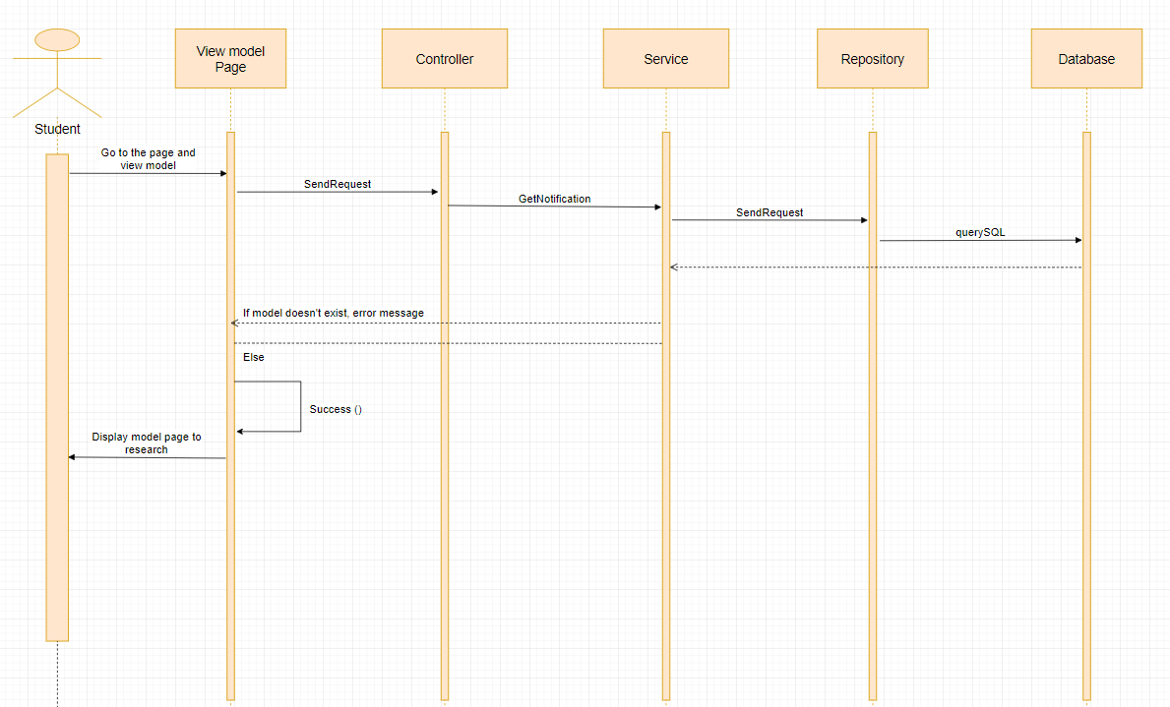

#### 4.4.1.6: Show list supervisors and choose

**Class Diagram:**

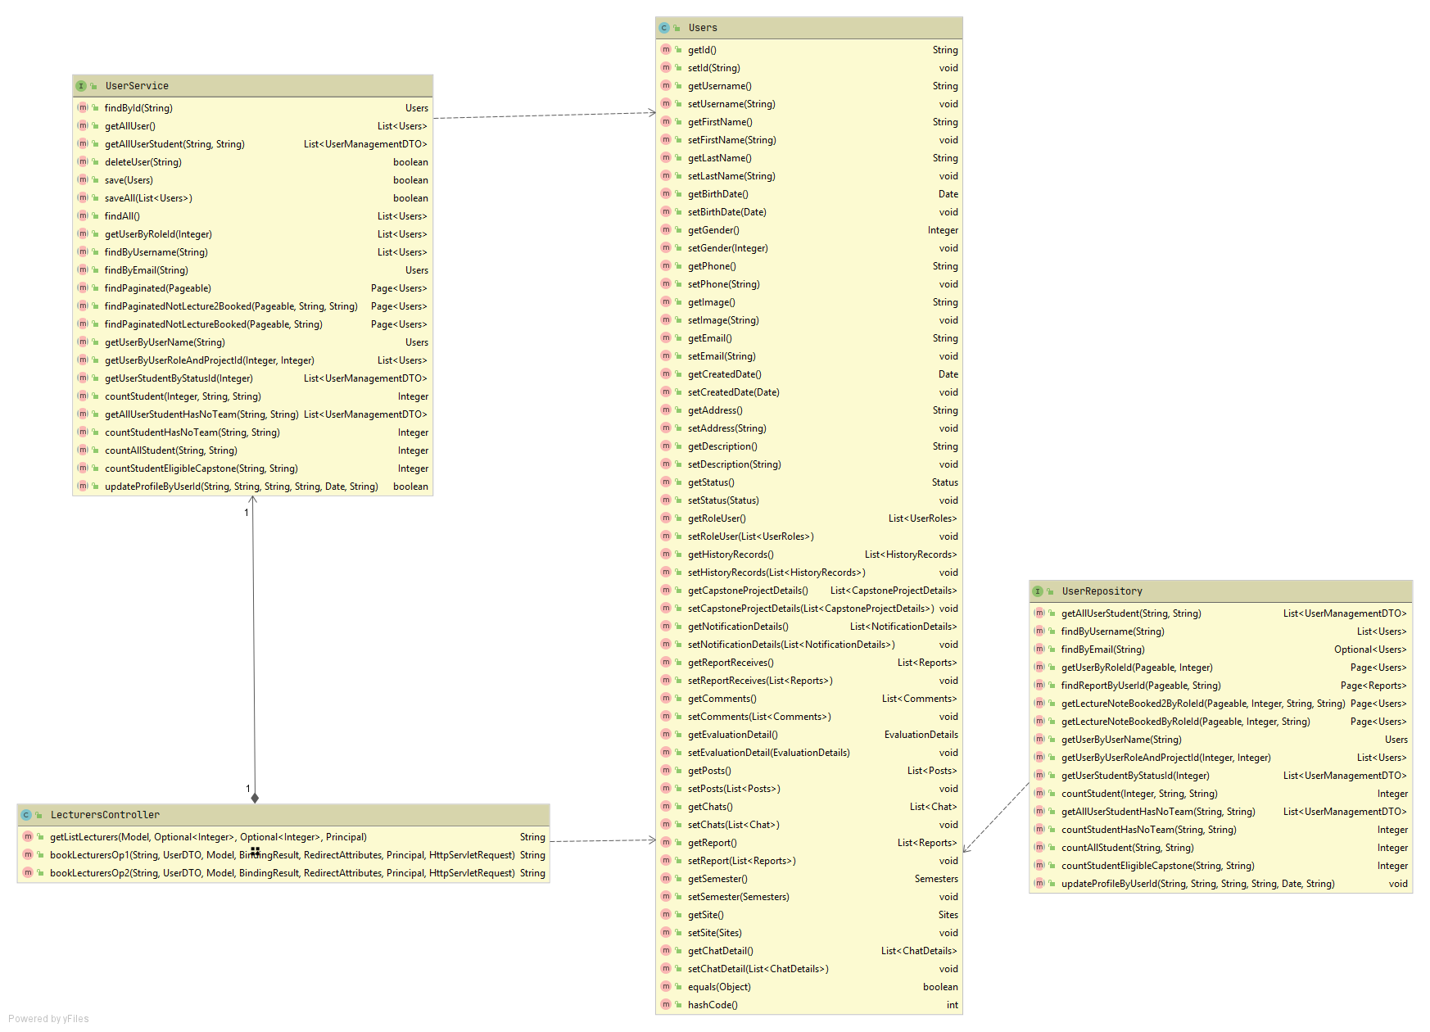

**Sequence Diagram:**

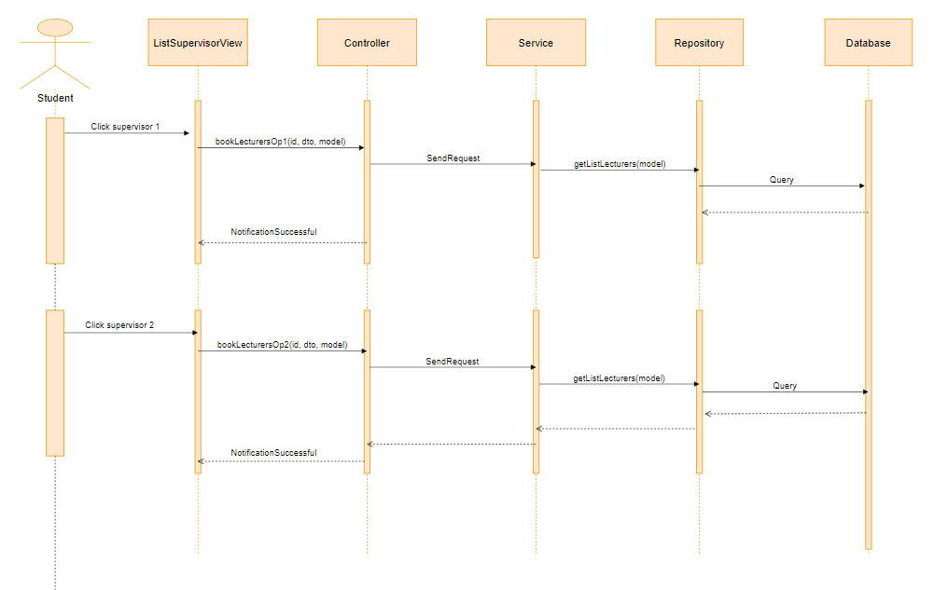

#### 4.4.1.7: view GUIDE

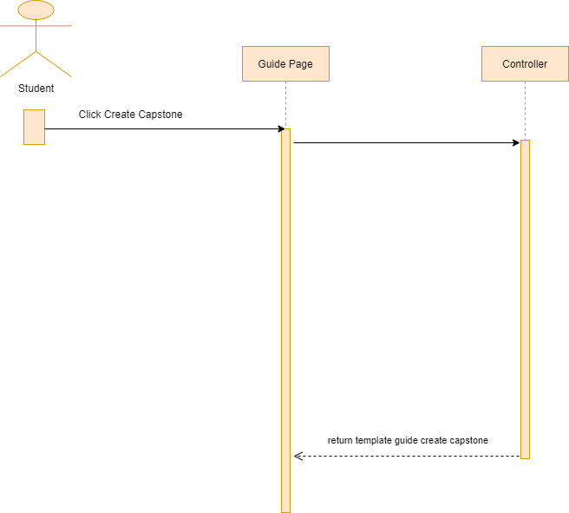

#### 4.4.1.8: Upload file

**Class Diagram:**

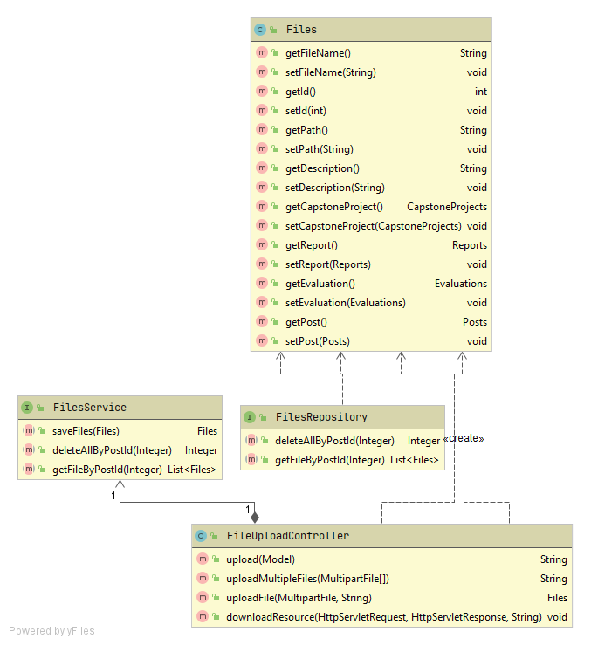

**Sequence Diagram:**

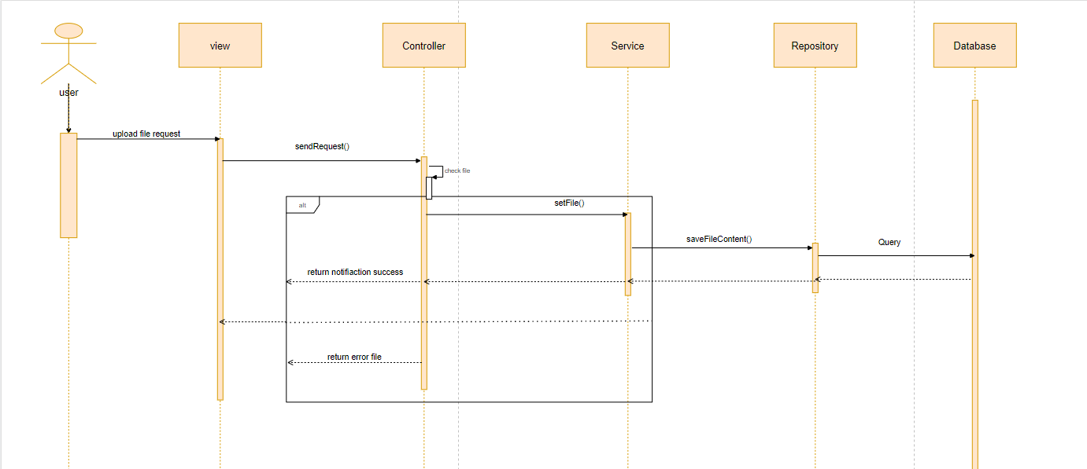

#### 4.4.1.9: Send mail

**Sequence Diagram:**

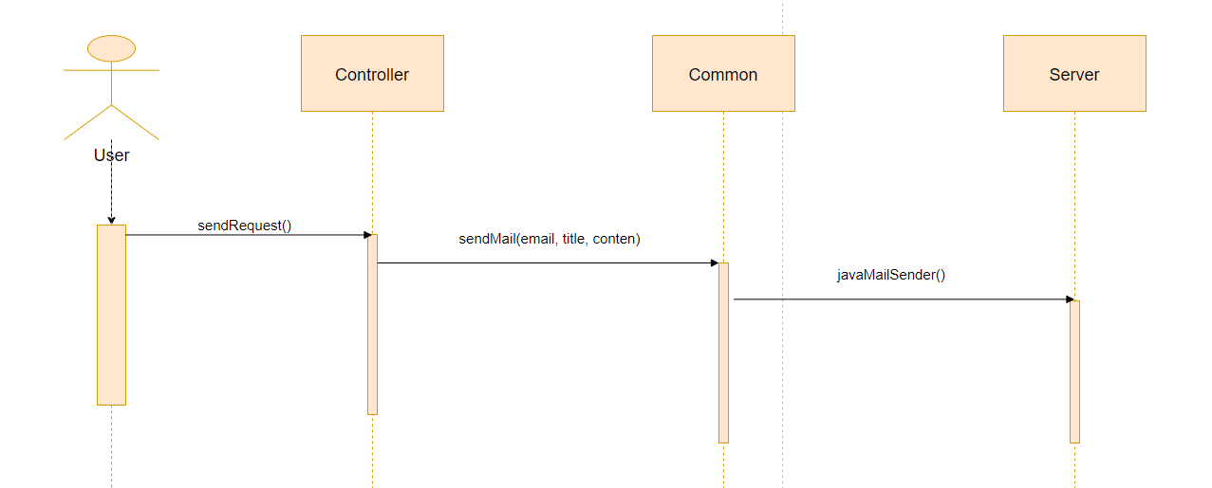

#### 4.4.1.10: Chat

**Class Diagram:**

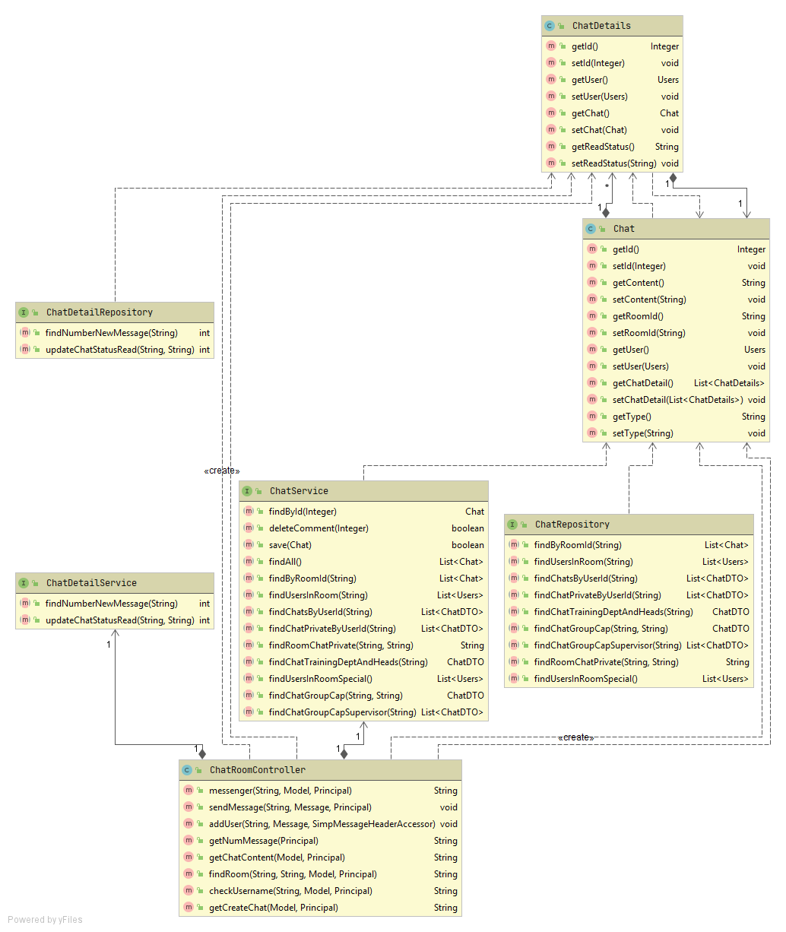

**Sequence Diagram:**

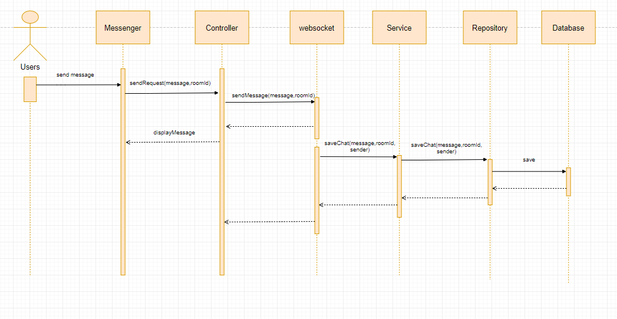

#### 4.4.1.11: Create chat

**Class Diagram:**

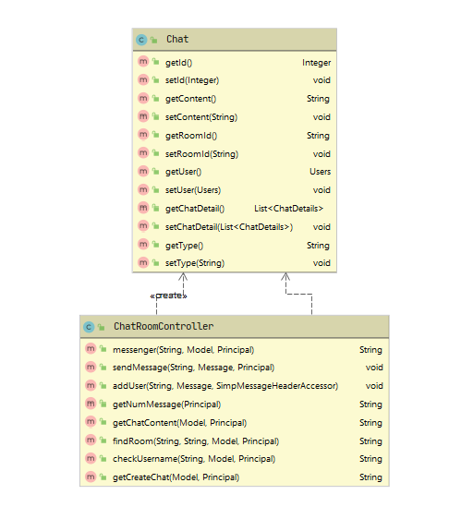

**Sequence Diagram:**

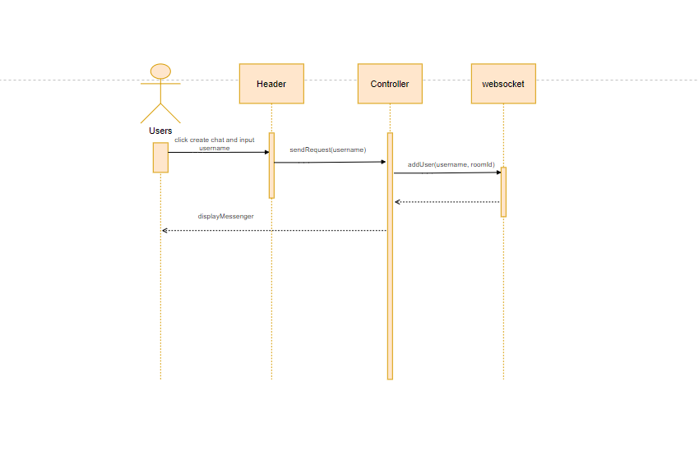

#### 4.4.1.12: Confirm join team feature

**Class Diagram:**

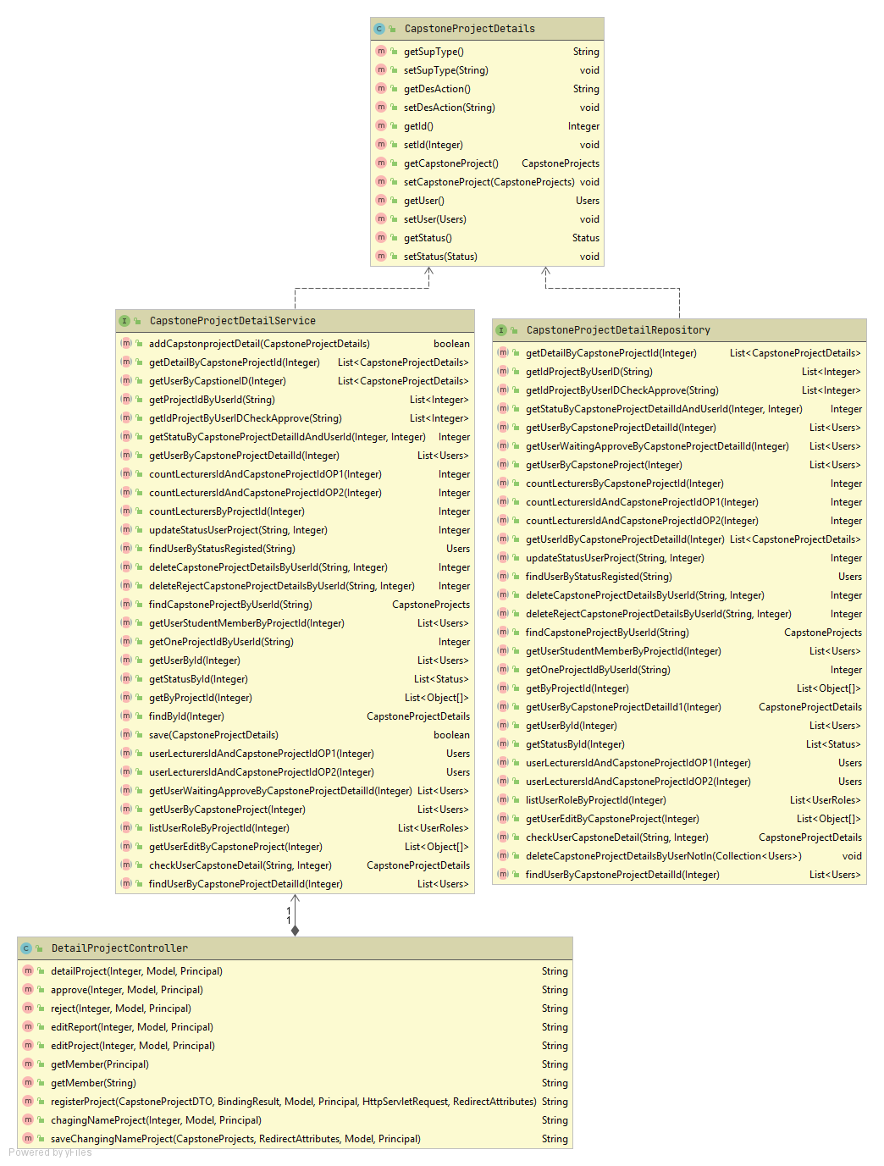

**Sequence Diagram:**

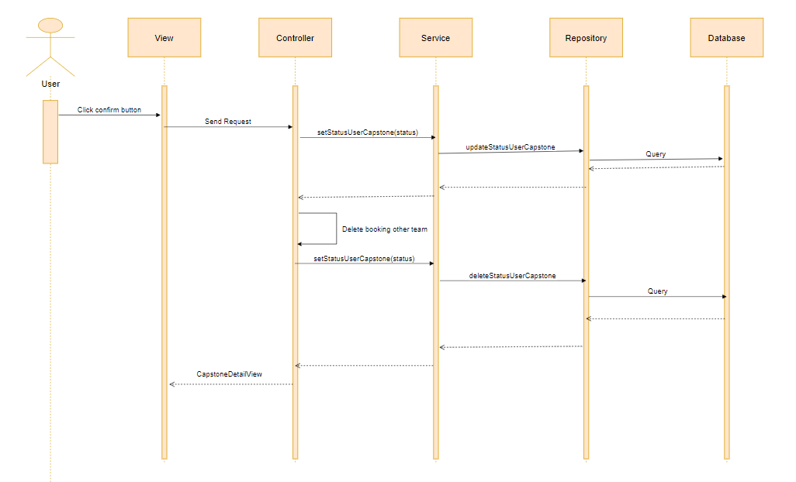

#### 4.4.1.13: Edit profile

**Class Diagram:**

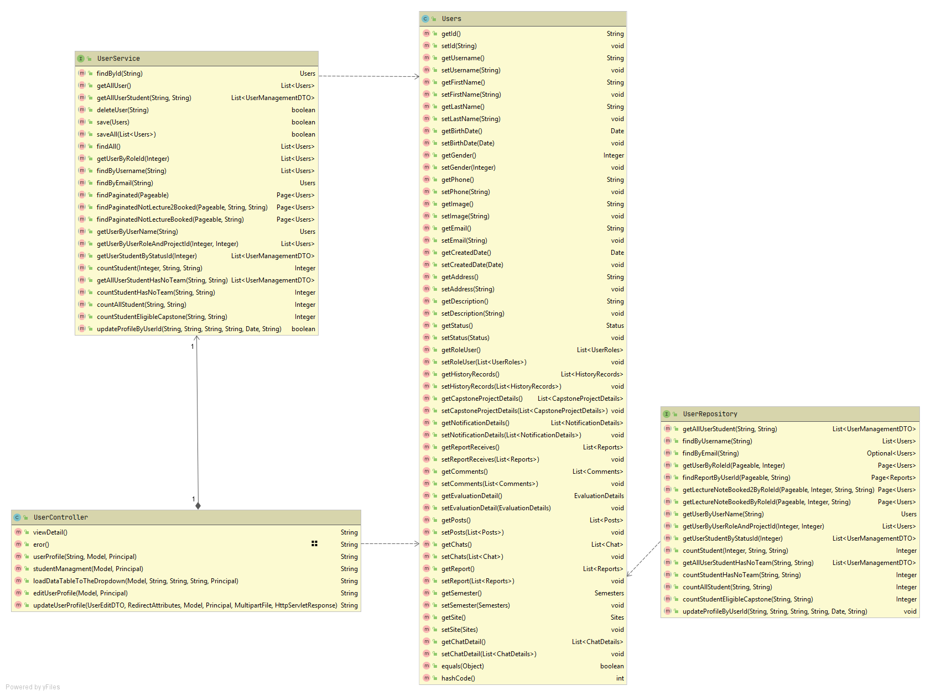

**Sequence Diagram:**

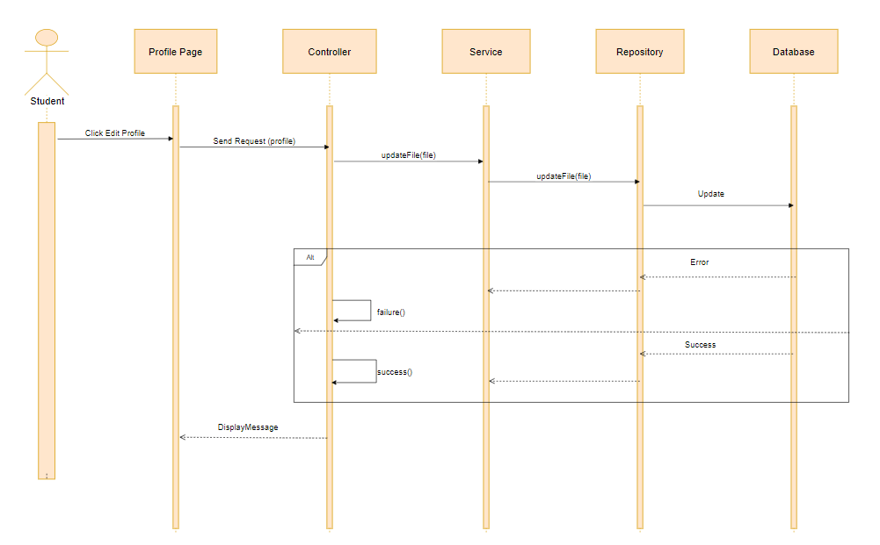

#### 4.4.1.14: Notification component

**Class Diagram:**

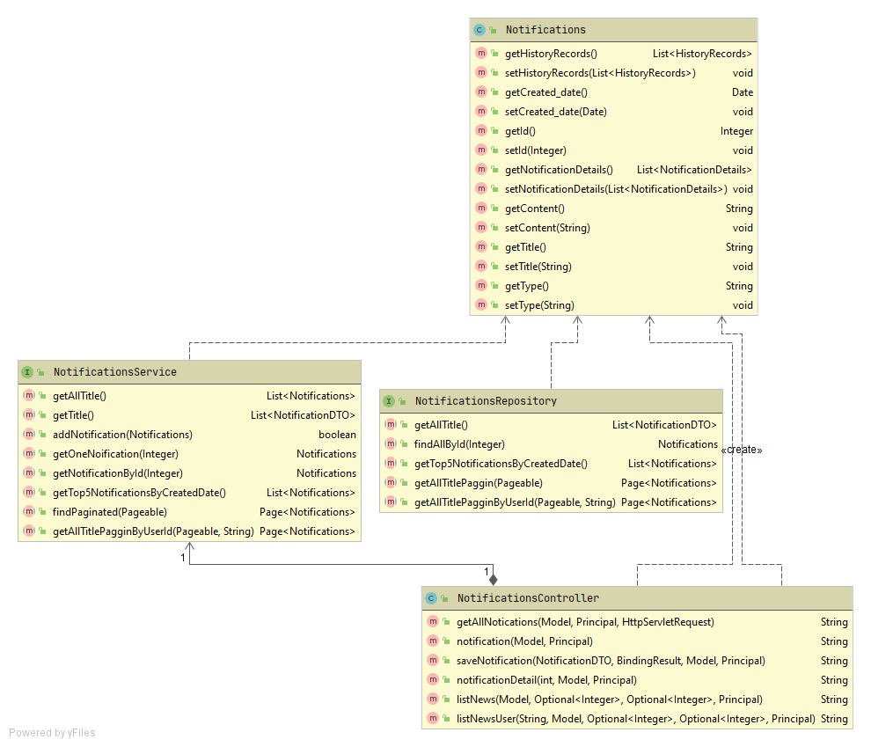

**Sequence Diagram:**

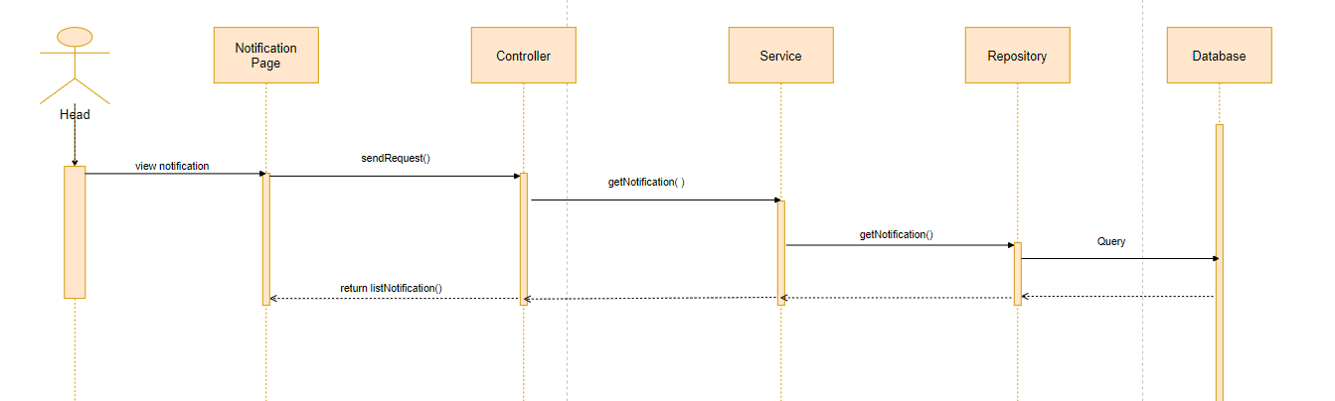

#### 4.4.1.15: Comment

**Class Diagram:**

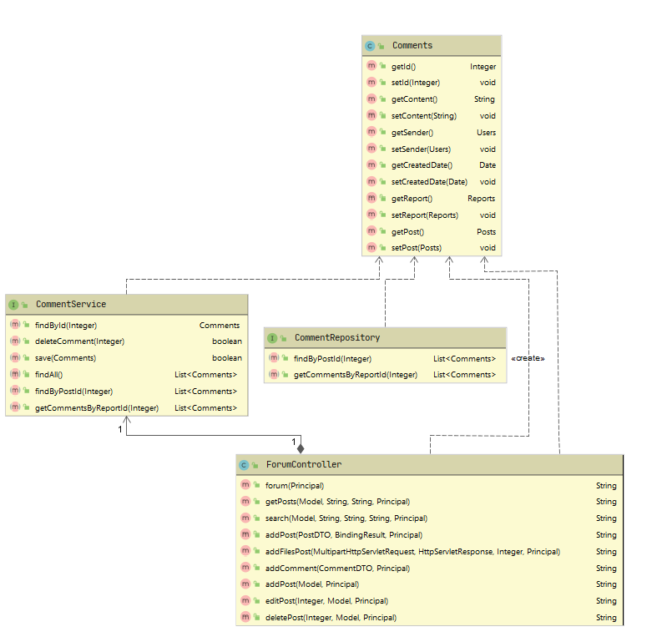

**Sequence Diagram:**

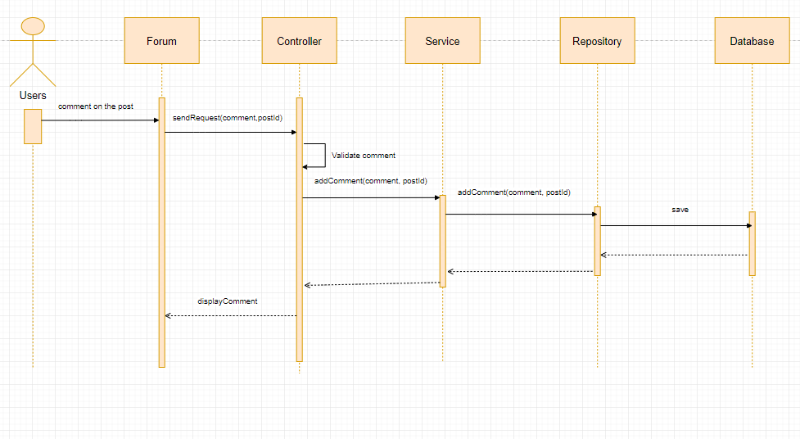

#### 4.4.1.16: Daily report to member to leader

**Class Diagram:**

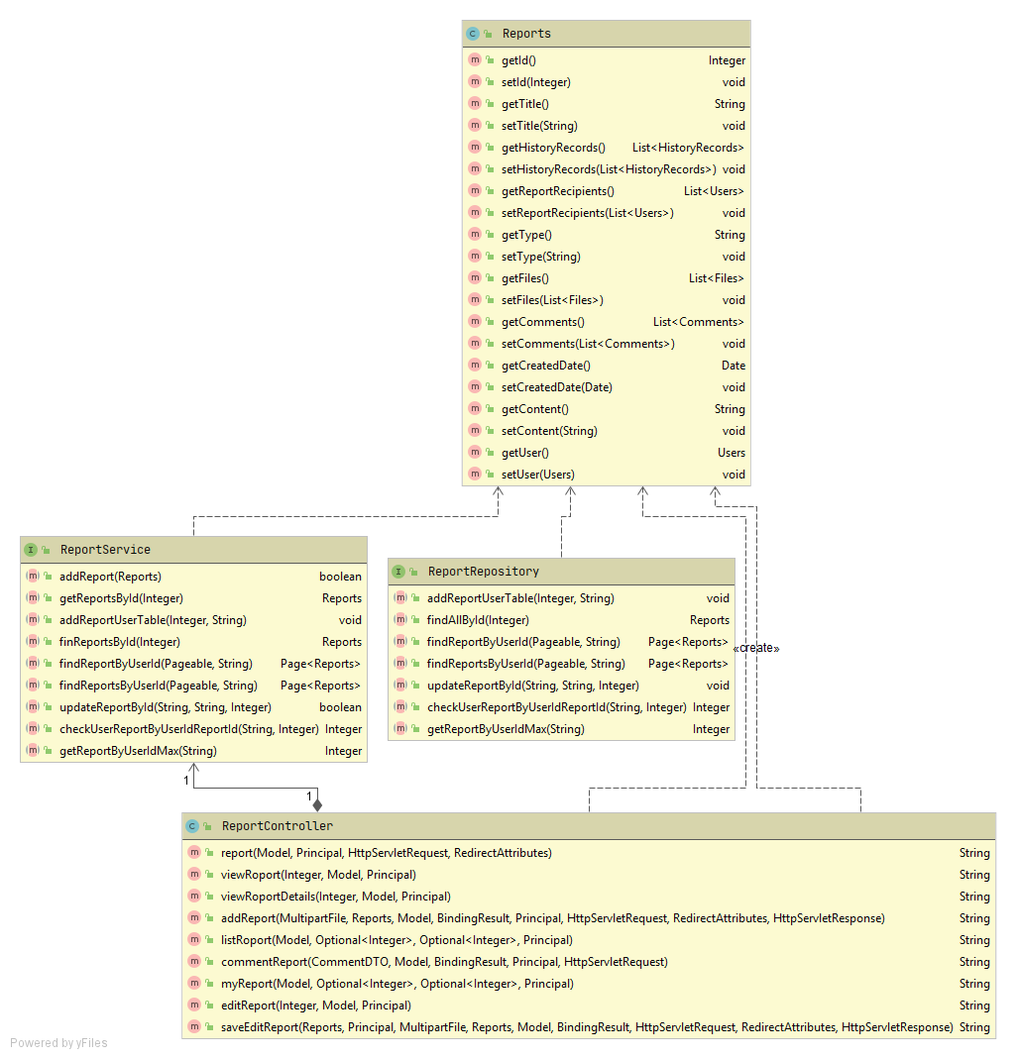

**Sequence Diagram:**

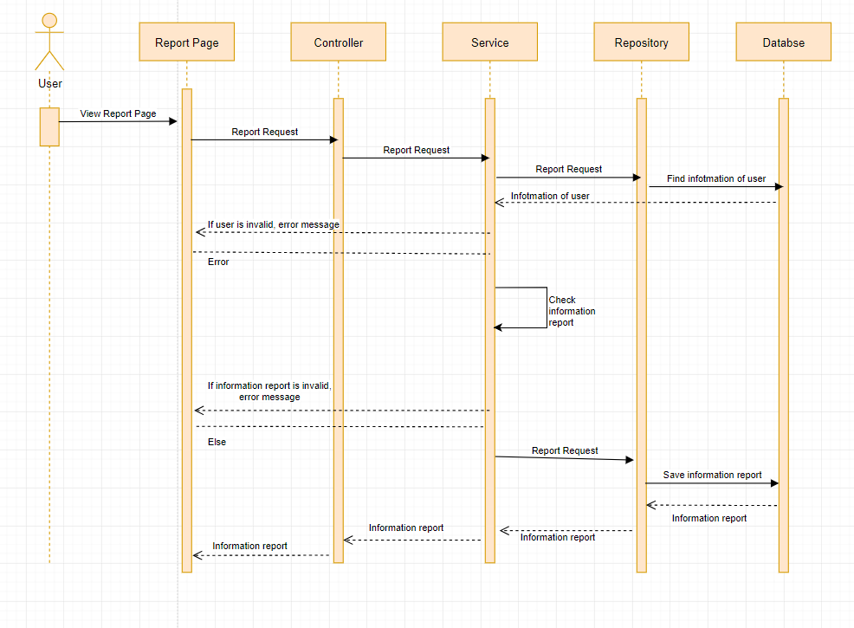

#### 4.4.1.17: Weekly report to leader to supervisor

**Class Diagram:**



**Sequence Diagram:**

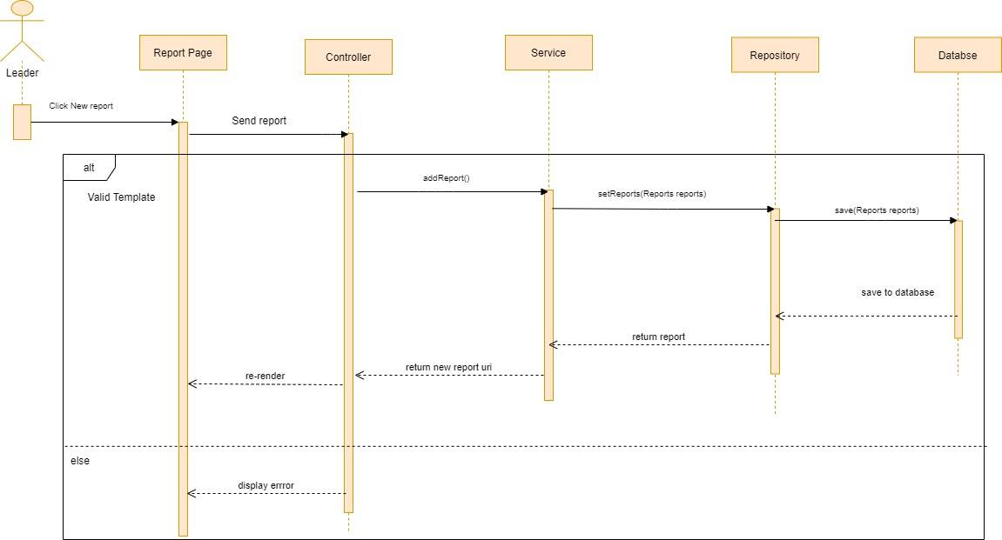

#### 4.4.1.18: Manage user

**Class Diagram:**

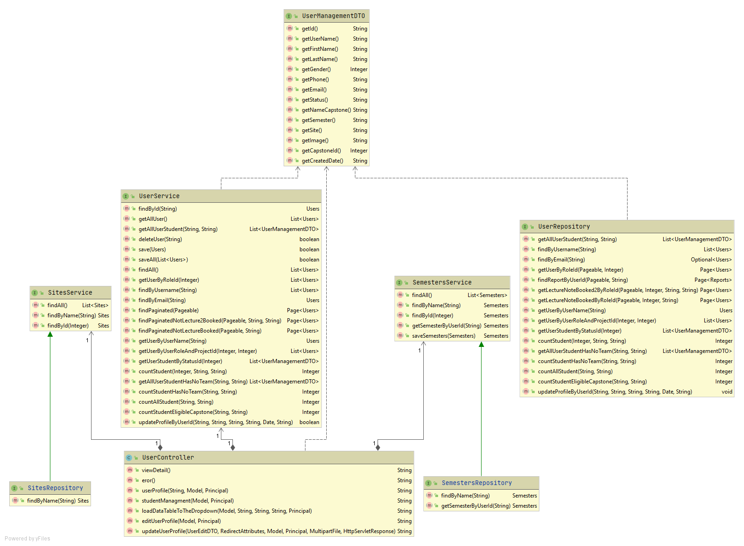

**Sequence Diagram:**

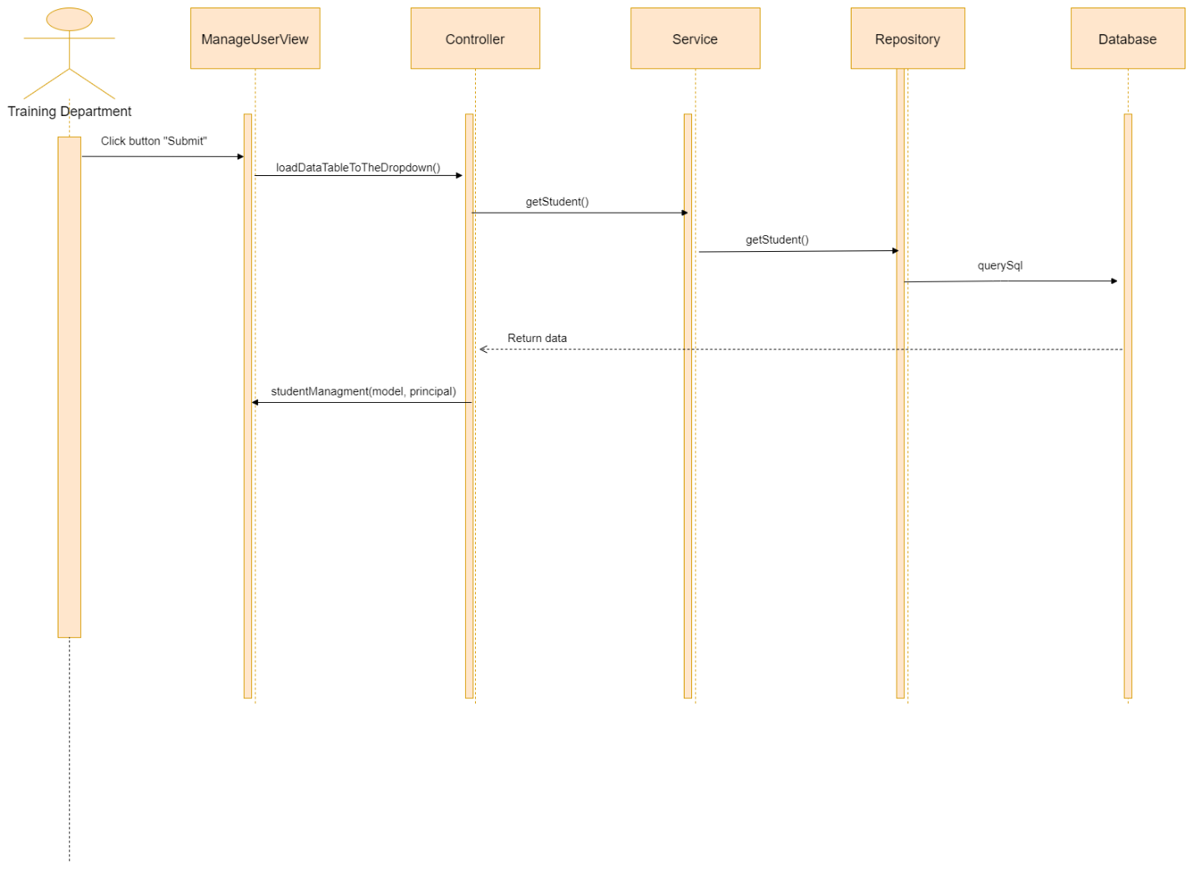

#### 4.4.1.19: View information, status of list student

**Class Diagram:**

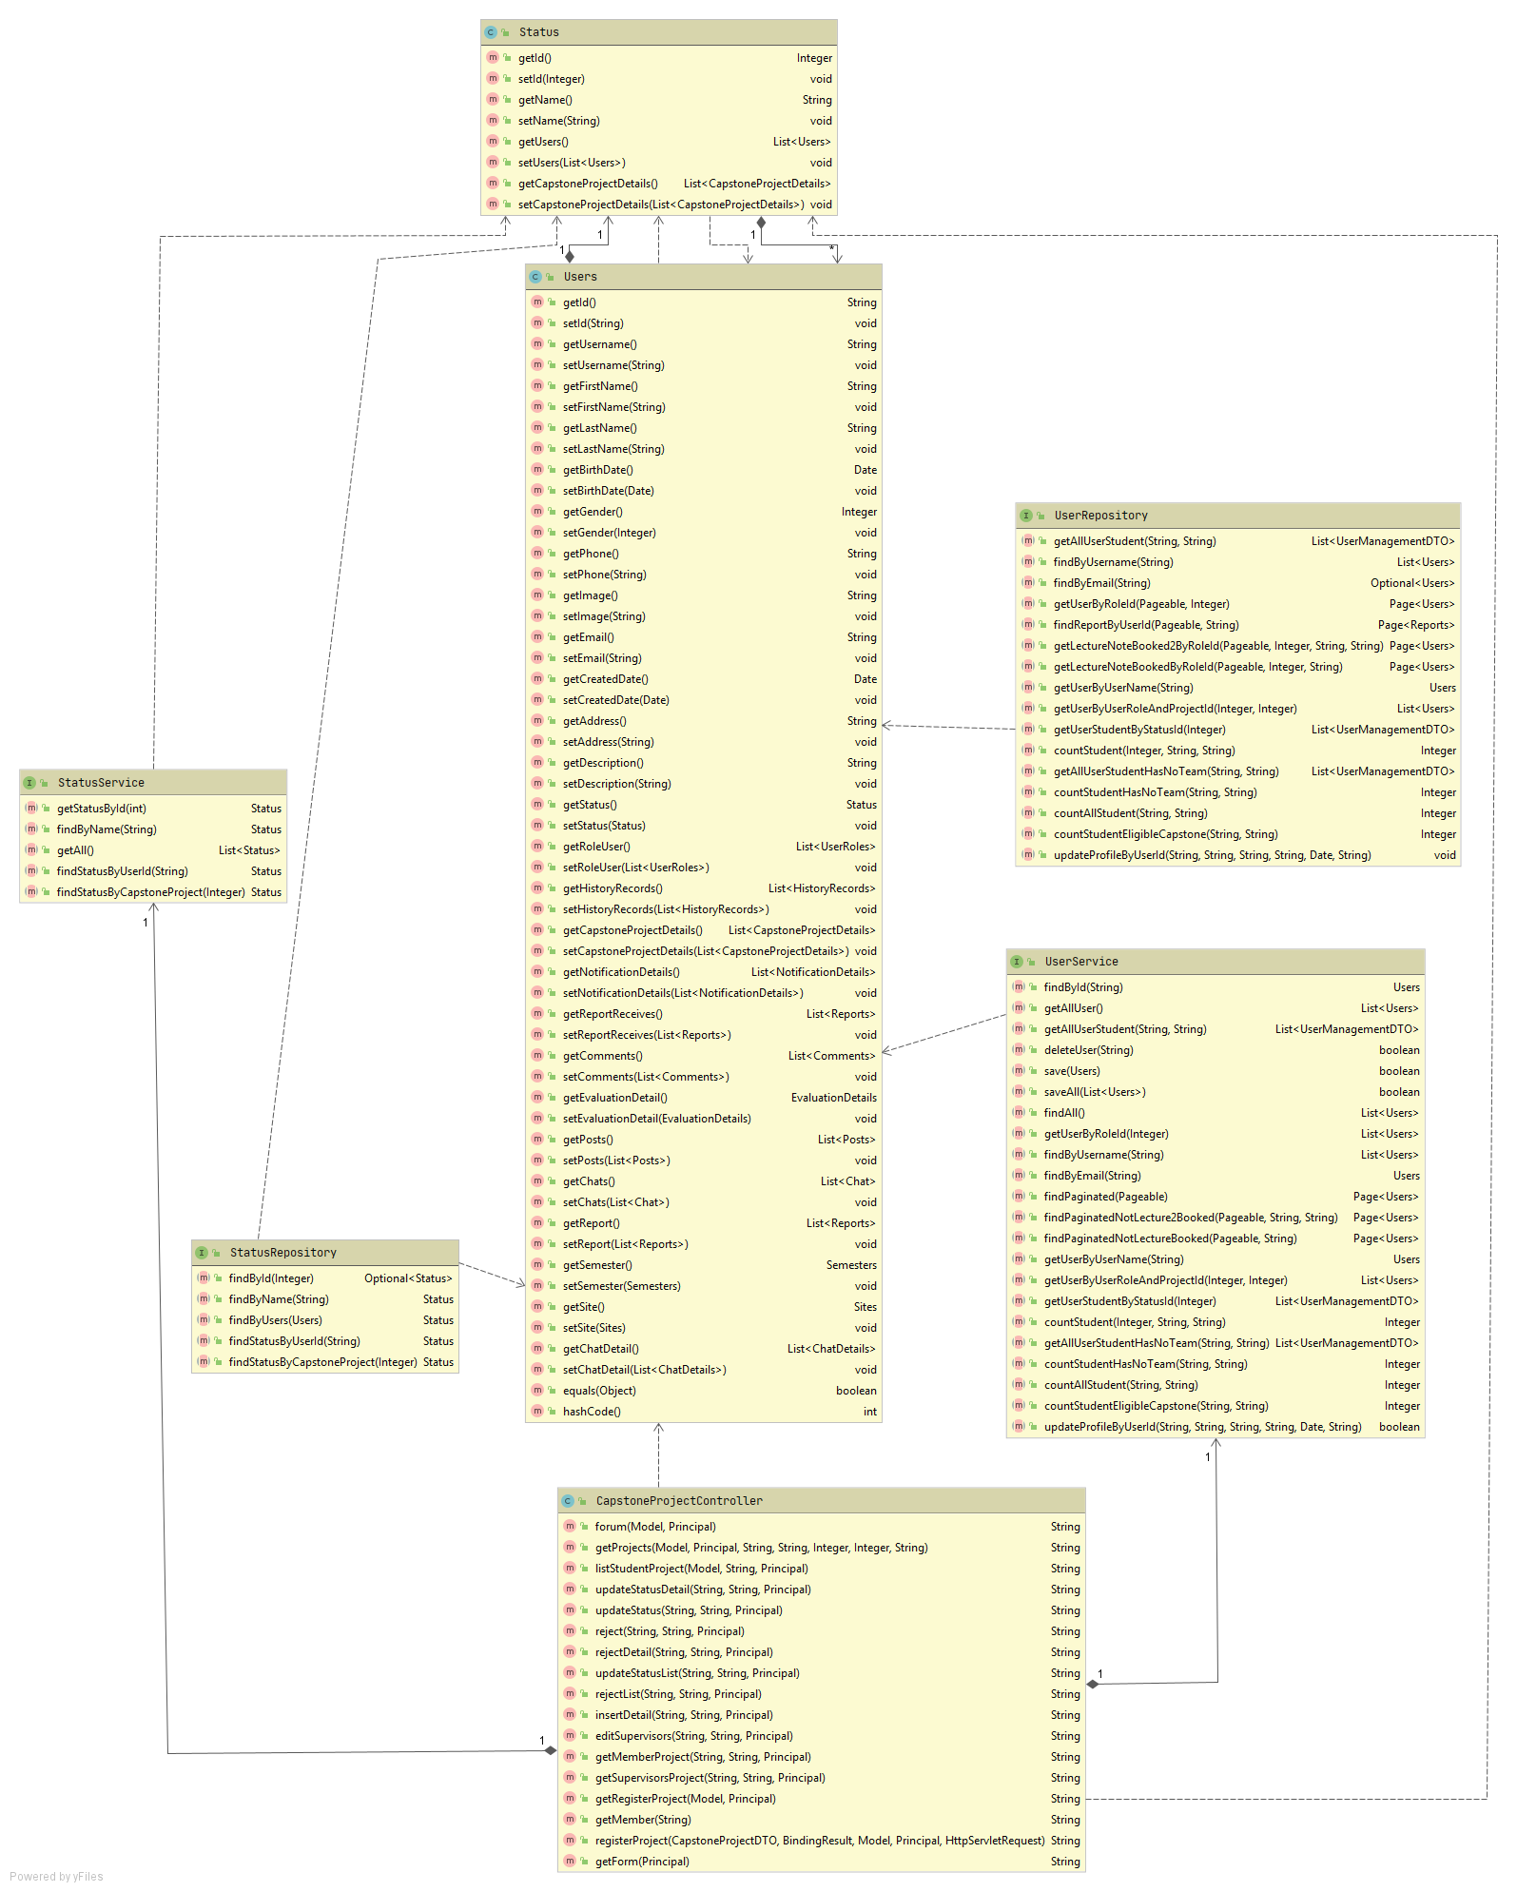

**Sequence Diagram:**

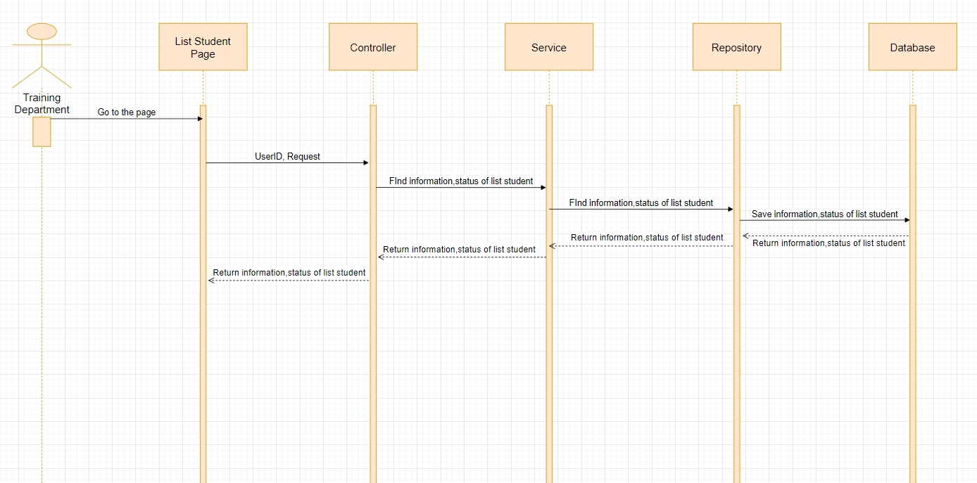

#### 4.4.1.20: Add student and edit supervisor of Capstone Project

**Class Diagram:**

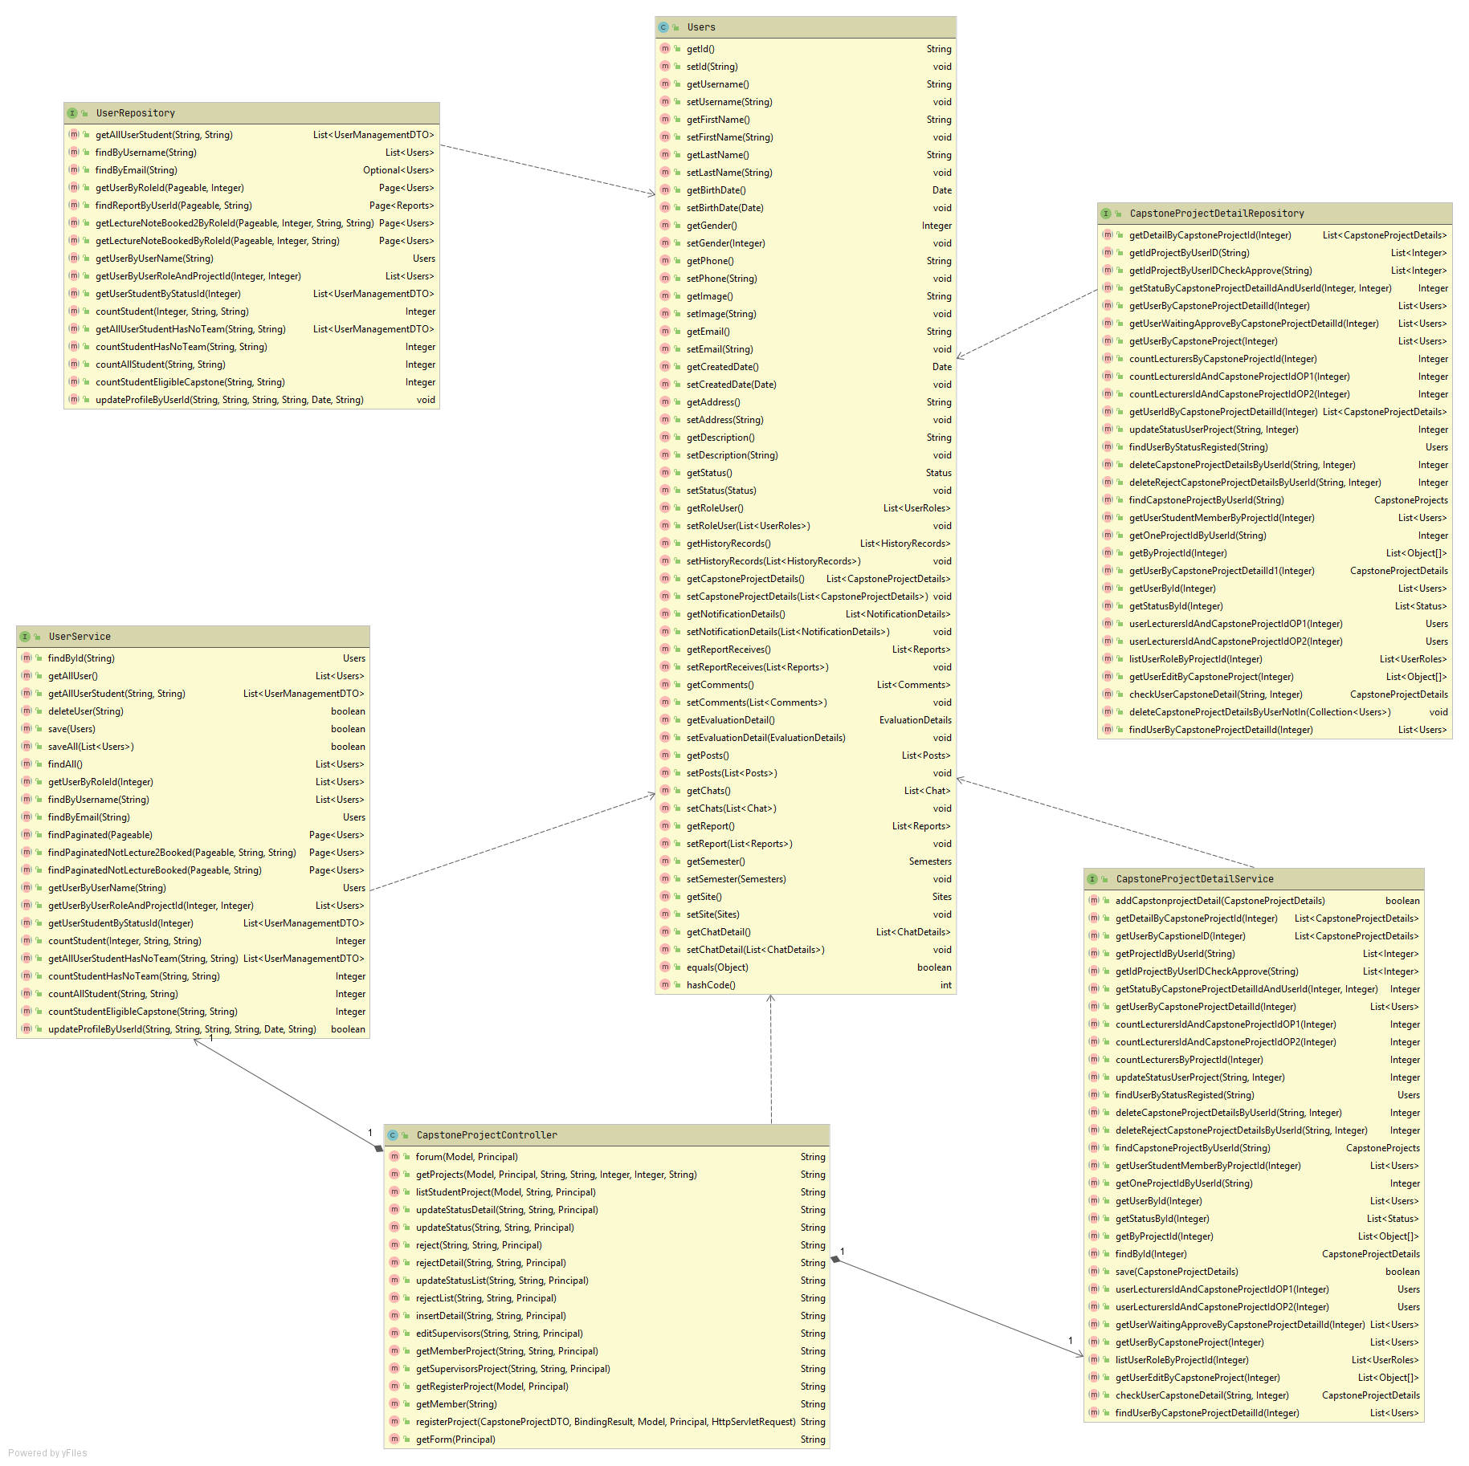

**Sequence Diagram:**

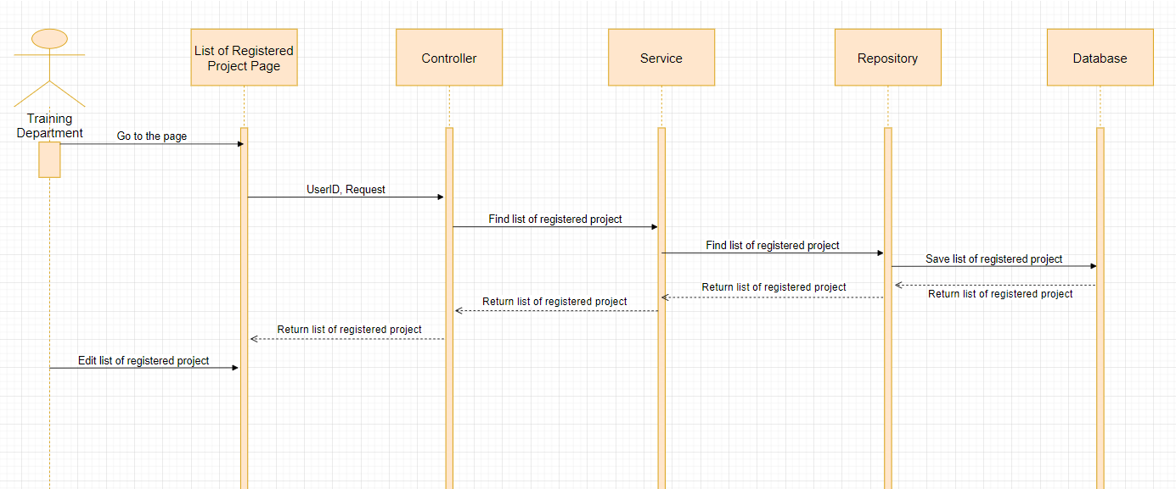

#### 4.4.1.21: View list capstone project

**Class Diagram:**

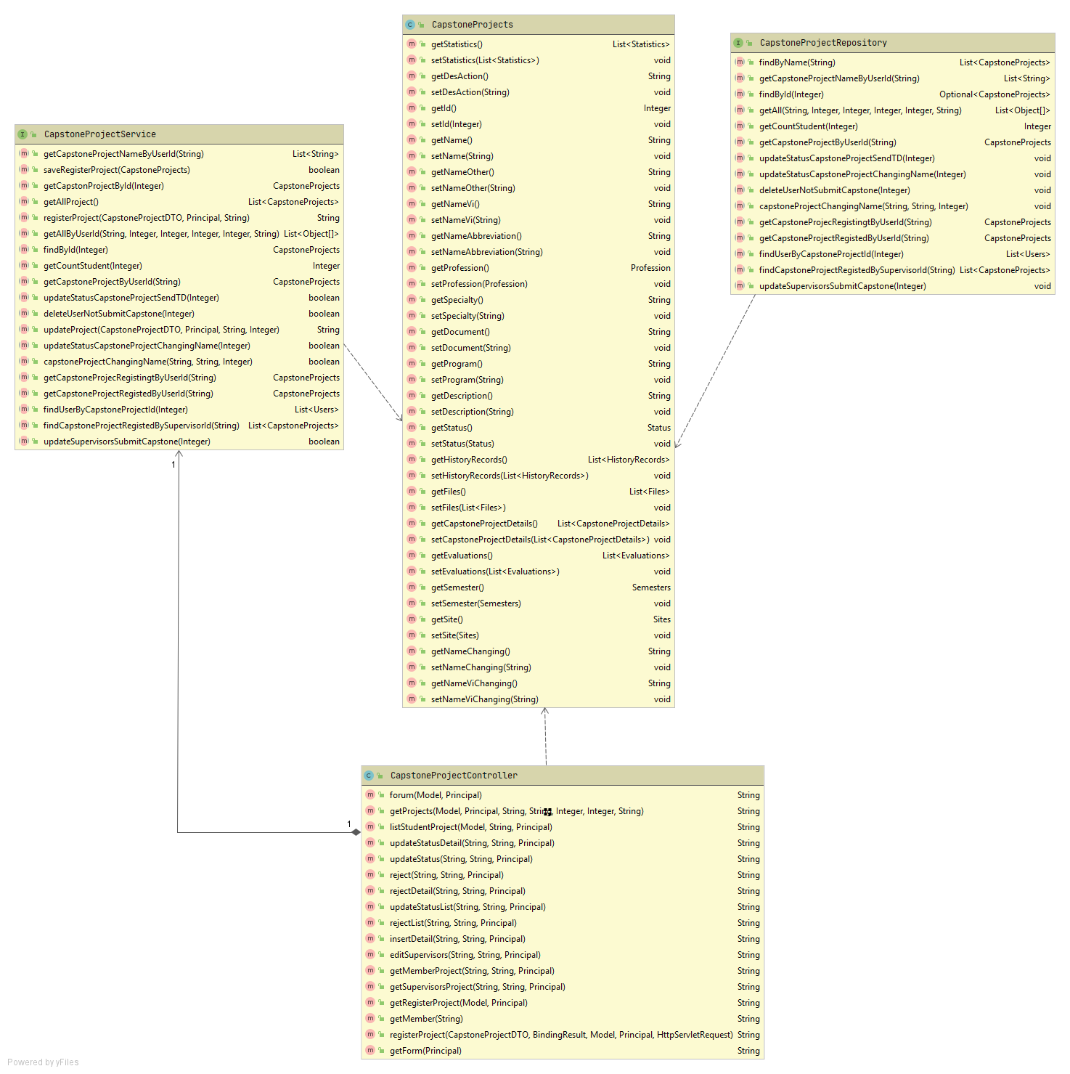

**Sequence Diagram:**

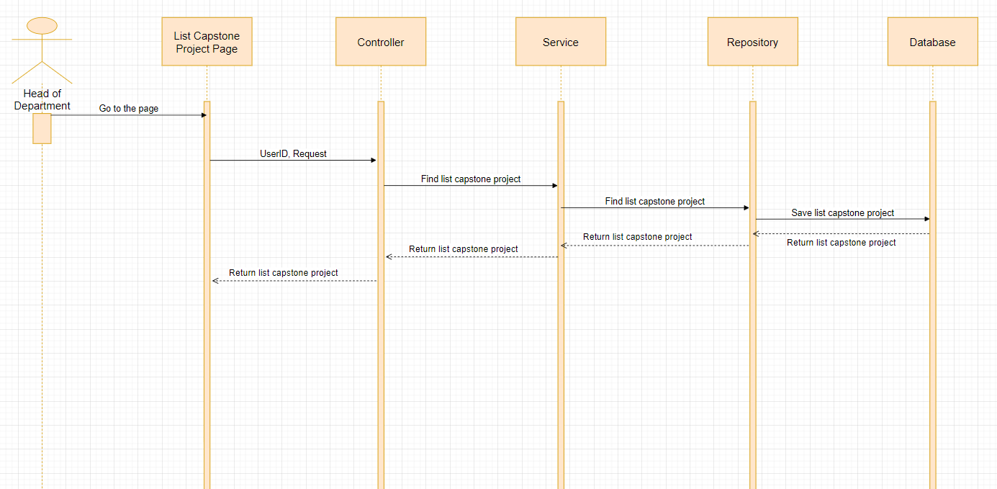

#### 4.4.1.22: View detail project

**Class Diagram:**

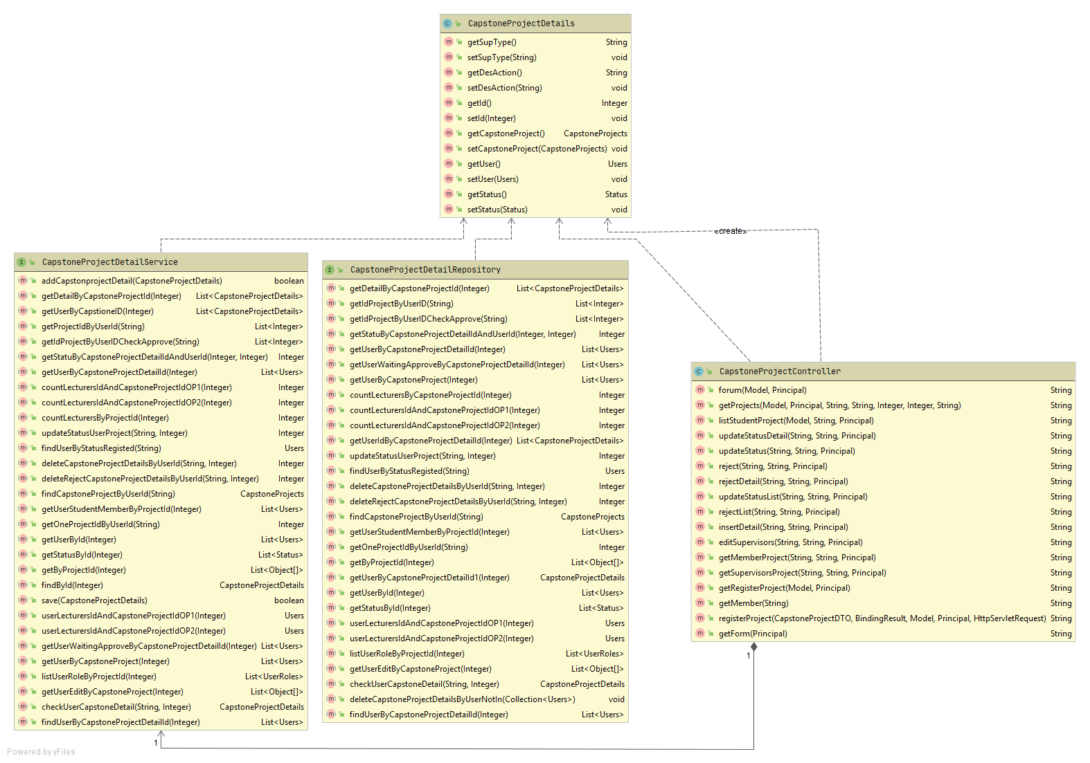

**Sequence Diagram:**

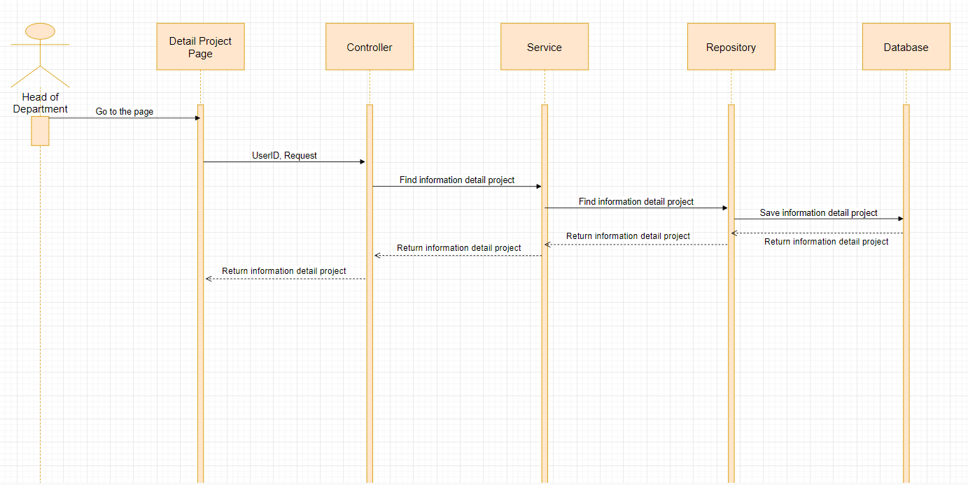

#### 4.4.1.23: Manage Capstone Project

**Class Diagram:**

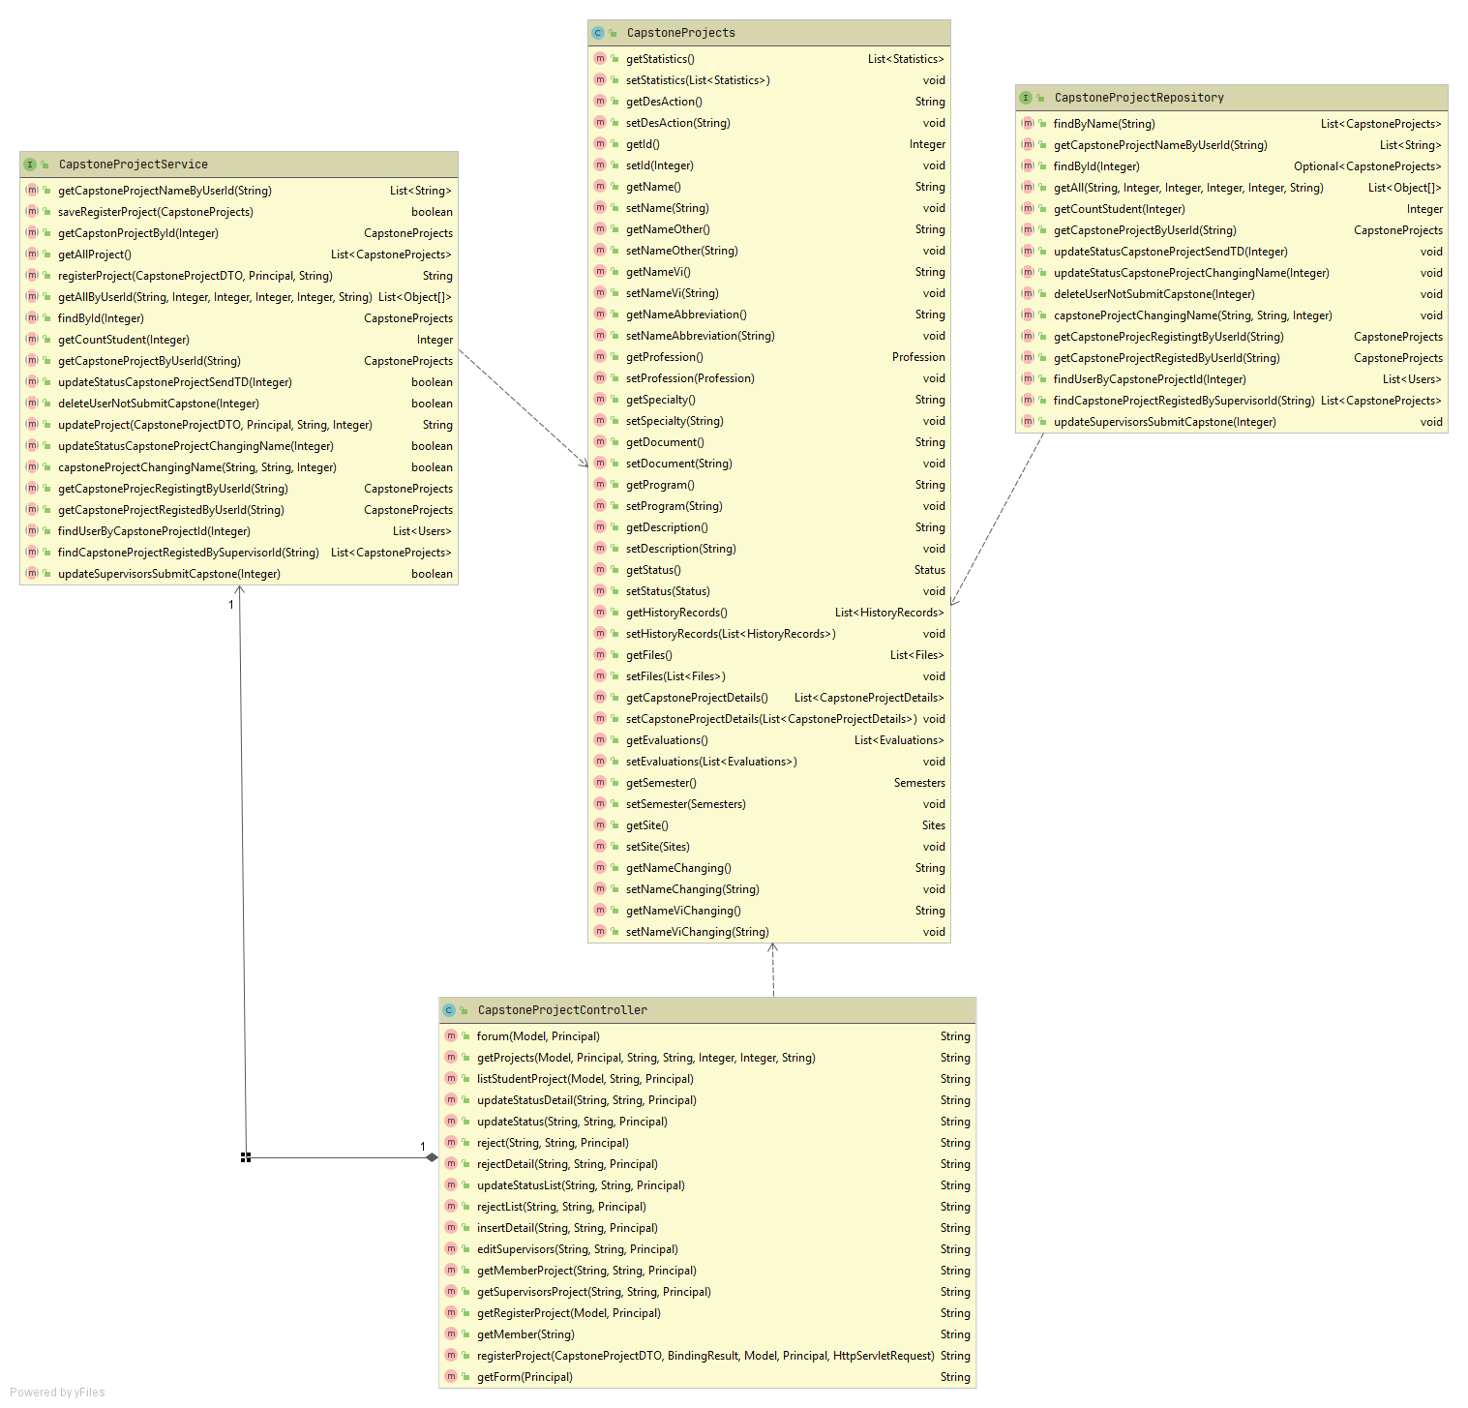

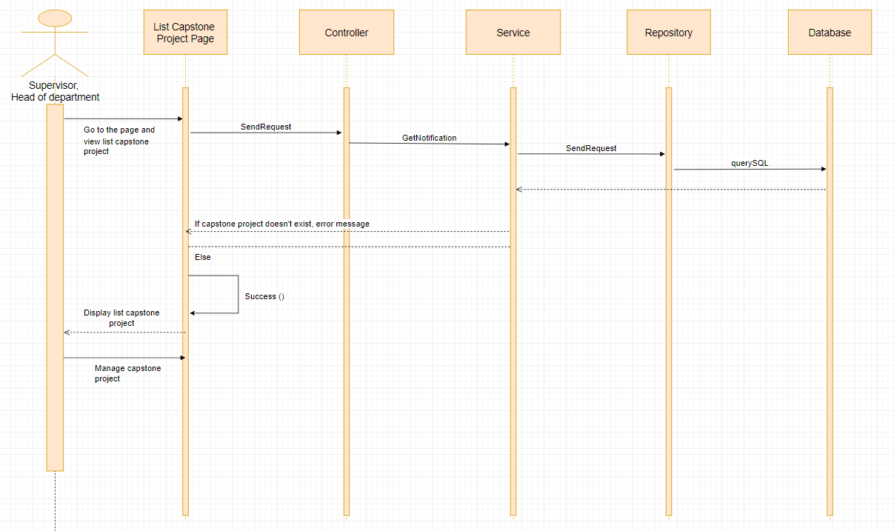

#### 4.4.1.24: View task detail of Capstone Project

**Class Diagram:**

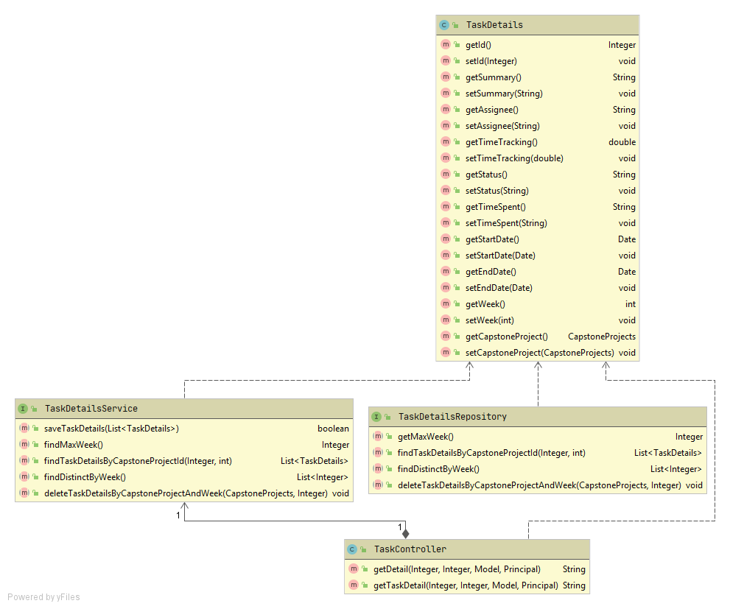

**Sequence Diagram:**

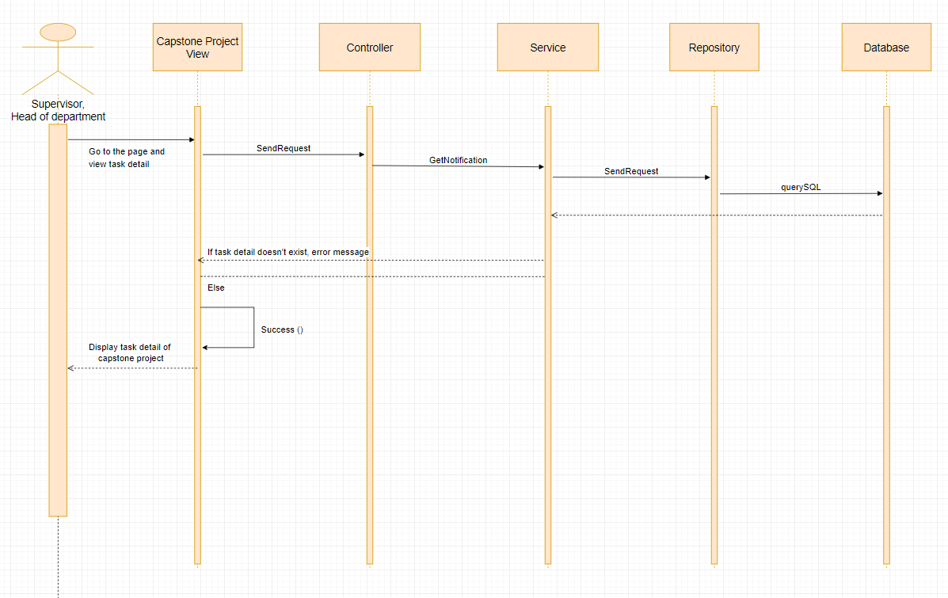

#### 4.4.1.25: Dashboard statistical of project

**Class Diagram:**

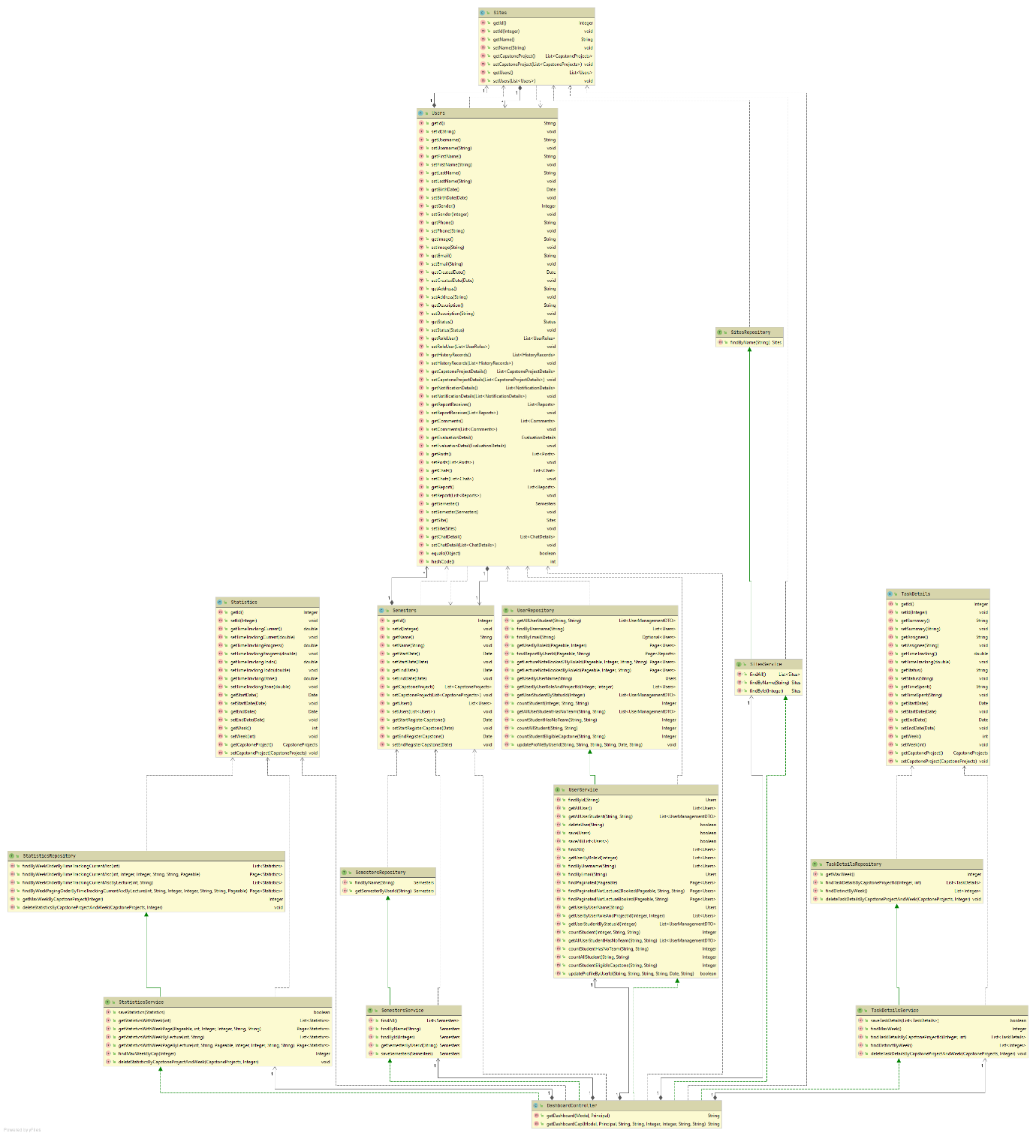

**Sequence diagram:**

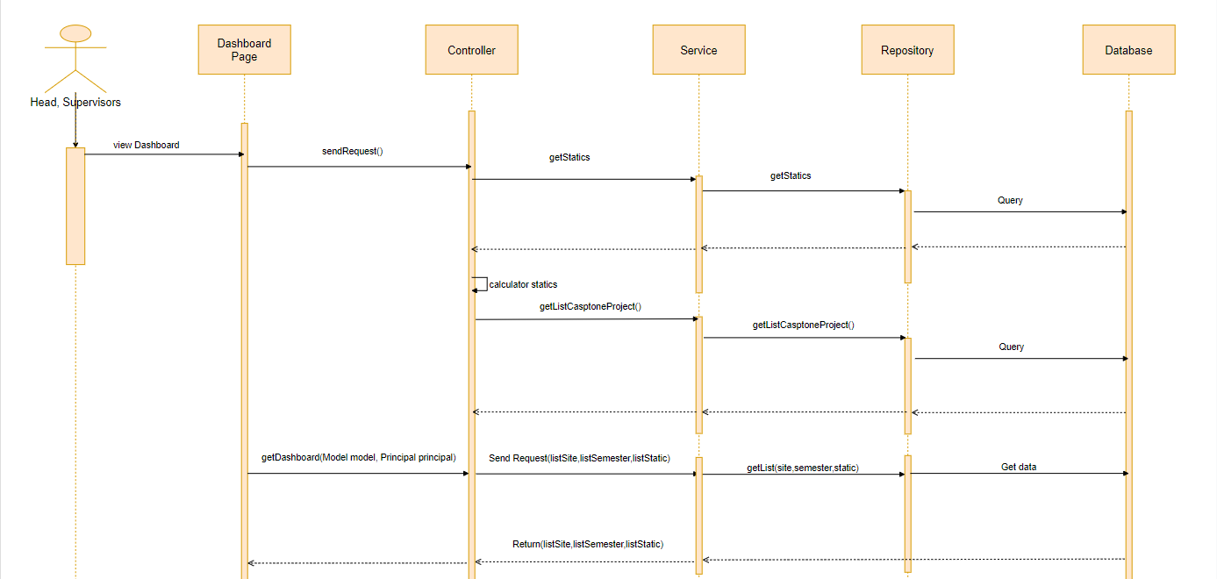

#### 4.4.1.26: View information of user

**Class Diagram:**

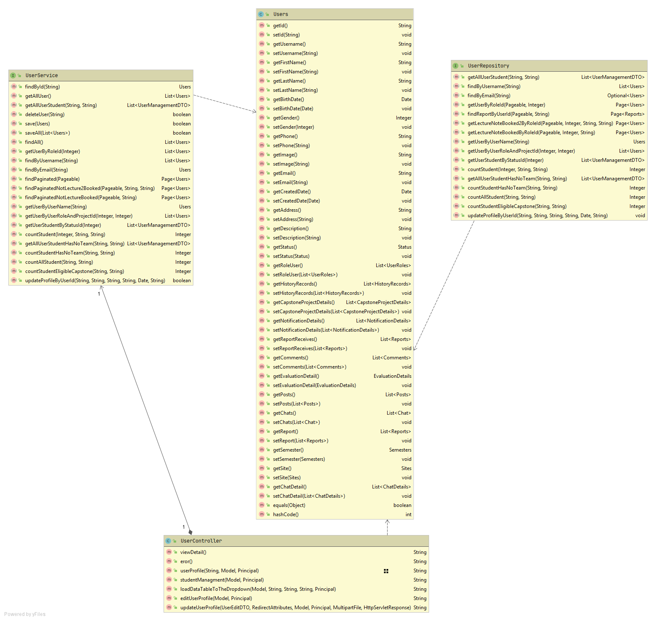

**Sequence Diagram:**

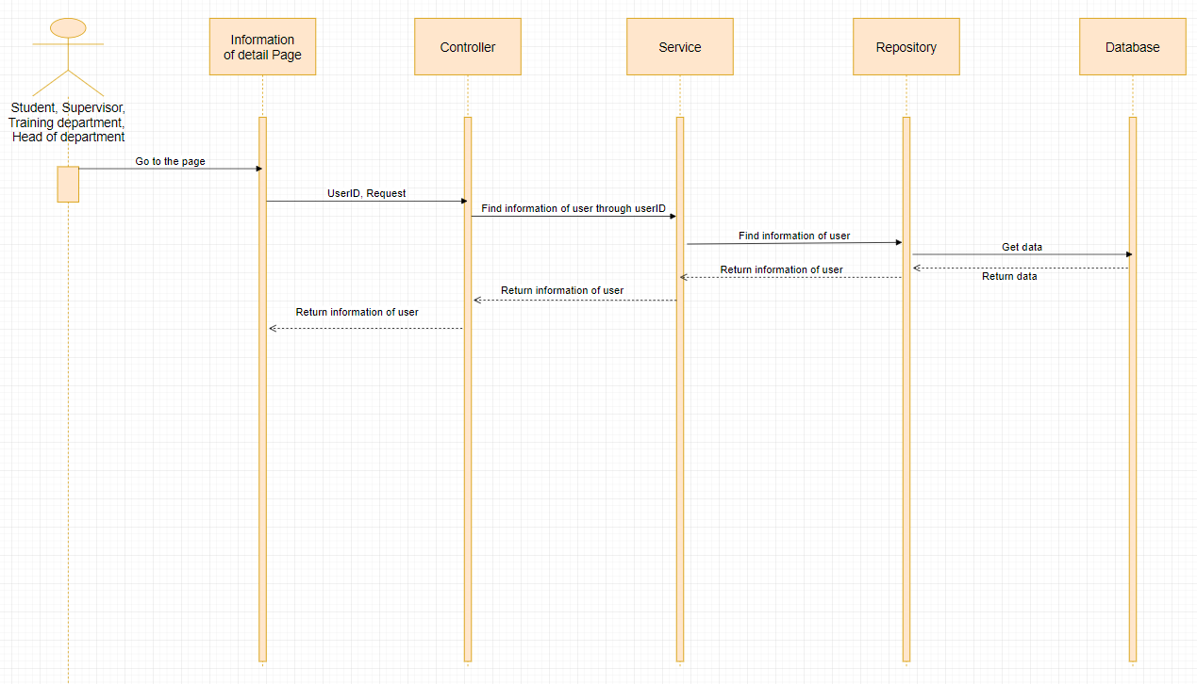

#### 4.4.1.27: Approve capstone project in the project registration stage

**Class Diagram:**

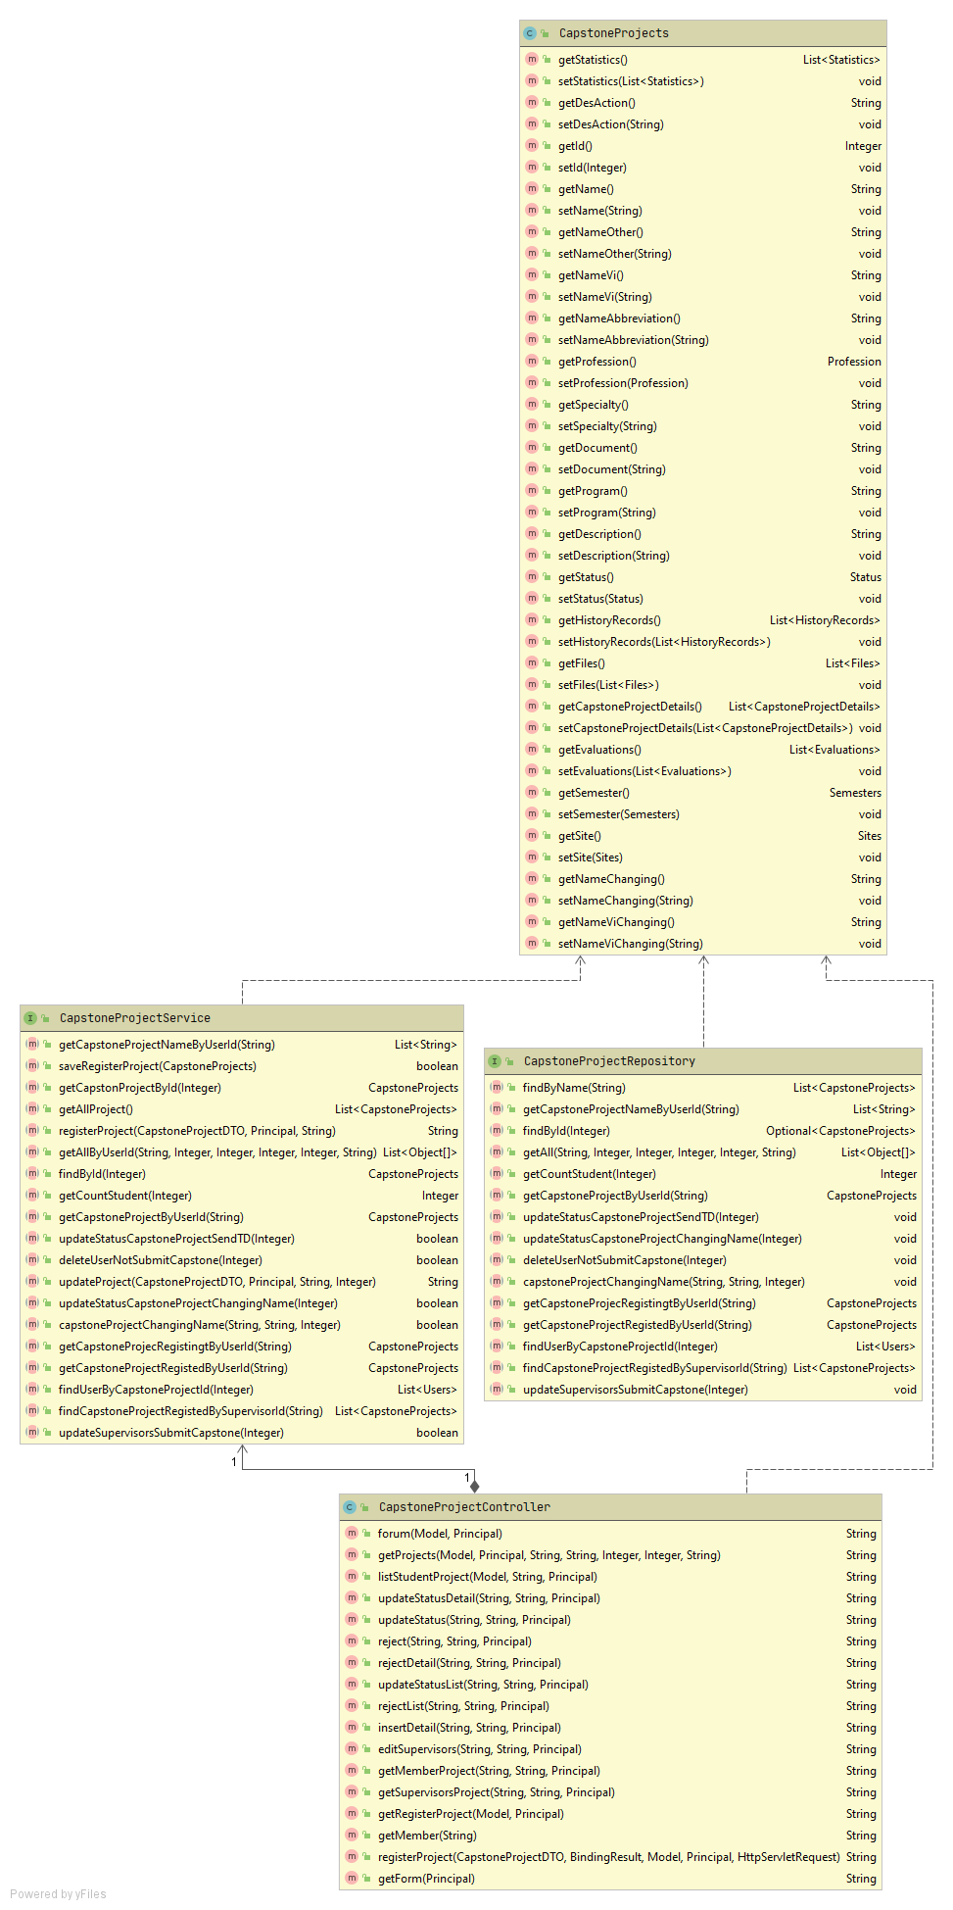

**Sequence Diagram:**

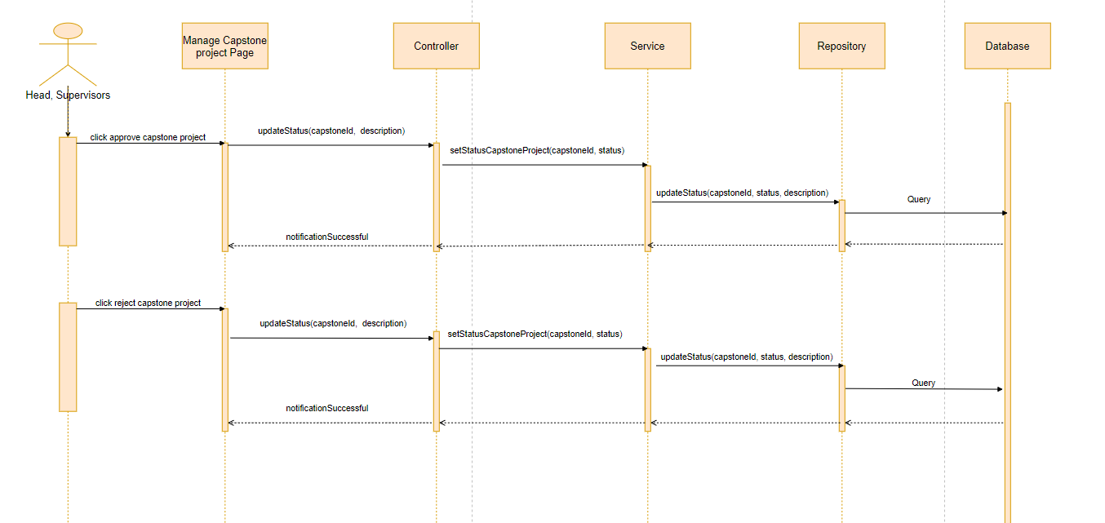

#### 4.4.1.28: Change pass / fail results

**Class Diagram:**

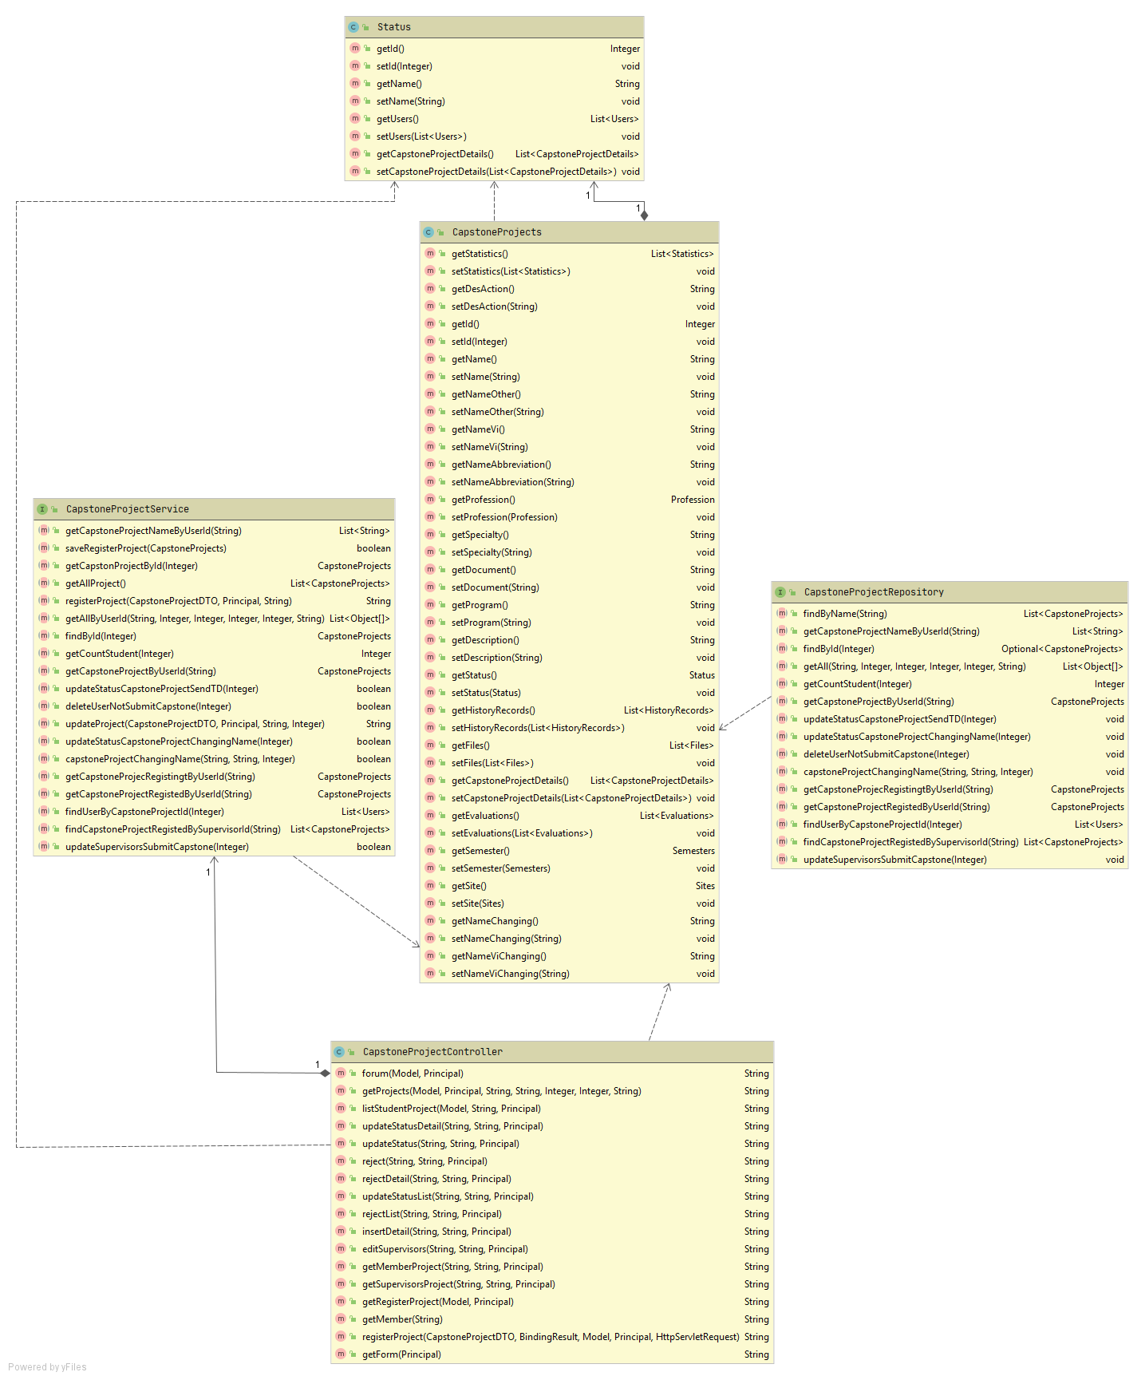

**Sequence Diagram:**

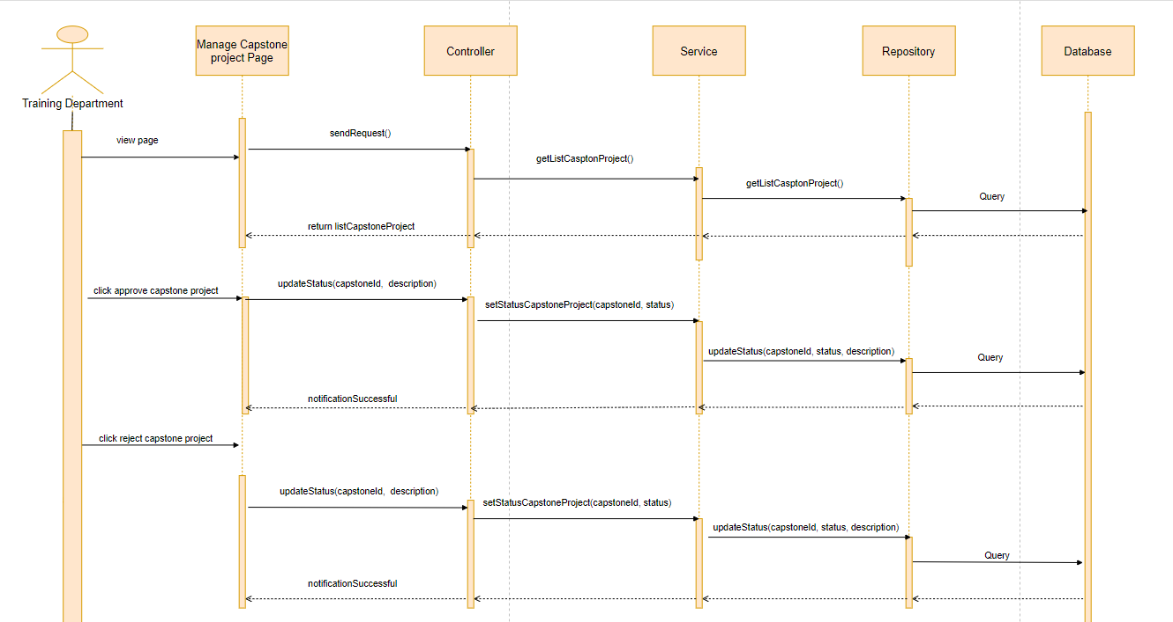

#### 4.4.1.29: Create notification

**Class Diagram:**

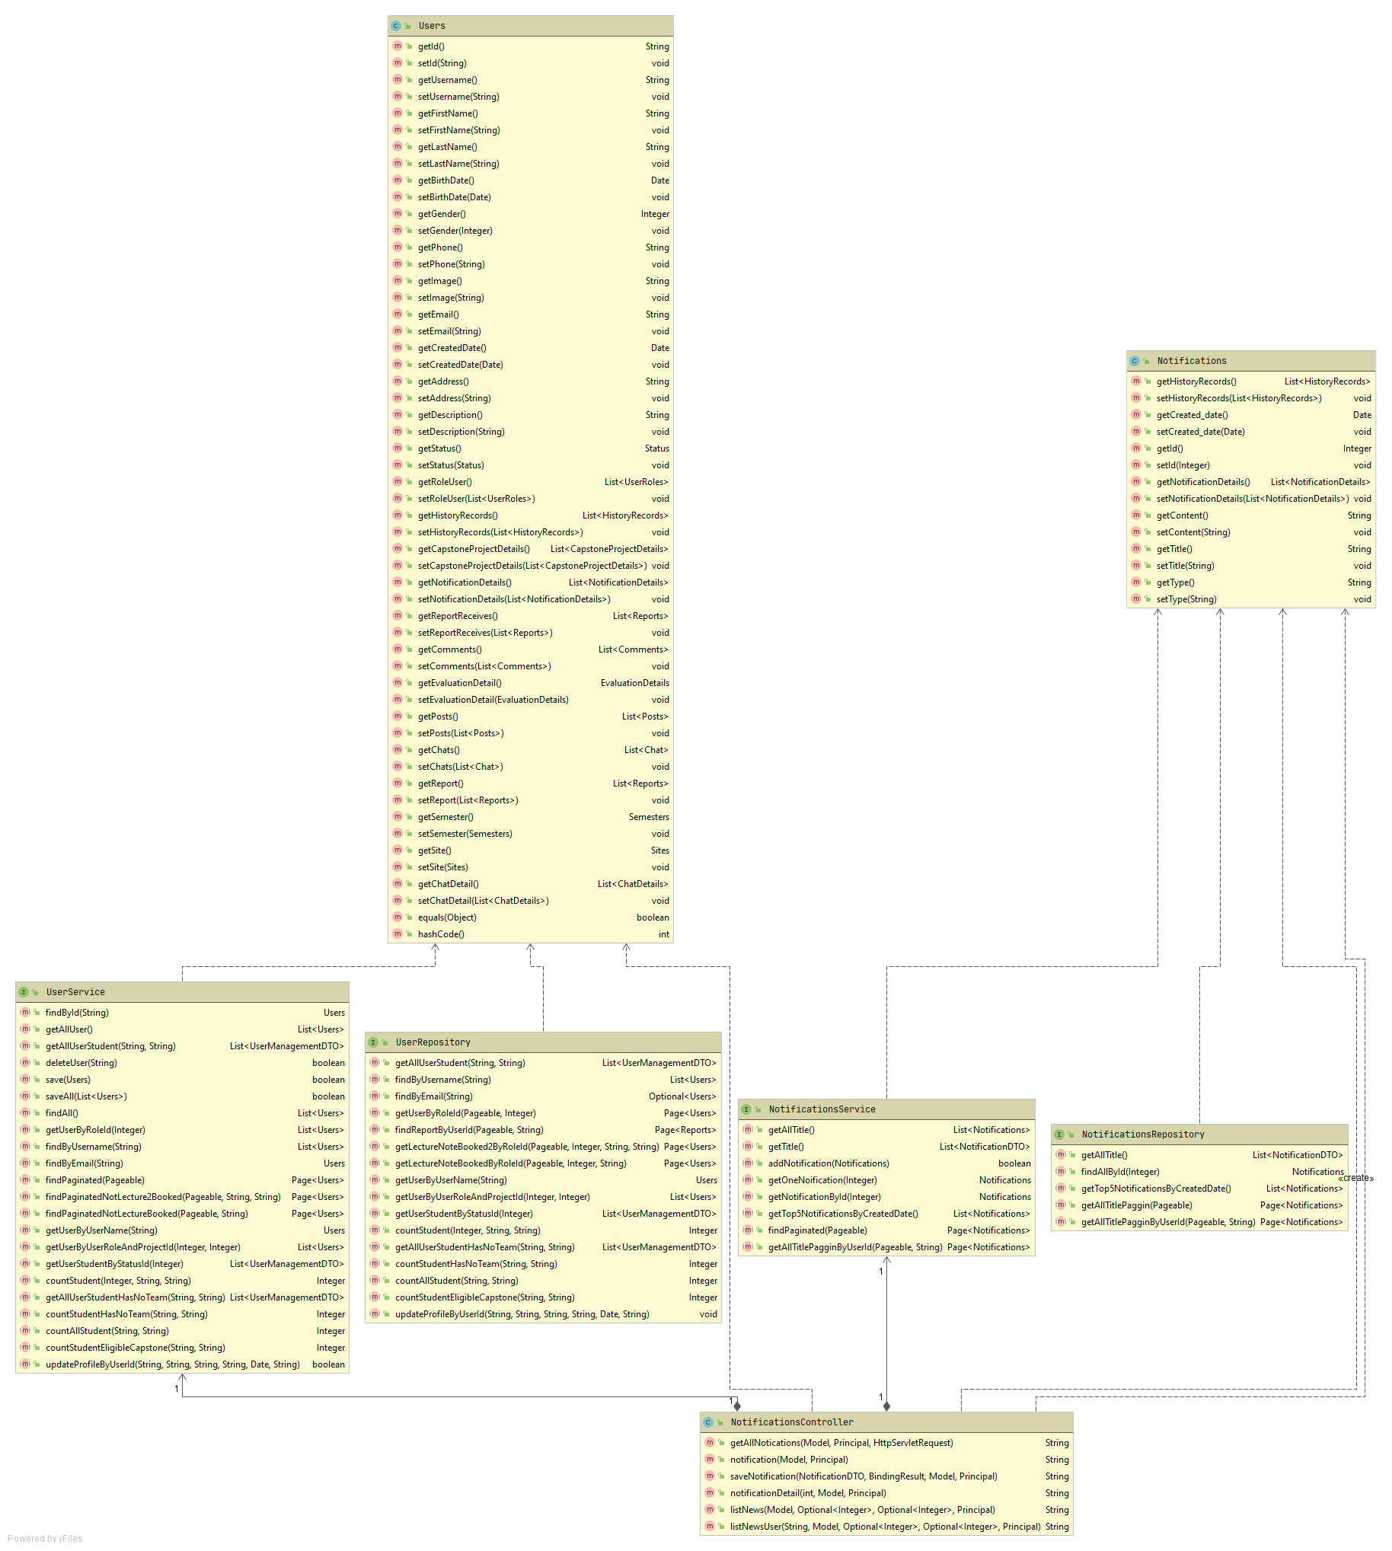

**Sequence Diagram:**

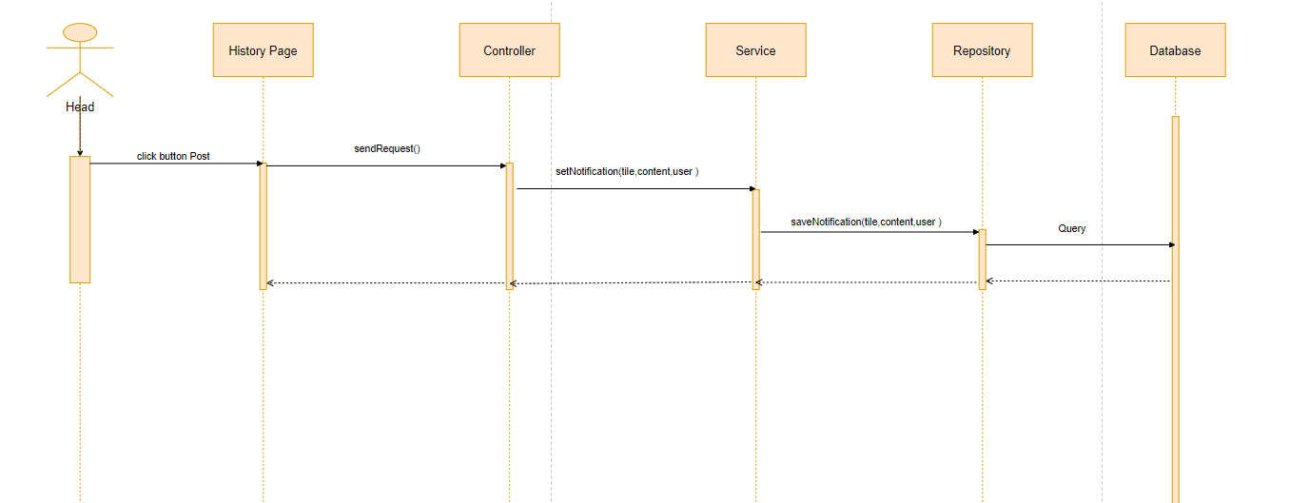

#### 4.4.1.30: View history record

**Class Diagram:**

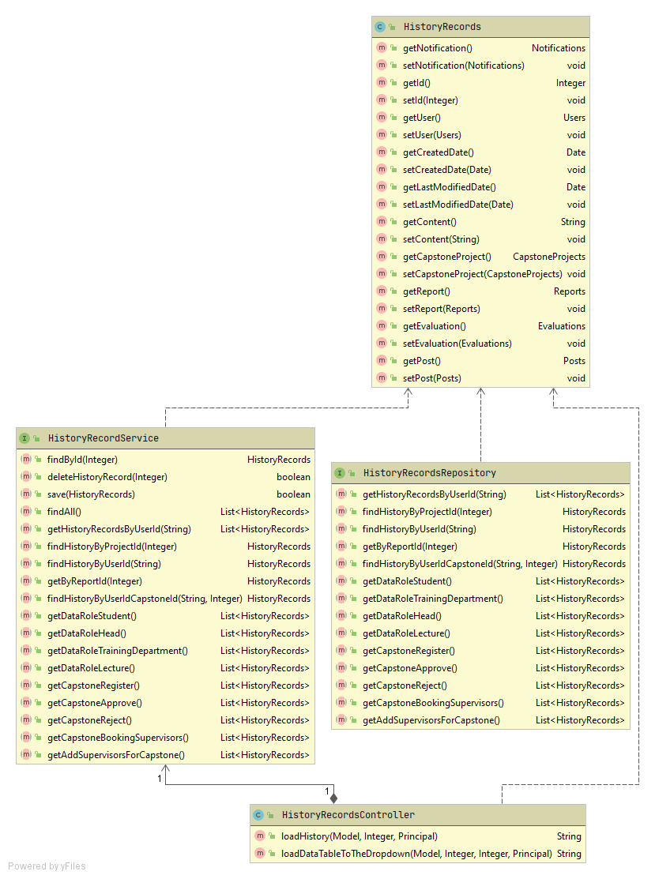

**Sequence Diagram:**

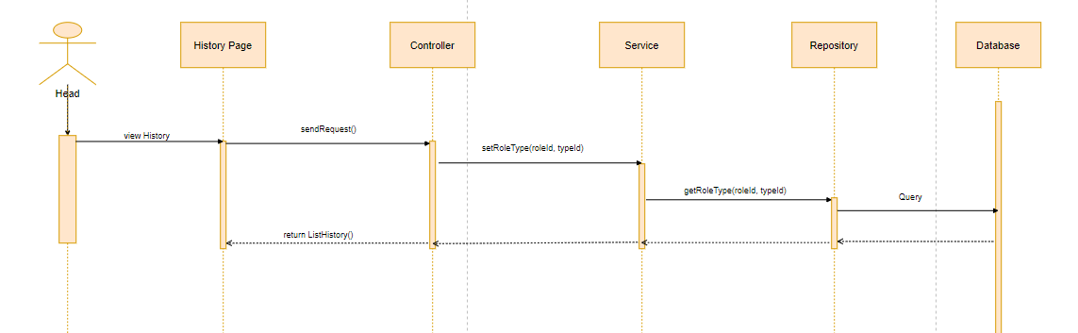

#### 4.4.1.31: Change name capstone project

**Class Diagram:**

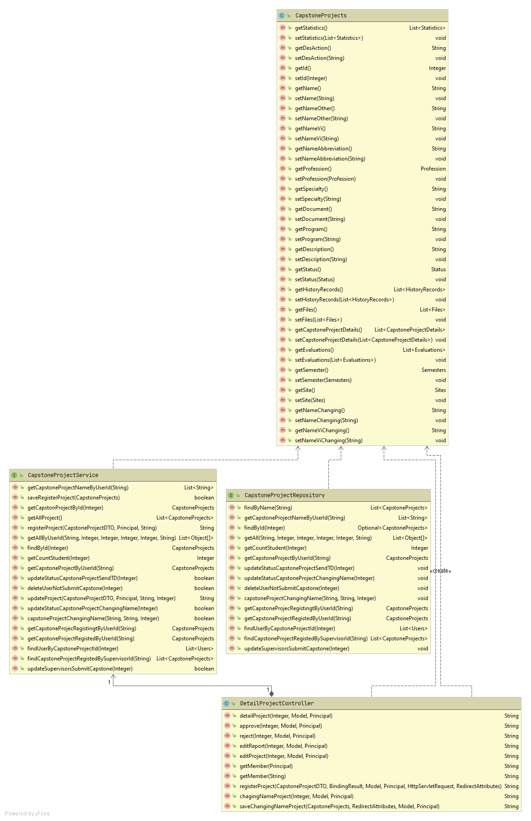

**Sequence Diagram:**

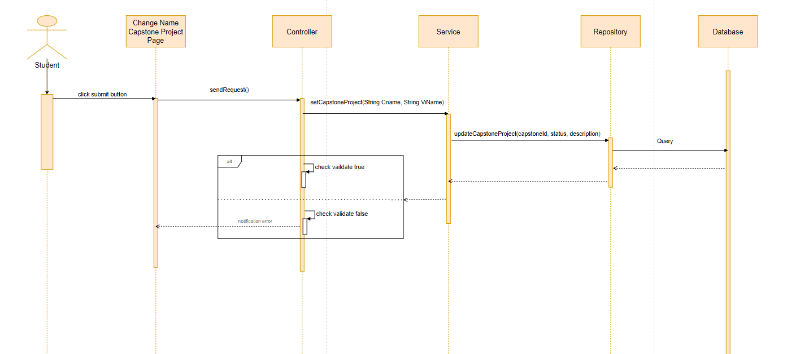

#### 4.4.1.32: View list post

**Class Diagram:**

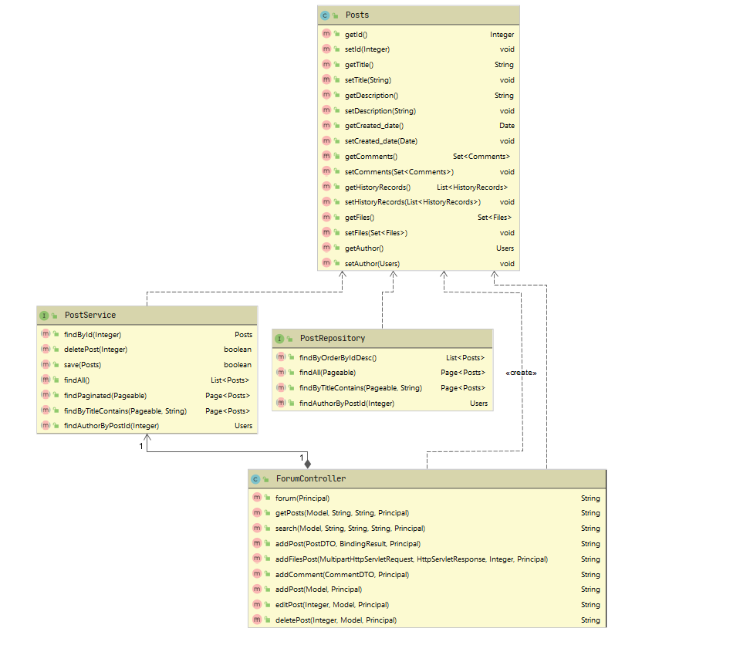

**Sequence Diagram:**

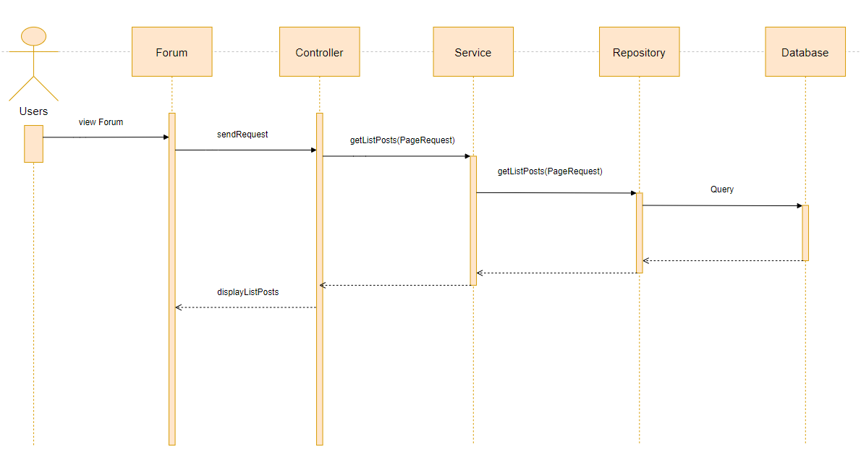

#### 4.4.1.33: Get comment

**Class Diagram:**



**Sequence Diagram:**

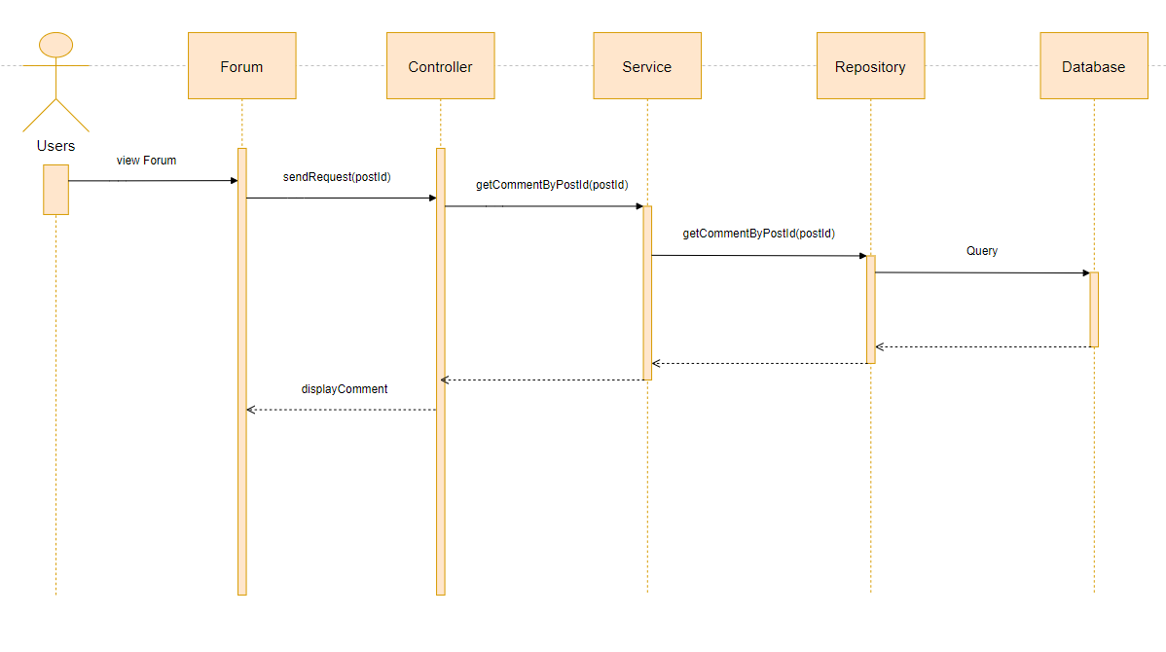

#### 4.4.1.34: Add post

**Class Diagram:**



**Sequence Diagram:**

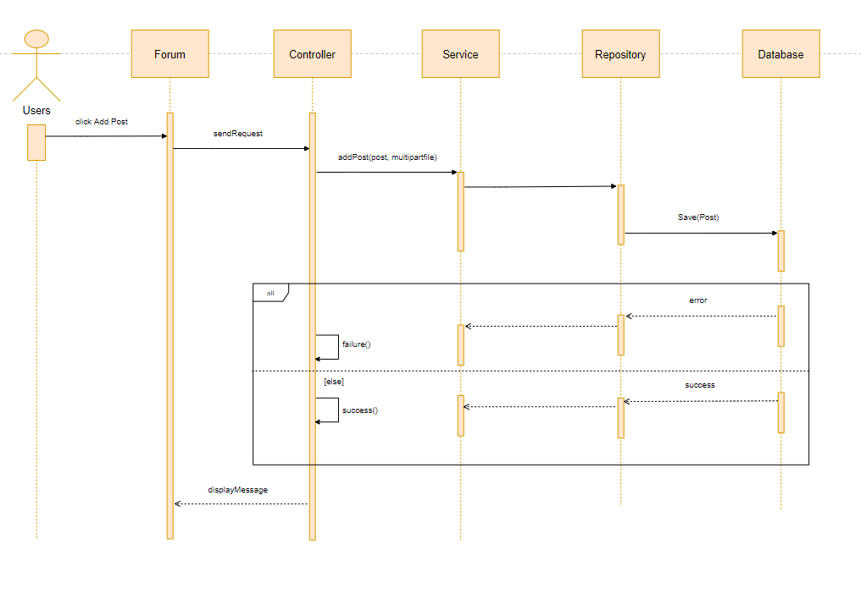

#### 4.4.1.35: Edit post

**Class Diagram:**



**Sequence Diagram:**

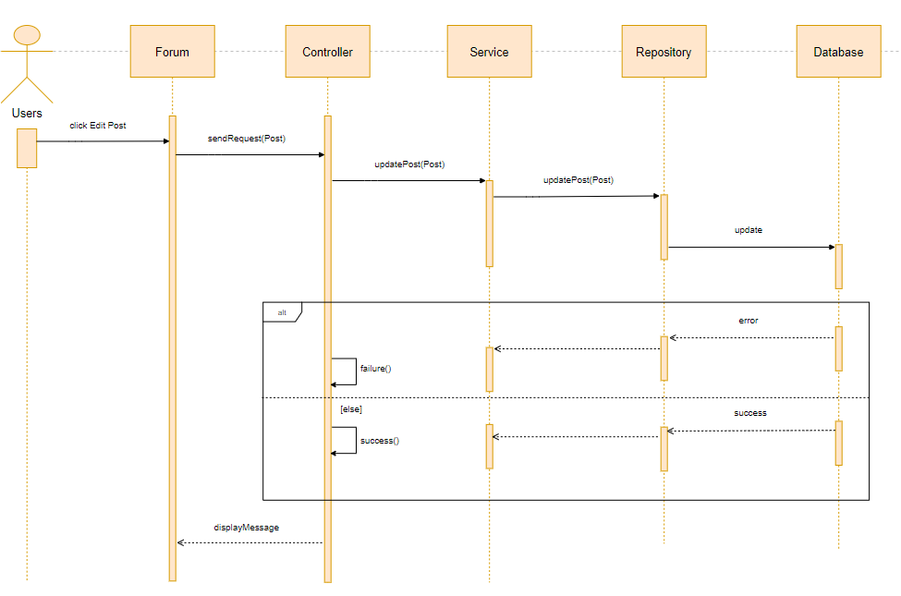

#### 4.4.1.36: Delete post

**Class Diagram:**



**Sequence Diagram:**

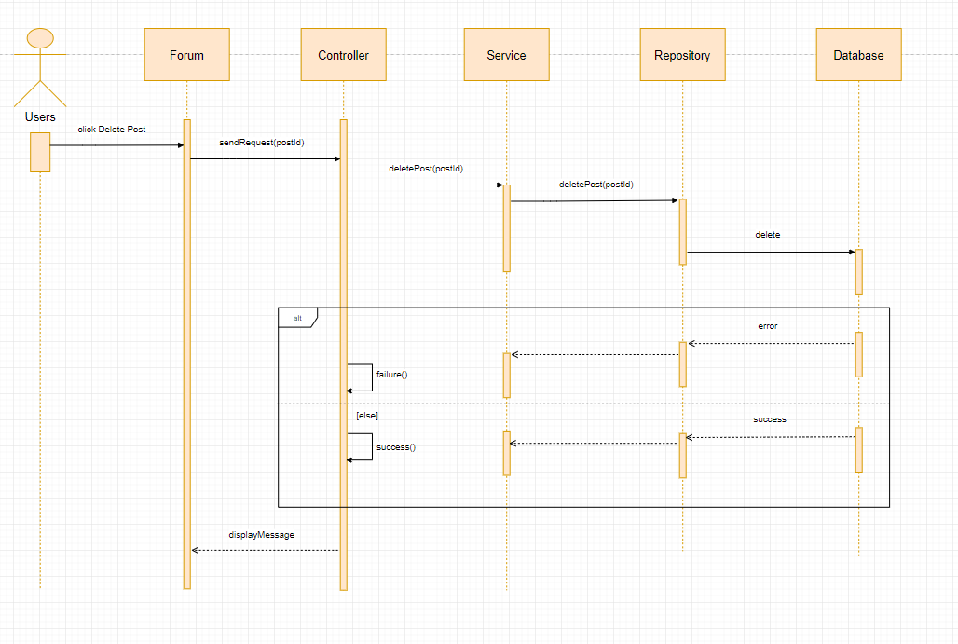

#### 4.4.1.37: Search post

**Class Diagram:**



**Sequence Diagram:**

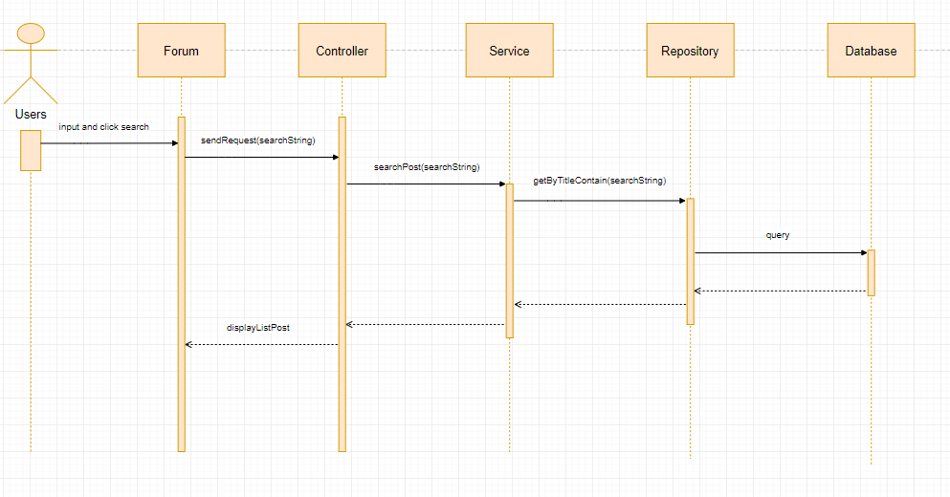

#### 4.4.1.38: Add user

**Class Diagram:**

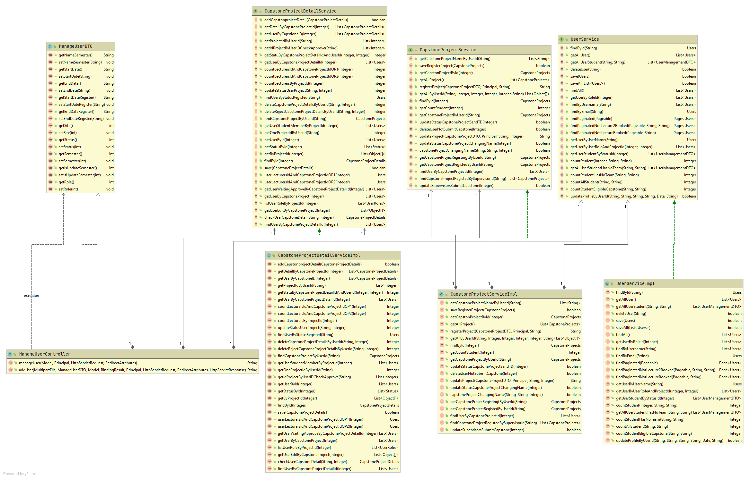

**Sequence Diagram:**

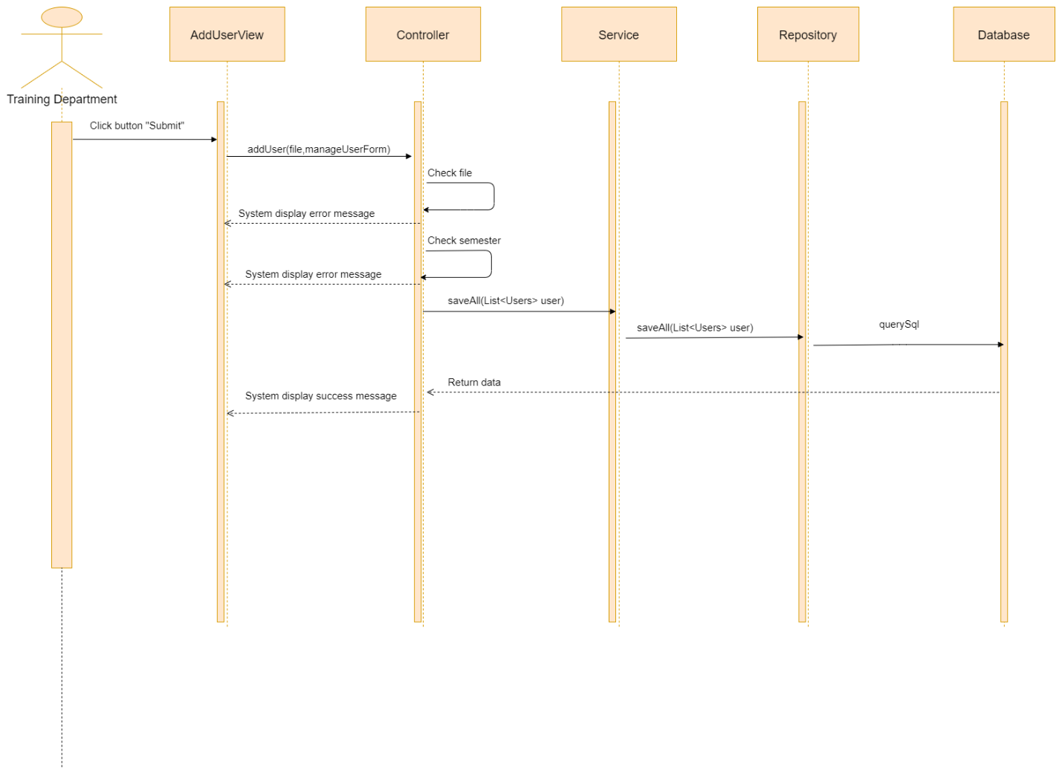

#### 4.4.1.39: Approve capstone project in the changing name stage

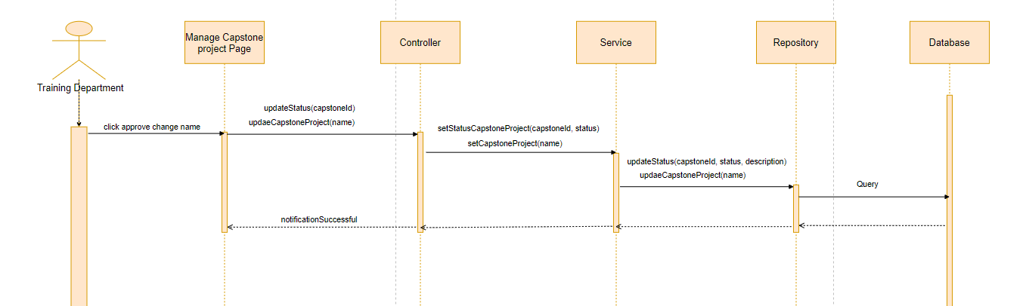

## 4.5. User Interface Design

### 4.5.1 Description of the User Interface

#### 4.5.1.1. Login

* **Screen Images**



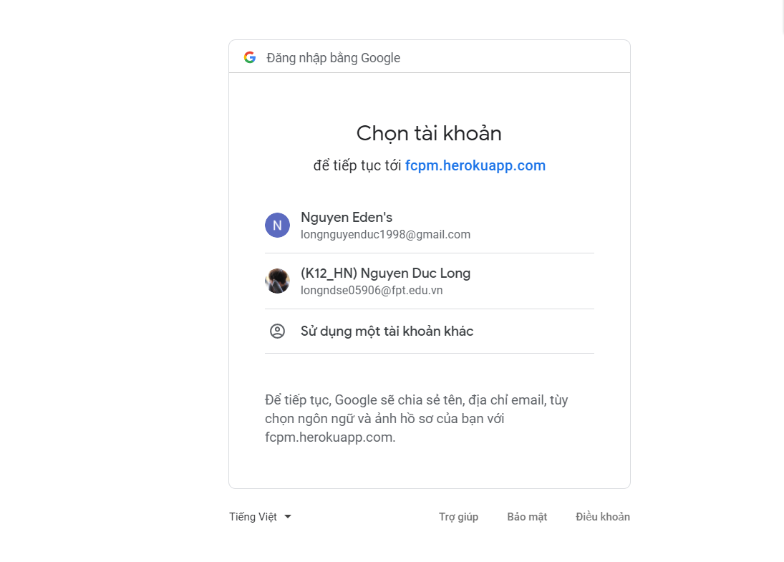

Button/ Hyperlinks

|  |  |  |  |  |
| --- | --- | --- | --- | --- |
| **No** | **Function** | **Description** | **Validation** | **Outcome** |
| 1 | Login | Click to Sign in  With Google | No | Navigate to account  for authentication |
| 2 | Login | Choose FPT email | No | Navigate to forum |

#### 4.5.1.2. Logout

* **Screen Images**

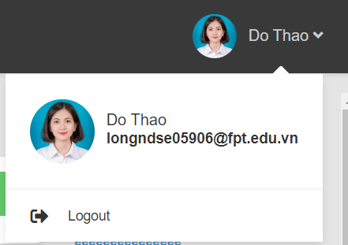

Button/ Hyperlinks

|  |  |  |  |  |
| --- | --- | --- | --- | --- |
| **No** | **Function** | **Description** | **Validation** | **Outcome** |
| 1 | Logout | Click to Do Thao | No | Show logout |
| 2 | Logout | Clock to Logout | No | Navigate to Login  Page |

#### 4.5.1.3. Register Capstone Project

* **Screen Images**

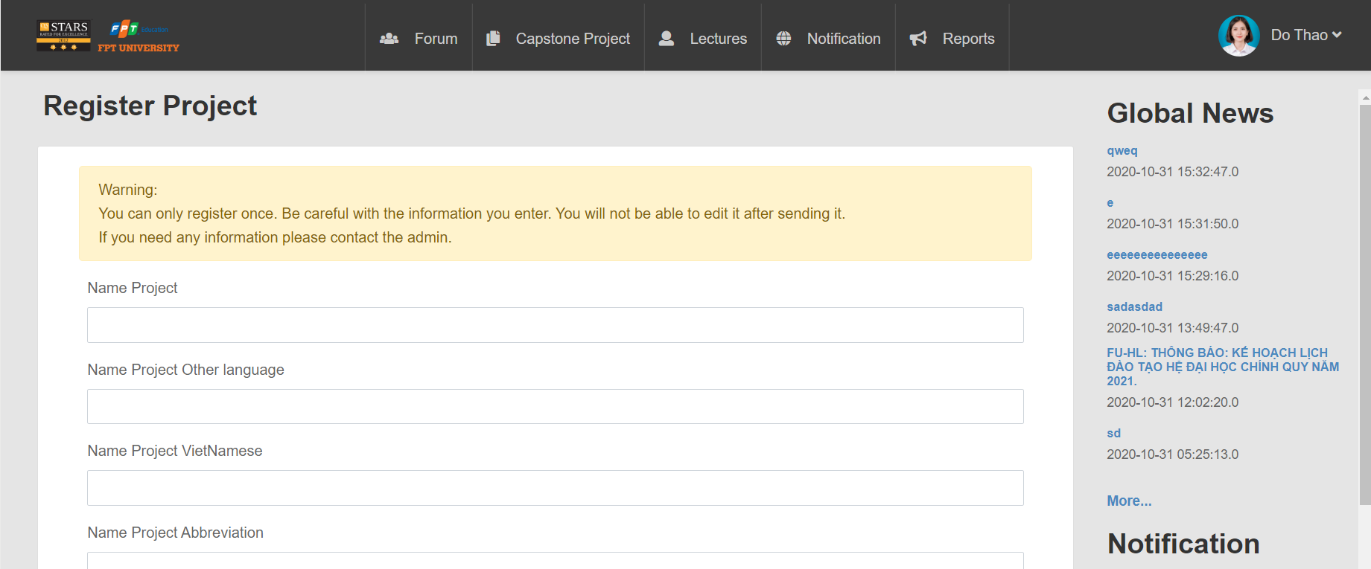

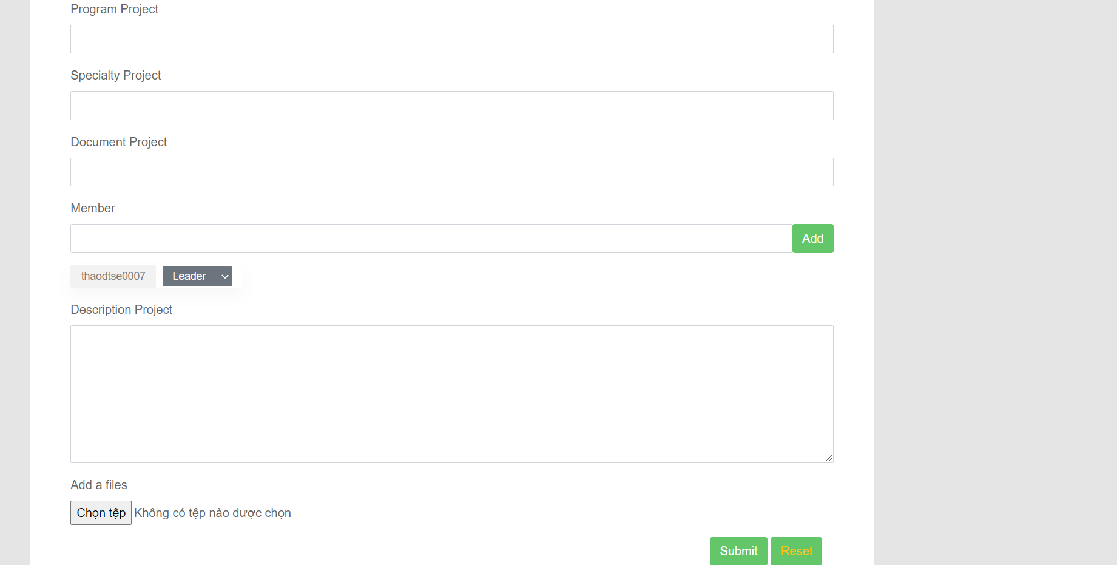

Button/ Hyperlinks

|  |  |  |  |  |
| --- | --- | --- | --- | --- |
| **No** | **Function** | **Description** | **Validation** | **Outcome** |
| 1 | Register | Click to Create  Capstone | No | Navigate to Register Project Page |
| 2  3  4  5  6 | Choose leader or  member  Add member  Add file  Submit  Register  Reset  register | Choose leader or  member  Click to Add  Click to choose  file  Click to submit  Click to reset | No  No  No  No  No | Show leader or  Member  Show name  of member  Show file  Show submit success or fail  Re-register |

Fields

|  |  |  |  |  |  |  |  |
| --- | --- | --- | --- | --- | --- | --- | --- |
| **No** | **Field**  **Name** | **Description** | **Read**  **Only** | **Mandatory** | **Control**  **Type** | **Data**  **Type** | **Length** |
| 7 | Name  Project | Name of  project | No | Yes | Text | String | 120 |
| 8 | Name project other language | Name project other language | No | Yes | Text | String | 120 |
| 9 | Name project Vietnamese | Name project Vietnam | No | Yes | Text | String | 120 |
| 10 | Name project Abbreviation | Name project Abbreviation | No | Yes | Text | String | 120 |
| 11 | Profession  project | Profession  Project | No | Yes | Text | String | 120 |
| 12 | Program  project | Program  Project | No | Yes | Text | String | 120 |
| 13 | Specialty  project | Specialty  Project | No | Yes | Text | String | 120 |
| 14 | Document  project | Document  Project | No | Yes | Text | String | 120 |
| 12 | Member | Member add | No | Yes | Text | String | 120 |
| 13 | Description  project | Description  Project | No | Yes | Text | String | 120 |
|  |  |  |  |  |  |  |  |

#### 4.5.1.4 Add member

* **Screen Images**

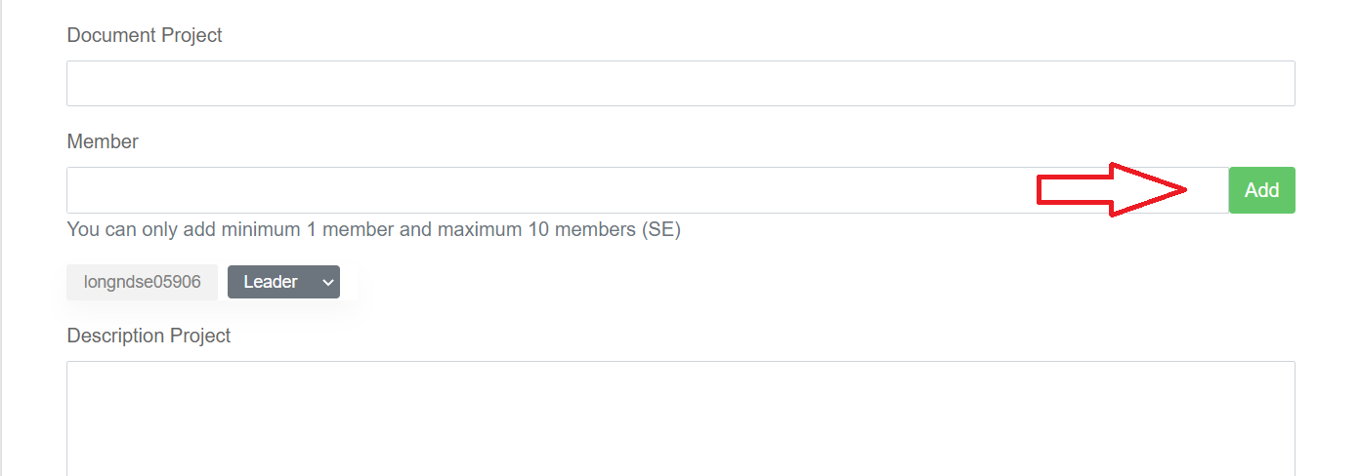

Button/ Hyperlinks

|  |  |  |  |  |
| --- | --- | --- | --- | --- |
| **No** | **Function** | **Description** | **Validation** | **Outcome** |
| 1 | Add member | Click to “Add” | No | Show name  of member |

#### 4.5.1.5 Research model

* **Screen Images:**

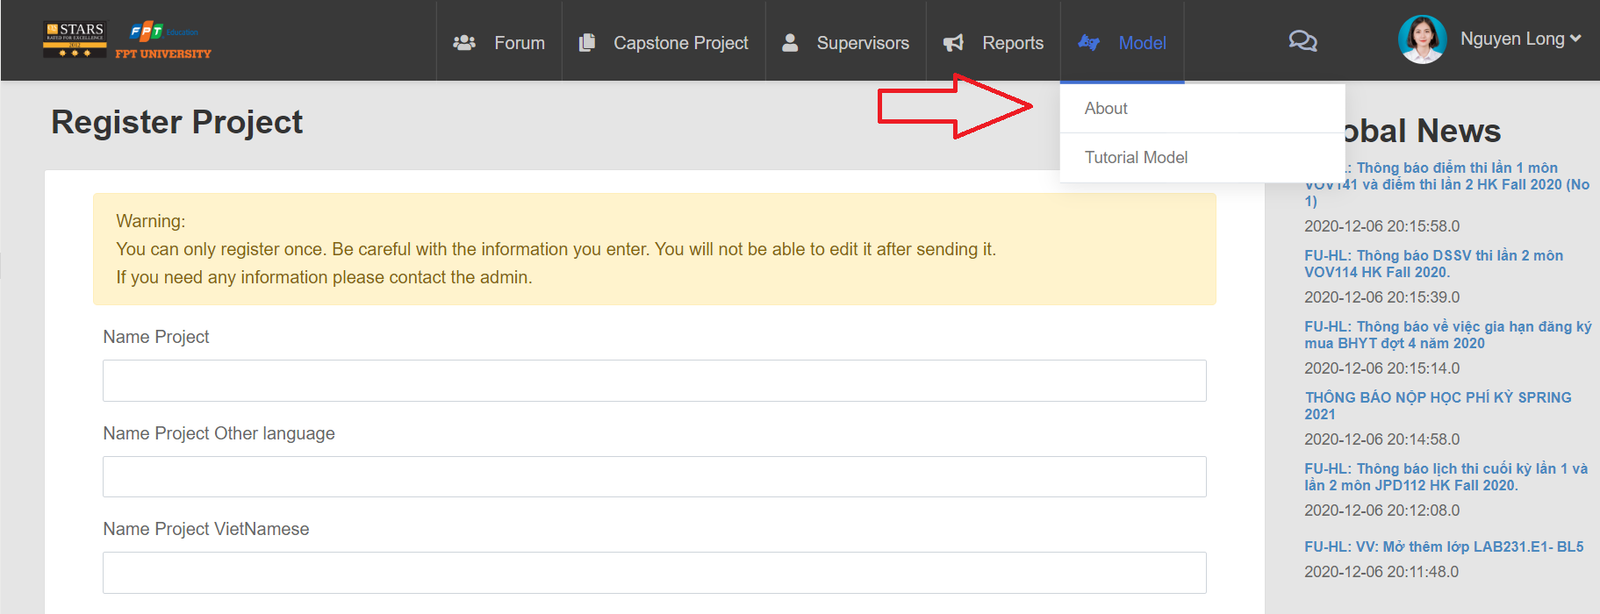

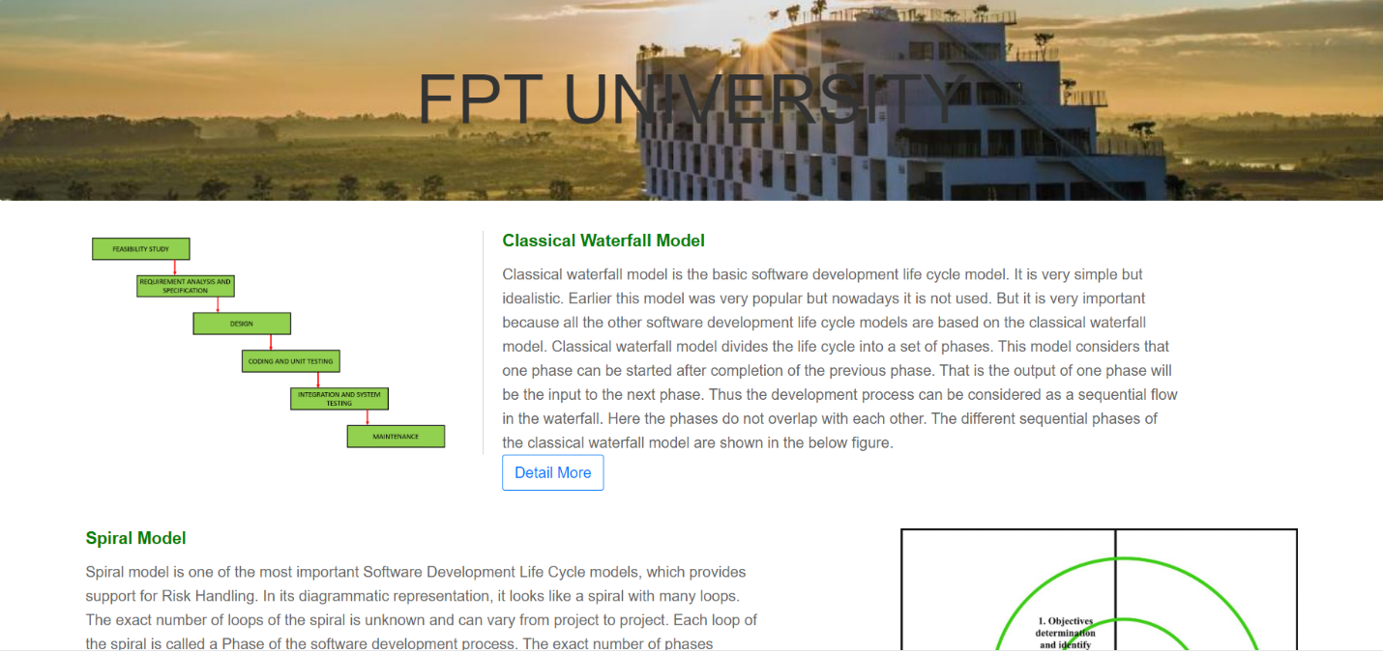

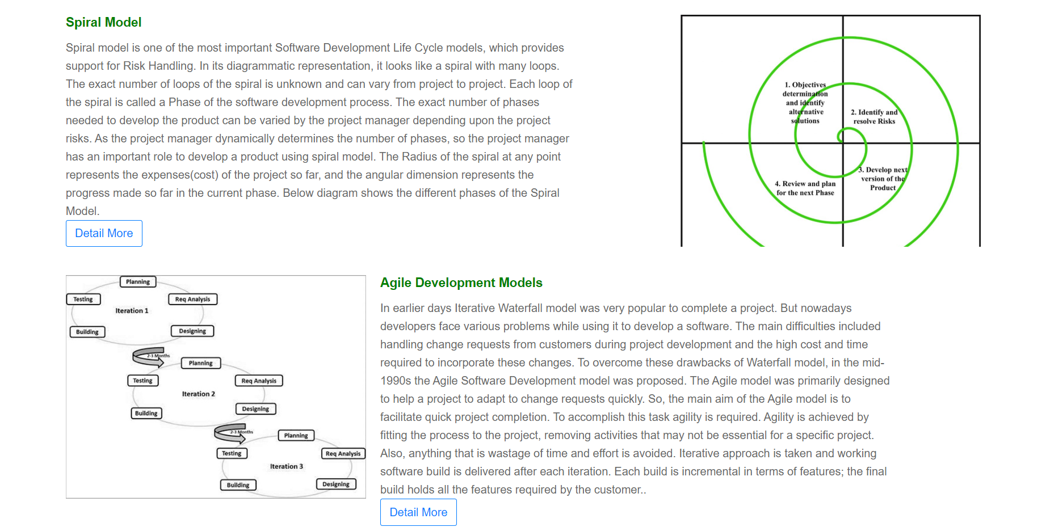

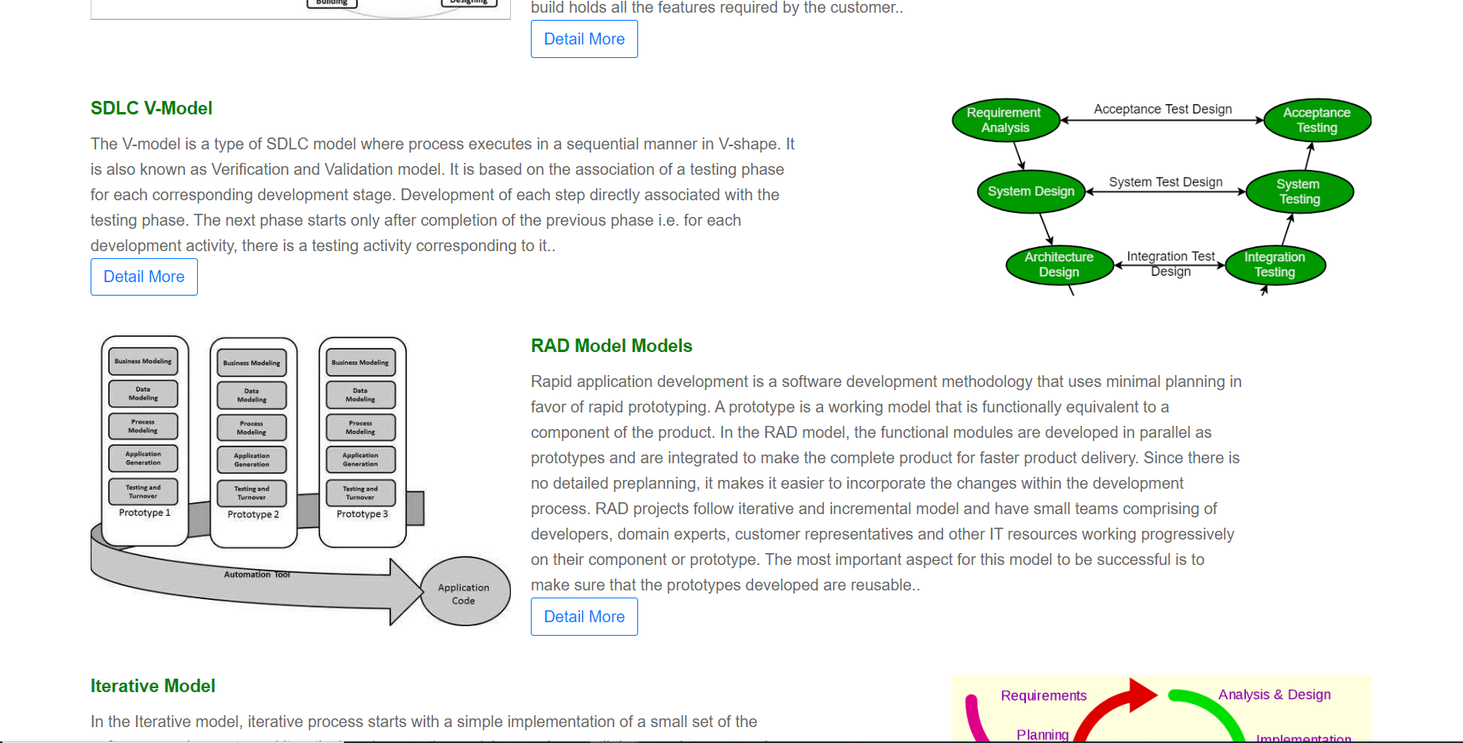

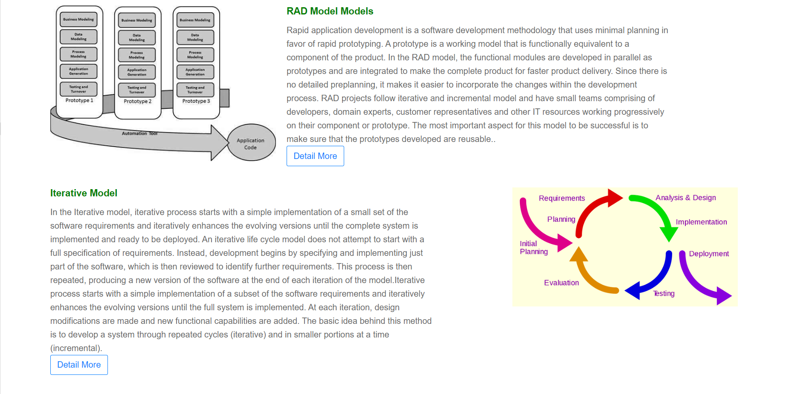

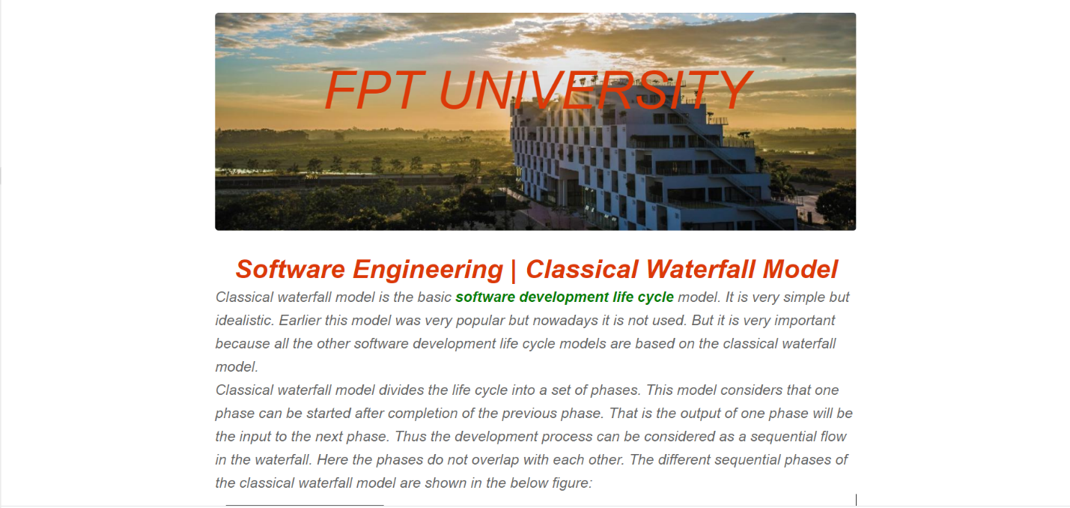

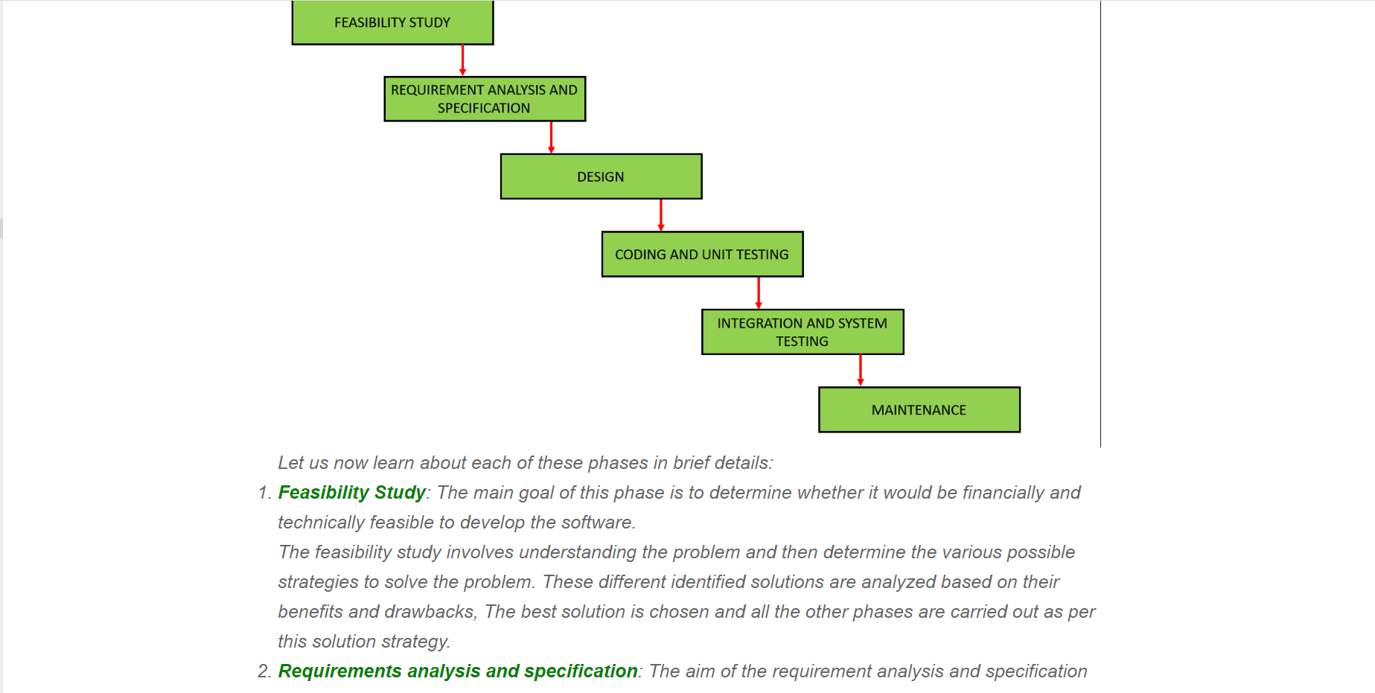

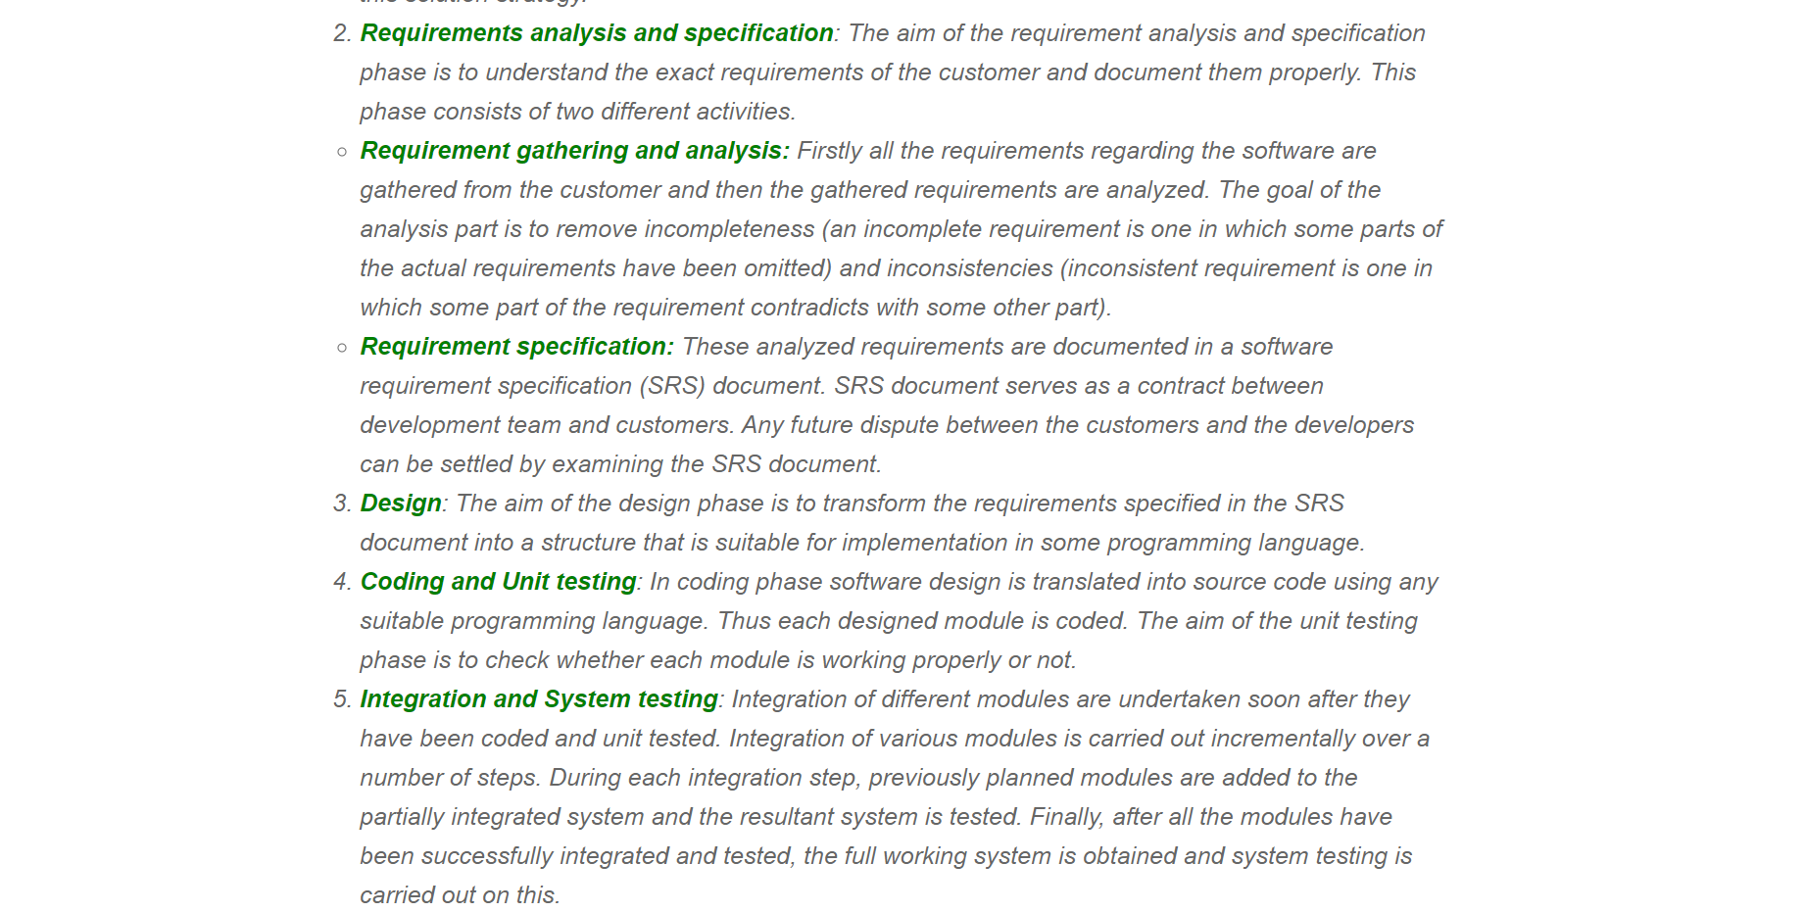

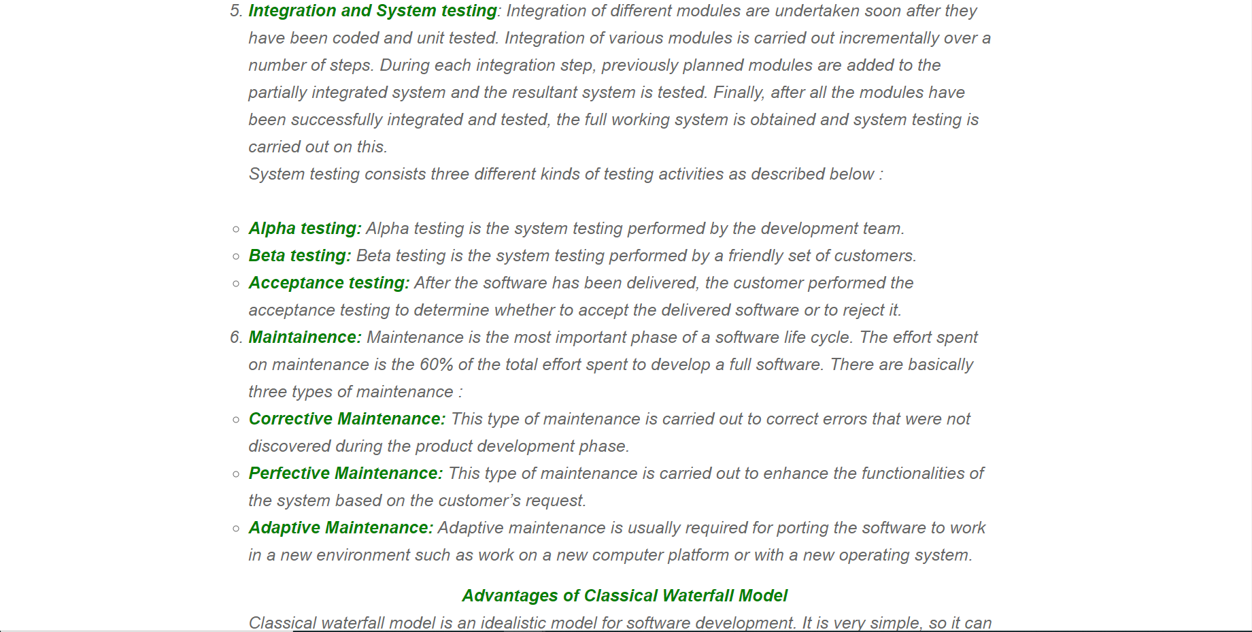

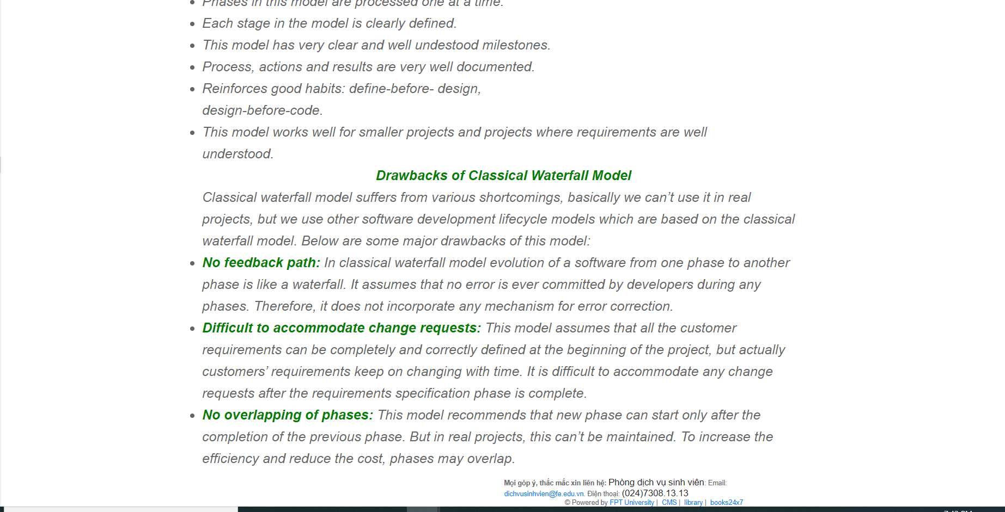

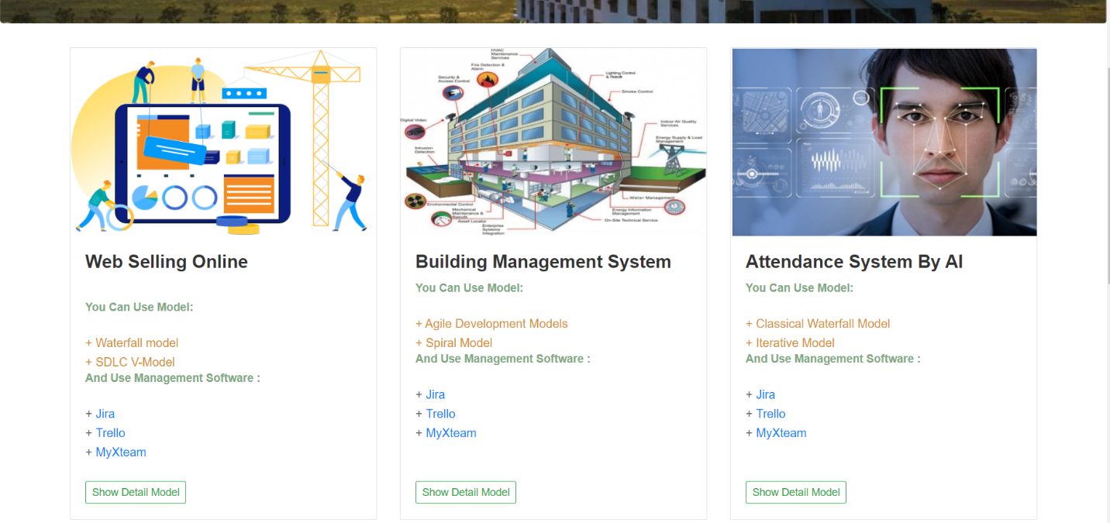

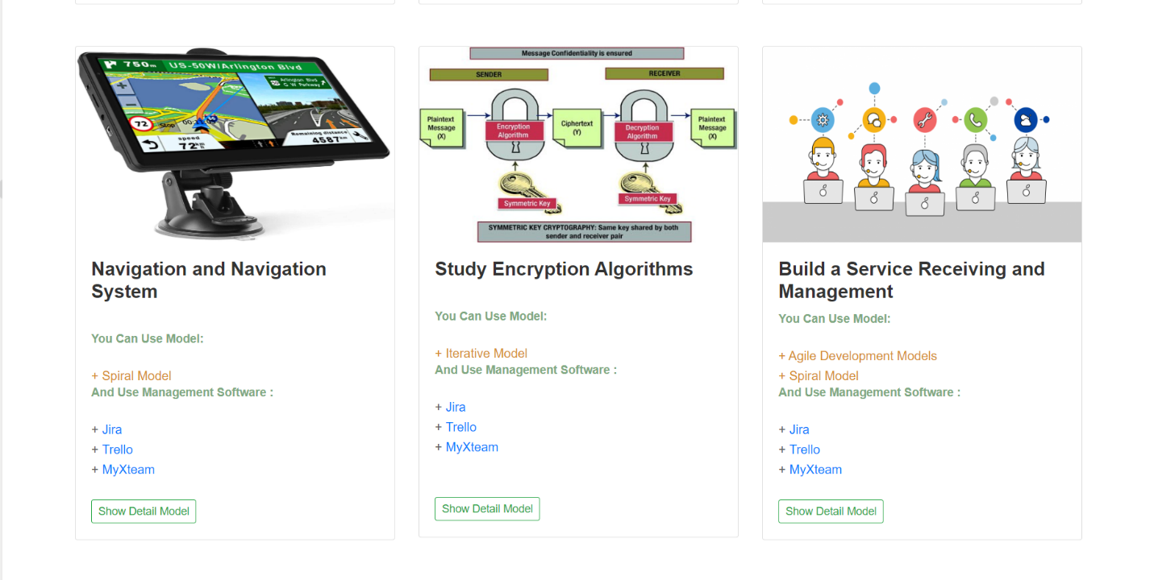

Button/ Hyperlinks

|  |  |  |  |  |
| --- | --- | --- | --- | --- |
| **No** | **Function** | **Description** | **Validation** | **Outcome** |
| 1  2  3 | Research model  Research  model  View detail about model | Click to “About”  Click to “Tutorial  model”  Click to button “Detail more” | No  No  No | Show About model  page  Show Tutorial model page  Show detail about model |
| 4 | View detail tutorial model | Click to button “Show detail model” | No | Show detail tutorial model |

#### 4.5.1.6. Show list supervisors and booking

* **Screen Images**

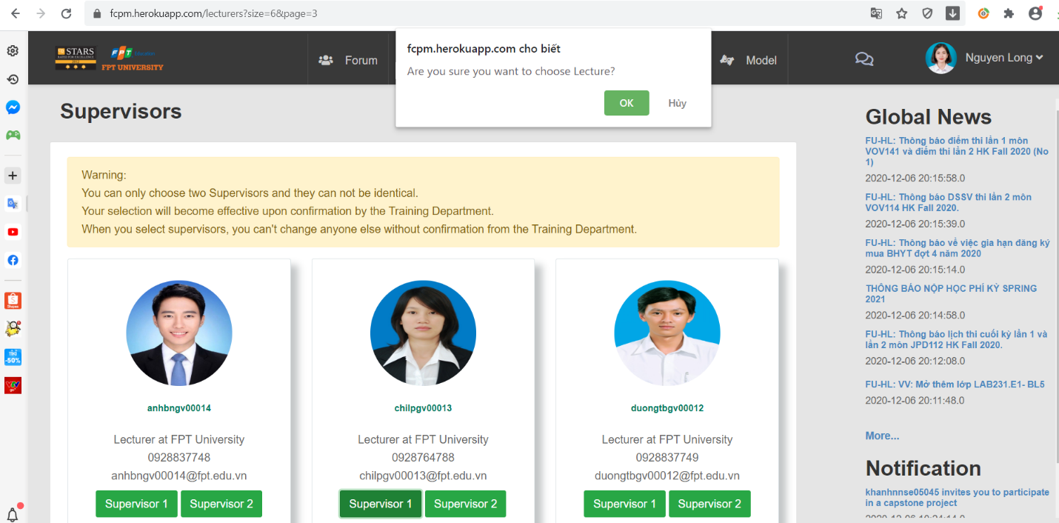

Button/ Hyperlinks

|  |  |  |  |  |
| --- | --- | --- | --- | --- |
| **No** | **Function** | **Description** | **Validation** | **Outcome** |
| 1  2  3  4 | Booking  Booking  Confirm booking  Confirm booking | Click to button “Supervisor 1”  Click to button “Supervisor 2”  Click to button “Ok”  Click to button “Huy” | No  No  No  No | Display notification  confirm  Display notification  confirm  Display notification  booking successful  Keep the list supervisors page |

#### 4.5.1.7. View GUIDE

* **Screen Images**

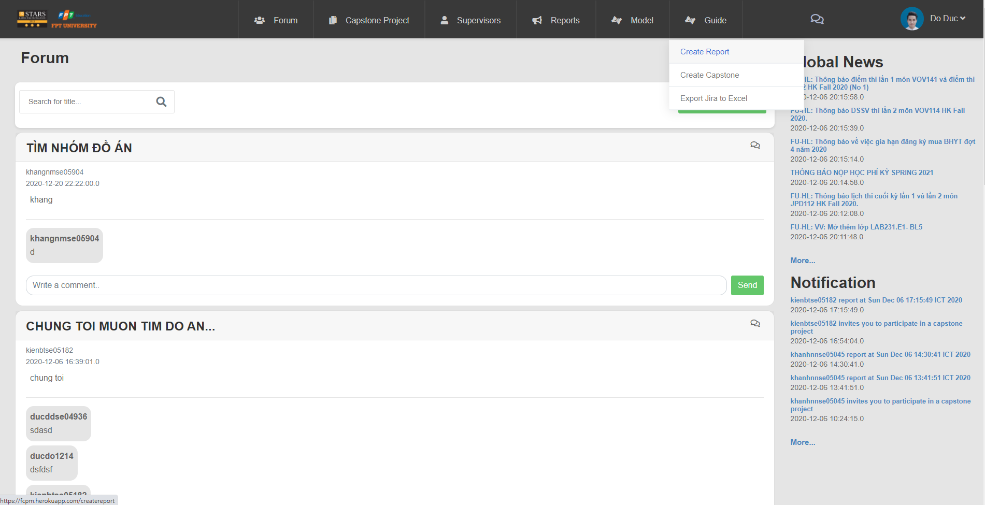

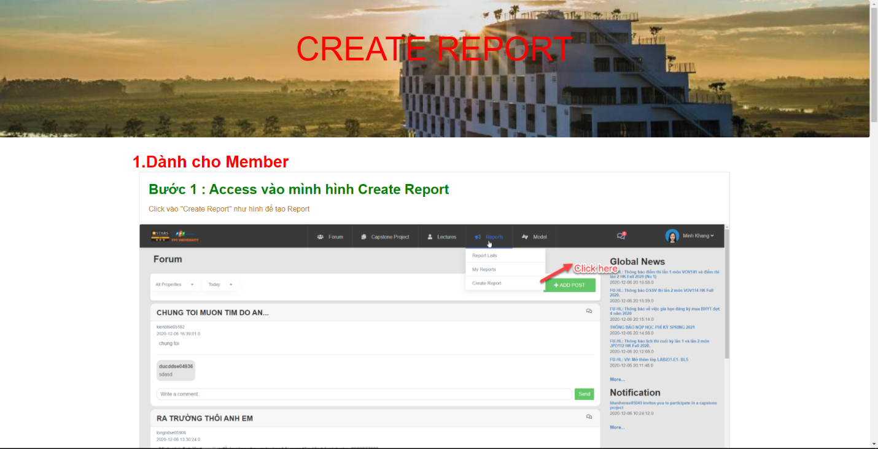

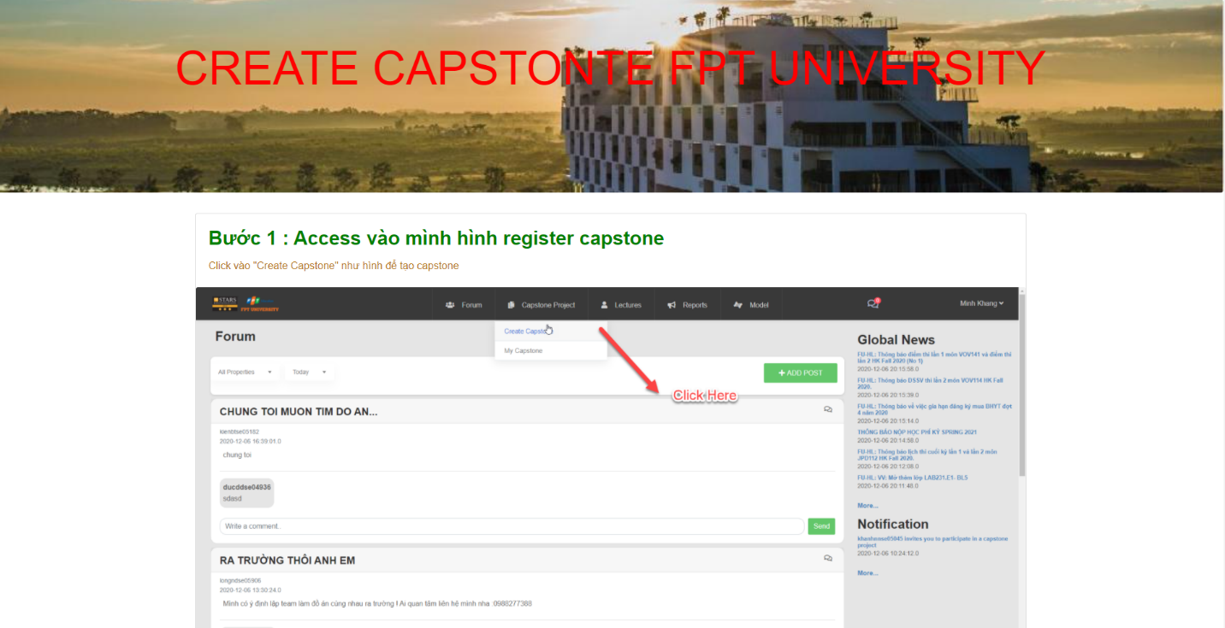

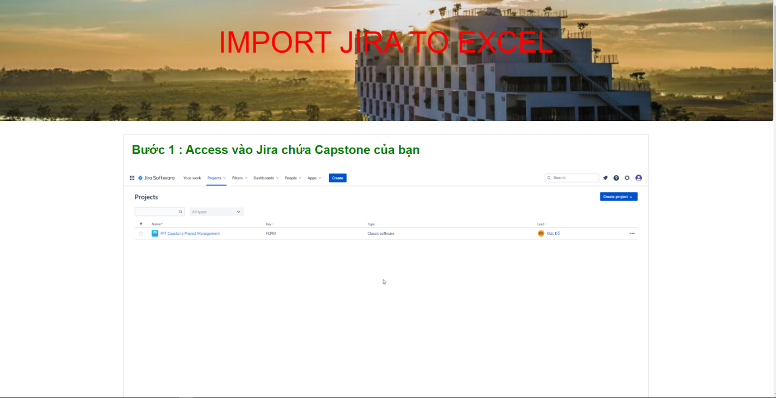

#### 4.5.1.8. Upload file

* **Screen Images**

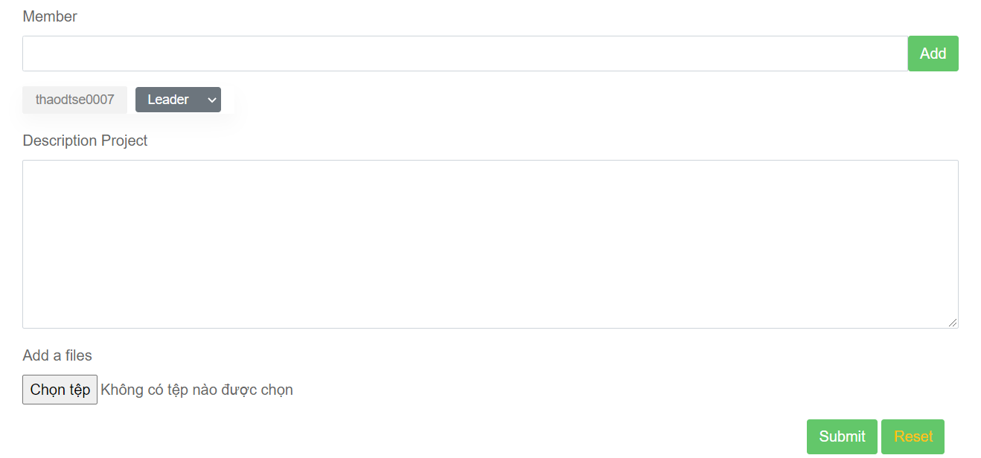

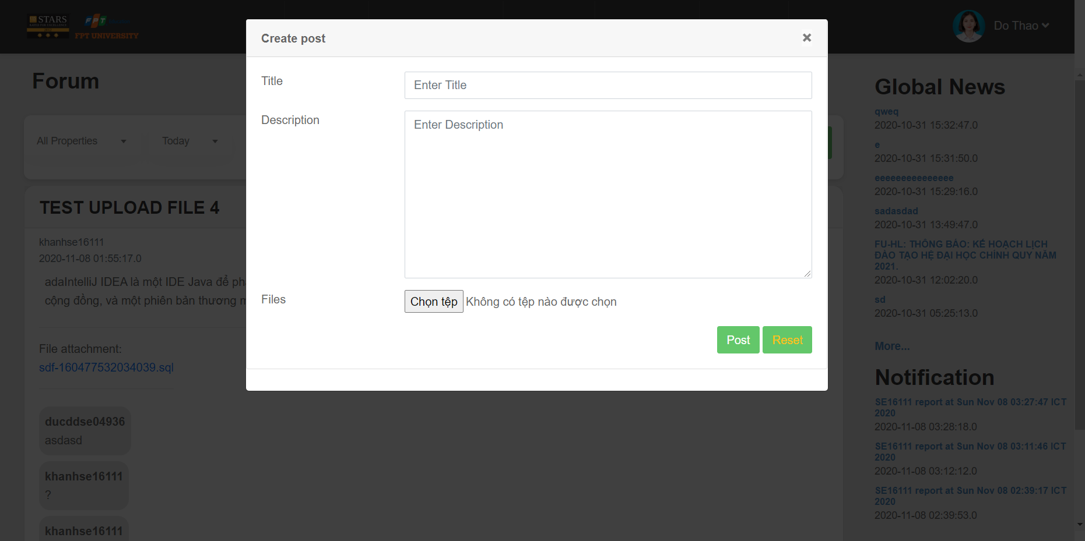

Button/ Hyperlinks

|  |  |  |  |  |
| --- | --- | --- | --- | --- |
| **No** | **Function** | **Description** | **Validation** | **Outcome** |
| 1  2  3 | Upload file  Post  Reset post | Click to choose  File  Click to post  Click to reset | No  No  No | Show file  Navigate to forum  Re-post |

Fields

|  |  |  |  |  |  |  |  |
| --- | --- | --- | --- | --- | --- | --- | --- |
| **No** | **Field**  **Name** | **Description** | **Read**  **Only** | **Mandatory** | **Control**  **Type** | **Data**  **Type** | **Length** |
| 7 | Title | Title post | No | Yes | Text | String | 120 |
| 8 | Description | Description  post | No | Yes | Text | String | 120 |

#### 4.5.1.9. Send mail

* **Screen Images**

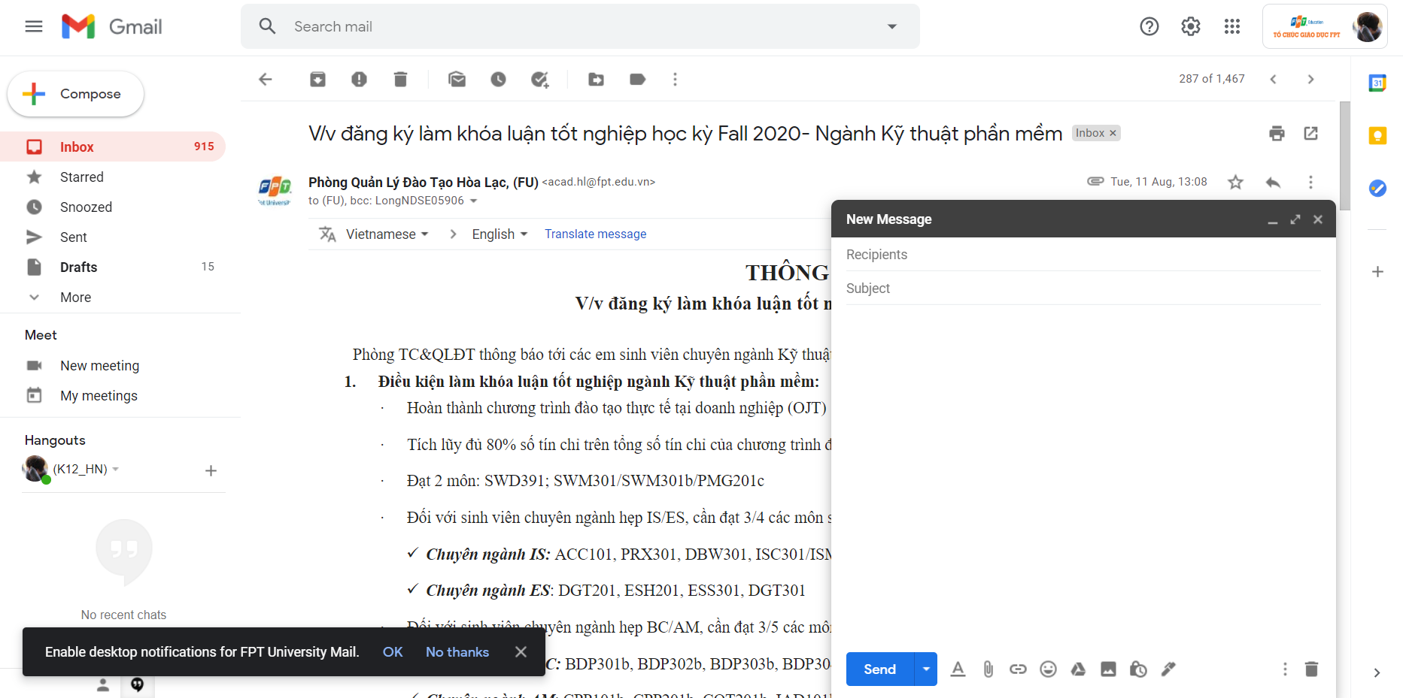

#### 4.5.1.10 Chat

* **Screen Images**

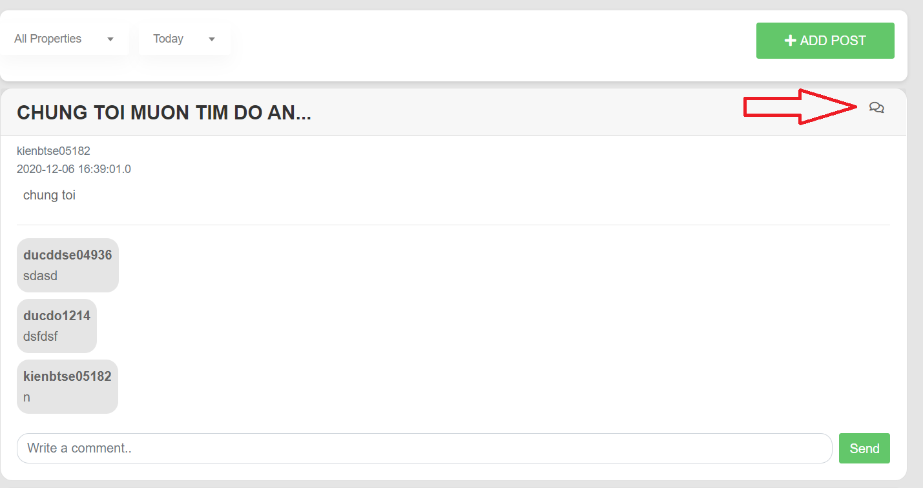

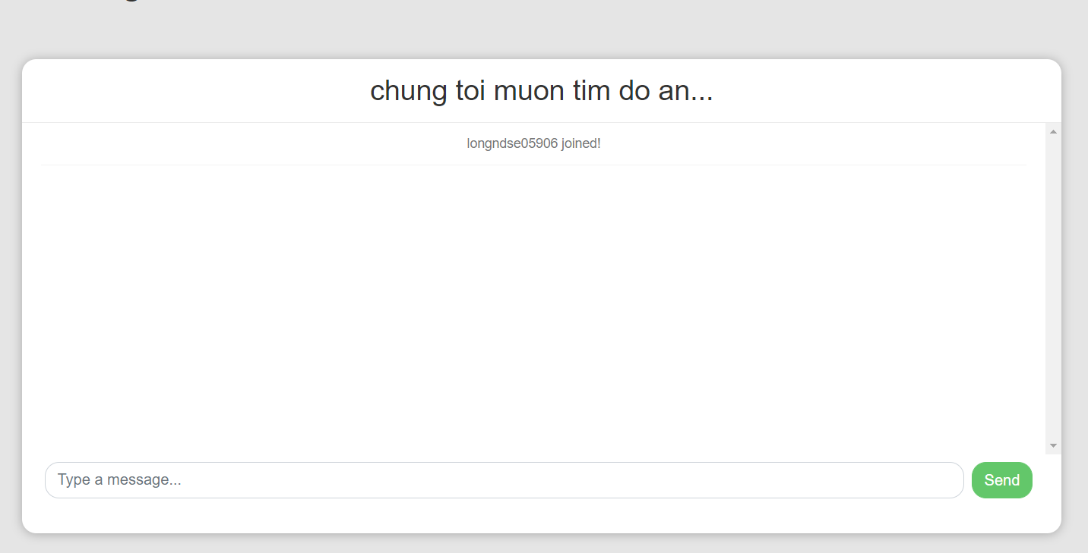

Button/ Hyperlinks

|  |  |  |  |  |
| --- | --- | --- | --- | --- |
| **No** | **Function** | **Description** | **Validation** | **Outcome** |
| 1  2 | View group chat to chat  Chat | Click to icon  Click to button  “Send” | No  No | Navigate to group chat  Display content chat |

Fields

|  |  |  |  |  |  |  |  |
| --- | --- | --- | --- | --- | --- | --- | --- |
| **No** | **Field**  **Name** | **Description** | **Read**  **Only** | **Mandatory** | **Control**  **Type** | **Data**  **Type** | **Length** |
| 3 | Content | Content chat | No | Yes | Text | String | 120 |

|  |  |  |  |  |  |  |  |
| --- | --- | --- | --- | --- | --- | --- | --- |
|  |  |  |  |  |  |  |  |
|  |  |  |  |  |  |  |  |

#### 4.5.1.11. Create chat

* **Screen Images**

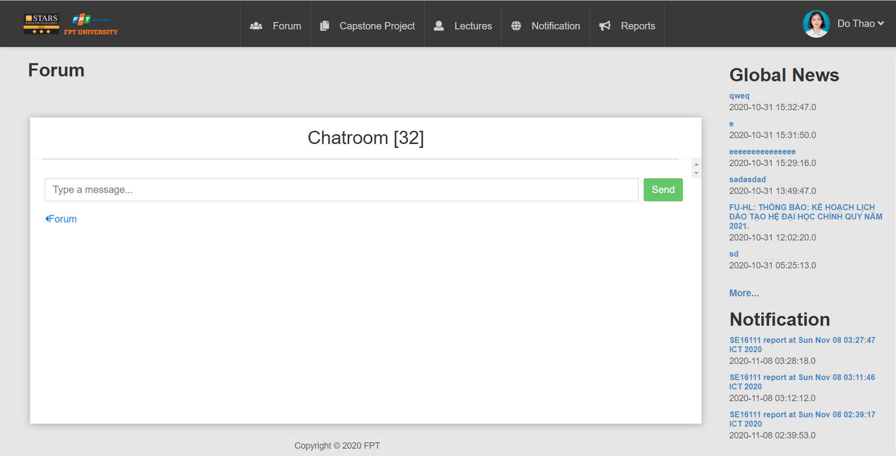

Button/ Hyperlinks

|  |  |  |  |  |
| --- | --- | --- | --- | --- |
| **No** | **Function** | **Description** | **Validation** | **Outcome** |
| 1 | Create  Group for  chatting | Click to send | No | Send message to  group |

#### 4.5.1.12. Confirm join team feature

* **Screen Images**

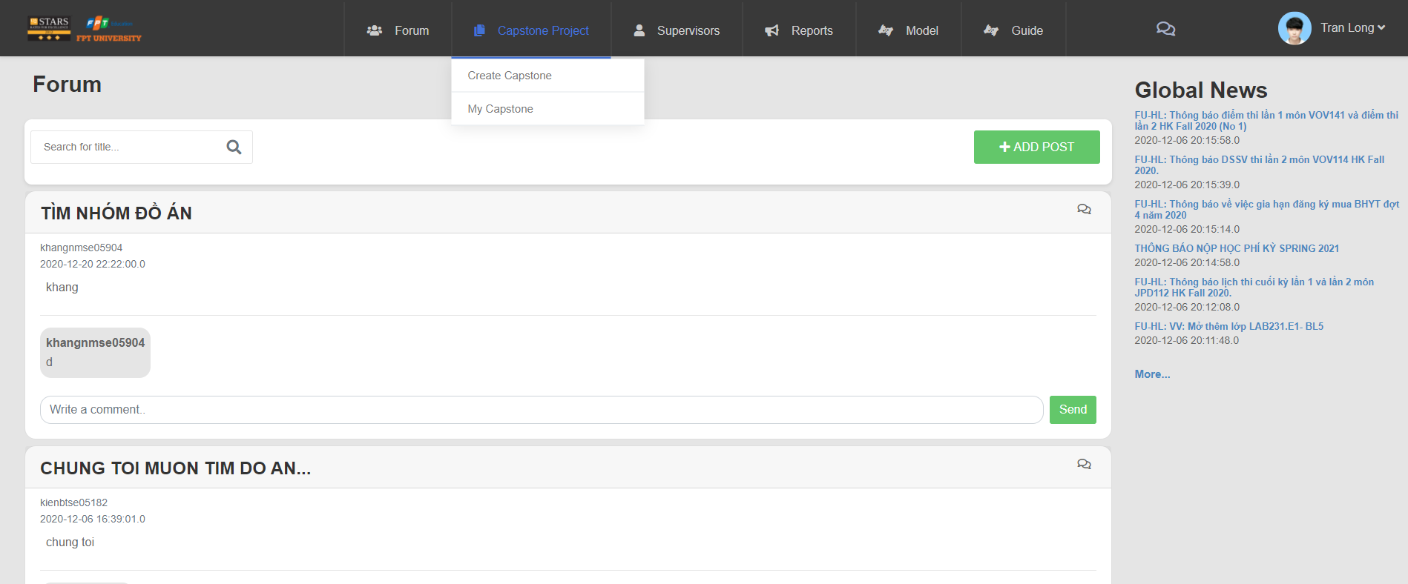

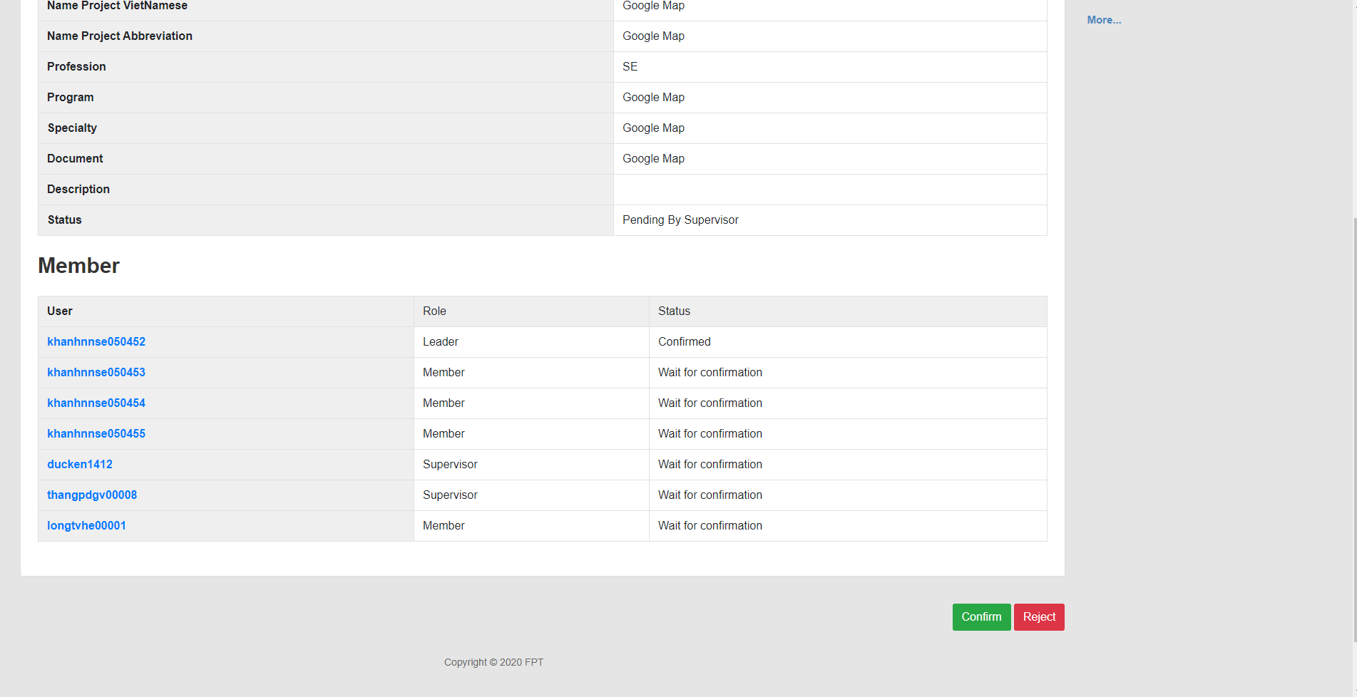

Button/ Hyperlinks

|  |  |  |  |  |
| --- | --- | --- | --- | --- |
| **No** | **Function** | **Description** | **Validation** | **Outcome** |
| 1  2 | Confirm join  Team feature  Reject | Click to button  “Confirm”  Click button  “Reject” | No  No | Display confirm  Dialog  Display confirm  Dialog |

#### 4.5.1.13 Edit profile

* **Screen Images:**

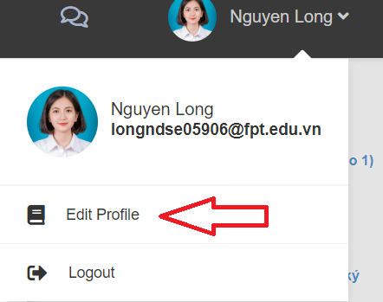

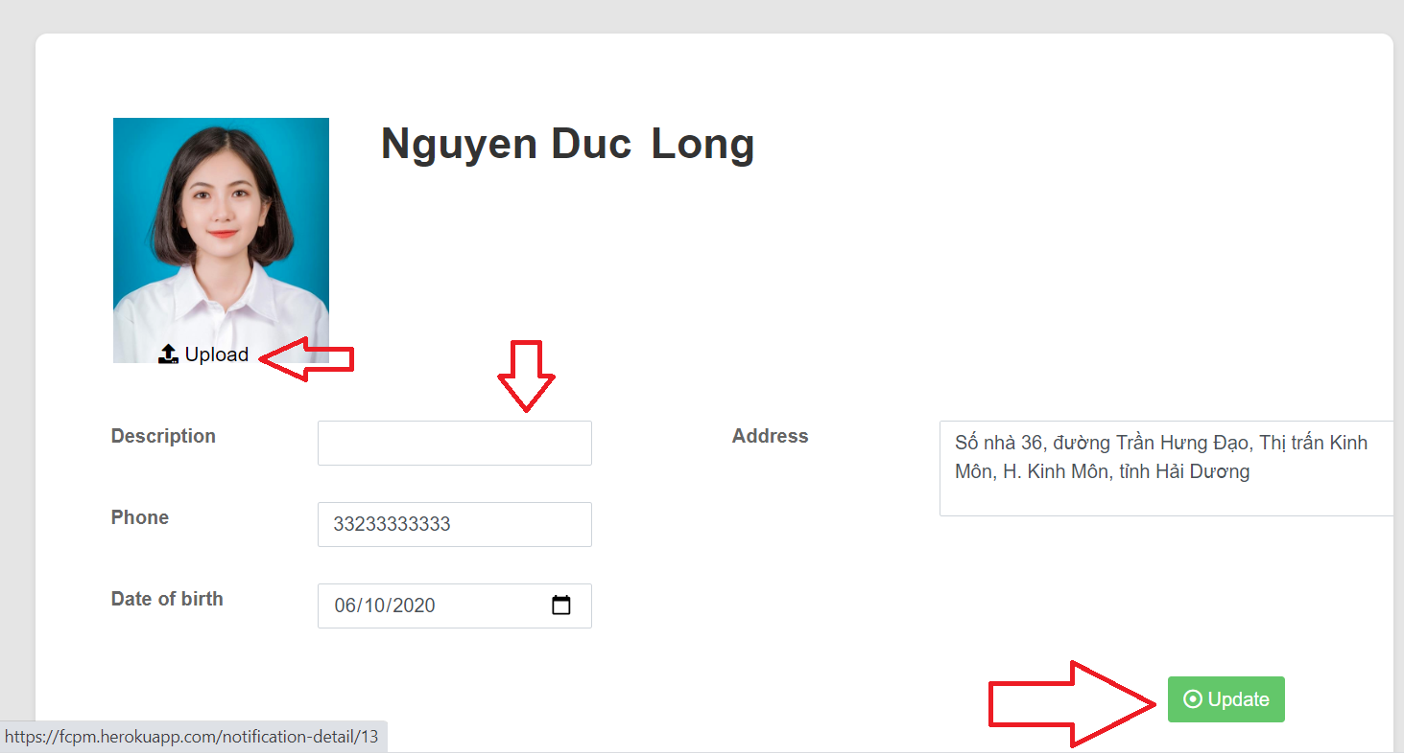

Button/ Hyperlinks

|  |  |  |  |  |
| --- | --- | --- | --- | --- |
| **No** | **Function** | **Description** | **Validation** | **Outcome** |
| 1  2  3 | Edit profile  Upload image  Update profile | Click to button  “Edit profile”  Click button  “Upload”  Click button  “Update” | No  No  No | Navigate to Profile  page  Display folder that you choose image  Display notification  Update successful |

Fields

|  |  |  |  |  |  |  |  |
| --- | --- | --- | --- | --- | --- | --- | --- |
| **No** | **Field**  **Name** | **Description** | **Read**  **Only** | **Mandatory** | **Control**  **Type** | **Data**  **Type** | **Length** |
| 4  5  6  7 | Description  Phone  Date of birth  Address | describe hobbies, forte  Phone  Date of birth  Address | No  No  No  No | Yes  Yes  Yes  Yes | Text  Text  Text  Text | String  String  Date  String | 120  120  120 |
|  |  |  |  |  |  |  |  |

#### 4.5.1.14. Notification component

* **Screen Images**

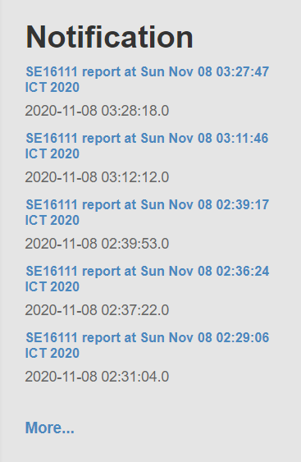

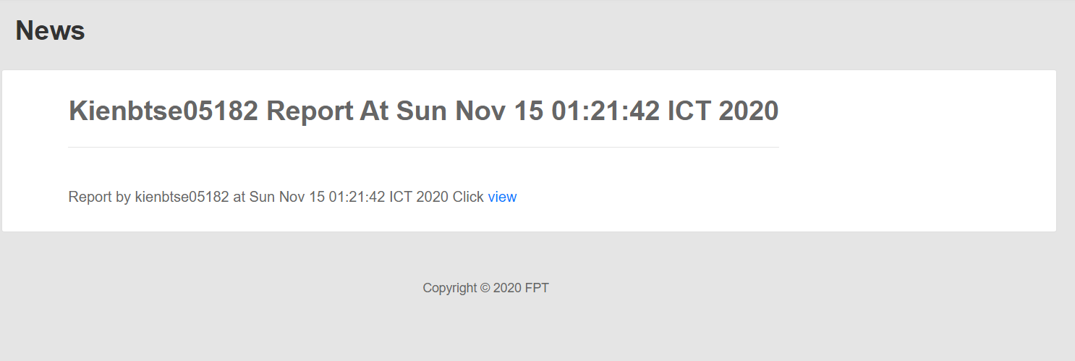

Button/ Hyperlinks

|  |  |  |  |  |
| --- | --- | --- | --- | --- |
| **No** | **Function** | **Description** | **Validation** | **Outcome** |
| 1  2  3 | View  Notification  View detail notification  View list  Notification | Click to name  Of notification  Click to “view”  Click to “more” | No  No  No | Navigate to Notification detail page  Navigate to detail information notification page  Navigate to list  Notification page |
|  |  |  |  |  |

#### 4.5.1.15. Comment

* **Screen Images**

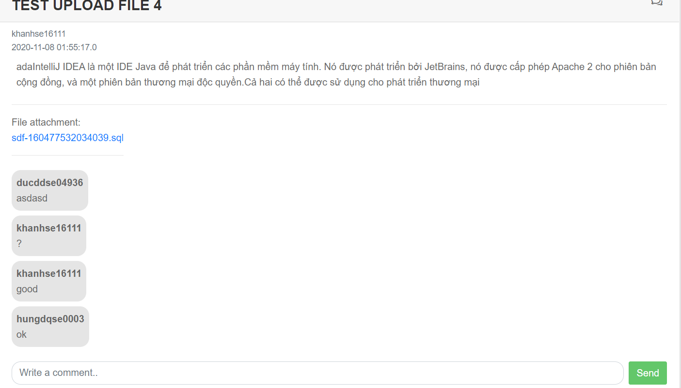

Button/ Hyperlinks

|  |  |  |  |  |
| --- | --- | --- | --- | --- |
| **No** | **Function** | **Description** | **Validation** | **Outcome** |
| 1 | Comment | Click to send | No | Send comment to  Post |

#### 4.5.1.16. Daily report to member to leader

* **Screen Images**

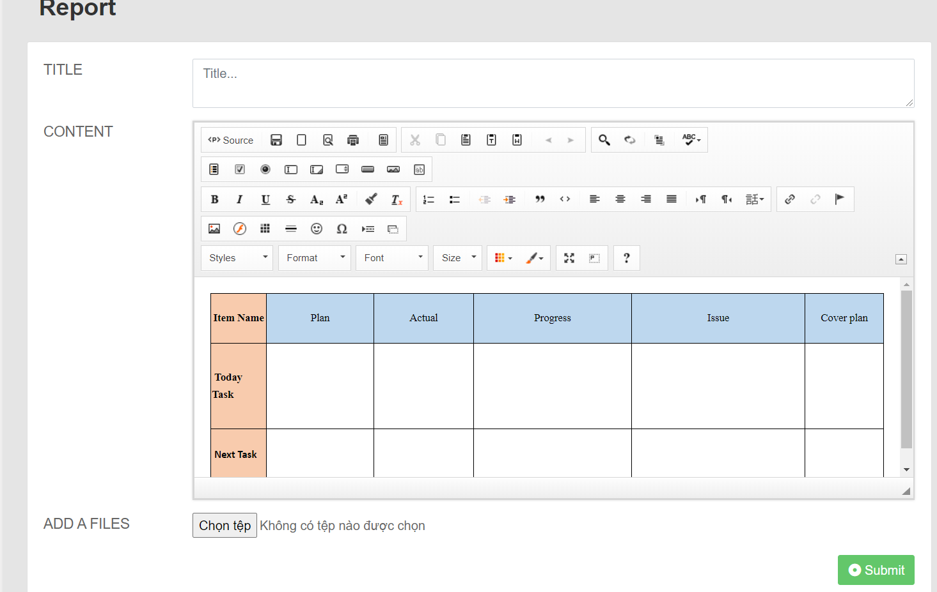

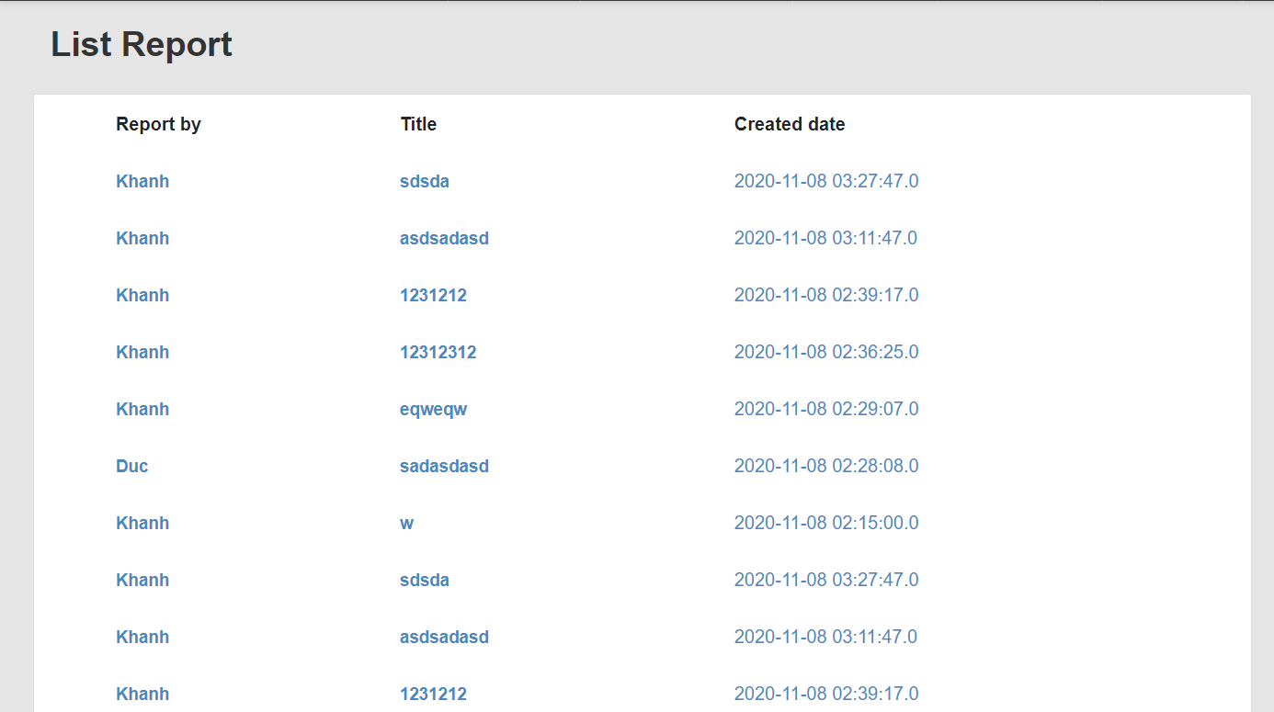

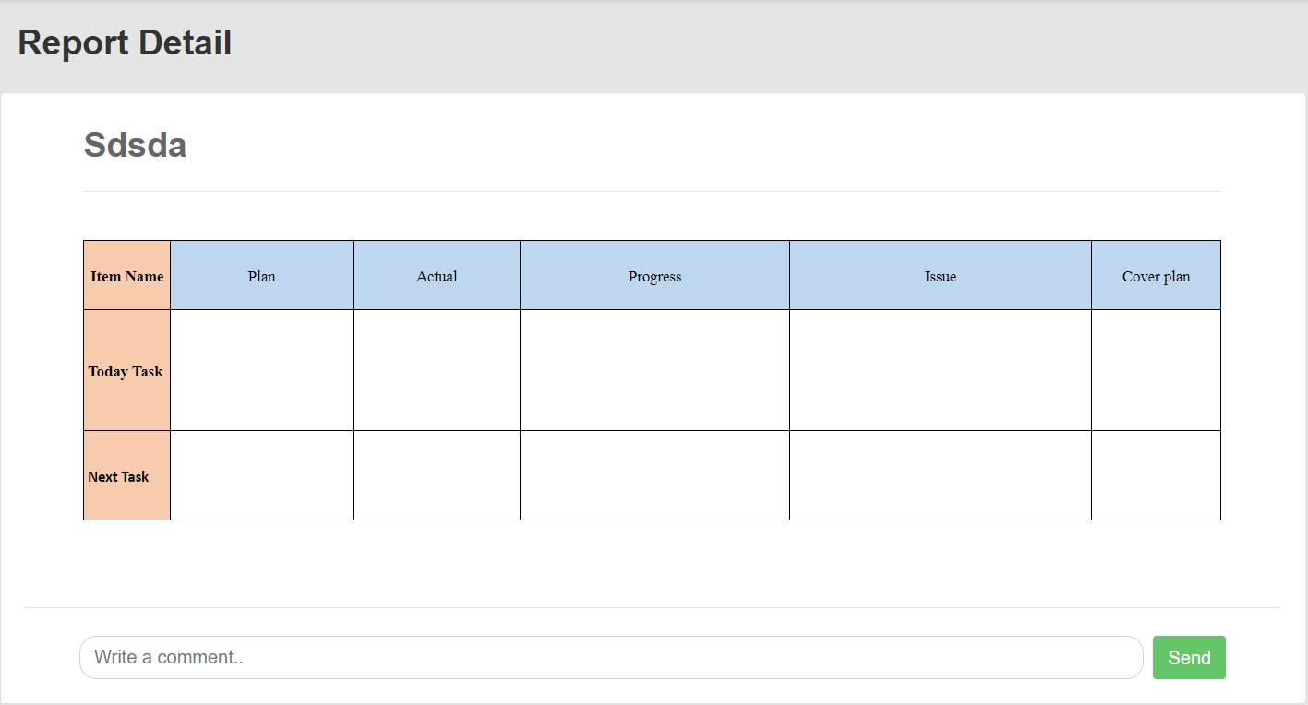

Button/ Hyperlinks

|  |  |  |  |  |
| --- | --- | --- | --- | --- |
| **No** | **Function** | **Description** | **Validation** | **Outcome** |
| 1  2 | Add file  Report | Click to choose  File  Click to submit | No  No | Show file  Navigate to List-report page |

Fields

|  |  |  |  |  |  |  |  |  |
| --- | --- | --- | --- | --- | --- | --- | --- | --- |
| **No** | **Field**  **Name** | **Description** | | **Read**  **Only** | **Mandatory** | **Control**  **Type** | **Data**  **Type** | **Length** |
| 1  2 | Title  Content | | Title  report  Content report | No  No | Yes  Yes | Text  Text | String  String | N/A  N/A |

#### 4.5.1.17. Weekly report to leader to supervisor

* **Screen Images**







Button/ Hyperlinks

|  |  |  |  |  |
| --- | --- | --- | --- | --- |
| **No** | **Function** | **Description** | **Validation** | **Outcome** |
| 1  2 | Add file  Report | Click to choose  File  Click to submit | No  No | Show file  Navigate to List-report page |

Fields

|  |  |  |  |  |  |  |  |  |
| --- | --- | --- | --- | --- | --- | --- | --- | --- |
| **No** | **Field**  **Name** | **Description** | | **Read**  **Only** | **Mandatory** | **Control**  **Type** | **Data**  **Type** | **Length** |
| 1  2 | Title  Content | | Title  report  Content report | No  No | Yes  Yes | Text  Text | String  String | N/A  N/A |

#### 4.5.1.18 Manage user

* **Screen Images**

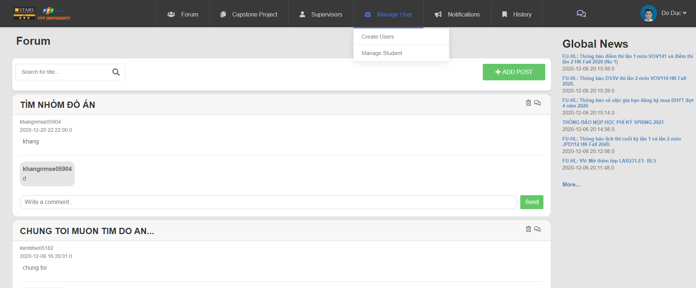

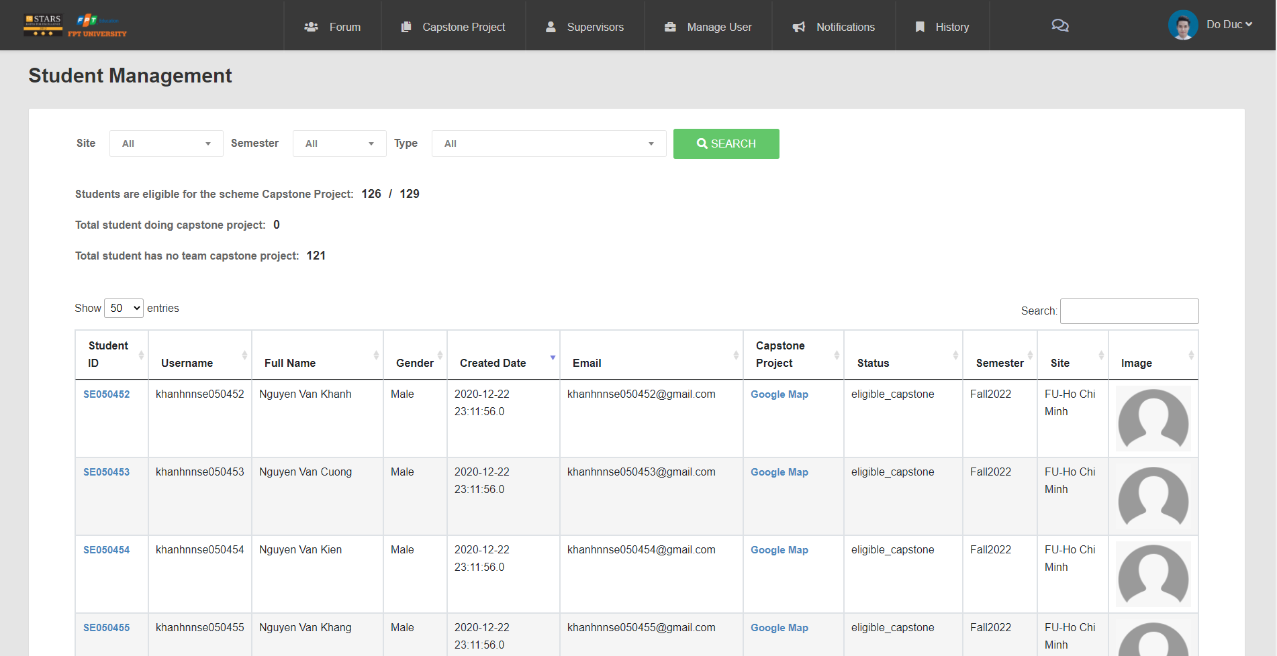

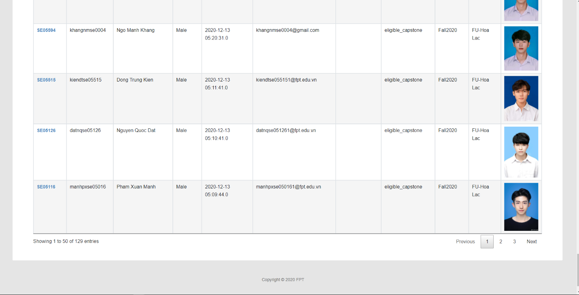

Button/ Hyperlinks

|  |  |  |  |  |
| --- | --- | --- | --- | --- |
| **No** | **Function** | **Description** | **Validation** | **Outcome** |
| 1 | Search capstone project | Click “Search”  button | No | Show list capstone project |

Fields

|  |  |  |  |  |  |  |  |  |
| --- | --- | --- | --- | --- | --- | --- | --- | --- |
| **No** | **Field**  **Name** | **Description** | | **Read**  **Only** | **Mandatory** | **Control**  **Type** | **Data**  **Type** | **Length** |
| 1 | ID | | ID | No | Yes | Text | Integer | N/A |
| 2 | Username | | Username | No | Yes | Text | String | N/A |
| 3 | Full Name | | Full Name | No | Yes | Text | String | N/A |
| 4 | Gender | | Gender | No | Yes | Text | String | N/A |
| 5 | Created date | | Created date | No | Yes | Text | Date | N/A |
| 6 | Email | | Email | No | Yes | Text | String | N/A |
| 7 | Capstone  Project | | Capstone  Project | No | Yes | Text | String | N/A |
| 8 | Status | | Status | No | Yes | Text | String | N/A |
| 9  10 | Semester  Site | | Semester  Site | No  No | Yes  Yes | Text  Text | Integer  String | N/A  N/A |

#### 4.5.1.19. View information, status of list student

* **Screen Images**

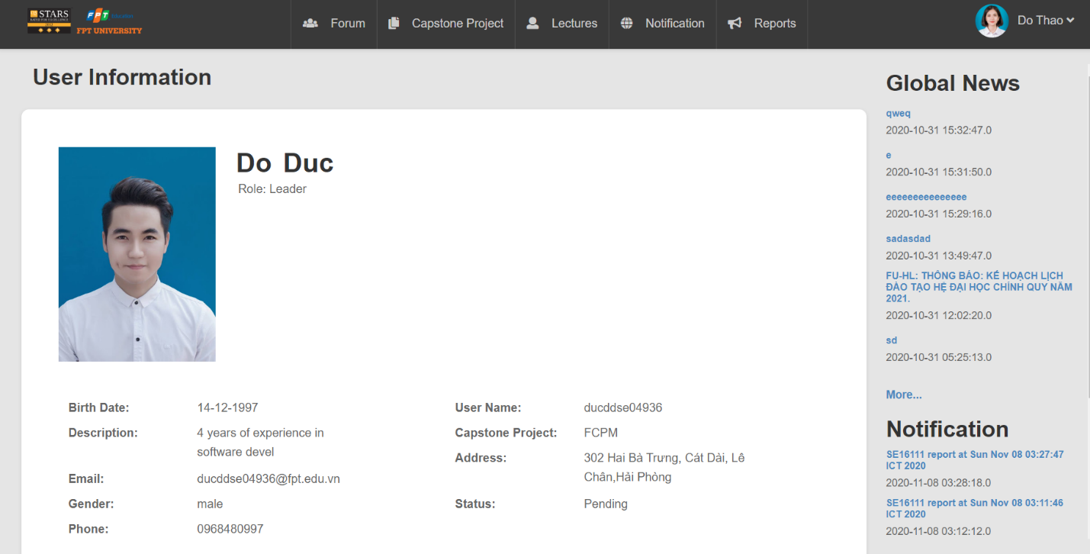

Fields

|  |  |  |  |  |  |  |  |  |
| --- | --- | --- | --- | --- | --- | --- | --- | --- |
| **No** | **Field**  **Name** | **Description** | | **Read**  **Only** | **Mandatory** | **Control**  **Type** | **Data**  **Type** | **Length** |
| 1 | User Name | | User Name | No | Yes | Text | String | N/A |
| 2 | Capstone  Project | | Capstone  Project | No | Yes | Text | String | N/A |
| 3 | Address | | Address | No | Yes | Text | String | N/A |
| 4 | Status | | Status | No | Yes | Text | String | N/A |
| 5 | Birth date | | Birth date | No | Yes | Text | Date | N/A |
| 6 | Description | | Description | No | Yes | Text | String | N/A |
| 7 | Email | | Email | No | Yes | Text | String | N/A |
| 8 | Gender | | Gender | No | Yes | Text | String | N/A |
| 9 | Phone | | Phone | No | Yes | Text | INT | N/A |

#### 4.5.1.20. View and edit the list of registered project

* **Screen Images**

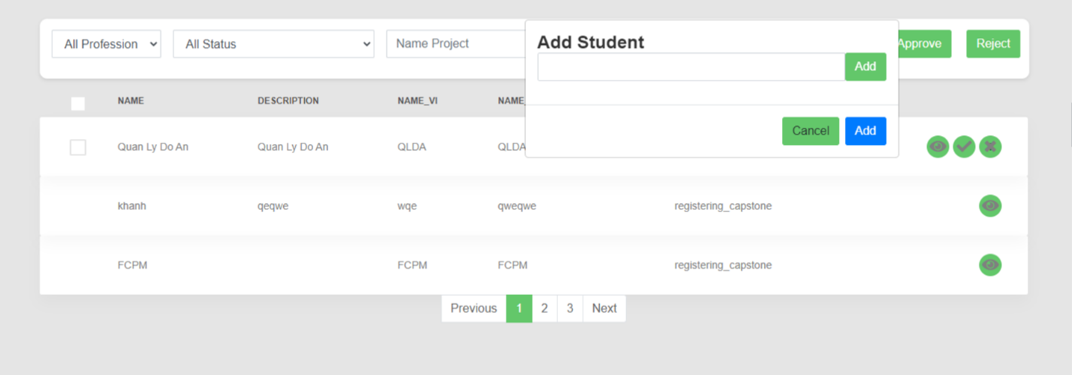

Button/ Hyperlinks

|  |  |  |  |  |
| --- | --- | --- | --- | --- |
| **No** | **Function** | **Description** | **Validation** | **Outcome** |
| 1  2  3  4  5  6  7  8  9 | Choose all profession  Choose all profession  Search name  project  Approve  Project  Reject project  See next page  Edit project  Add Student  Cancel Student | Click to all profession  Click to all status  Click to search  Click to approve  Click to reject  Click to next  Click to “v”  Click to add  Click to cancel | No  No  No  No  No  No  No  No  No | Show professions  Show statuses  Show name project  Approve project  Reject project  Show next page  Edit project  Add student  Cancel student |

Fields

|  |  |  |  |  |  |  |  |  |
| --- | --- | --- | --- | --- | --- | --- | --- | --- |
| **No** | **Field**  **Name** | **Description** | | **Read**  **Only** | **Mandatory** | **Control**  **Type** | **Data**  **Type** | **Length** |
| 1  2  3  4  5 | Name  Description  Name-vi  Name-Abbreviation  Status | | Name project  Description project  Name Vietnam project  Name Abbreviation  Status | No  No  No  No  No | Yes  Yes  Yes  Yes  Yes | Text  Text  Text  Text  Text | String  String  String  String  String | N/A  N/A  N/A  N/A  N/A |

#### 4.5.1.21. View list capstone project

* **Screen Images**

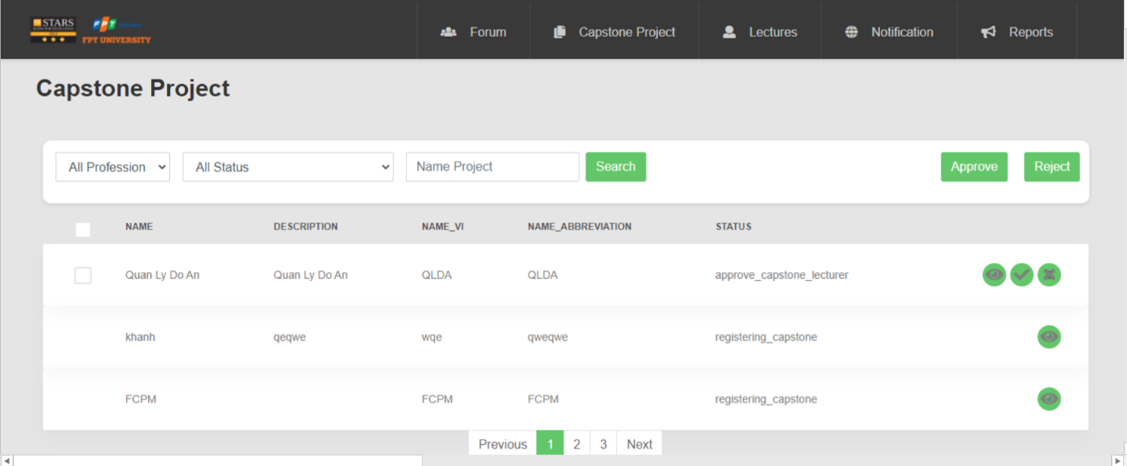

Button/ Hyperlinks

|  |  |  |  |  |
| --- | --- | --- | --- | --- |
| **No** | **Function** | **Description** | **Validation** | **Outcome** |
| 1  2  3  4  5  6 | Choose all profession  Choose all profession  Search name  project  Approve  Project  Reject project  See next page | Click to all profession  Click to all status  Click to search  Click to approve  Click to reject  Click to next | No  No  No  No  No  No | Show professions  Show statuses  Show name project  Approve project  Reject project  Show next page |

Fields

|  |  |  |  |  |  |  |  |  |
| --- | --- | --- | --- | --- | --- | --- | --- | --- |
| **No** | **Field**  **Name** | **Description** | | **Read**  **Only** | **Mandatory** | **Control**  **Type** | **Data**  **Type** | **Length** |
| 1  2  3  4  5 | Name  Description  Name-vi  Name-Abbreviation  Status | | Name project  Description project  Name Vietnam project  Name Abbreviation  Status | No  No  No  No  No | Yes  Yes  Yes  Yes  Yes | Text  Text  Text  Text  Text | String  String  String  String  String | N/A  N/A  N/A  N/A  N/A |

#### 4.5.1.22. View detail project

* **Screen Images**

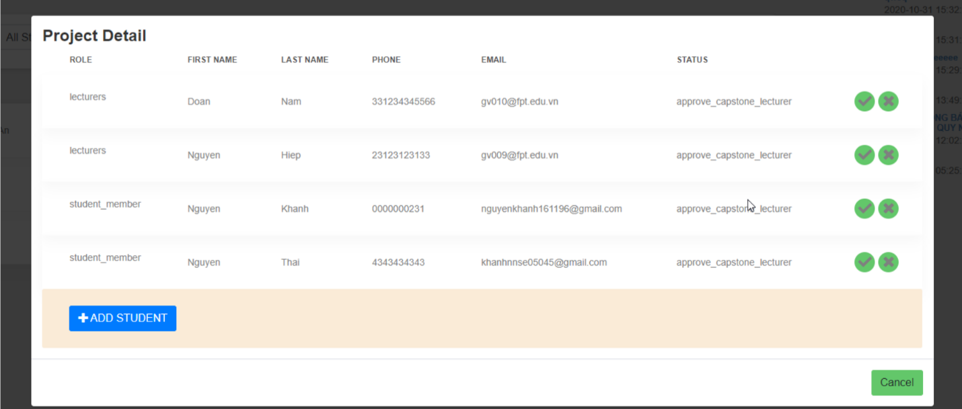

Button/ Hyperlinks

|  |  |  |  |  |
| --- | --- | --- | --- | --- |
| **No** | **Function** | **Description** | **Validation** | **Outcome** |
| 1  2  3 | Add student  Cancel  Delete project | Click to add student  Click to cancel  Click to “x” | No  No  No | Show information of add student  Cancel  Delete project |

Fields

|  |  |  |  |  |  |  |  |  |
| --- | --- | --- | --- | --- | --- | --- | --- | --- |
| **No** | **Field**  **Name** | **Description** | | **Read**  **Only** | **Mandatory** | **Control**  **Type** | **Data**  **Type** | **Length** |
| 1  2  3  4  5  6 | Role  First Name  Last Name  Phone  Email  Status | | Role  First Name  Last Name  Phone  Email  Status | No  No  No  No  No  No | Yes  Yes  Yes  Yes  Yes  Yes | Text  Text  Text  Text  Text  Text | String  String  String  INT  String  String | N/A  N/A  N/A  N/A  N/A  N/A |

#### 4.5.1.23 Manage Capstone Project

* **Screen Images**

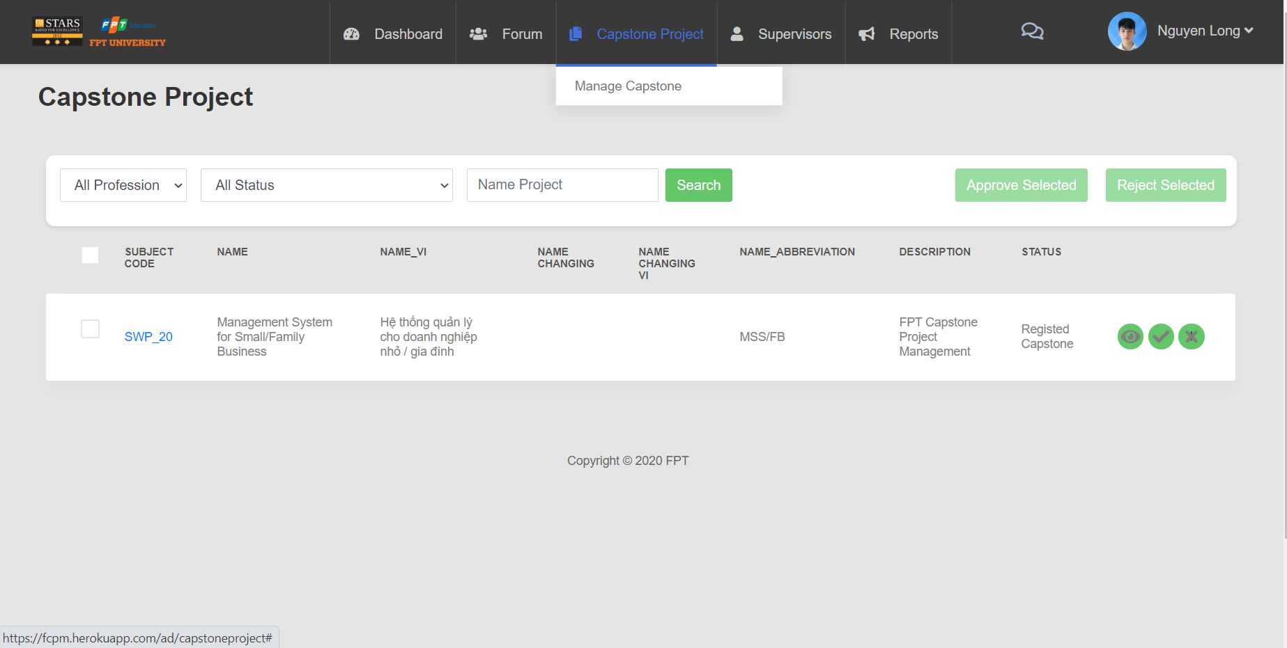

Button/ Hyperlinks

|  |  |  |  |  |
| --- | --- | --- | --- | --- |
| **No** | **Function** | **Description** | **Validation** | **Outcome** |
| 1  2  3  4  5  6 | View detail  project  Accept project  Reject project  Search project  Choose  Profession  Choose Status | Click to icon  Click to icon V  or button  “Approve Selected”  Click to icon X  or button  “Reject Selected”  Click to button  “Search”  Click to dropdown  “Profession”  Click to dropdown  “Status” | No  No  No  No  No  No | Display detail project  Display notification “Do you want approve project”  Display notification “Do you want reject project”  Display project  Display list profession  Display list status |

Fields

|  |  |  |  |  |  |  |  |  |
| --- | --- | --- | --- | --- | --- | --- | --- | --- |
| **No** | **Field**  **Name** | **Description** | | **Read**  **Only** | **Mandatory** | **Control**  **Type** | **Data**  **Type** | **Length** |
| 1  2  3  4  5  6  7  8  9 | Name project  Subject Code  Name  Name-Vi  Name changing  Name changing vi  Name abbreviation  Description  Status | | Name project  Subject Code  Name  Name Vietnamese  Name changing  Name changing Vietnamese  Name abbreviation  Description  Status | No  No  No  No  No  No  No  No  No | Yes  Yes  Yes  Yes  Yes  Yes  Yes  Yes  Yes | Text  Text  Text  Text  Text  Text  Text  Text  Text | String  String  String  String  String  String  String  String  String | N/A  N/A  N/A  N/A  N/A  N/A  N/A  N/A  N/A |
|  |  | |  |  |  |  |  |  |

#### 4.5.1.24 View task detail of Capstone Project

* **Screen Images**

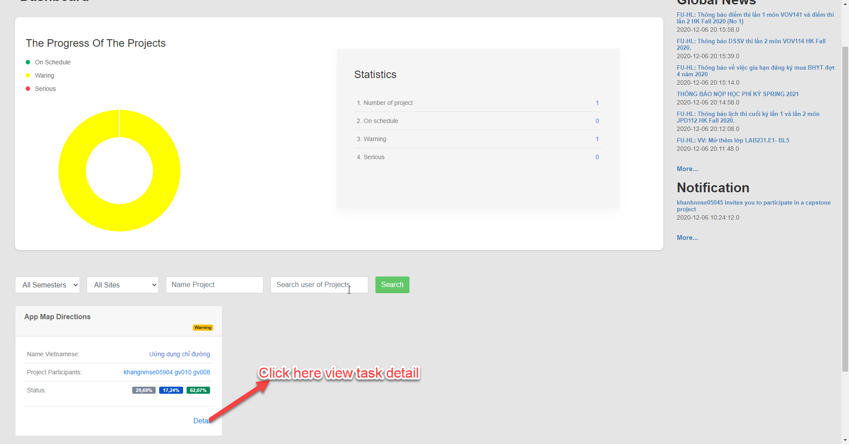

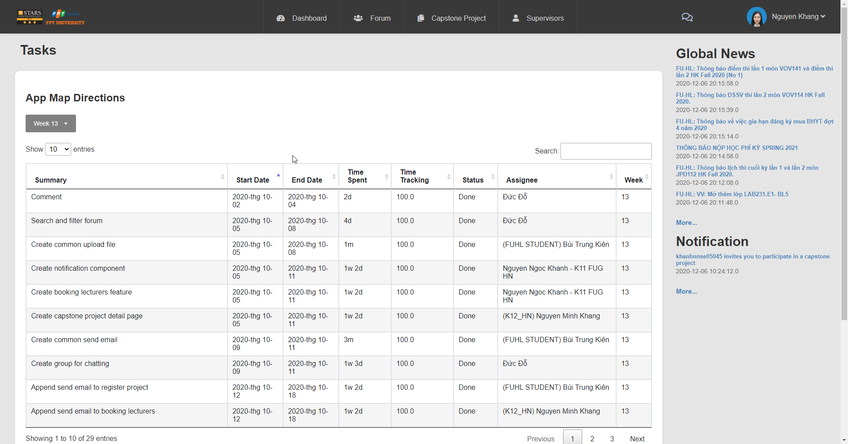

Fields

|  |  |  |  |  |  |  |  |  |  |
| --- | --- | --- | --- | --- | --- | --- | --- | --- | --- |
| **No** | **Field**  **Name** | **Description** | | **Read**  **Only** | **Mandatory** | **Control**  **Type** | **Data**  **Type** | | **Length** |
| 1  2  3  4  5  6  7 | Summary  Start Date  End Date  Time Spent  Status  Assignee  Week | | Summary  Start Date  End Date  Time Spent  Status  Assignee  Week | No  No  No  No  No  No  No | Yes  Yes  Yes  Yes  Yes  Yes  Yes | Text  Text  Text  Text  Text  Text  Text | String  Date  Date  String  String  String  Integer | N/A  N/A  N/A  N/A  N/A  N/A  N/A | |

#### 4.5.1.25. Dashboard statistical of project

* **Screen Images**

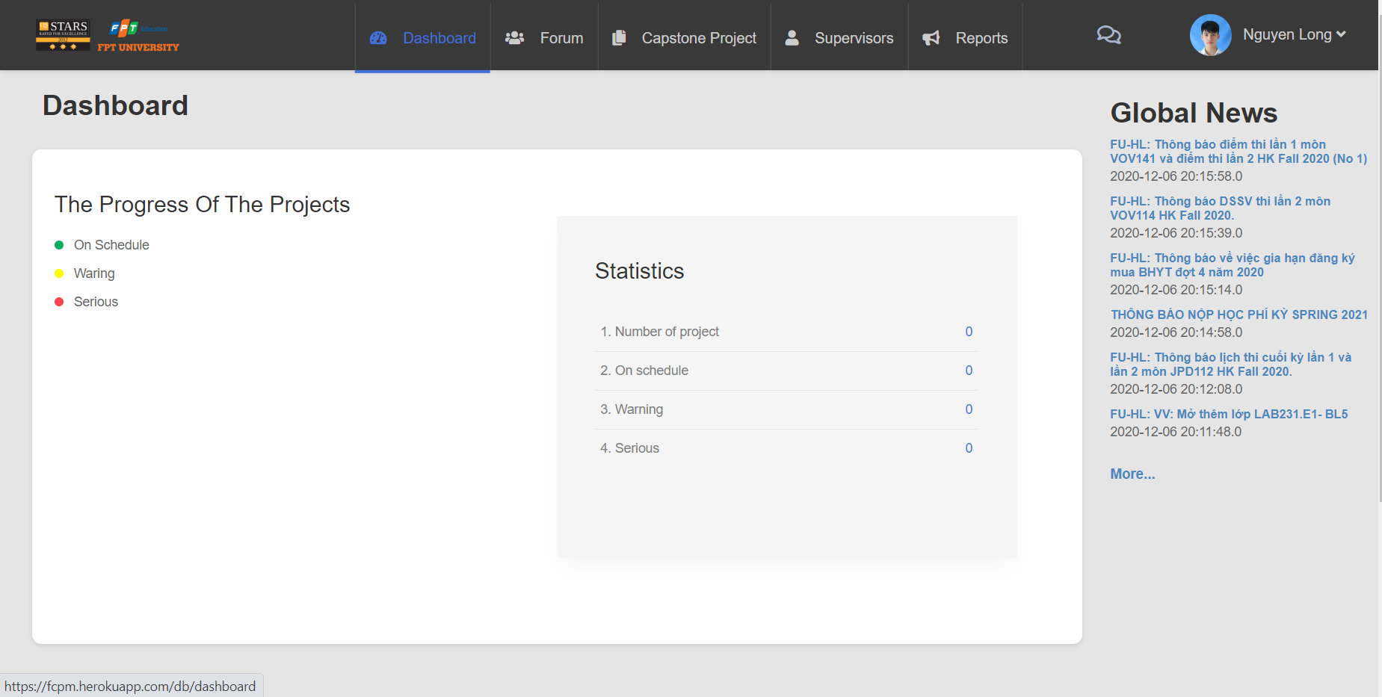

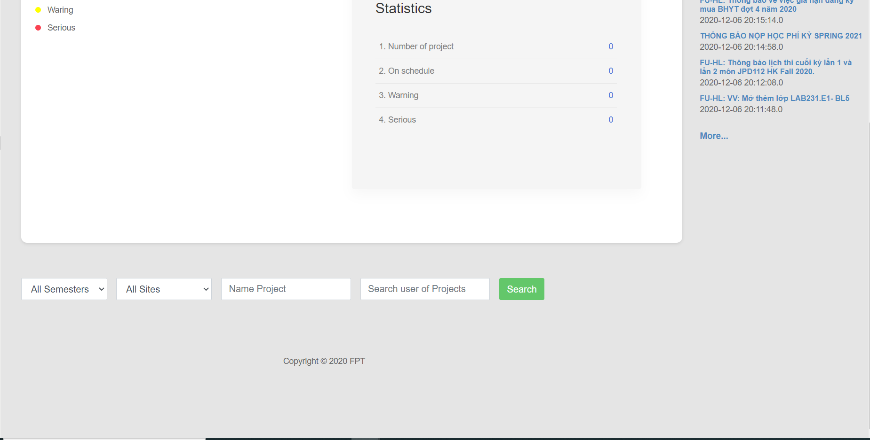

Button/ Hyperlinks

|  |  |  |  |  |
| --- | --- | --- | --- | --- |
| **No** | **Function** | **Description** | **Validation** | **Outcome** |
| 1  2  3 | Search user of project  Choose semester  Choose site | Click to button  “Search”  Click to dropdown  “Semesters”  Click to dropdown  “Sites” | No  No  No | Display dashboard  Display list semester  Display list sites |

Fields

|  |  |  |  |  |  |  |  |  |
| --- | --- | --- | --- | --- | --- | --- | --- | --- |
| **No** | **Field**  **Name** | **Description** | | **Read**  **Only** | **Mandatory** | **Control**  **Type** | **Data**  **Type** | **Length** |
| 1  2 | Name project  Search user of project | | Name project  Search user of project | No  No | Yes  Yes | Text  Text | String  String | N/A  N/A |

#### 4.5.1.26. View information of user

* **Screen Images**

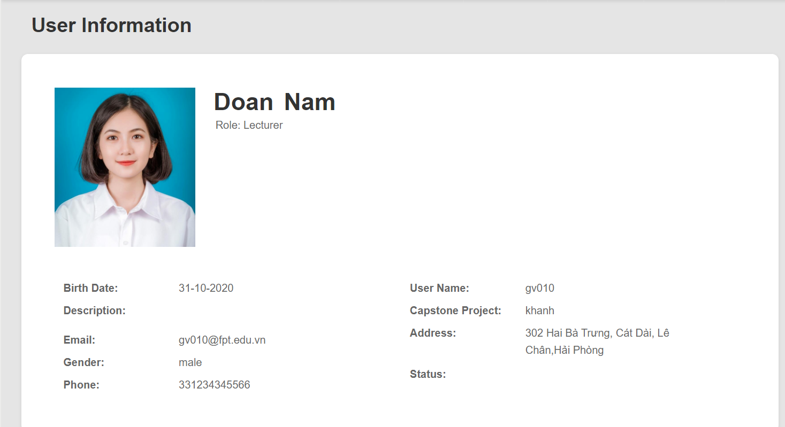

Fields

|  |  |  |  |  |  |  |  |  |
| --- | --- | --- | --- | --- | --- | --- | --- | --- |
| **No** | **Field**  **Name** | **Description** | | **Read**  **Only** | **Mandatory** | **Control**  **Type** | **Data**  **Type** | **Length** |
| 1 | User Name | | User Name | No | Yes | Text | String | N/A |
| 2 | Capstone  Project | | Capstone  Project | No | Yes | Text | String | N/A |
| 3 | Address | | Address | No | Yes | Text | String | N/A |
| 4 | Status | | Status | No | Yes | Text | String | N/A |
| 5 | Birth date | | Birth date | No | Yes | Text | Date | N/A |
| 6 | Description | | Description | No | Yes | Text | String | N/A |
| 7 | Email | | Email | No | Yes | Text | String | N/A |
| 8 | Gender | | Gender | No | Yes | Text | String | N/A |
| 9 | Phone | | Phone | No | Yes | Text | INT | N/A |

#### 4.5.1.27. Approve capstone project in the project registration stage

* **Screen Images**



Button/ Hyperlinks

|  |  |  |  |  |
| --- | --- | --- | --- | --- |
| **No** | **Function** | **Description** | **Validation** | **Outcome** |
| 1  2  3  4  5  6 | Choose all profession  Choose all profession  Search name  project  Approve  Project  Reject project  See next page | Click to all profession  Click to all status  Click to search  Click to approve  Click to reject  Click to next | No  No  No  No  No  No | Show professions  Show statuses  Show name project  Approve project  Reject project  Show next page |

Fields

|  |  |  |  |  |  |  |  |  |
| --- | --- | --- | --- | --- | --- | --- | --- | --- |
| **No** | **Field**  **Name** | **Description** | | **Read**  **Only** | **Mandatory** | **Control**  **Type** | **Data**  **Type** | **Length** |
| 1  2  3  4  5 | Name  Description  Name-vi  Name-Abbreviation  Status | | Name project  Description project  Name Vietnam project  Name Abbreviation  Status | No  No  No  No  No | Yes  Yes  Yes  Yes  Yes | Text  Text  Text  Text  Text | String  String  String  String  String | N/A  N/A  N/A  N/A  N/A |

#### 4.5.1.28 Change pass / fail results

* **Screen Images**

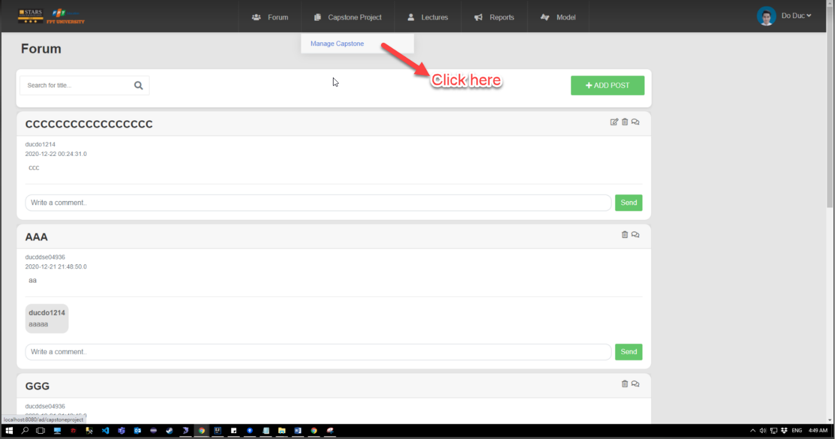

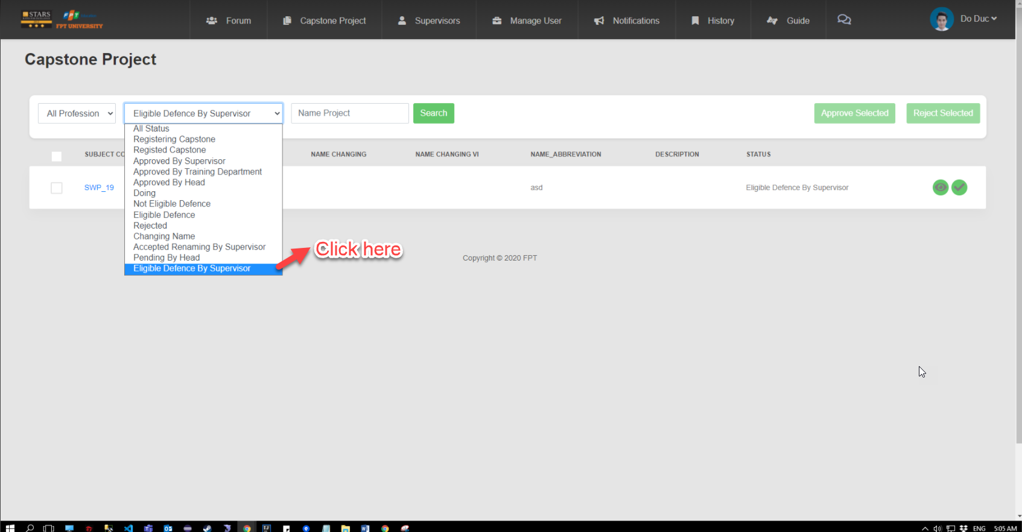

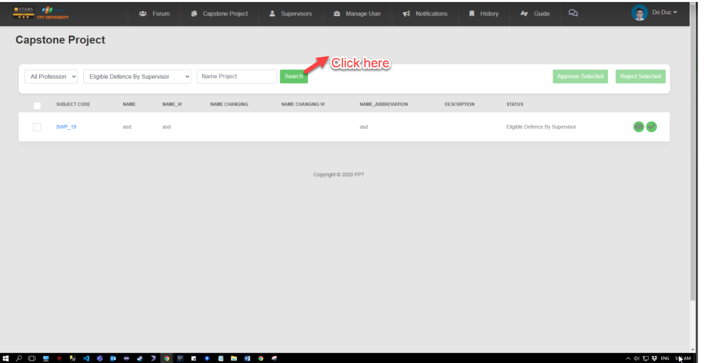

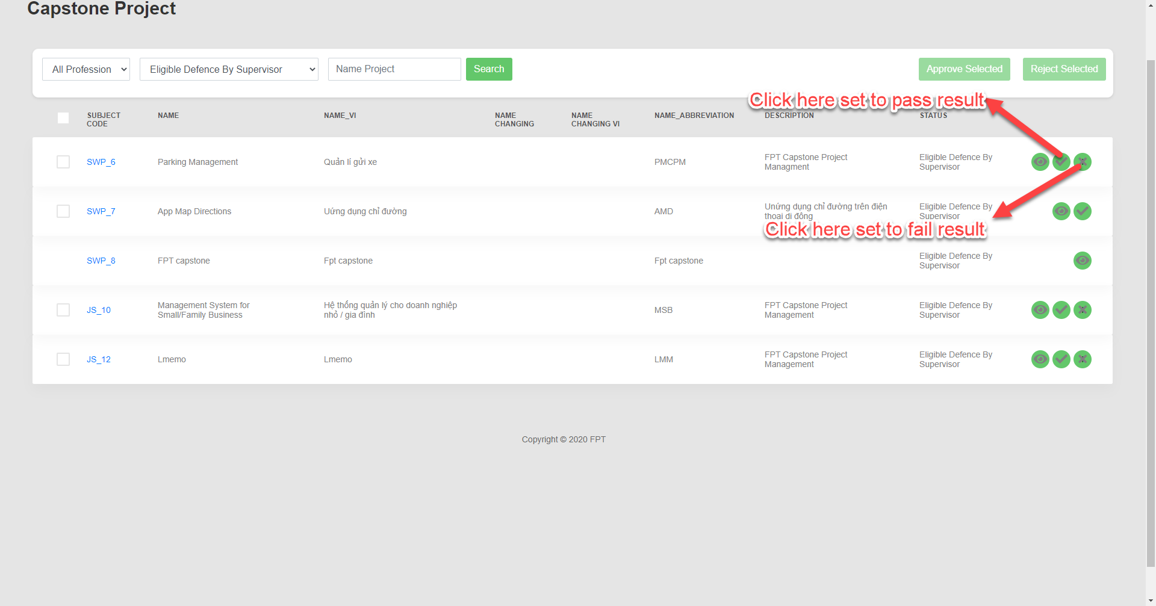

Button/ Hyperlinks

|  |  |  |  |  |
| --- | --- | --- | --- | --- |
| **No** | **Function** | **Description** | **Validation** | **Outcome** |
| 1  2  3  4  5  6 | Choose all profession  Choose all profession  Search name  project  Approve  Project  Reject project  See next page | Click to all profession  Click to all status  Click to search  Click to approve  Click to reject  Click to next | No  No  No  No  No  No | Show professions  Show statuses  Show name project  Approve project  Reject project  Show next page |

Fields

|  |  |  |  |  |  |  |  |  |
| --- | --- | --- | --- | --- | --- | --- | --- | --- |
| **No** | **Field**  **Name** | **Description** | | **Read**  **Only** | **Mandatory** | **Control**  **Type** | **Data**  **Type** | **Length** |
| 1  2  3  4  5 | Name  Description  Name-vi  Name-Abbreviation  Status | | Name project  Description project  Name Vietnam project  Name Abbreviation  Status | No  No  No  No  No | Yes  Yes  Yes  Yes  Yes | Text  Text  Text  Text  Text | String  String  String  String  String | N/A  N/A  N/A  N/A  N/A |

#### 4.5.1.29 Create notification

* **Screen Images**

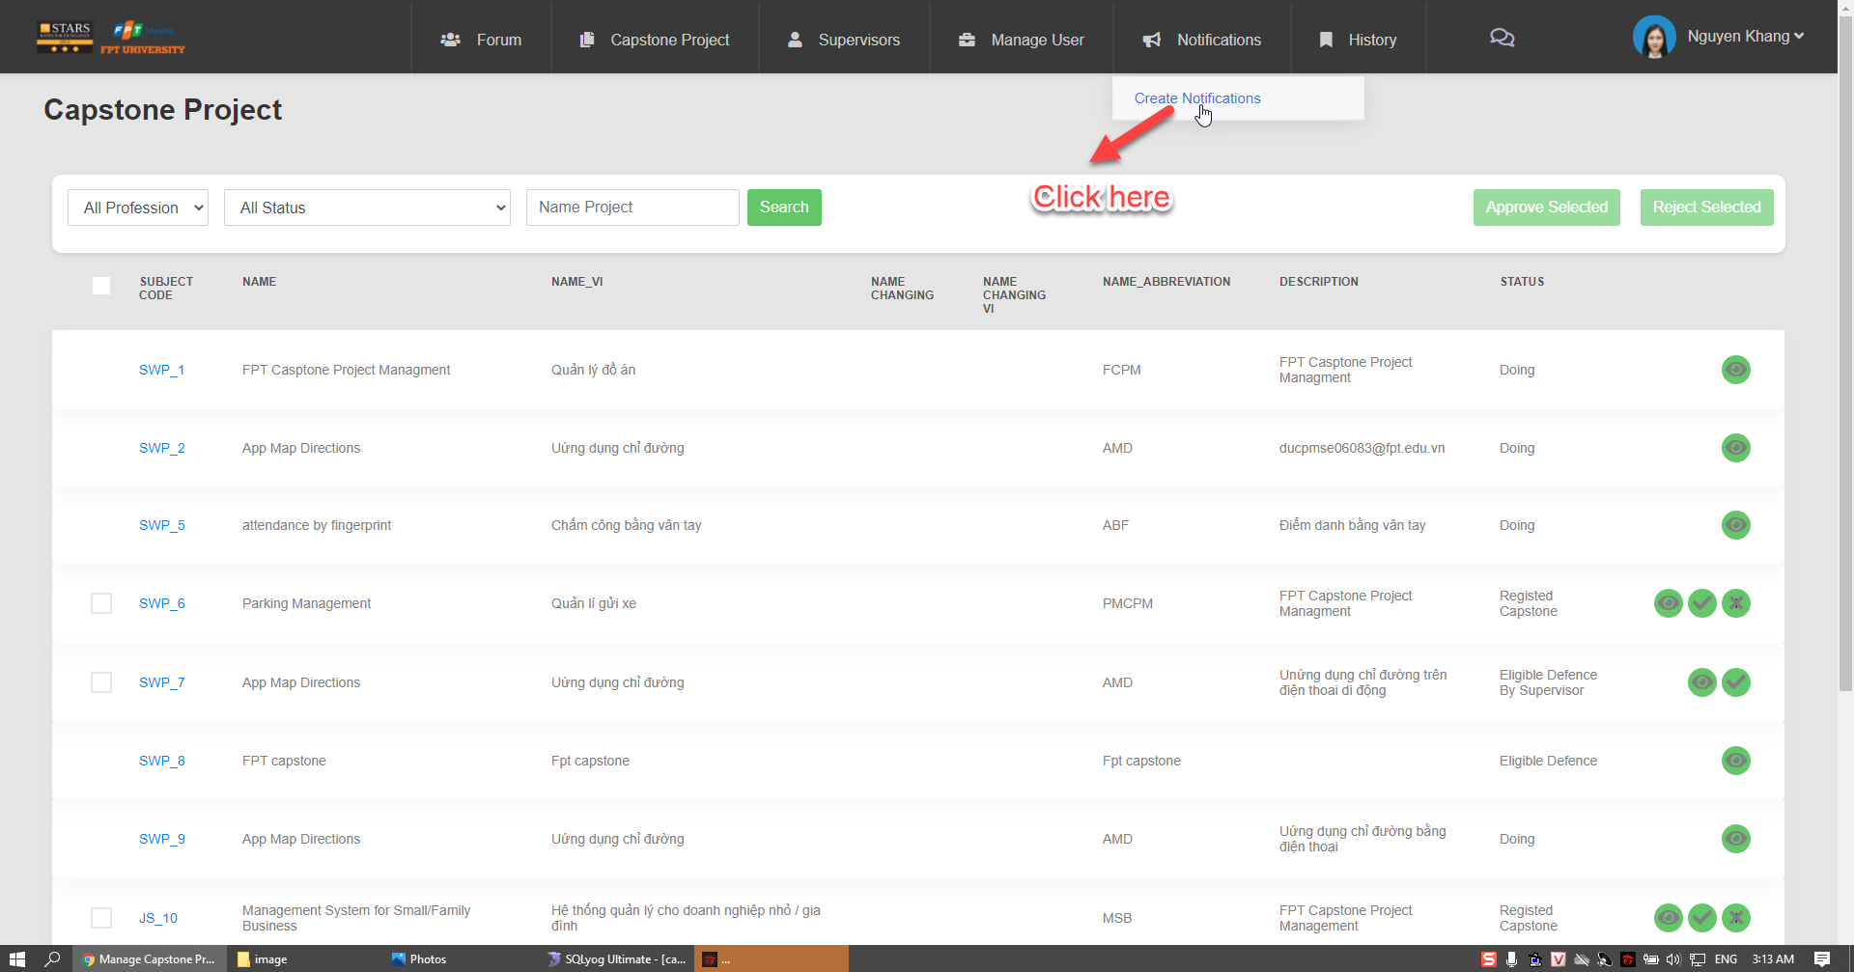

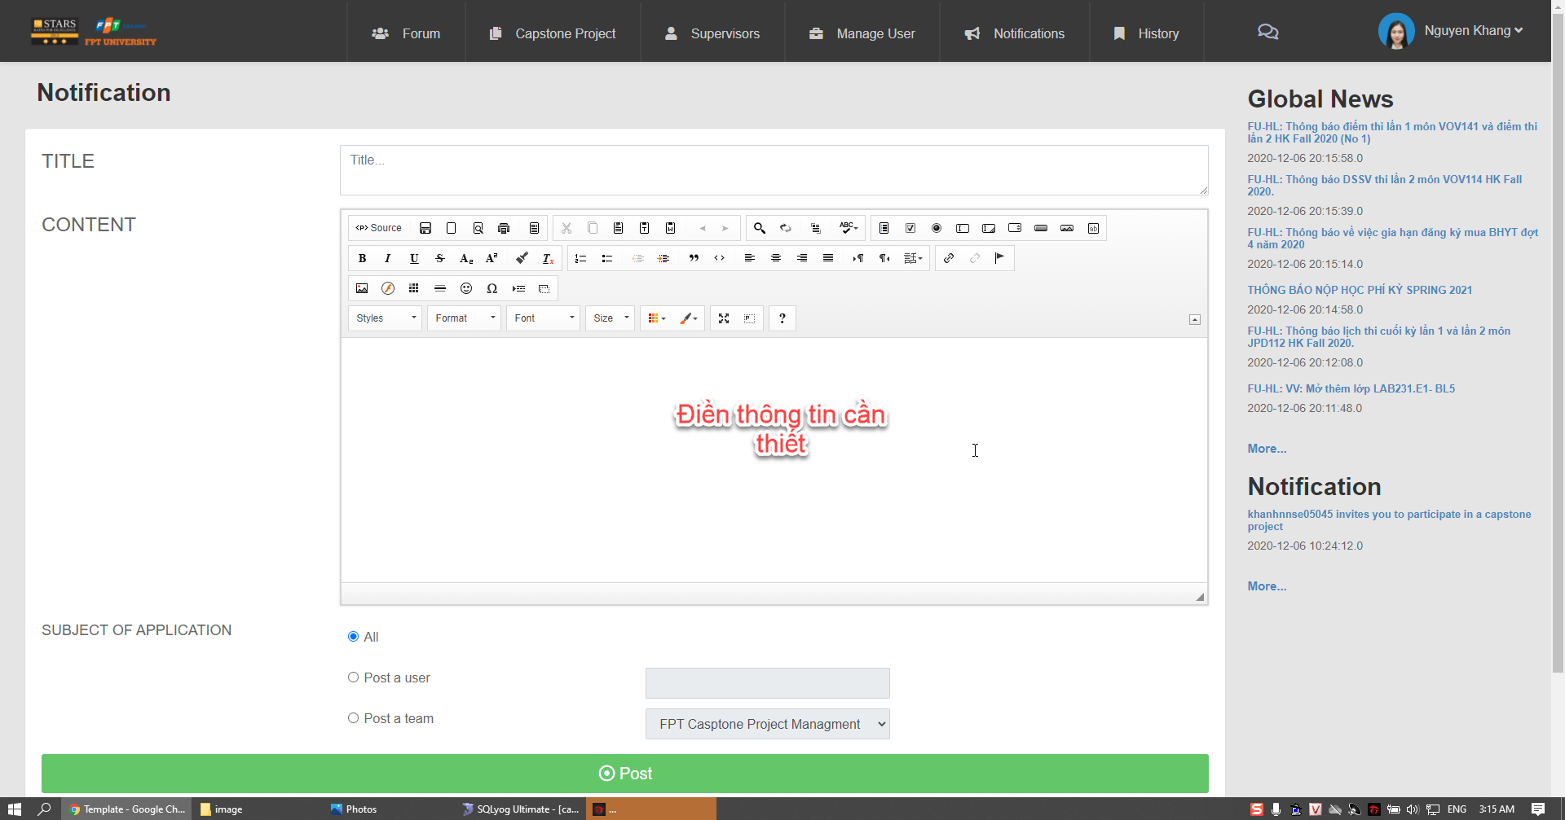

Button/ Hyperlinks

|  |  |  |  |  |
| --- | --- | --- | --- | --- |
| **No** | **Function** | **Description** | **Validation** | **Outcome** |
| 1  2  3  4  5  6 | Choose all profession  Choose all profession  Search name  project  Approve  Project  Reject project  See next page | Click to all profession  Click to all status  Click to search  Click to approve  Click to reject  Click to next | No  No  No  No  No  No | Show professions  Show statuses  Show name project  Approve project  Reject project  Show next page |

Fields

|  |  |  |  |  |  |  |  |  |
| --- | --- | --- | --- | --- | --- | --- | --- | --- |
| **No** | **Field**  **Name** | **Description** | | **Read**  **Only** | **Mandatory** | **Control**  **Type** | **Data**  **Type** | **Length** |
| 1  2  3  4  5  6  7 | Name  Description  Name-vi  Name-Abbreviation  Status  Title  Content | | Name project  Description project  Name Vietnam project  Name Abbreviation  Status  Title  Content | No  No  No  No  No  No  No | Yes  Yes  Yes  Yes  Yes  Yes  Yes | Text  Text  Text  Text  Text  Text  Text | String  String  String  String  String  String  String | N/A  N/A  N/A  N/A  N/A  N/A  N/A |

#### 4.5.1.30 View History Record

* **Screen Images**

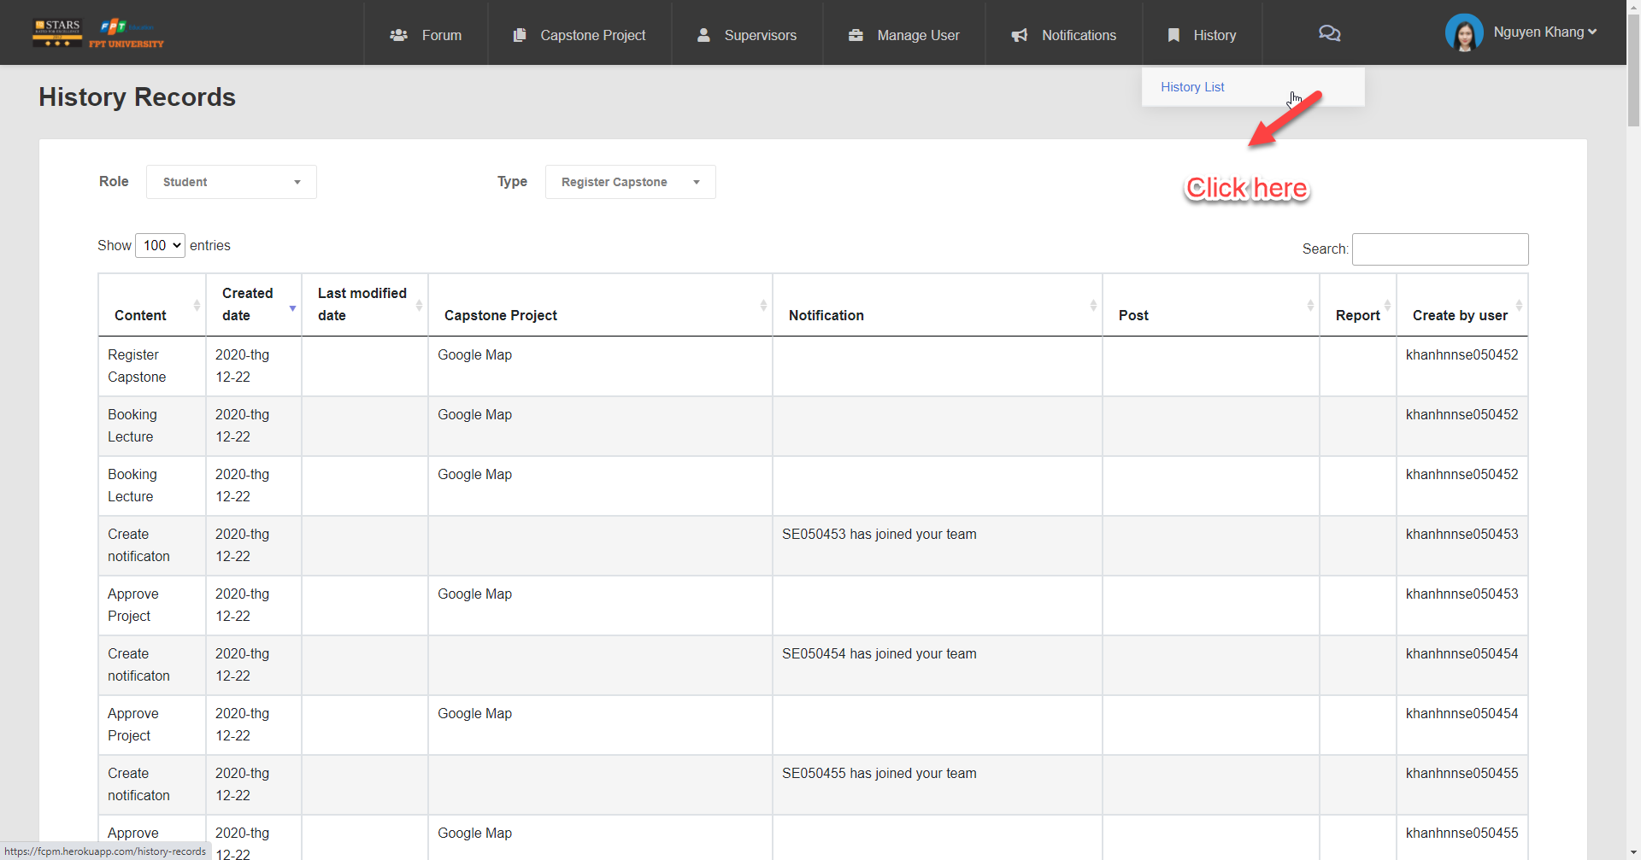

Fields

|  |  |  |  |  |  |  |  |  |
| --- | --- | --- | --- | --- | --- | --- | --- | --- |
| **No** | **Field**  **Name** | **Description** | | **Read**  **Only** | **Mandatory** | **Control**  **Type** | **Data**  **Type** | **Length** |
| 1  2  3  4  5  6  7 | Content  Create date  Last modified date  Capstone project  Notification  Post  Report | | Content  Create date  Last modified date  Capstone project  Notification  Post  Report | No  No  No  No  No  No  No | Yes  Yes  Yes  Yes  Yes  Yes  Yes | Text  Text  Text  Text  Text  Text  Text | String  Date  Date  String  String  String  String | N/A  N/A  N/A  N/A  N/A  N/A  N/A |

#### 4.5.1.31 Change name capstone project

* **Screen Images**

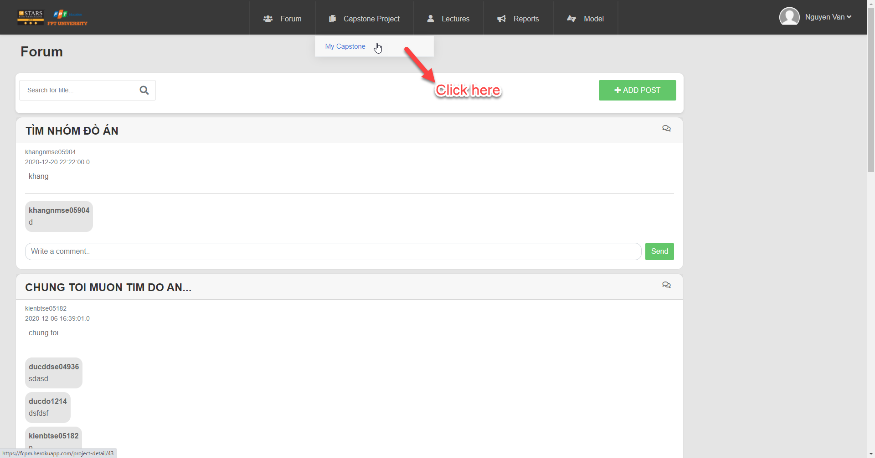

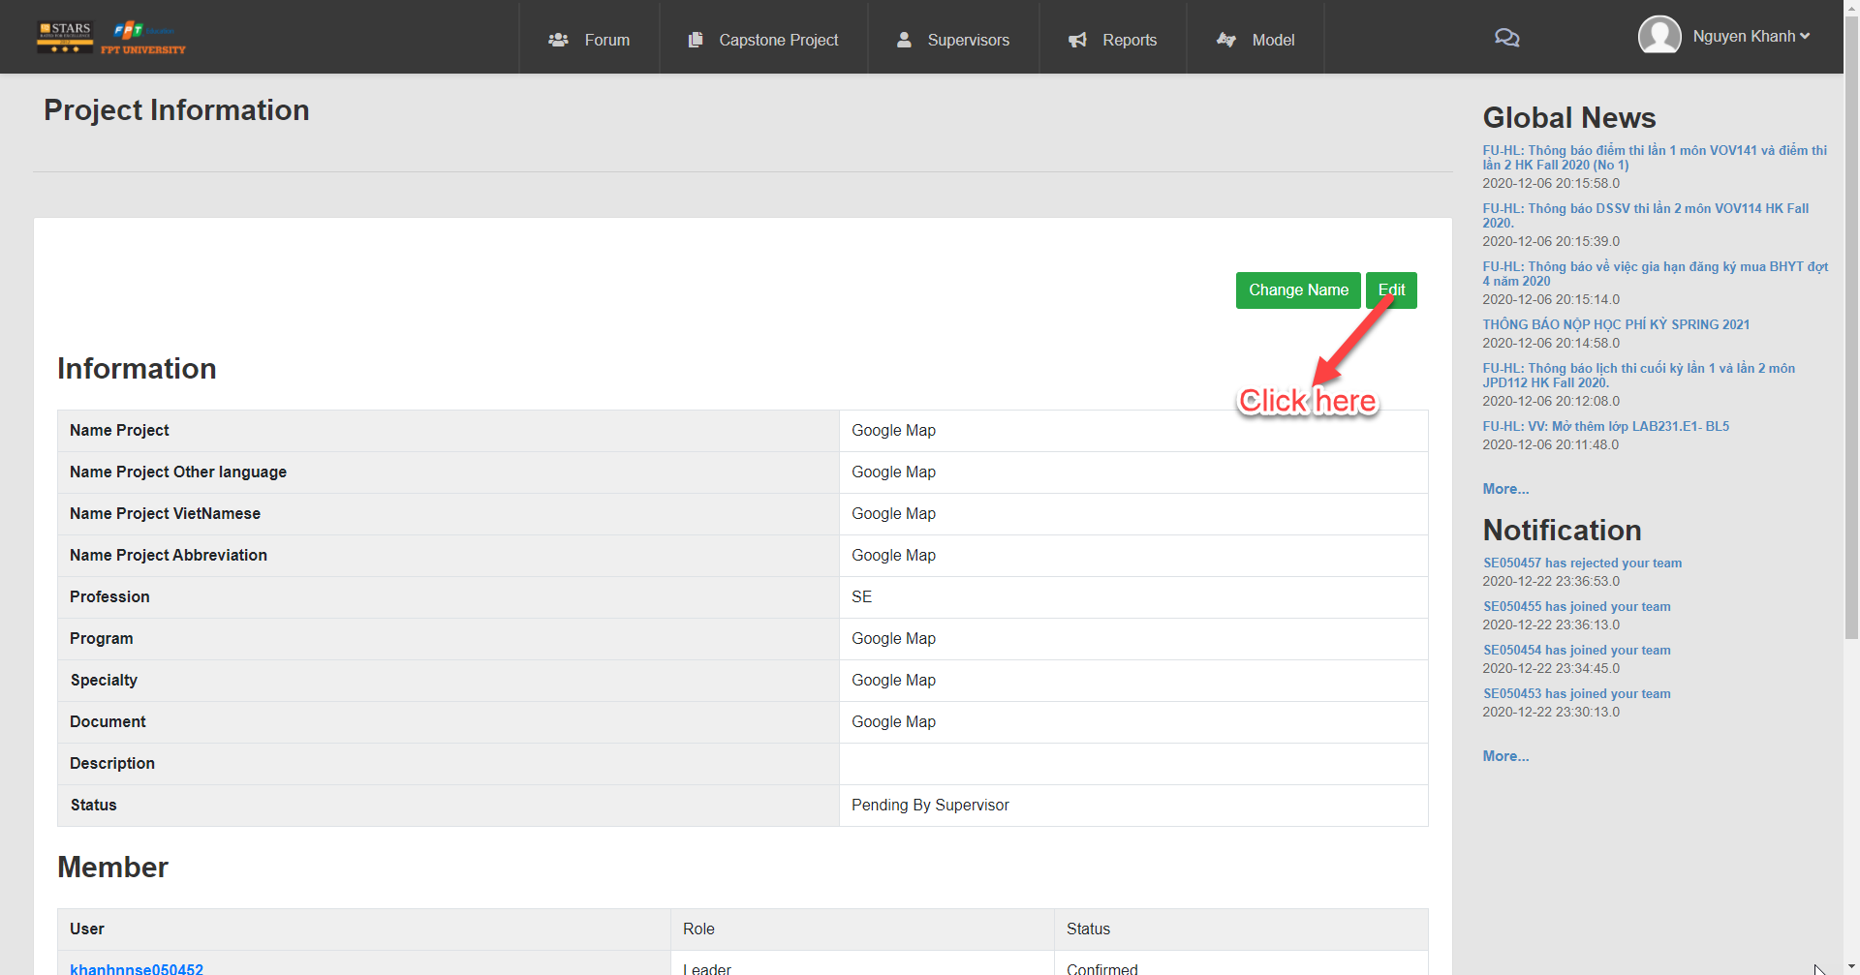

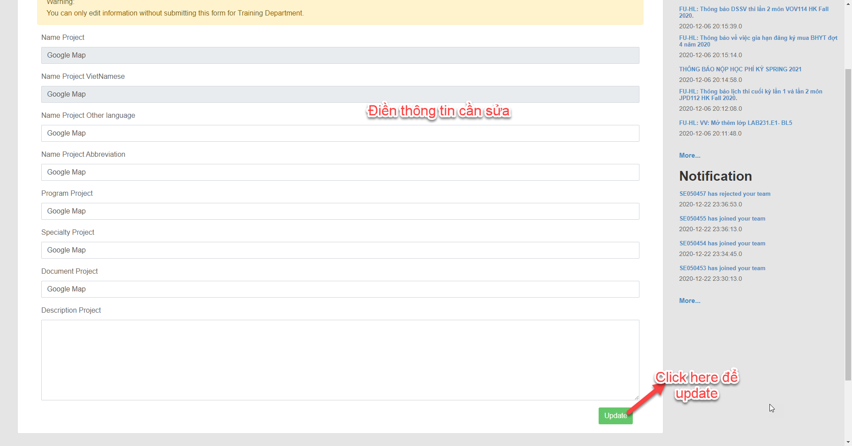

Button/ Hyperlinks

|  |  |  |  |  |
| --- | --- | --- | --- | --- |
| **No** | **Function** | **Description** | **Validation** | **Outcome** |
| 1 | Change name | Click to Change name | No | Change game |
| 2  3 | Edit  Update | Click to Edit  Click to Update | No  No | Navigate to Edit capstone project page  Display successful notification |

Fields

|  |  |  |  |  |  |  |  |
| --- | --- | --- | --- | --- | --- | --- | --- |
| **No** | **Field**  **Name** | **Description** | **Read**  **Only** | **Mandatory** | **Control**  **Type** | **Data**  **Type** | **Length** |
| 7 | Name  Project | Name of  project | No | Yes | Text | String | 120 |
| 8 | Name project other language | Name project other language | No | Yes | Text | String | 120 |
| 9 | Name project Vietnamese | Name project Vietnam | No | Yes | Text | String | 120 |
| 10 | Name project Abbreviation | Name project Abbreviation | No | Yes | Text | String | 120 |
| 11 | Profession  project | Profession  Project | No | Yes | Text | String | 120 |
| 12 | Program  project | Program  Project | No | Yes | Text | String | 120 |
| 13 | Specialty  project | Specialty  Project | No | Yes | Text | String | 120 |
| 14 | Document  project | Document  Project | No | Yes | Text | String | 120 |
| 12 | Member | Member add | No | Yes | Text | String | 120 |
| 13 | Description  project | Description  Project | No | Yes | Text | String | 120 |
|  |  |  |  |  |  |  |  |

#### 4.5.1.32 View list post

* **Screen Images**

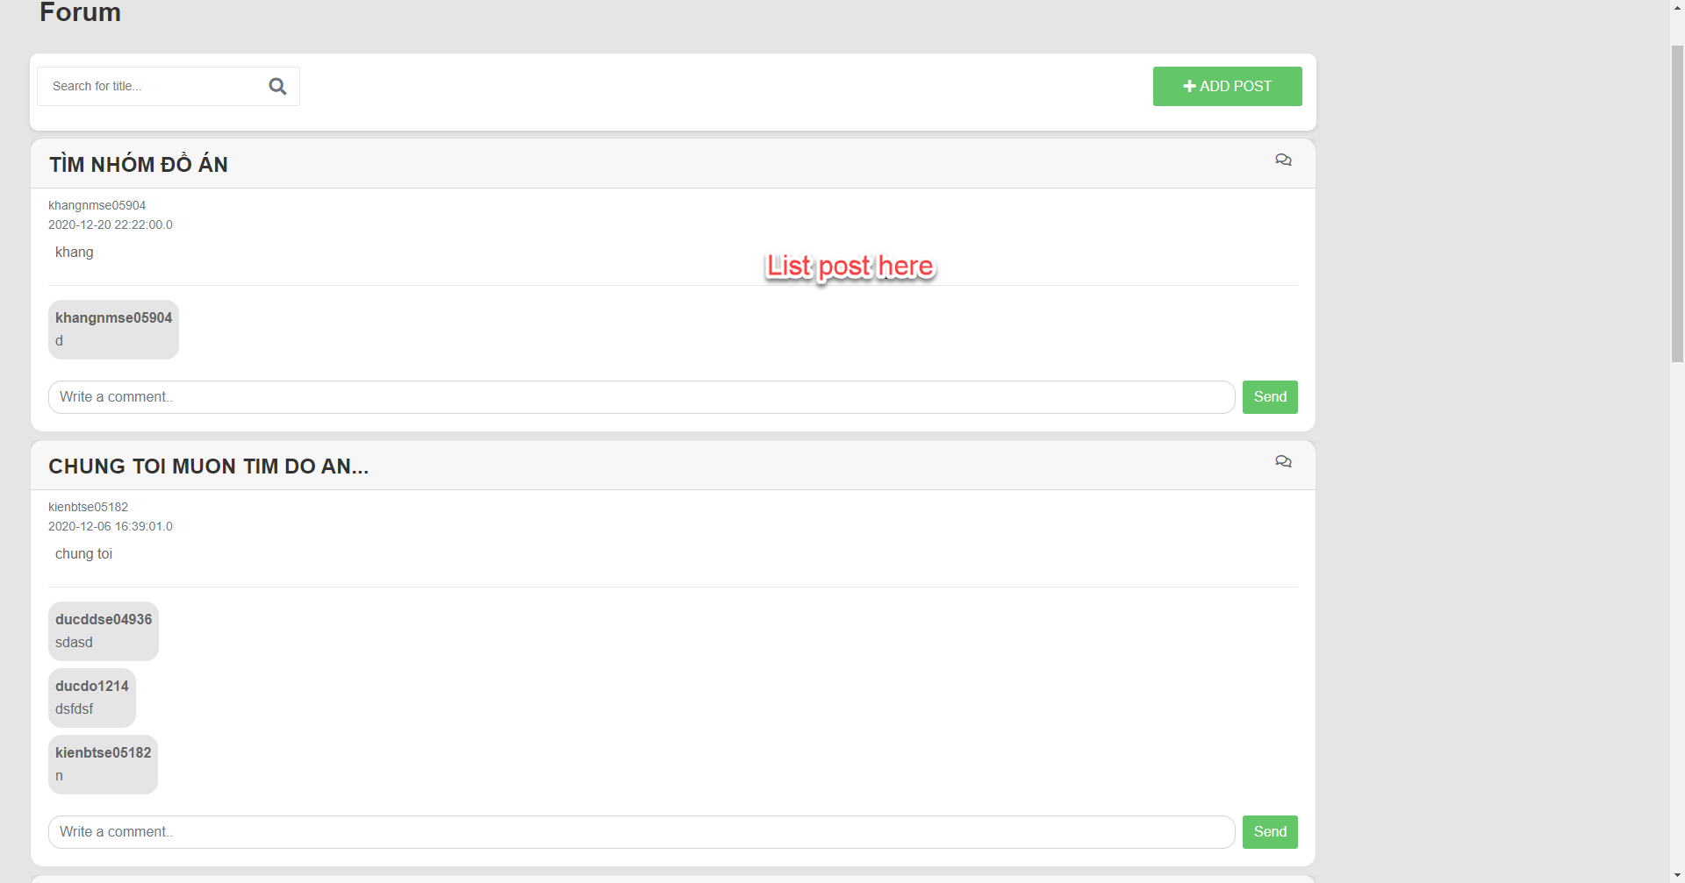

Button/ Hyperlinks

|  |  |  |  |  |
| --- | --- | --- | --- | --- |
| **No** | **Function** | **Description** | **Validation** | **Outcome** |
| 1 | Search for title | Click to Search | No | Search for title |
| 2  3 | Add post  Send comment | Click to Add post  Click to send | No  No | Display screen add post  Comment |

#### 4.5.1.33 Get comment

* **Screen Images**

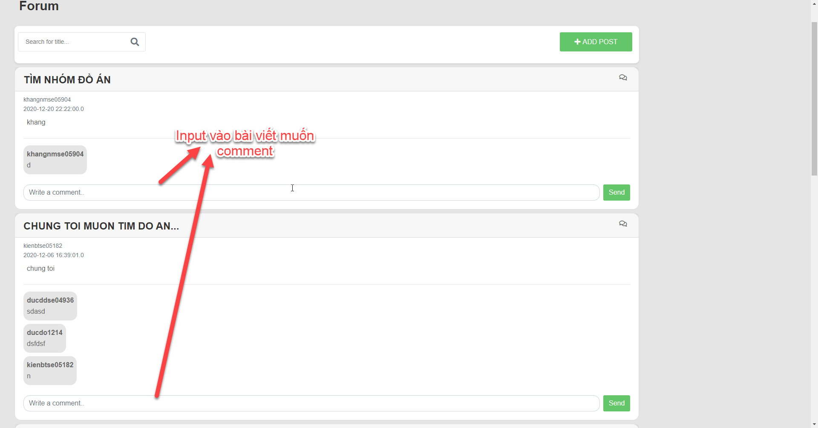

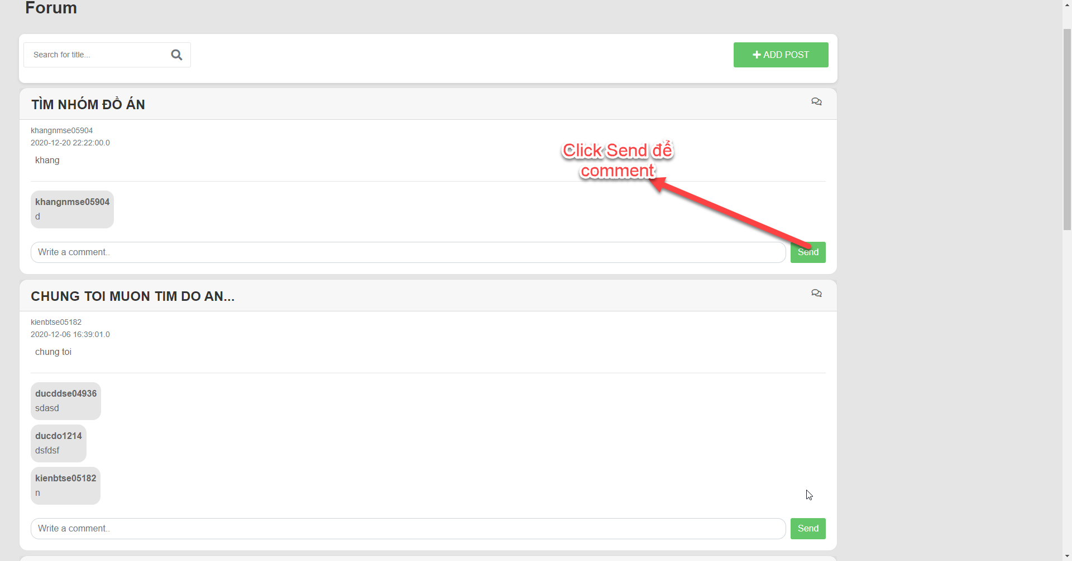

Button/ Hyperlinks

|  |  |  |  |  |
| --- | --- | --- | --- | --- |
| **No** | **Function** | **Description** | **Validation** | **Outcome** |
| 1 | Search for title | Click to Search | No | Search for title |
| 2  3 | Add post  Send comment | Click to Add post  Click to send | No  No | Display screen add post  Comment |

#### 4.5.1.34 Add post

* **Screen Images**

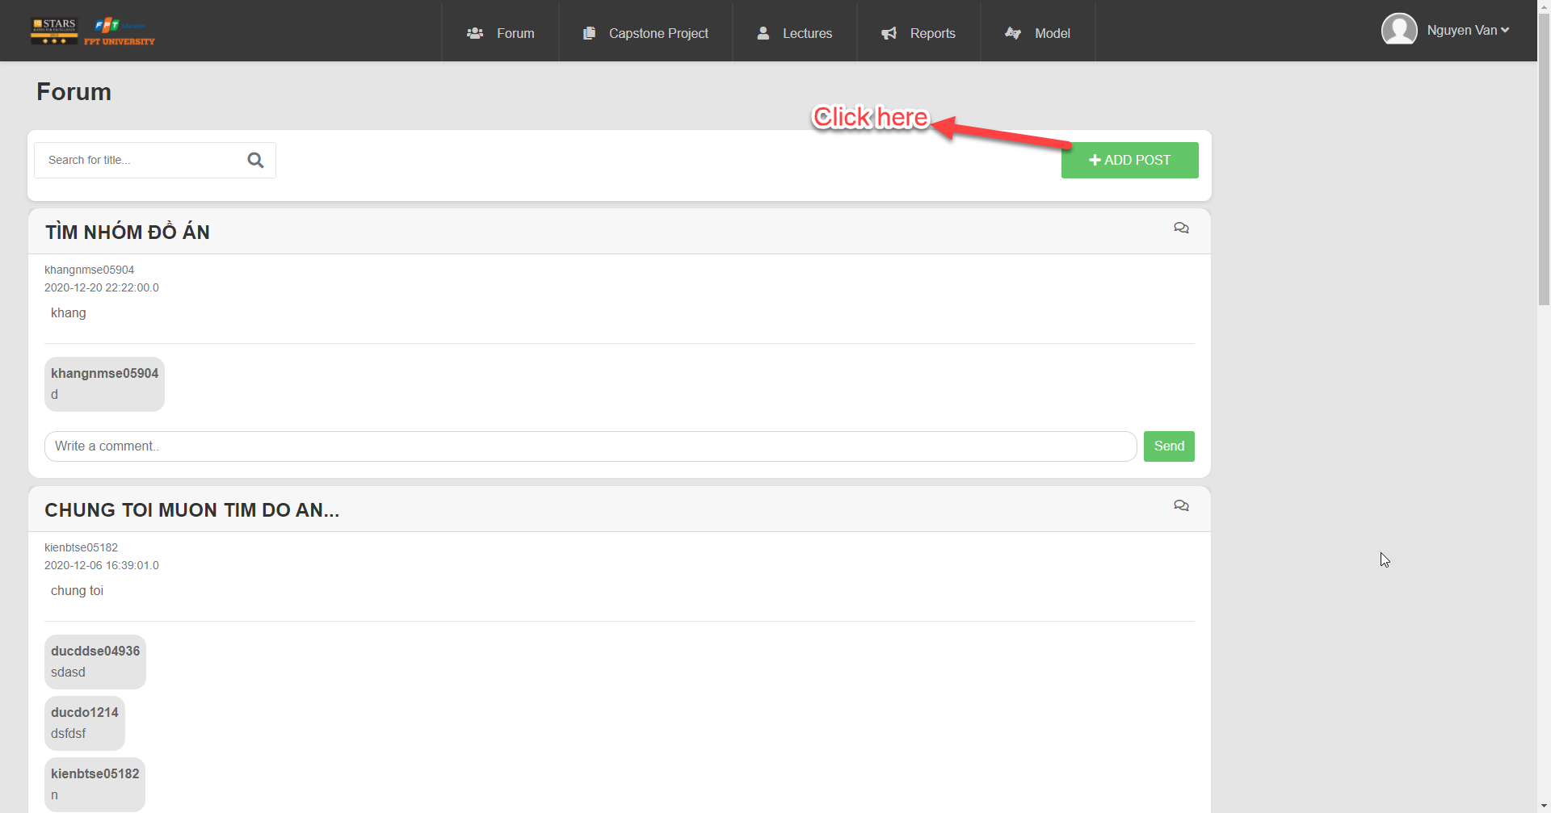

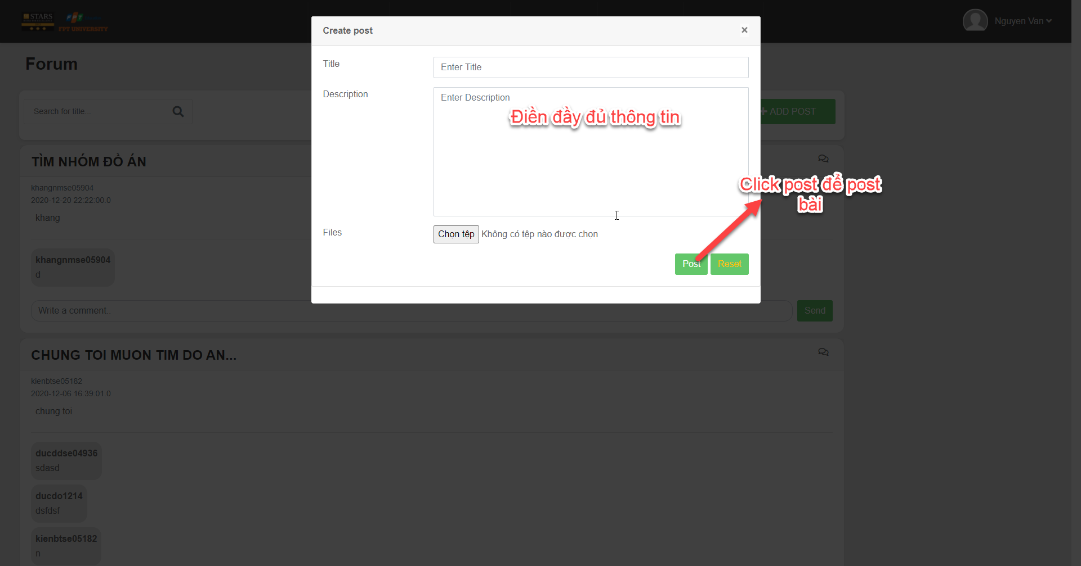

Button/ Hyperlinks

|  |  |  |  |  |
| --- | --- | --- | --- | --- |
| **No** | **Function** | **Description** | **Validation** | **Outcome** |
| 1  2  3 | Add post  Post  Reset post | Click to add post  Click to reset | No  No  No | Show file  Navigate to forum  Re-post |

Fields

|  |  |  |  |  |  |  |  |
| --- | --- | --- | --- | --- | --- | --- | --- |
| **No** | **Field**  **Name** | **Description** | **Read**  **Only** | **Mandatory** | **Control**  **Type** | **Data**  **Type** | **Length** |
| 7 | Title | Title post | No | Yes | Text | String | 120 |
| 8 | Description | Description  post | No | Yes | Text | String | 120 |

#### 4.5.1.35 Edit post

* **Screen Images**

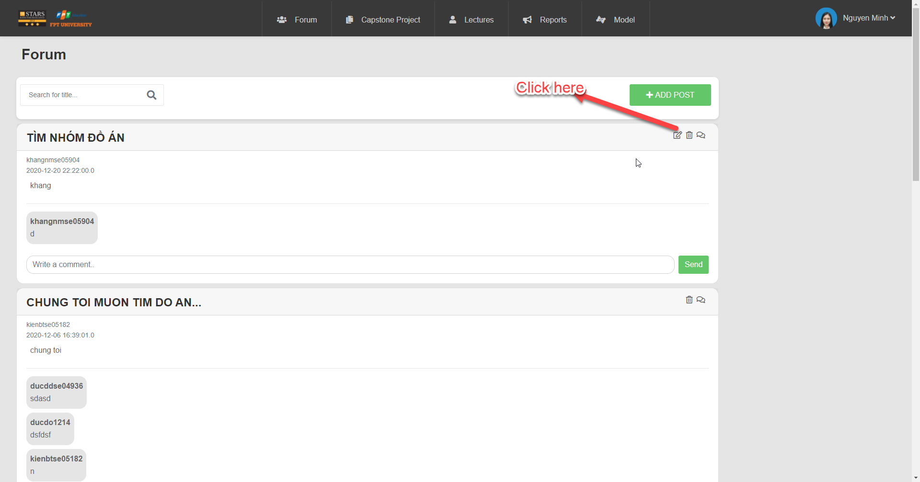

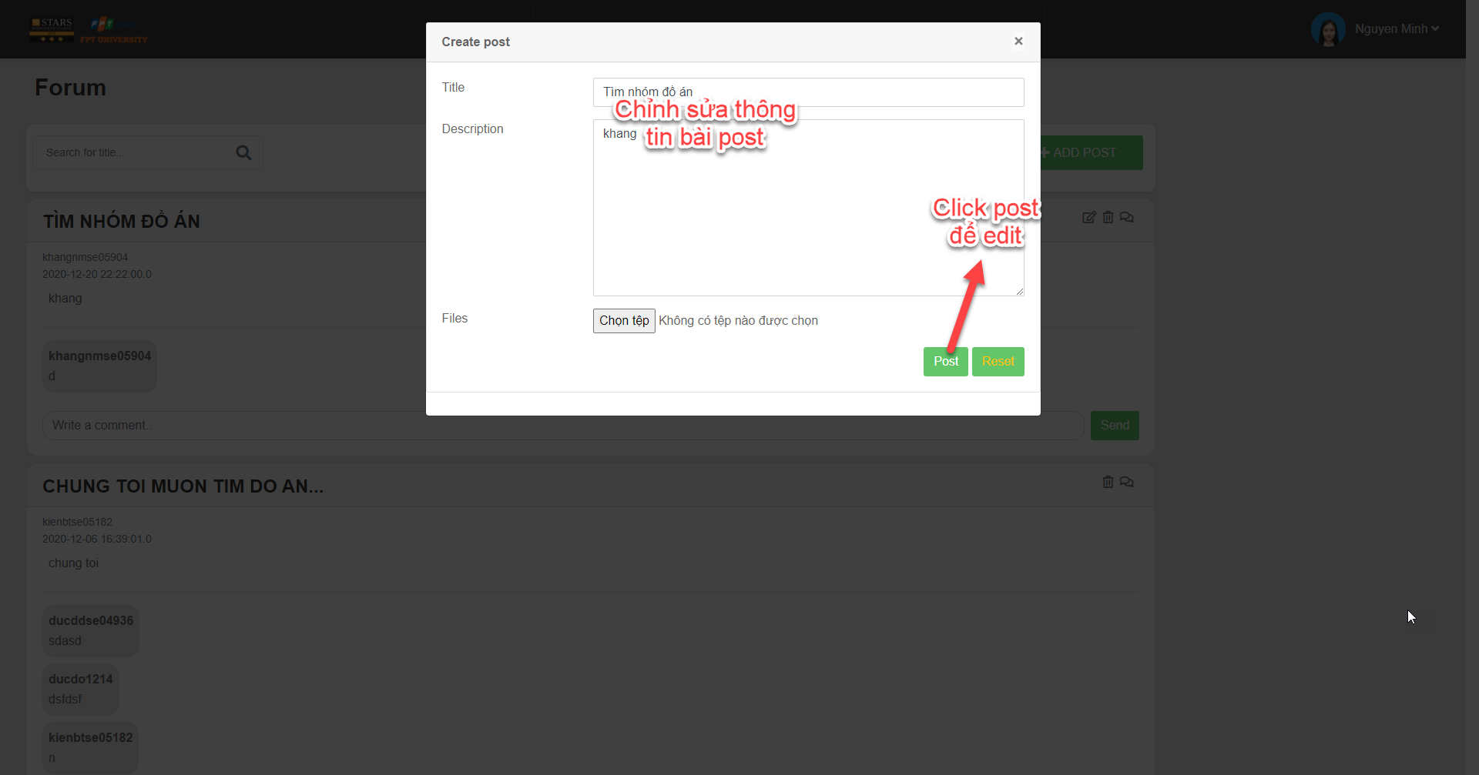

Button/ Hyperlinks

|  |  |  |  |  |
| --- | --- | --- | --- | --- |
| **No** | **Function** | **Description** | **Validation** | **Outcome** |
| 1  2  3 | Add post  Post  Reset post | Click to add post  Click to reset | No  No  No | Show file  Navigate to forum  Re-post |

Fields

|  |  |  |  |  |  |  |  |
| --- | --- | --- | --- | --- | --- | --- | --- |
| **No** | **Field**  **Name** | **Description** | **Read**  **Only** | **Mandatory** | **Control**  **Type** | **Data**  **Type** | **Length** |
| 7 | Title | Title post | No | Yes | Text | String | 120 |
| 8 | Description | Description  post | No | Yes | Text | String | 120 |

#### 4.5.1.36 Delete post

* **Screen Images**

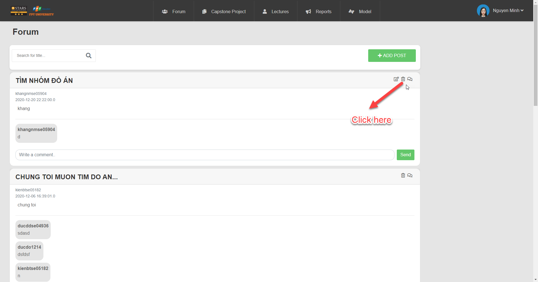

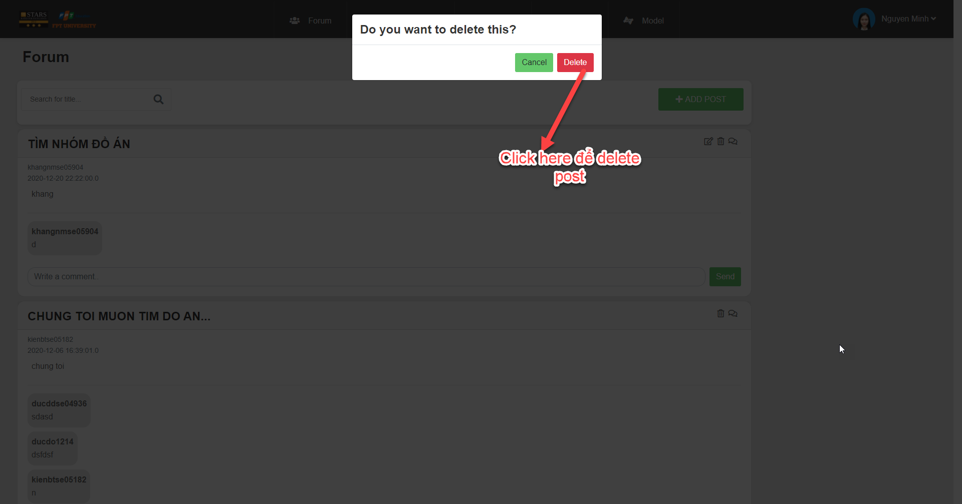

Button/ Hyperlinks

|  |  |  |  |  |
| --- | --- | --- | --- | --- |
| **No** | **Function** | **Description** | **Validation** | **Outcome** |
| 1  2  3 | Add post  Delete  Cancel | Click to add post  Click to Delete  Click to Cancel | No  No  No | Show file  Display successful notification  Back to the page |

#### 4.5.1.37 Search code

* **Screen Images**

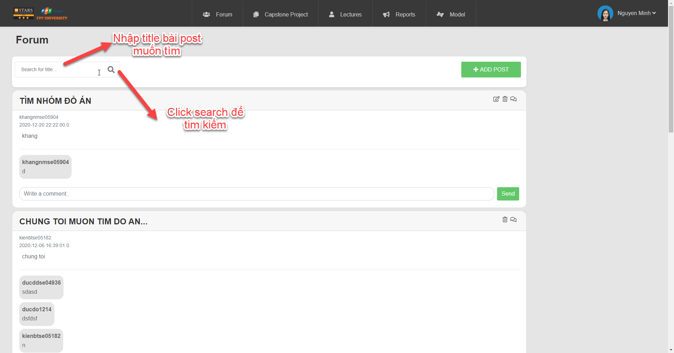

Button/ Hyperlinks

|  |  |  |  |  |
| --- | --- | --- | --- | --- |
| **No** | **Function** | **Description** | **Validation** | **Outcome** |
| 1 | Search for title | Click to Search | No | Search for title |
| 2  3 | Add post  Send comment | Click to Add post  Click to send | No  No | Display screen add post  Comment |

#### 4.5.1.38 Add user

* **Screen Images**

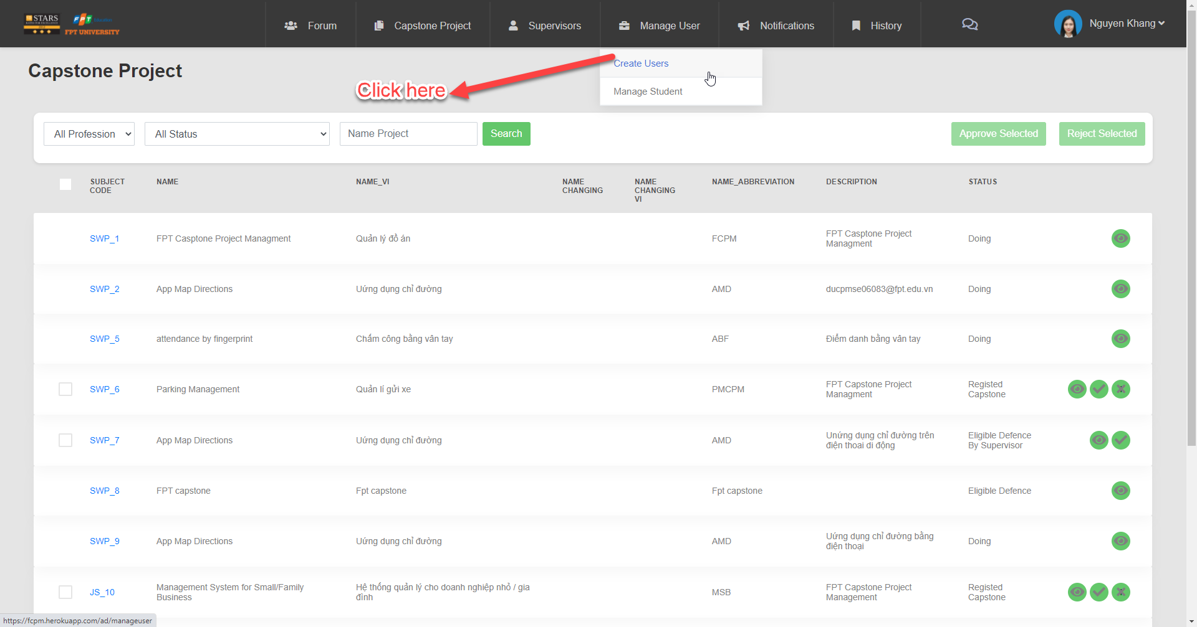

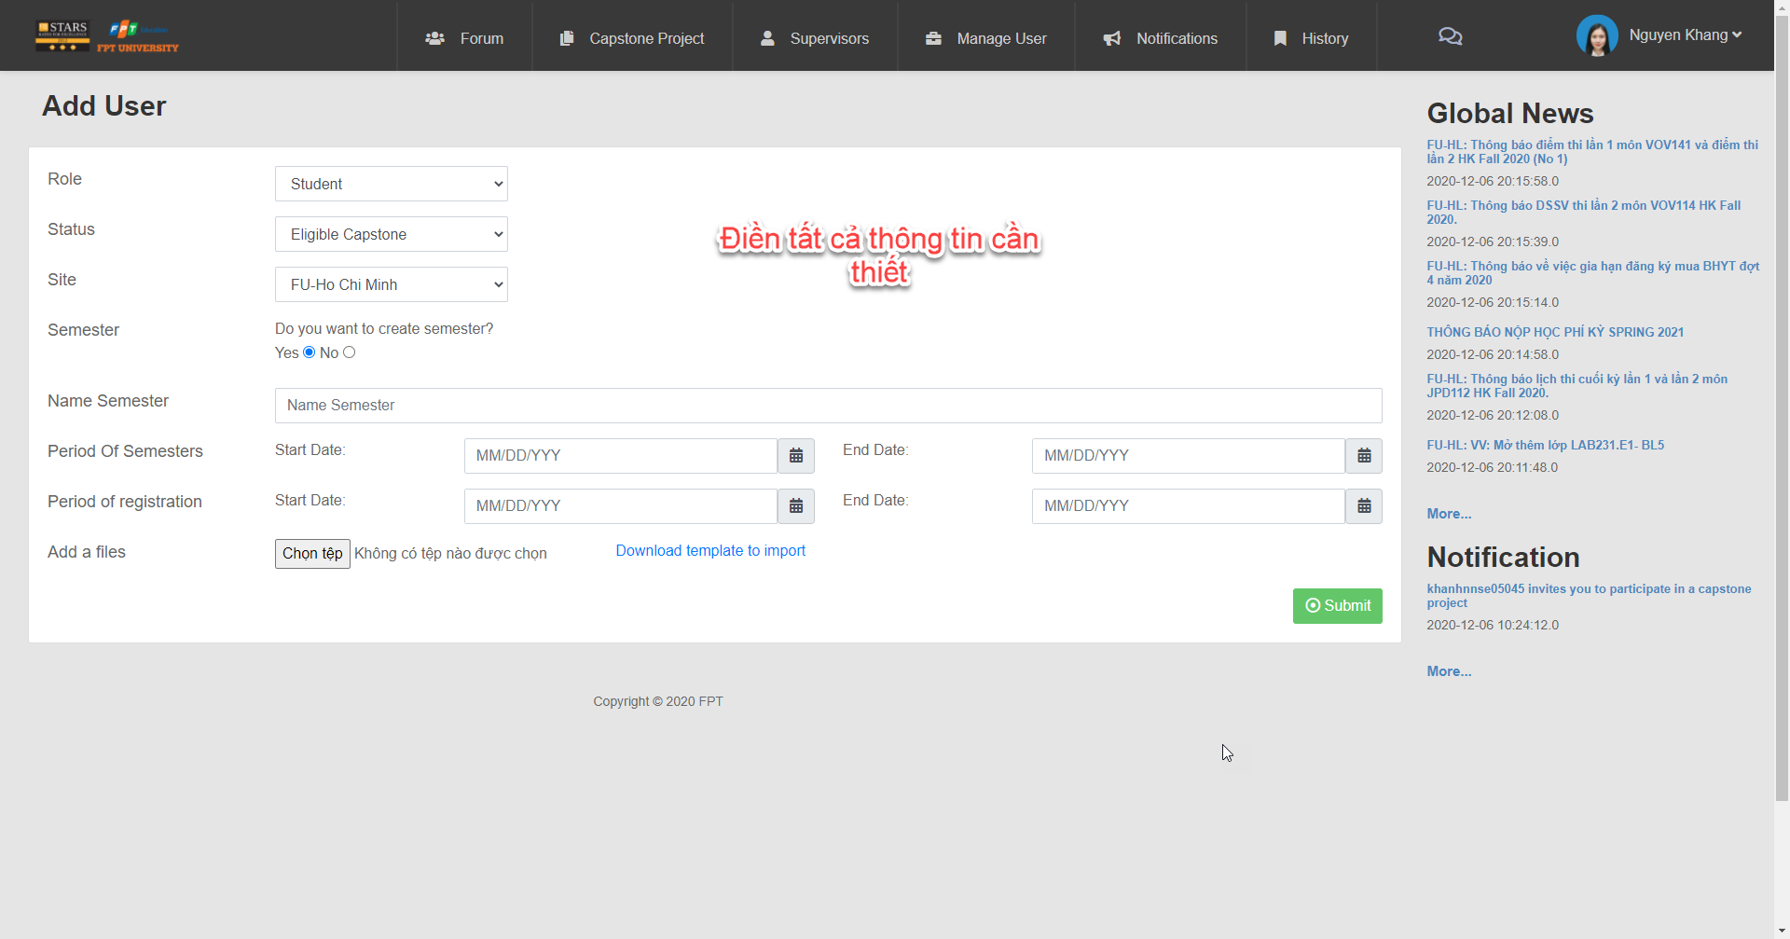

Button/ Hyperlinks

|  |  |  |  |  |
| --- | --- | --- | --- | --- |
| **No** | **Function** | **Description** | **Validation** | **Outcome** |
| 1  2  3  4  5  6  7 | Choose all profession  Choose all profession  Search name  project  Approve  Project  Reject project  See next page  Submit | Click to all profession  Click to all status  Click to search  Click to approve  Click to reject  Click to next  Click to submit | No  No  No  No  No  No  No | Show professions  Show statuses  Show name project  Approve project  Reject project  Show next page  Display successful notification |

Fields

|  |  |  |  |  |  |  |  |  |
| --- | --- | --- | --- | --- | --- | --- | --- | --- |
| **No** | **Field**  **Name** | **Description** | | **Read**  **Only** | **Mandatory** | **Control**  **Type** | **Data**  **Type** | **Length** |
| 1  2  3  4  5  6  7 | Name  Description  Name-vi  Name-Abbreviation  Status  Title  Content | | Name project  Description project  Name Vietnam project  Name Abbreviation  Status  Title  Content | No  No  No  No  No  No  No | Yes  Yes  Yes  Yes  Yes  Yes  Yes | Text  Text  Text  Text  Text  Text  Text | String  String  String  String  String  String  String | N/A  N/A  N/A  N/A  N/A  N/A  N/A |

#### 4.5.1.39: Approve capstone project in the changing name stage

* **Screen Images**



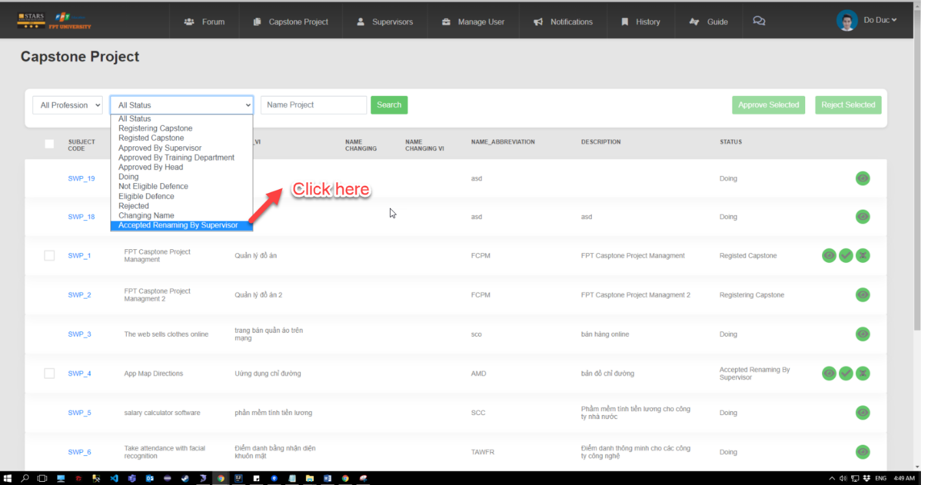

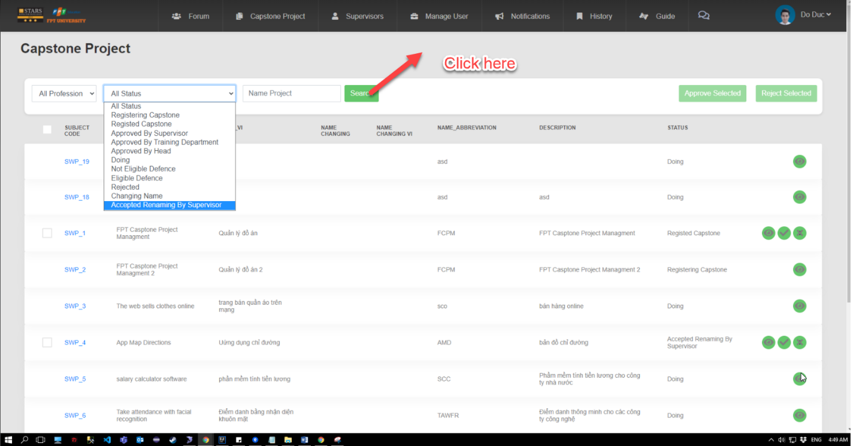

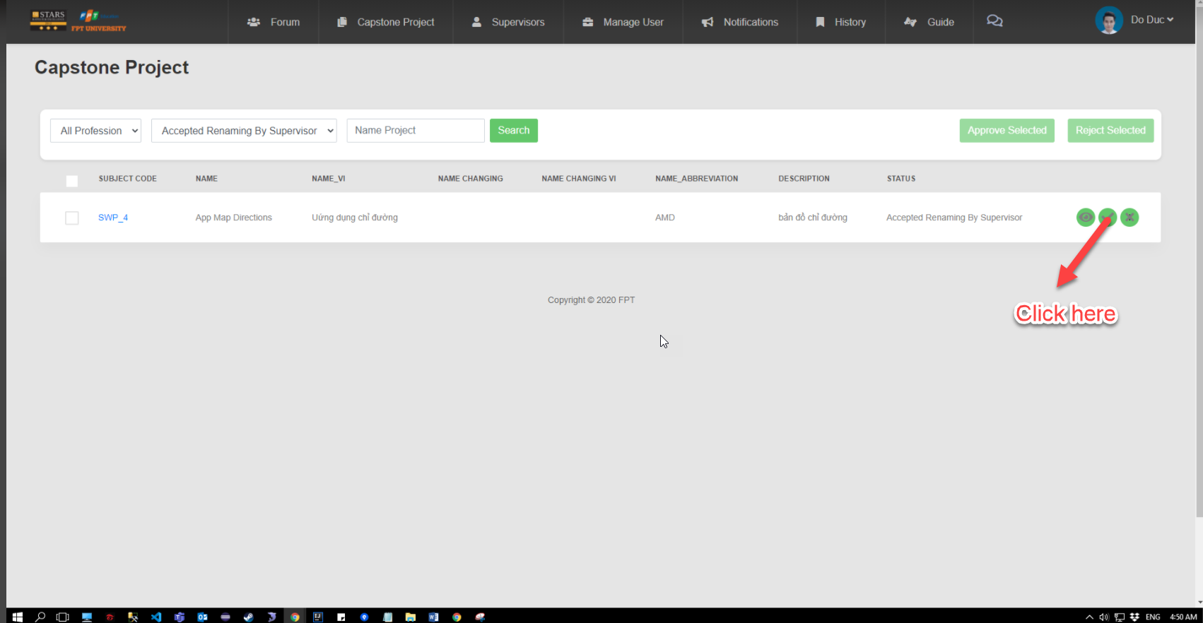

Button/ Hyperlinks

|  |  |  |  |  |
| --- | --- | --- | --- | --- |
| **No** | **Function** | **Description** | **Validation** | **Outcome** |
| 1  2  3  4  5  6 | Choose all profession  Choose all profession  Search name  project  Approve  Project  Reject project  See next page | Click to all profession  Click to all status  Click to search  Click to approve  Click to reject  Click to next | No  No  No  No  No  No | Show professions  Show statuses  Show name project  Approve project  Reject project  Show next page |

Fields

|  |  |  |  |  |  |  |  |  |
| --- | --- | --- | --- | --- | --- | --- | --- | --- |
| **No** | **Field**  **Name** | **Description** | | **Read**  **Only** | **Mandatory** | **Control**  **Type** | **Data**  **Type** | **Length** |
| 1  2  3  4  5 | Name  Description  Name-vi  Name-Abbreviation  Status | | Name project  Description project  Name Vietnam project  Name Abbreviation  Status | No  No  No  No  No | Yes  Yes  Yes  Yes  Yes | Text  Text  Text  Text  Text | String  String  String  String  String | N/A  N/A  N/A  N/A  N/A |

# **5. Software Test Documentation**

## 5.1. Introduction

### 5.1.1 Purpose

* The primary purpose of this chapter is to detect and prevent defects which may be created by developers while developing the software and this may lead to software failures. Through testing, system defects can be discovered and fixed, then help to build better software quality. Using the contents of this chapter, developers and testers can work together to ensure that the system is thoroughly tested and performs functions as intended.
* Scope of Testing.
* Test Plan
* Test Case
* Test Report

### 5.1.2 Scope of testing

#### 5.1.2.1 States of testing

The testing process is divided into 3 phases: Unit testing, Integration testing and System testing.

|  |  |
| --- | --- |
| **States of testing** | **Description** |
| Unit test | Unit Tests are performed to guarantee that individual units of source code work well. In this phase, a unit can refer to a function, individual program or even a procedure, and a White-box Testing method is usually used to get the job done |
| Integration test | Integration testing allows individuals the opportunity to combine all of the units within a program and test them as a group. This testing level is designed to find interface defects between the modules/functions. Putting integration tests of all modules into the application is performed by CPM tester to check if the combined units were working as expected. |
| System test | System testing is performed to monitor and evaluate the behaviour of a completely integrated software product or software system, based on predefined specification and functional requirements. The goal at this level is to evaluate whether the system has complied with all of the outlined requirements and to see that it meets Quality Standards. |

Table 5.1 Scope of testing

#### 5.1.2.2 Types of testing

The following types of testing are performed:

* Function testing:
* Unit test
* Integration test
* System test

#### 5.1.2.3 Range of testing

All features described in the System Requirement Specification are tested.

## 5.2. Test Plan

### 5.2.1 Testing tools and Environment

#### 5.2.1.1 Testing tools

|  |  |
| --- | --- |
| **Tool** | **Purpose** |
| Junit | Used to view app, bug login, etc.. |
| Excel | Used to manage test cases |
| Google Chrome | Used to view the web page, bug logging page |
| IntelliJ | Used to view app, bug login, etc.. |
| Jira | Used to manage bugs |

Table 5.2 Testing tools

#### 5.2.1.1 Testing environment

|  |  |  |
| --- | --- | --- |
| **Type of testing** | **Software** | **Hardware** |
| Unit test | Junit  IntelliJ IDEA 2020.2.3 | Dell  Window 10  Intel core i7  RAM 8G  1T Disk Space |
| Integration test | Junit  Google Chrome  Microsoft Office 2016 | Dell  Window 10  Intel core i7  RAM 8G  1T Disk Space |
| System test | Google Chrome | Dell  Window 10  Intel core i7  RAM 8G  1T Disk Space |

Table 5.3 Testing environment

### 5.2.2 Resources and Responsibilities

|  |  |  |
| --- | --- | --- |
| **ID** | **Resource** | **Responsibilities** |
| 1 | Test Leader | • Review test cases and test reports.  • Review overall quality of the project.  • Define test strategy.  • Define test plan, test approach. |
| 2 | Tester | Performing the actual system testing  • Understand the requirements of the project.  • Implement integration test following requirement.  • Create test plan  • Create test cases  • Perform tests  • Write test reports  • Log bugs |
| 3 | Developer | Create and perform Unit Tests.  • Fix bugs. |

Table 5.4 Resources and Responsibilities

### 5.2.3 Test Strategy

#### 5.2.3.1 Test model

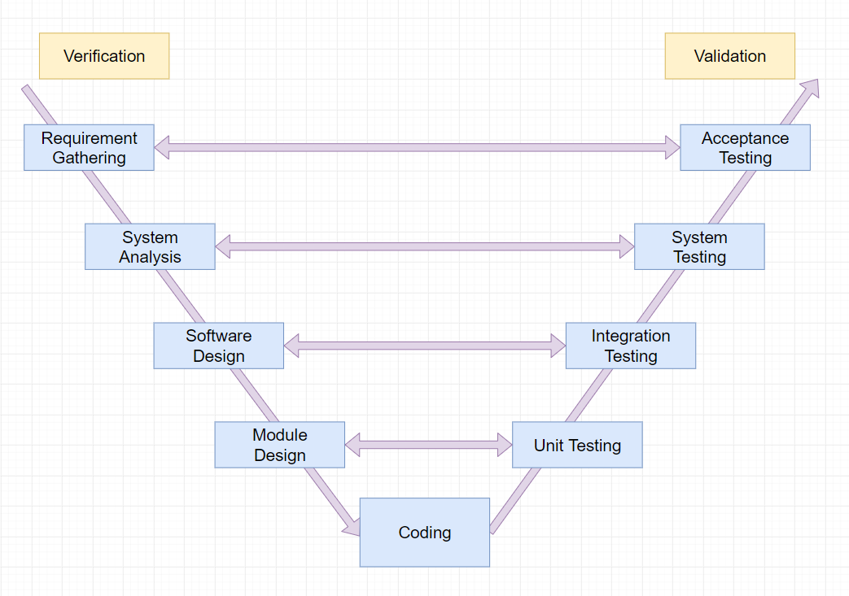

Figure 5.1 Test model

More information: <https://en.wikipedia.org/wiki/V-Model_(software_development)>

#### 5.2.3.2 Test types

|  |  |  |
| --- | --- | --- |
| **ID** | **Type of test** | **Description** |
| 1 | GUI (Graphical user interface)  testing | • GUI test is used to test the user interface of the software. It will be performed fully on all screens. The target is to cover the verification of mocks defined before. It also includes fields:   * Test whether the interface is displayed correctly or not. * Test if you can perform the intended functionality of the application using the GUI. * Test if the error messages are displayed correctly. * Test if the font used in the system is readable. * Test the fonts and warning messages. * Test if the images are clear or not. * Test if that the images are properly aligned |
| 2 | Regression testing | * Regression testing is necessary, even when making very small changes to the code. * Regression test ensures that the bugs are fixed. * Regression testing ensures bugs fixing does not affect other parts of the system. |
| 3 | Functional testing | * Functional test is used to test for each logical path of use case. * Tests if functions of the system work as intended on the CPM system. * Functional testing is a type of black-box testing and as such, internal structure is rarely considered. |

Table 5.4 Resources and Responsibilities

#### 

#### 5.2.3.3 State of testing

|  |  |  |  |
| --- | --- | --- | --- |
| **Test Type** | **States of testing** | | |
| **Unit Test** | **Integration Test** | **System Test** |
| Unit test | ✓ |  |  |
| GUI testing |  | ✓ | ✓ |
| Functional testing |  | ✓ | ✓ |

Table 5.5 States of testing

#### 5.2.3.4 Test schedule

Table below are the Test Schedule for CPM Project. That consist of two round:

|  |  |  |  |  |
| --- | --- | --- | --- | --- |
| **Test Schedule** | **Round 1** | | **Round 2** | |
| **Start Date** | **End Date** | **Start Date** | **End Date** |
| Unit Test | 10/10 | 10/11 |  |  |
| Integration test | 27/10 | 15/11 | 16/11 | 22/11 |
| System test |  |  |  |  |

#### 5.2.3.5 Deliverable

Table below is the Deliverables for FCPM Project:

|  |  |  |
| --- | --- | --- |
| **Deliverables** | **Responsibilities** | **Completion date** |
| Test plan | Test Leader | 09-10-2020 |
| Test cases | Testers | 20-10-2020 |
| Test case review | Testers + Test Leader | 02-11-2020 |
| Test data( Data Set) | Testers | 19-11-2020 |
| Defect report | All members | 02-12-2020 |
| Final test report | Test Leader | 10-12-2020 |

## 5.3. Test Approach

### 5.3.1 Unit test

* Unit Test is a method of testing software by breaking the source code into separate parts and testing each part. Unit testing is done by developers. FCPM developer team embraces this feature to gain the following advantages:
* Ensuring code quality
* Early error detection
* Reducing the Number of Bugs
* Automation tests can be run as frequently as required.
* Saving development time.
* Reducing product costs
* Improving code design, especially in test-driven developments
* Being able to review each other’s code, the teamwork is more cohesive and Agile.
* Providing clear documentation
* It is easier to maintain than Front-end tests which are difficult to maintain with the short release cycles and frequent changes and with a complex system.
* Reducing the cost of a resource to corresponding Front-end testing.

### 5.3.2 Integration and System test

* Integration and system tests are done by testers to ensure that combined units work correctly and that the system as a whole function as intended. Each test case is tested using Google Chrome, Android Devices. FCPM define that a test case is:
* Verifying the Layouts
* Testing user access privileges.
* Testing all the network features, like a request is passed over a HTTPS protocol or not.
* Verifying menu items and their functionality.
* Adherence to coding standards and practices.
* Testing whether after an action is performed, cleanup of data is performed. Database operations like insertion, deletion and updates should be done with an intimidation to the user.
* GUI testing is also done during this process to ensure that elements load and function correctly, text is readable, and the app interface looks good in various devices sizes.
* Test case details are described in the file: Report5_System Test Case.xlsx

## 5.4. Test Report

### 5.4.1 Unit test

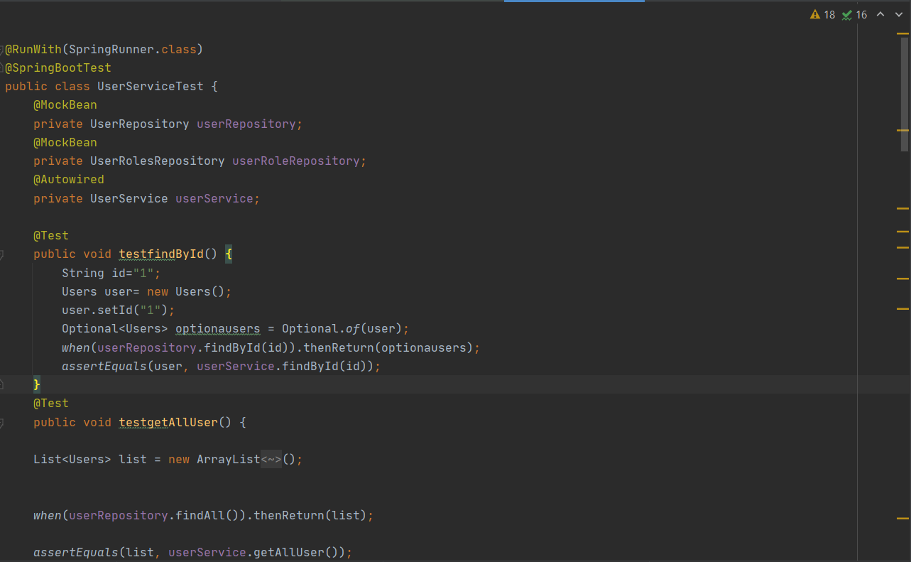

*Figure: Unit test case sample UserServiceTest*

The contents of the Unit Test Report are shown in the table below:

|  |  |  |
| --- | --- | --- |
| **Test Case** | **Pass** | **Fail** |
| Unit Test-TestfindByID | 16 | **0** |
| Unit Test- TestgetAllUser | 26 | 0 |
| Unit Test- TestdeleteeUserSuccess | 18 | 0 |
| Unit Test- TestGetAllDepartmentByID | 19 | 0 |
| Unit Test- TestSaveUserSuccess | 74 | 0 |
| Unit Test- TestFindAll | 12 | 0 |
| Unit Test- TestGetUserByRoleID | 15 | 0 |
| Unit Test- TestFindbyUsername | 27 | 0 |
| Unit Test- TestFindbyEmail | 66 | 0 |
| **Total all test case** | **273** | **0** |

For each of the tested unit, controller are tested.

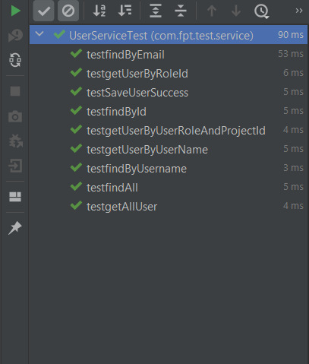

*Figure: Unit test case completed*

### 5.4.2 System test

|  |  |  |  |  |  |  |
| --- | --- | --- | --- | --- | --- | --- |
| **No** | **Module code** | **Pass** | **Fail** | **Untested** | **N/A** | **Number of test cases** |
| 1 | Login | 7 | 0 | 0 | 0 | 7 |
| 2 | Forum | 38 | 0 | 0 | 0 | 38 |
| 3 | Register | 32 | 0 | 0 | 0 | 32 |
| 4 | Supervisors | 18 | 0 | 0 | 0 | 18 |
| 5 | List Report | 14 | 0 | 0 | 0 | 14 |
| 6 | Notification | 13 | 0 | 0 | 0 | 13 |
| 7 | Model | 47 | 0 | 0 | 0 | 47 |
| 8 | My Report | 14 | 0 | 0 | 0 | 14 |
| 9 | Create Report | 35 | 0 | 0 | 0 | 35 |
| 10 | Dashboard | 103 | 0 | 0 | 0 | 103 |
| 11 | User Information | 11 | 0 | 0 | 0 | 11 |
| 12 | Manage Capstone Project | 132 | 0 | 0 | 0 | 132 |
| 13 | My Capstone | 17 | 0 | 0 | 0 | 17 |
| 14 | Manage User | 57 | 0 | 0 | 0 | 57 |
| 15 | Header | 19 | 0 | 0 | 0 | 19 |
|  | **Sub total** | 557 | 0 | 0 | 0 | 557 |
|  |  |  |  |  |  |  |
|  | **Test coverage** |  | **100.00** | % |  |  |
|  | **Test successful coverage** | | **100.00** | % |  |  |

Test case list:

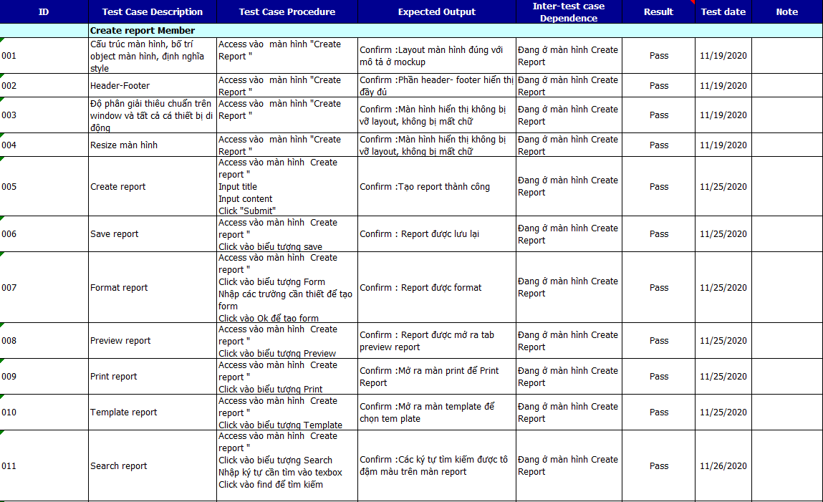

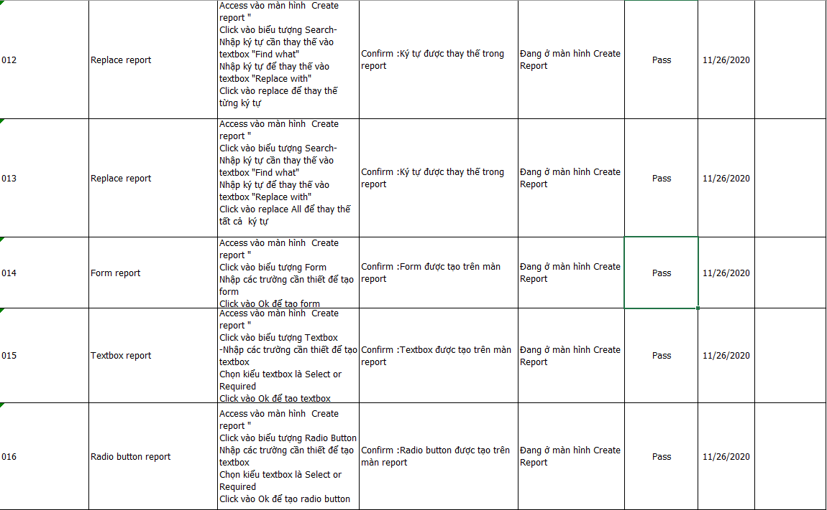

*Figure Test Case: Create report*

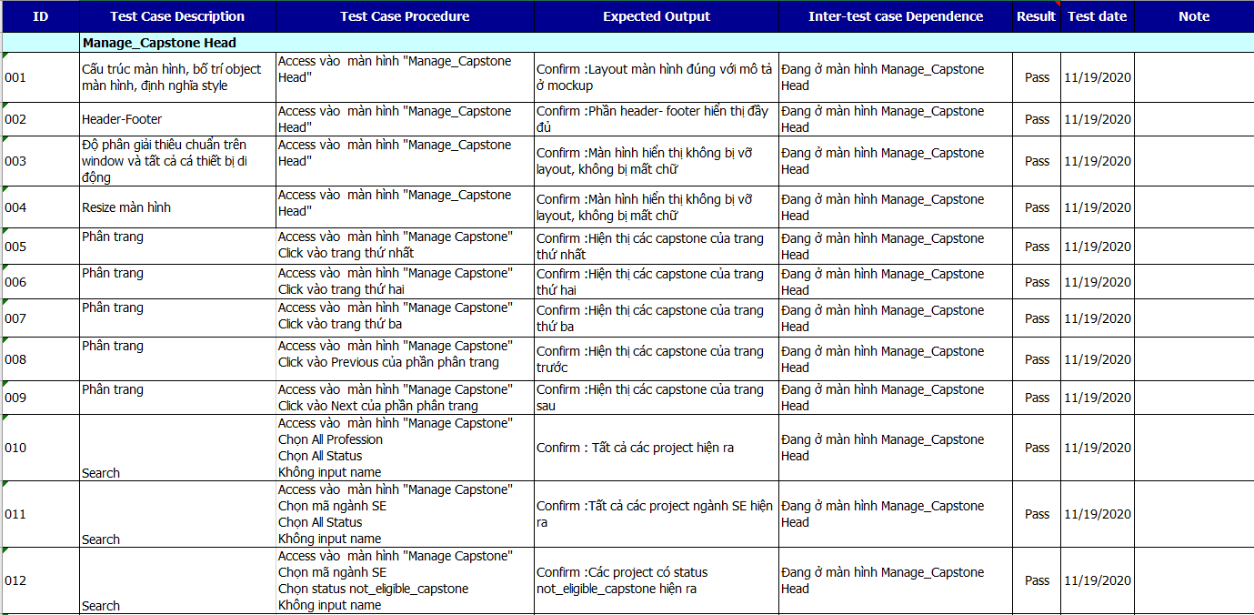

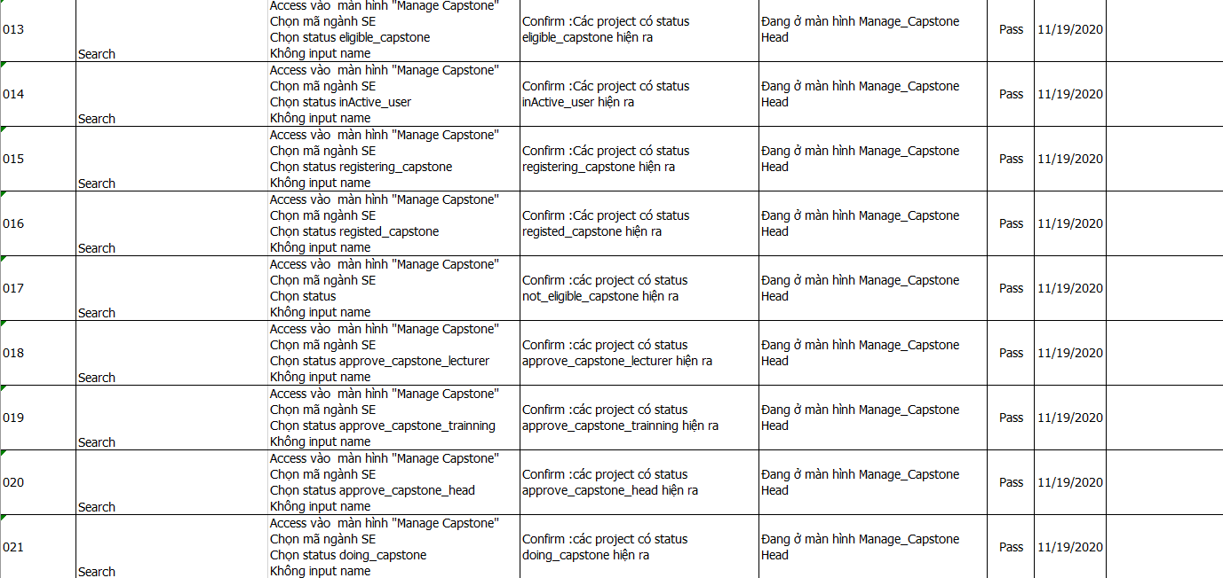

*Figure Test Case: Manage Capstone Project*

For more details about all test suites, please look at folder **“FCPM_TestCase”**

# **6. Software User’s Manual**

## 6.1. Installation Guide

## 6.2. User’s Guide

### 6.2.1 General function

#### 6.2.1.1 Login

Step 1: At the home page, click on “Sign in with Google” to navigate to Authenticate email FPT page



Step 2: After entering the Authenticate email FPT page, Select email FPT to login



Step 3: After login email FPT, to navigate to the forum

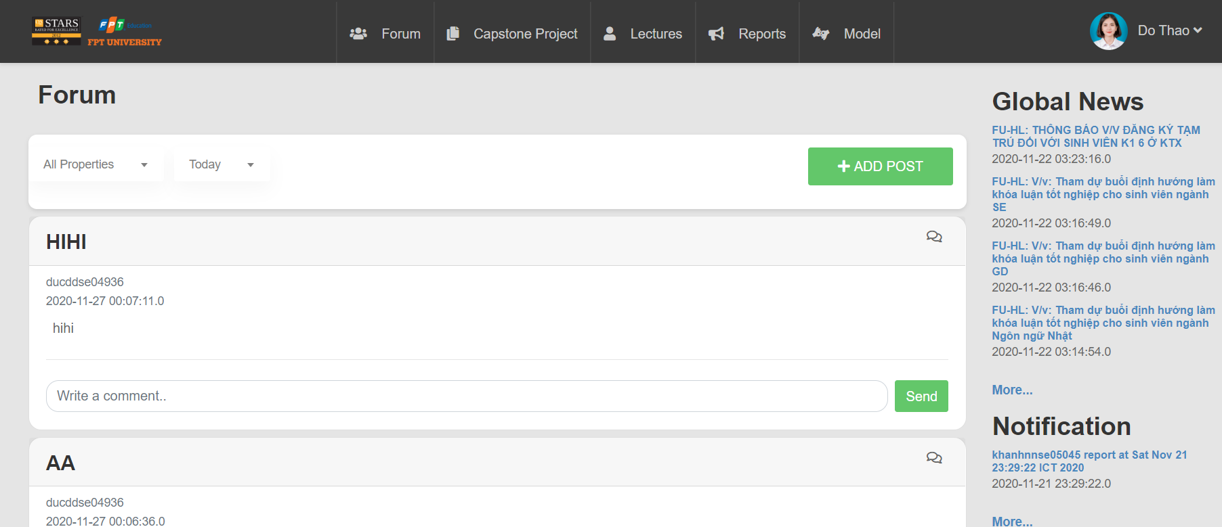

#### 6.2.1.2 Logout

Step 1: Click on the username in the upper right corner of the screen, Choose logout

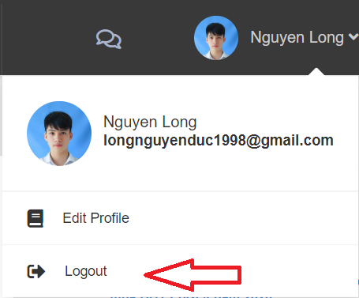

#### 6.2.1.3 Register Capstone Project

Step 1: Click the Capstone Project in the top of the page, choose Create Capstone Project

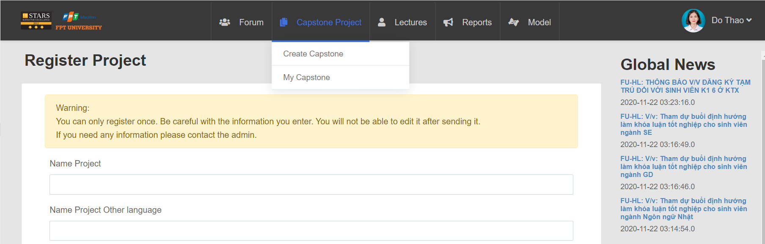

Step 2: Enter information to register project





Step 3: Click button submit to register project

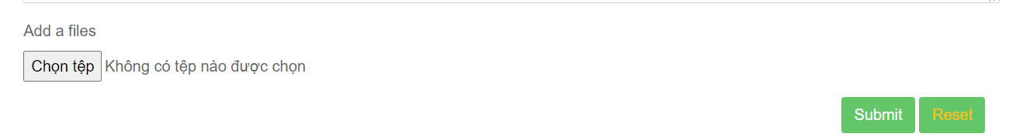

#### 6.2.1.4 Add member

Step 1: Click the Capstone Project in the top of the page, choose Create Capstone Project



Step 2: Enter account of member, click button “Add”



#### 6.2.1.5 Research model

Step 1: Access to forum, click button Model, choose About



Step 2: System display About Model



Step 3: Click button “Detail More” to view detail



Step 4: Return forum, click button Model, choose Tutorial Model

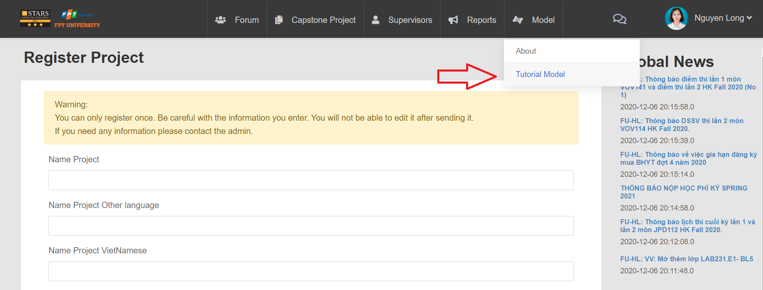

Step 5: System display Tutorial Model page to view



#### 6.2.1.6 Show list supervisors and booking

Step 1: Click the Capstone Project in the top of the page, choose Create Capstone Project



Step 2: Enter information to register project





Step 3: Click button submit to register project



Step 4: After register successfully, system display list supervisor to booking, click button Supervisor 1

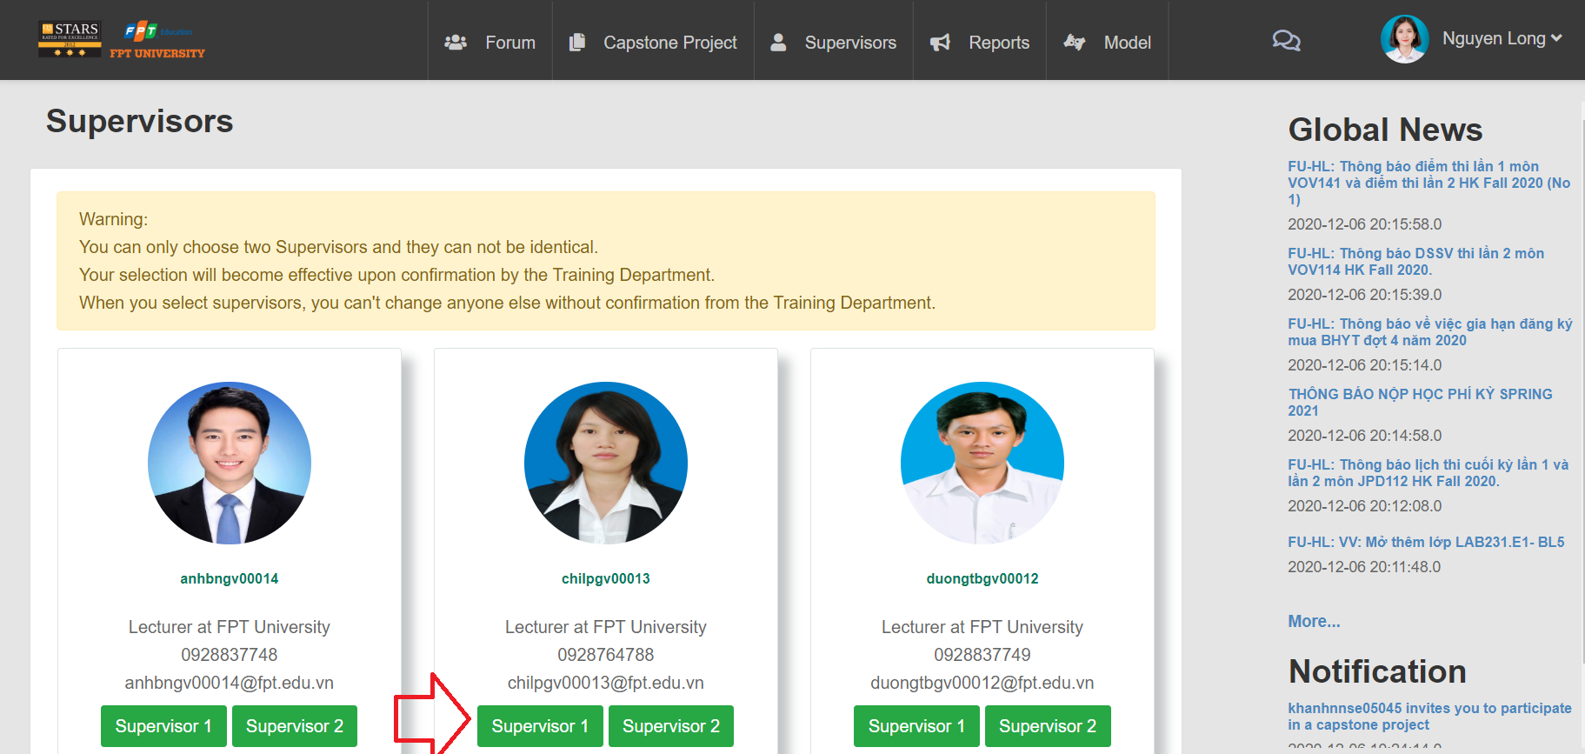

Step 5: Display notification “Are you sure you want to choose lecturer”, click “OK”



Step 6: After book supervisor 1 successfully, System display remain supervisors and don’t supervisor 1 to book supervisor 2, click button “Supervisor 2”

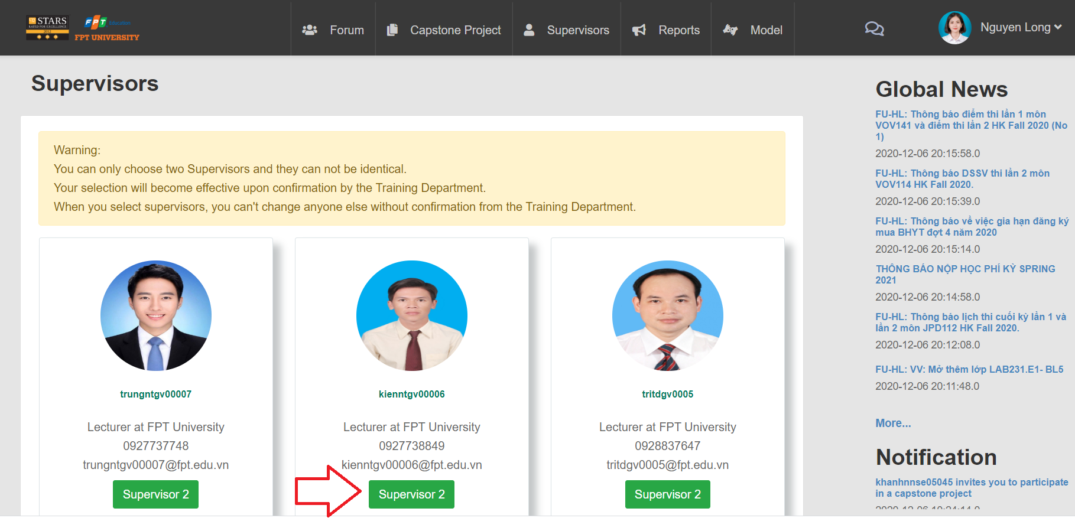

#### 6.2.1.7 View GUIDE

Step 1: Access forum, click GUIDE

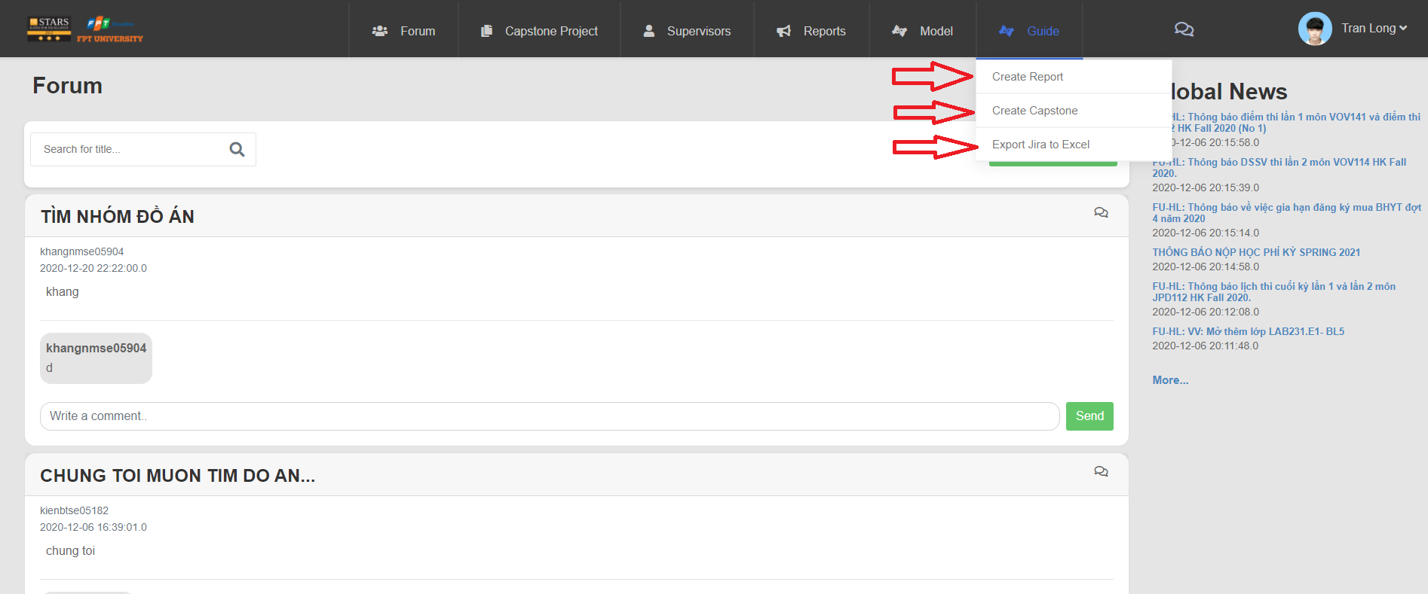

Step 2: System display GUIDE Page







#### 6.2.1.8 Upload file

Step 1: Click button “ADD POST”

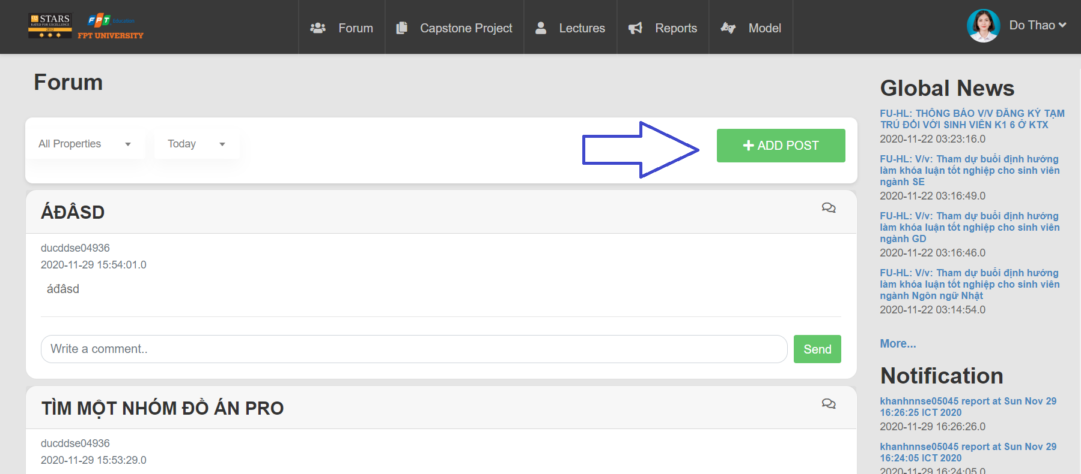

Step 2: After click button “ADD POST”, show form to create post



Step 3: Enter the required information, click button “Post” to upload file to forum

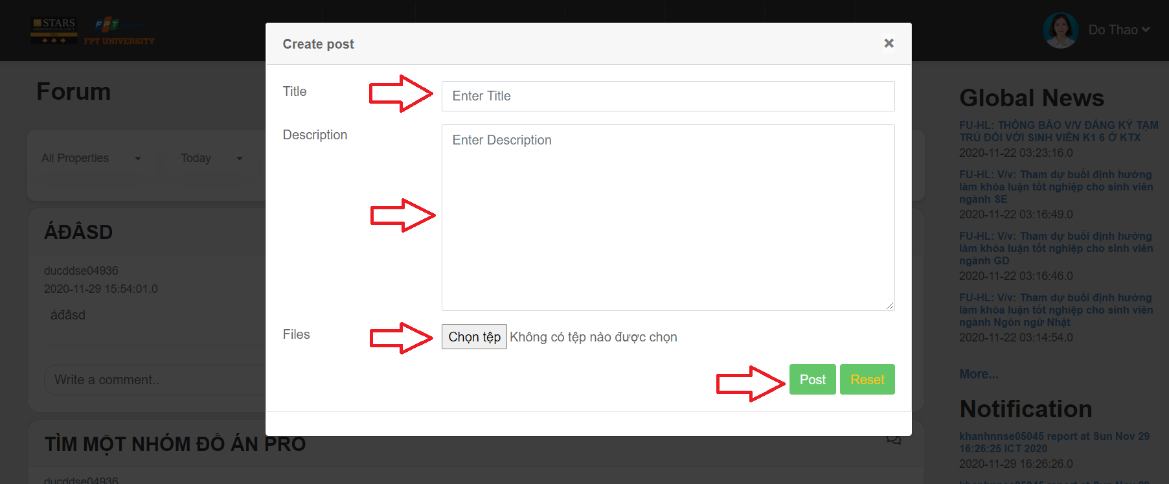

#### 6.2.1.9 Send mail

Step 1: Go to the email page, choose compose to send mail to register capstone project and booking supervisor



#### 6.2.1.10 Chat

Step 1: Access forum, Click icon in the right screen



Step 2: System display group chat to chat together



#### 6.2.1.11 Create chat

Step 1: Click icon on screen

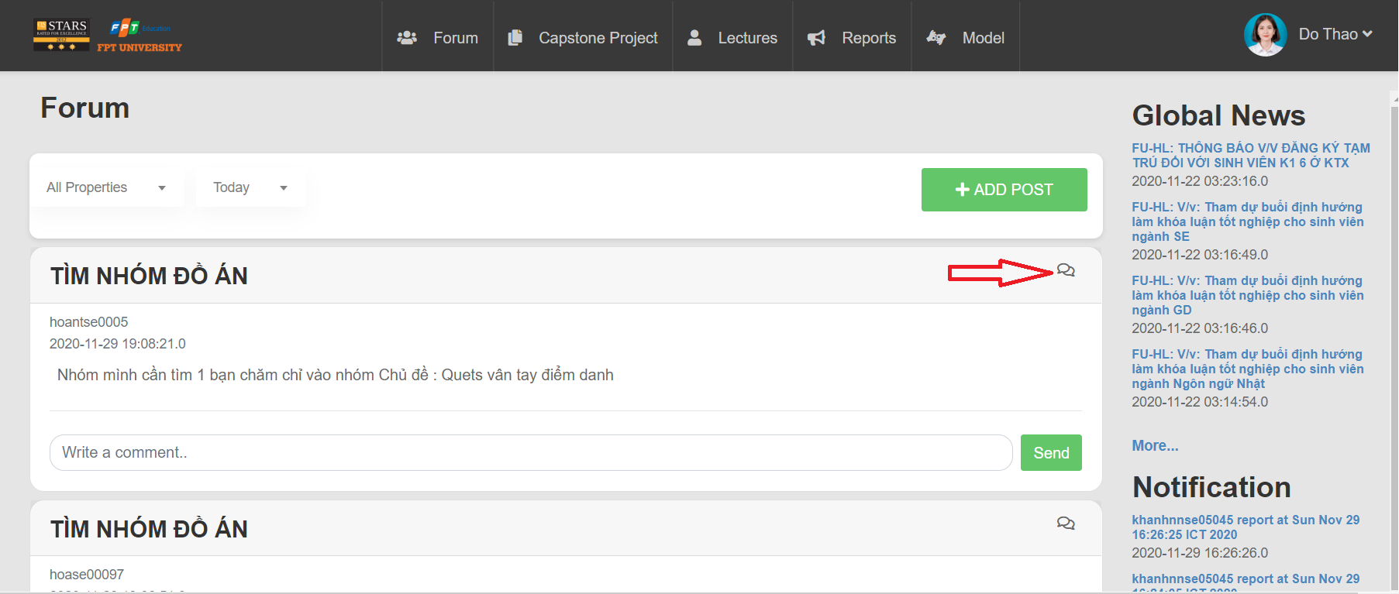

Step 2: Show room to student chat



#### 6.2.1.12 Confirm join team feature

Step 1: Access forum, Click Capstone Project, Choose My Capstone



Step 2: Click “Confirm” button



#### 6.2.1.13 Edit profile

Step 1: Access forum, click account, choose “Edit Profile”



Step 2 : System display detail information of user, enter information, click “Update” to edit profile



#### 6.2.1.14 Notification component

Step 1: Select the notifications you want to see

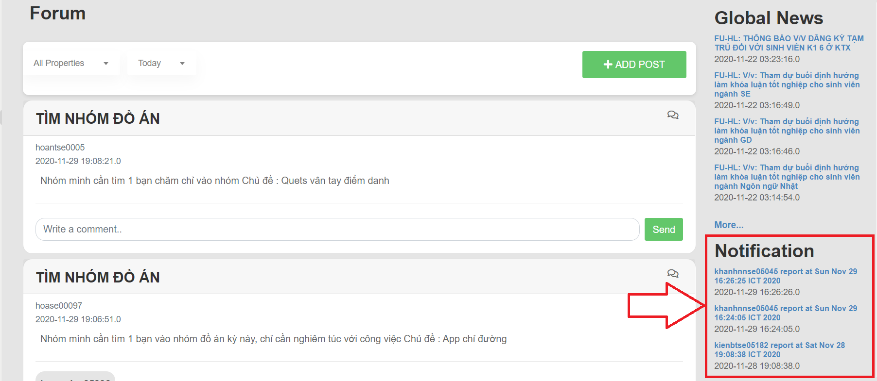

Step 2: Displays details of the notifications you want to see

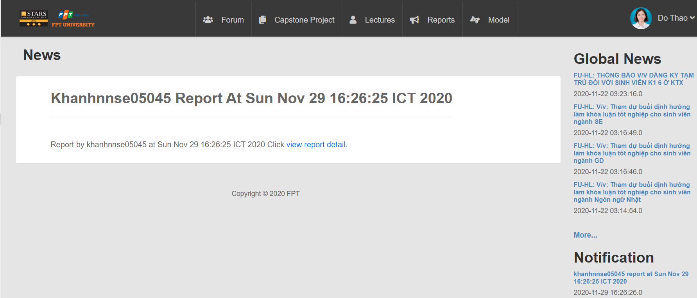

#### 6.2.1.15 Comment

Step 1: Enter information you want comment, click send

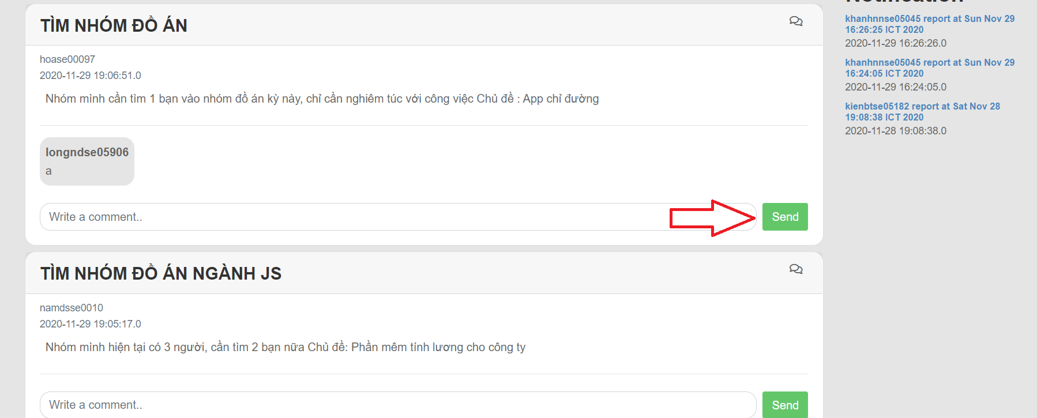

#### 6.2.1.16 Daily report to member to leader

Step 1: Select the Reports section at the top of the page, then select create report

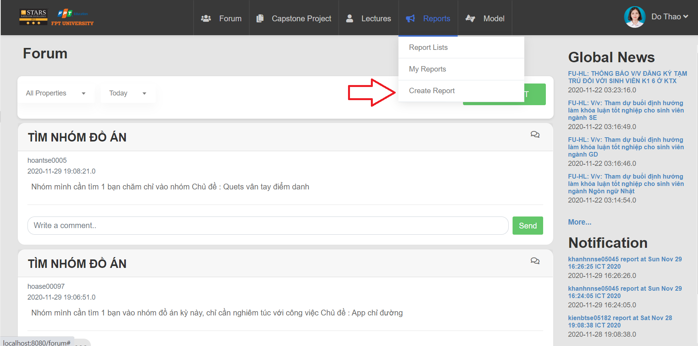

Step 2: Enter information report, then click button submit

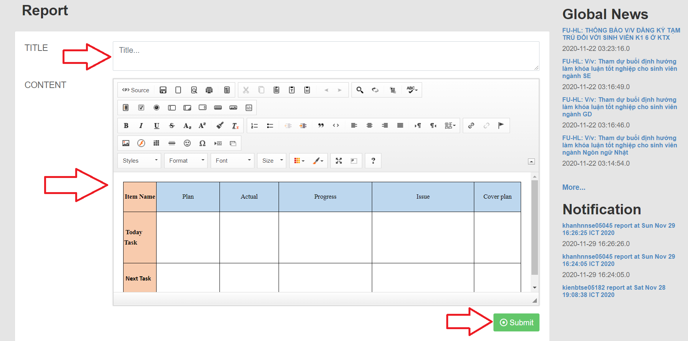

Step 3: Display reports of yourself and team members



Step 4: Click name of title to view detail information of report

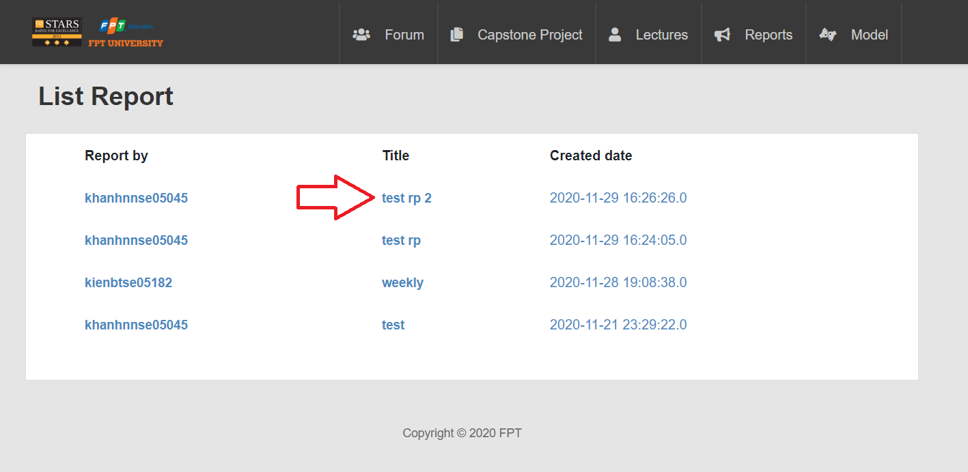

Step 5: Display report detail

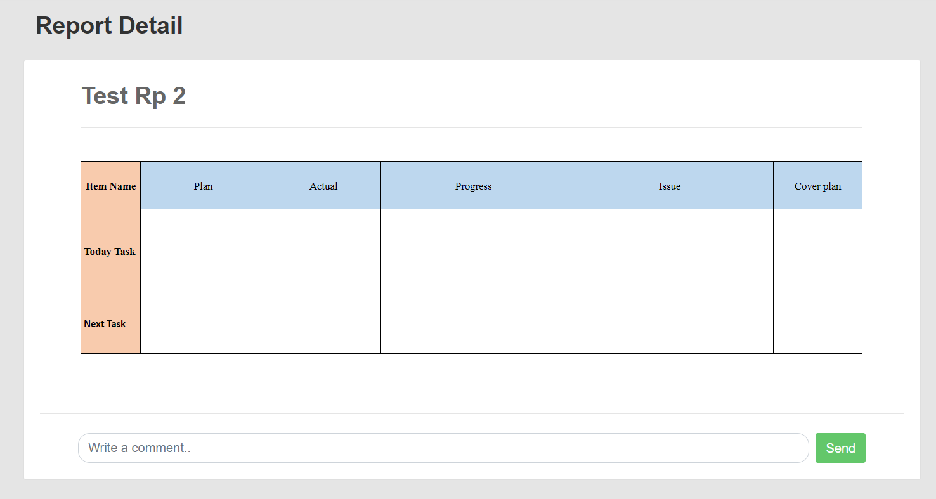

#### 6.2.1.17 Weekly report to leader to supervisor

Step 1: Select the Reports section at the top of the page, then select create report



Step 2: Enter information report, then click button submit



Step 3: Display reports of yourself and team members



Step 4: Click name of title to view detail information of report



Step 5: Display report detail



#### 6.2.1.18 Manage user

Step 1: Access forum, Click Manage User, choose Manage Student



Step 2: System display Student Management Page



#### 6.2.1.19 View information, status of list student

Step 1: View information, status of list student



#### 6.2.1.20 View and edit the list of registered project

Step 1: View and edit the list of registered project



#### 6.2.1.21 View list capstone project

Step 1: View list capstone project



#### 6.2.1.22 View detail project

Step 1: Access forum, click Capstone Project, choose Manage Capstone

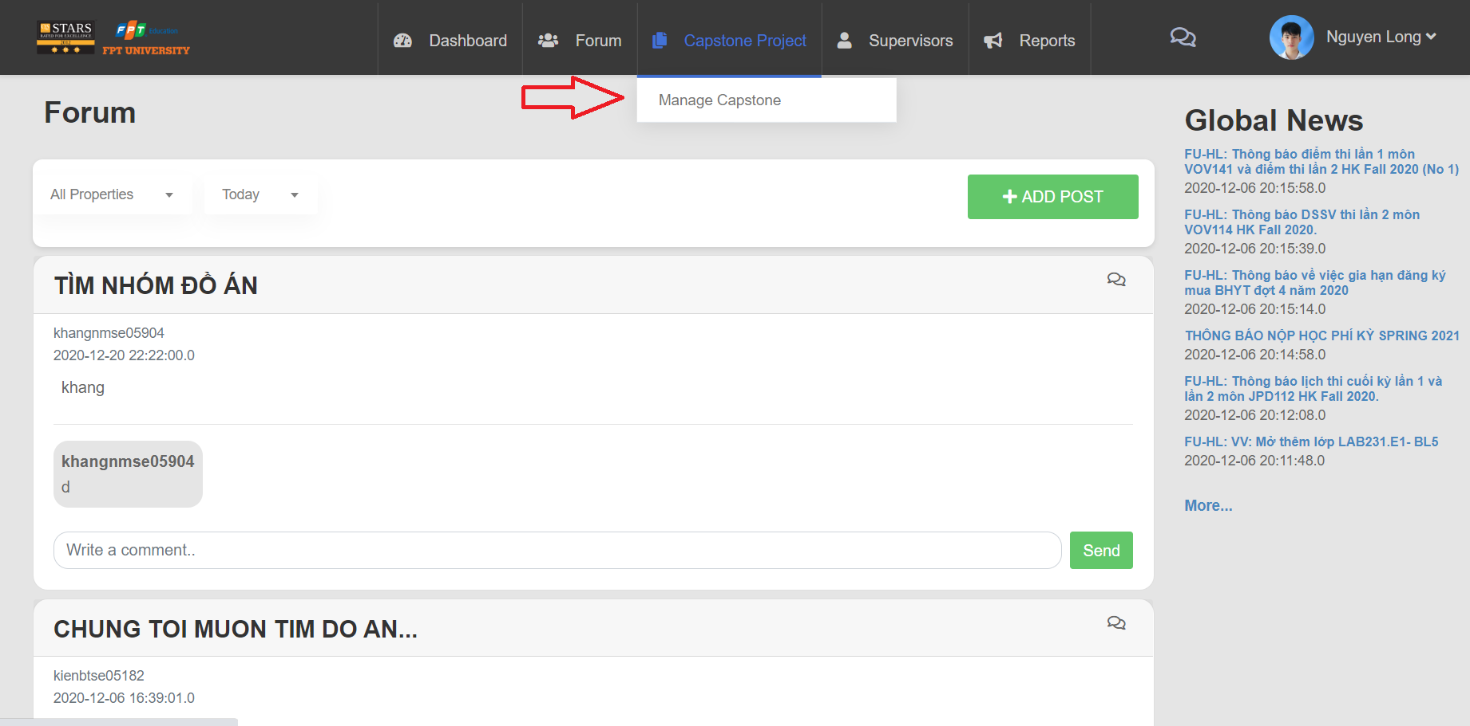

Step 2: System display Capstone Project Page



Step 3: Click to icon as screen

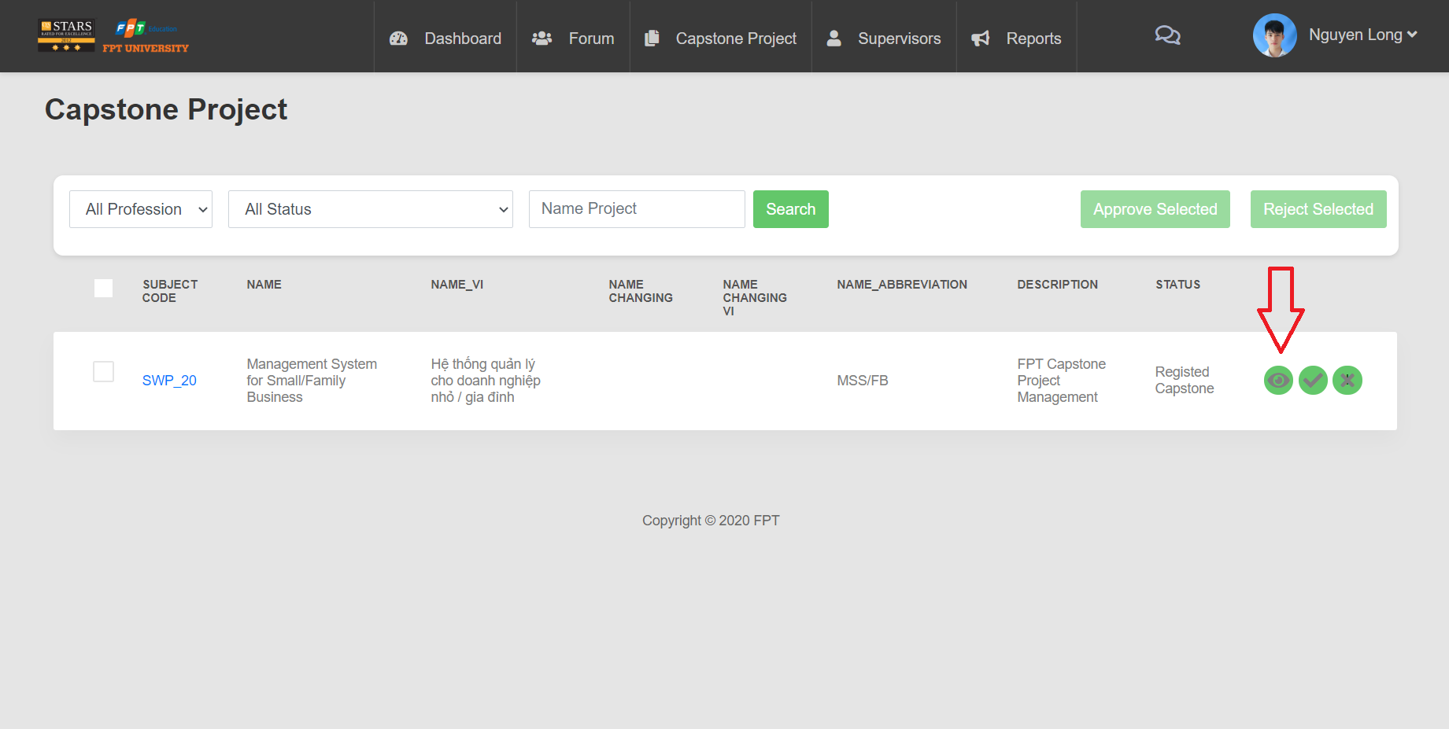

Step 4: System display detail project

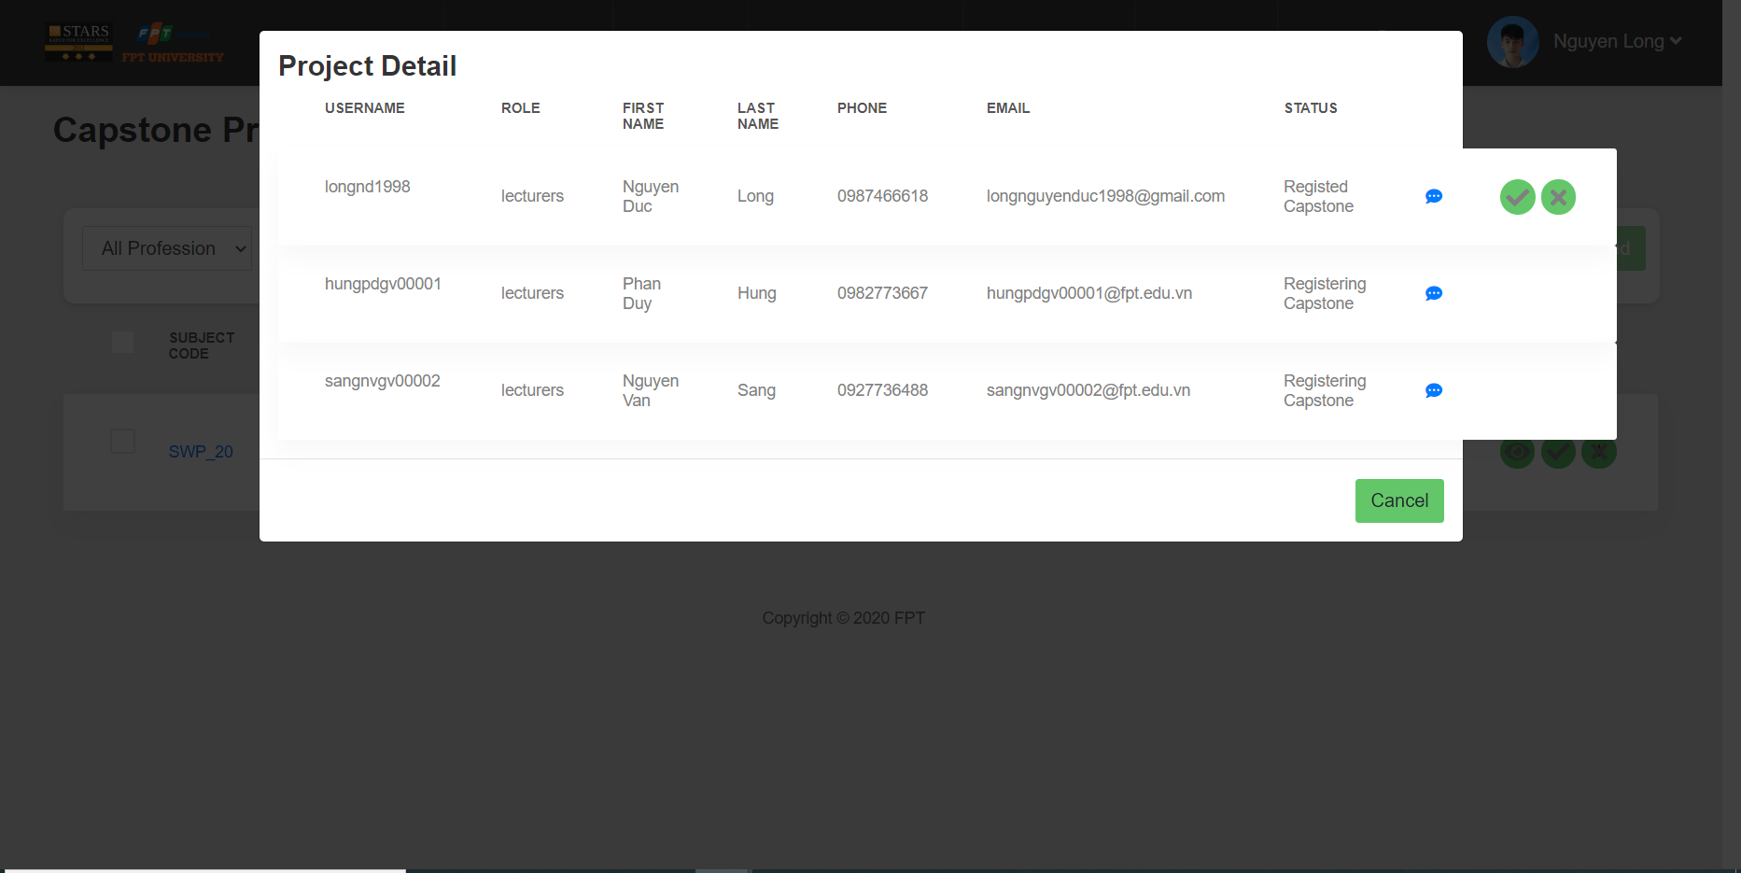

#### 6.2.1.23 Manage Capstone Project

Step 1: Access forum, click Capstone Project, choose Manage Capstone



Step 2: System display Capstone Project Page



#### 6.2.1.24 View task detail of Capstone Project

Step 1: Access Dashboard, click Detail in list project



Step 2: System display Task Detail Page



#### 6.2.1.25. Dashboard statistical of project

Step 1: Access forum, Click to Dashboard

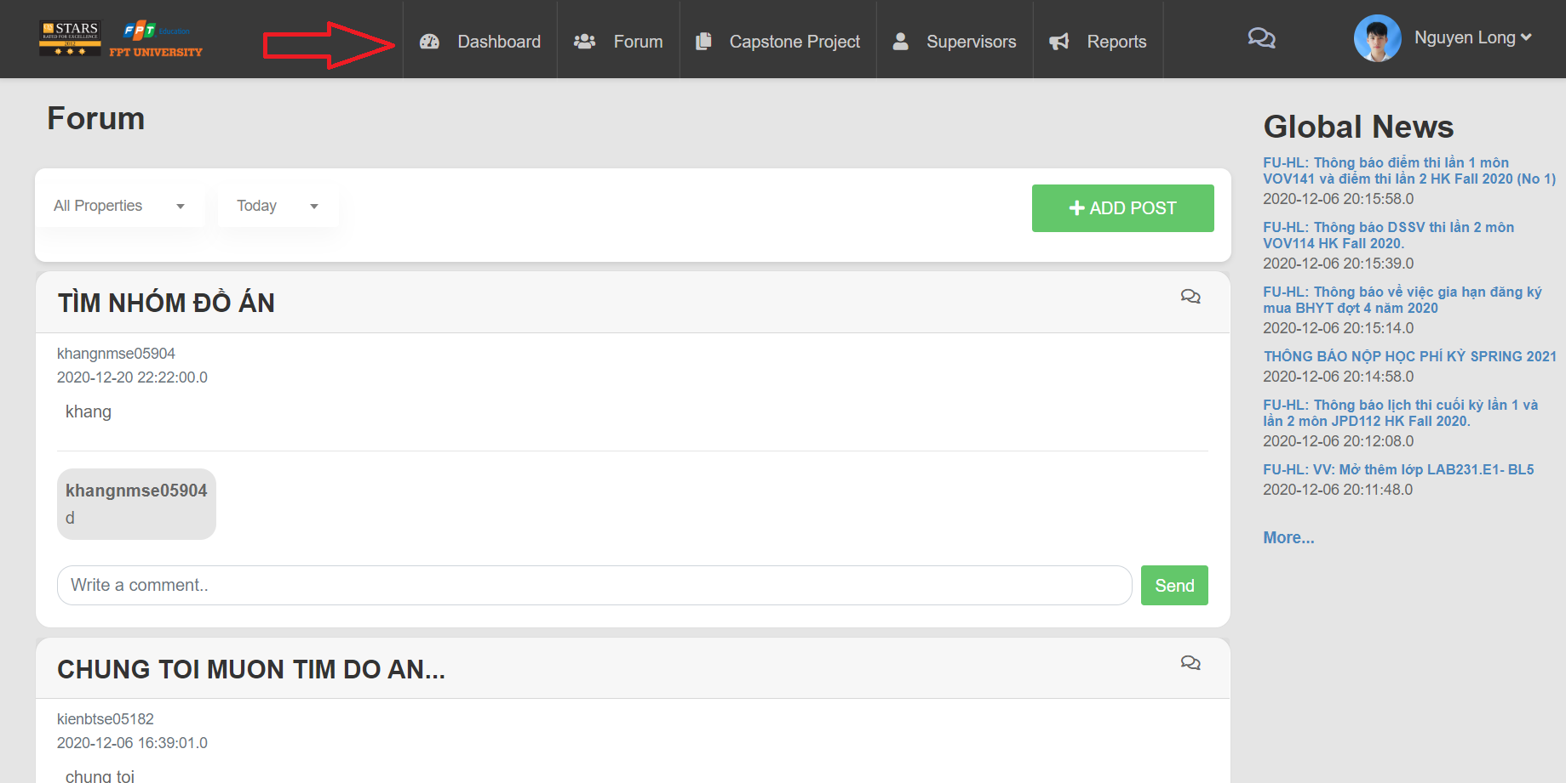

Step 2: System display Dashboard page





#### 6.2.1.26 View information of user

Step 1: Access forum, click to account of user

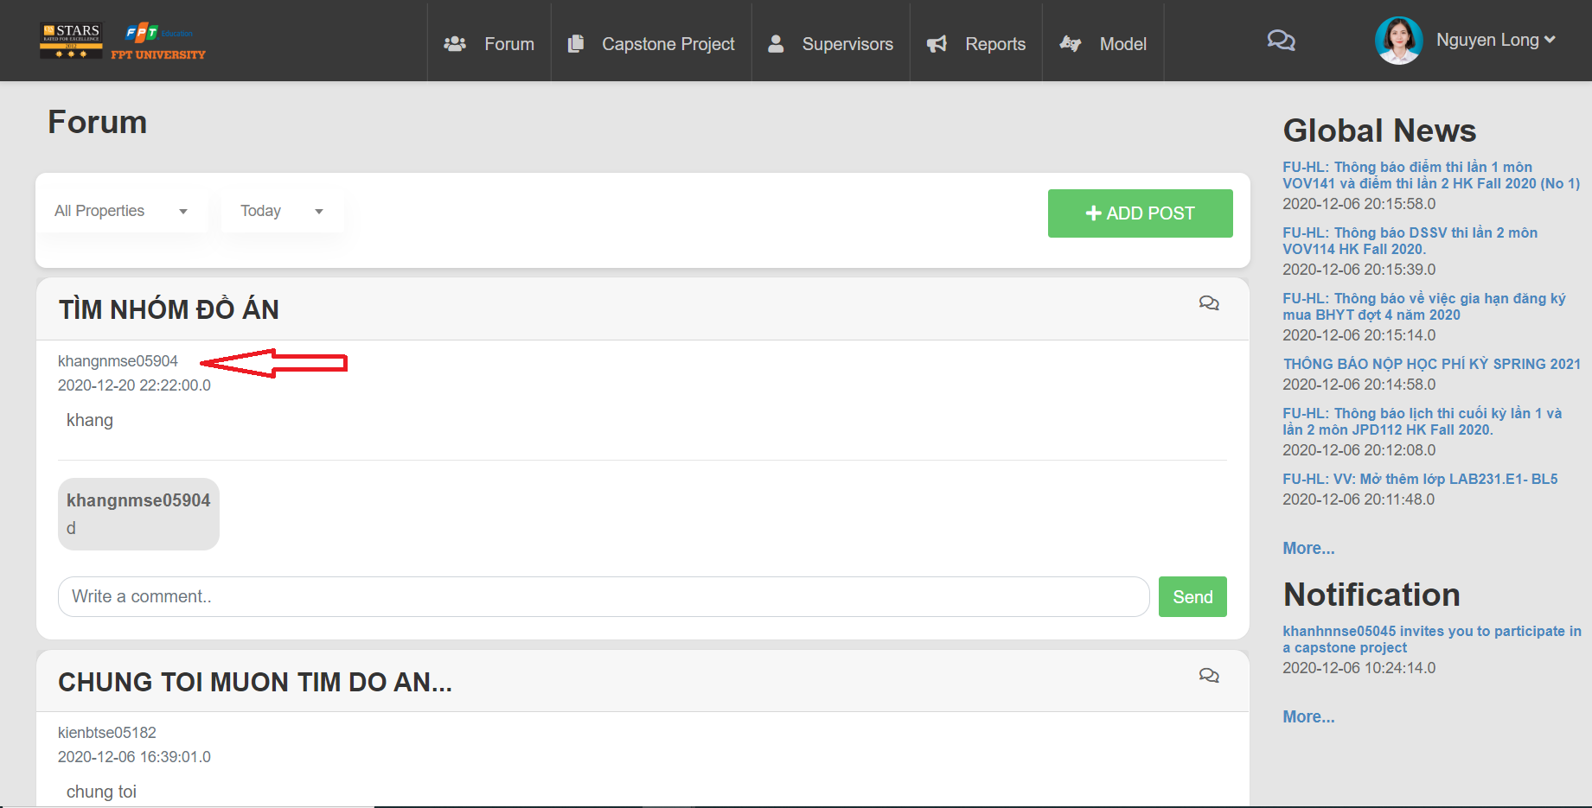

Step 2: Display information of user

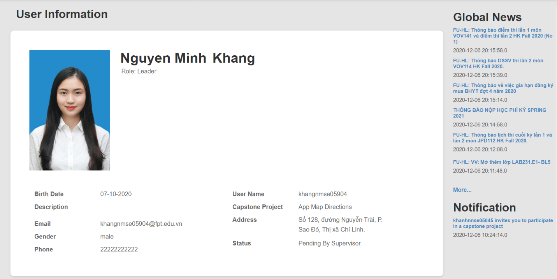

#### 6.2.1.27 Approve capstone project in the project registration stage

Step 1: Click button “Approve” or “Reject” project



#### 6.2.1.28 Change pass / fail results

Step 1: Access forum, Click Capstone Project, Choose Manage Capstone



Step 2: Choose status



Step 3: Click “Search” button



Step 4: Click icon as screen to pass result or fail result



#### 6.2.1.29 Create notification

Step 1: Access forum, click Notifications, choose Create Notifications



Step 2: Enter information, click “Post” button

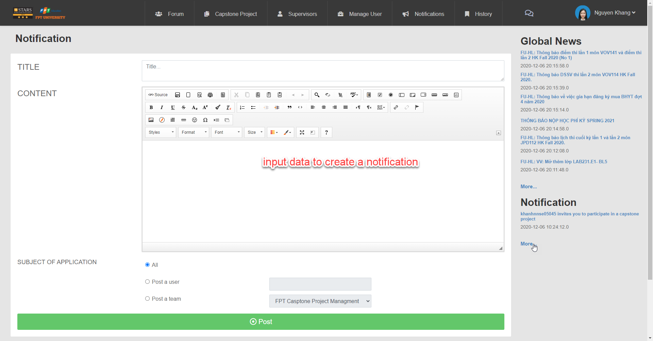

#### 6.2.1.30 View History Record

Step 1: Access forum, click History, choose History List, system display History Records



#### 6.2.1.31 Change name capstone project

Step 1: Access forum, click Capstone Project, choose My Capstone



Step 2: Click “Edit” button



Step 3: Enter information to correct, click “Update” button



#### 6.2.1.32 View list post

Step 1: Access forum display list post



#### 6.2.1.33 Get comment

Step1: Access forum, enter the article you want to comment on post

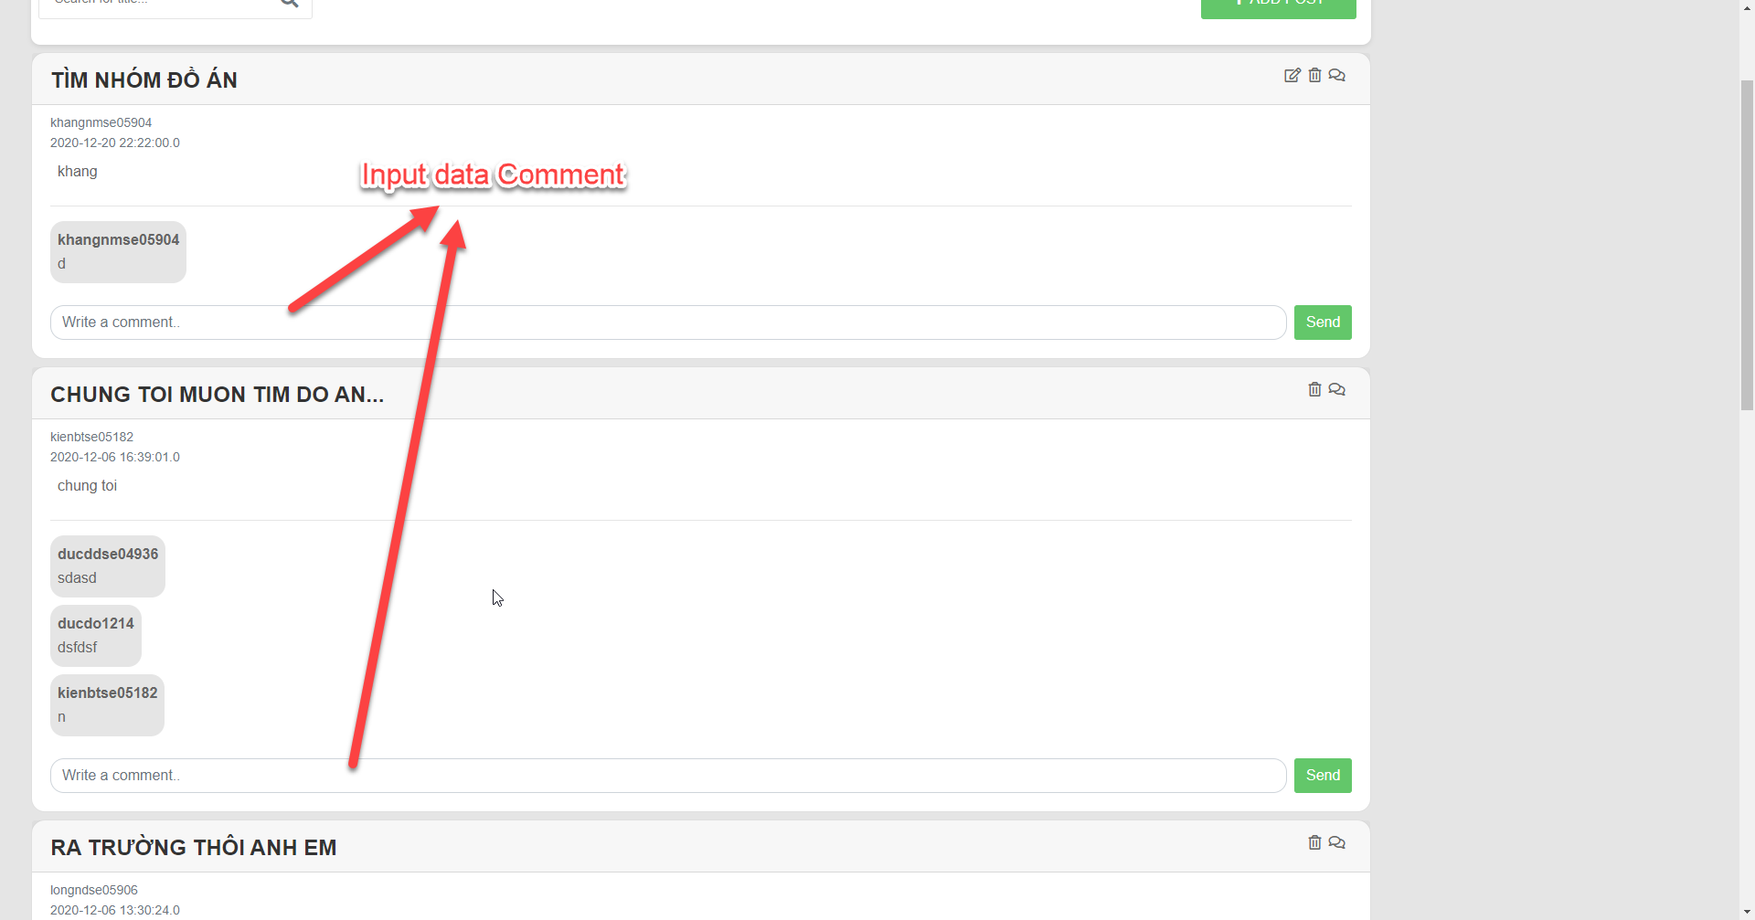

Step 2: Click “Send” button

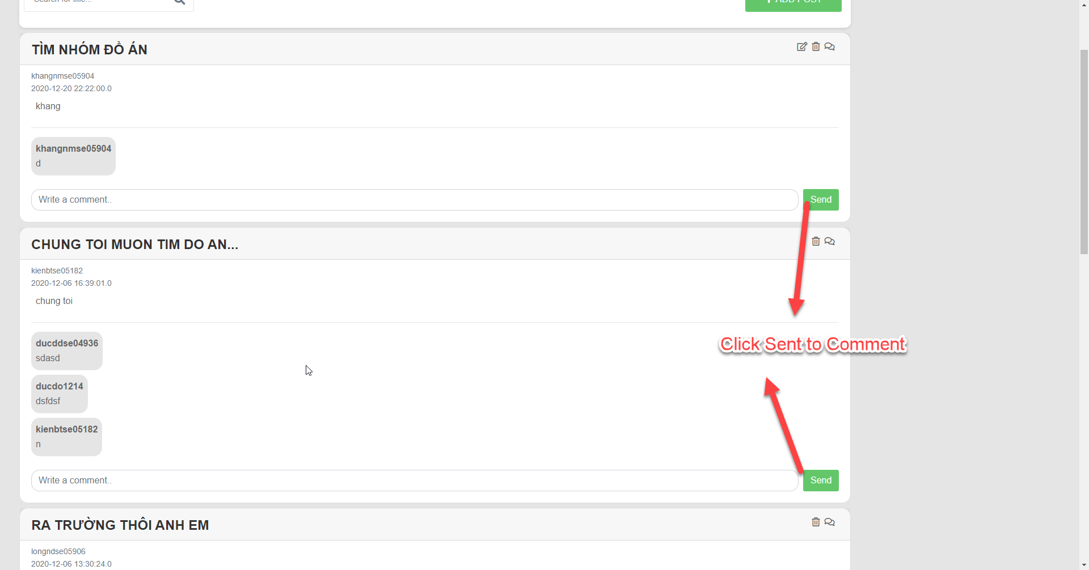

#### 6.2.1.34 Add post

Step 1: Access forum, click “Add Post” button



Step 2: Fill full the information, click “Post” button

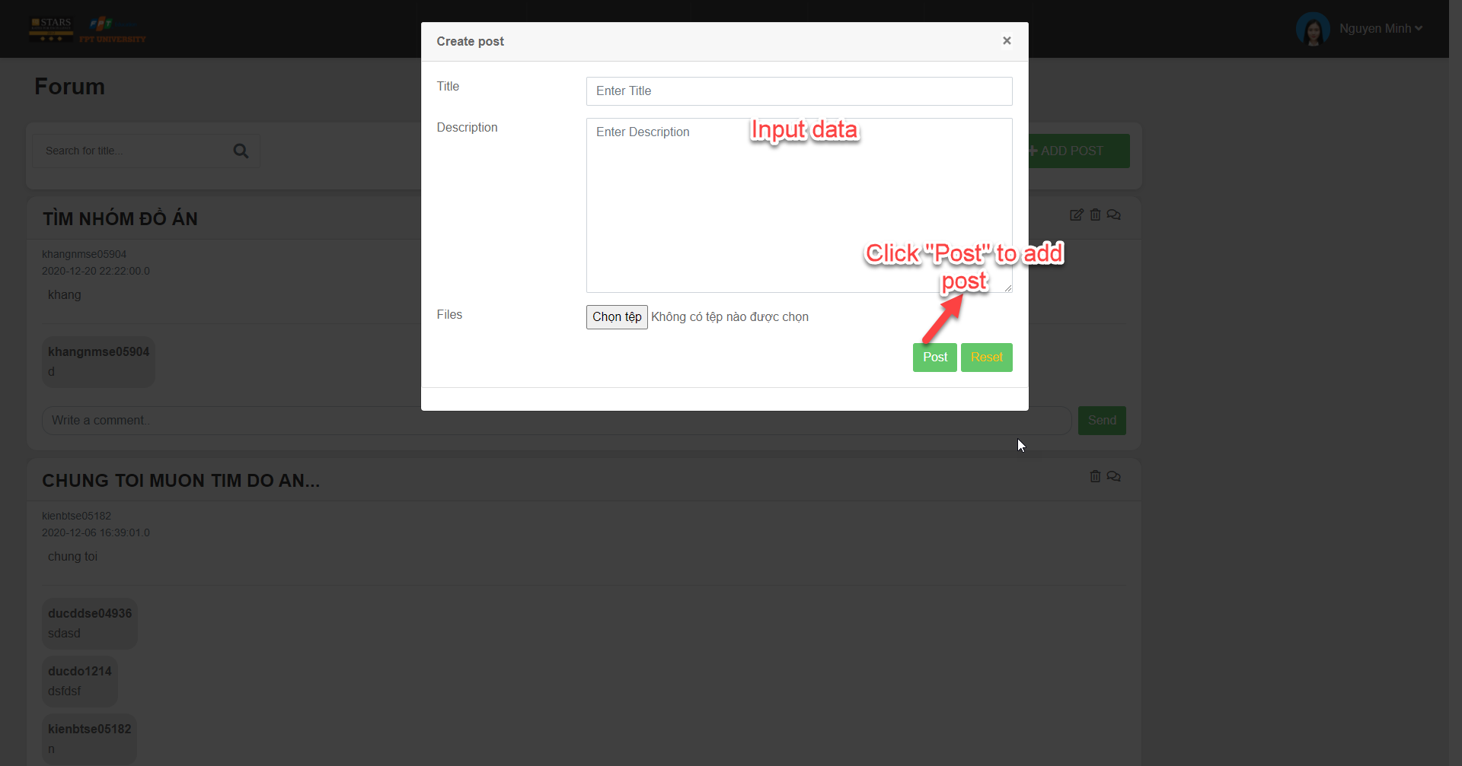

#### 6.2.1.35 Edit post

Step 1: Access forum, click on the icon as screen



Step 2: Edit post information, click “Post” button to edit

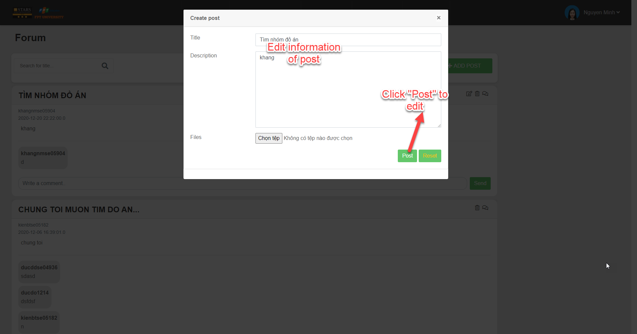

#### 6.2.1.36 Delete post

Step 1: Access forum, click on the icon as screen



Step 2: Click “Delete” button

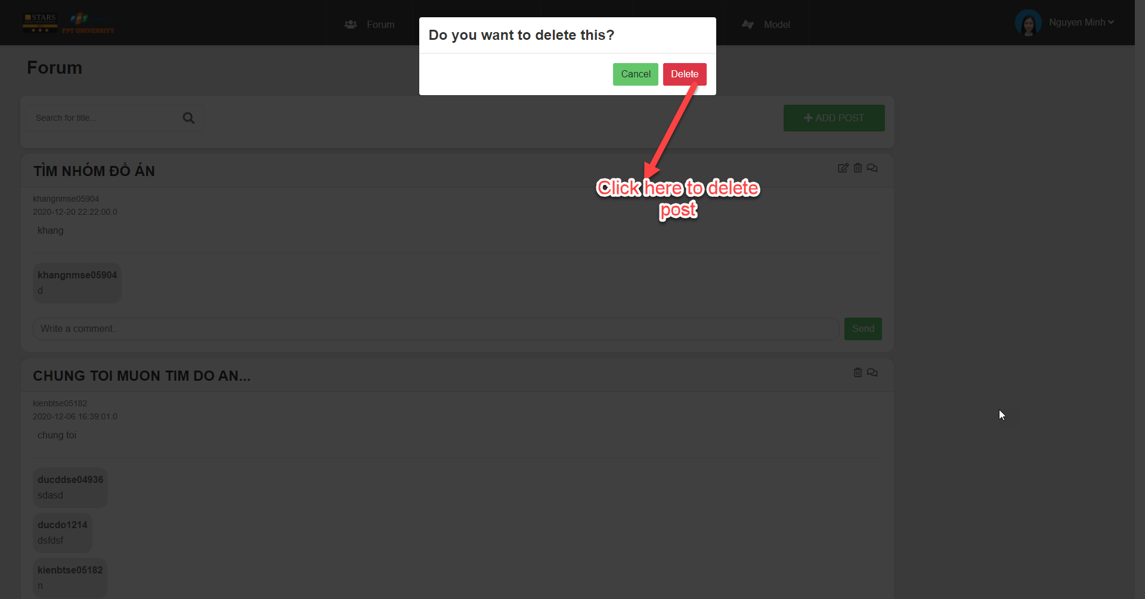

#### 6.2.1.37 Search code

Step 1: Access forum, enter title, click “Search”

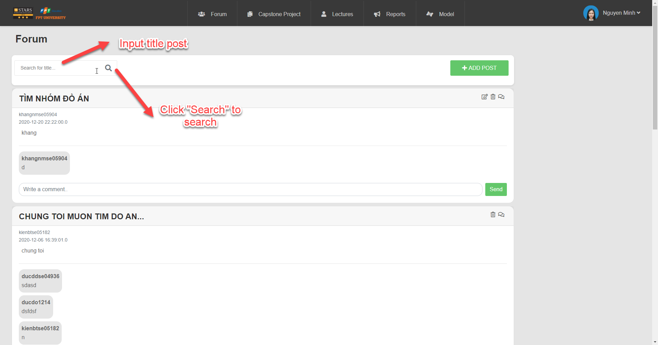

#### 6.2.1.38 Add user

Step 1: Access forum, click Manage User, choose Other User



Step 2: Fill full the information

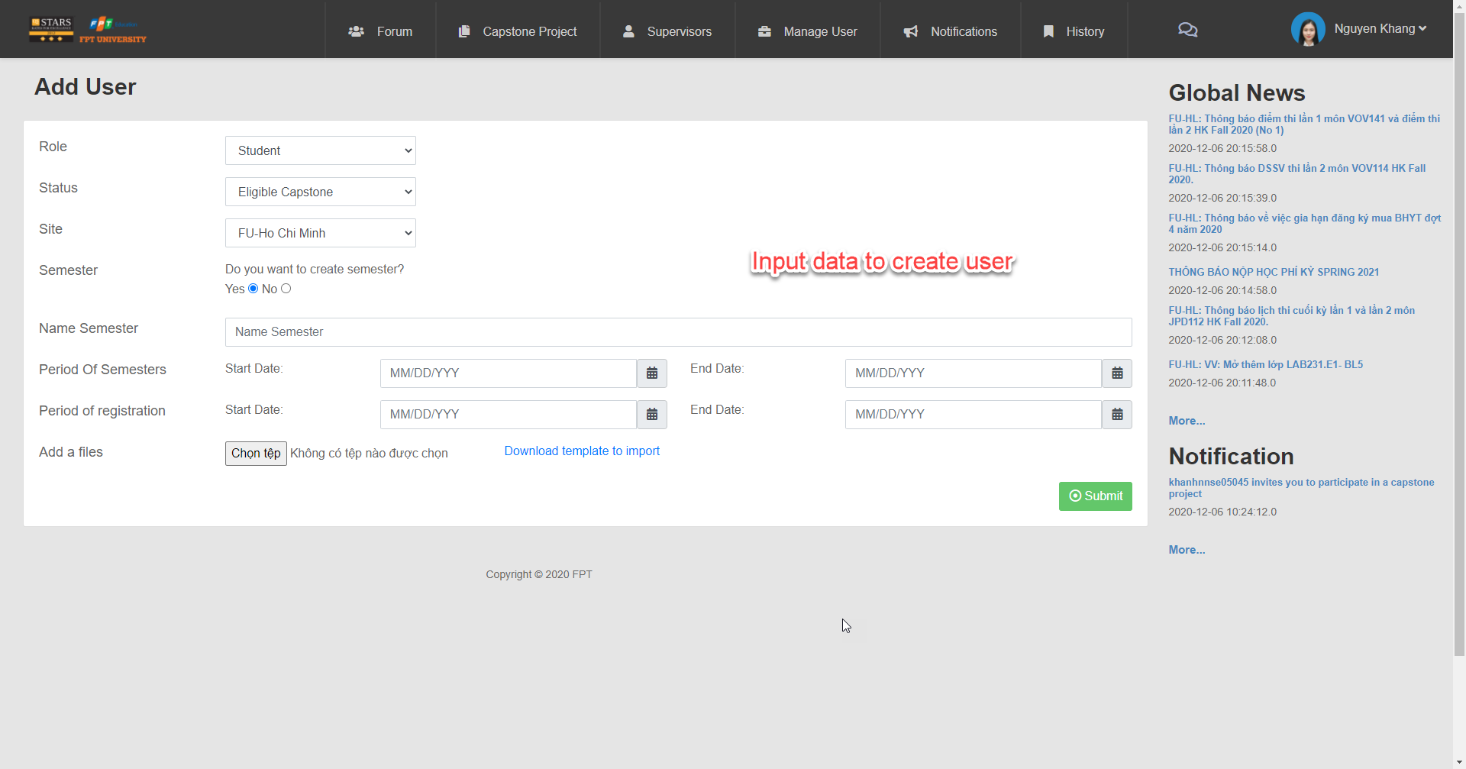

Step 3: Click “Submit” button

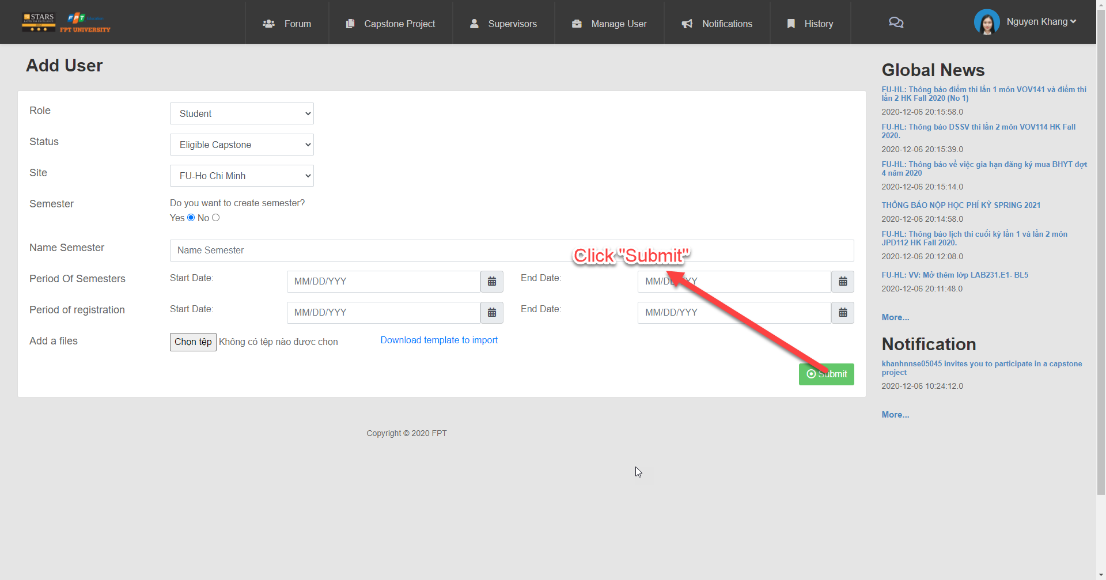

#### 6.1.1.39: Approve capstone project in the changing name stage

Step 1: Access forum, Click Capstone Project, Choose Manage Capstone



Step 2: Choose status



Step 3: Click “Search” button



Step 4: Click icon as screen to approve

